Supplementary Materials
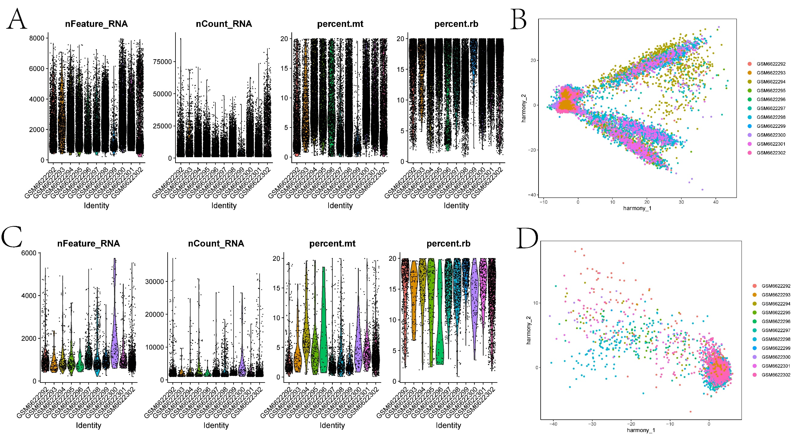
Figure S1 (A) Distribution of nFeature_RNA, nCount_RNA, percent.mt, and percent.rb in the cell population after quality control. (B) Scatter plot showing batch correction of cells from different samples using the Harmony algorithm. (C) Distribution of nFeature_RNA, nCount_RNA, percent.mt, and percent.rb in the T cell population after quality control. (D) Scatter plot showing batch correction of T cell from different samples using the Harmony algorithm.
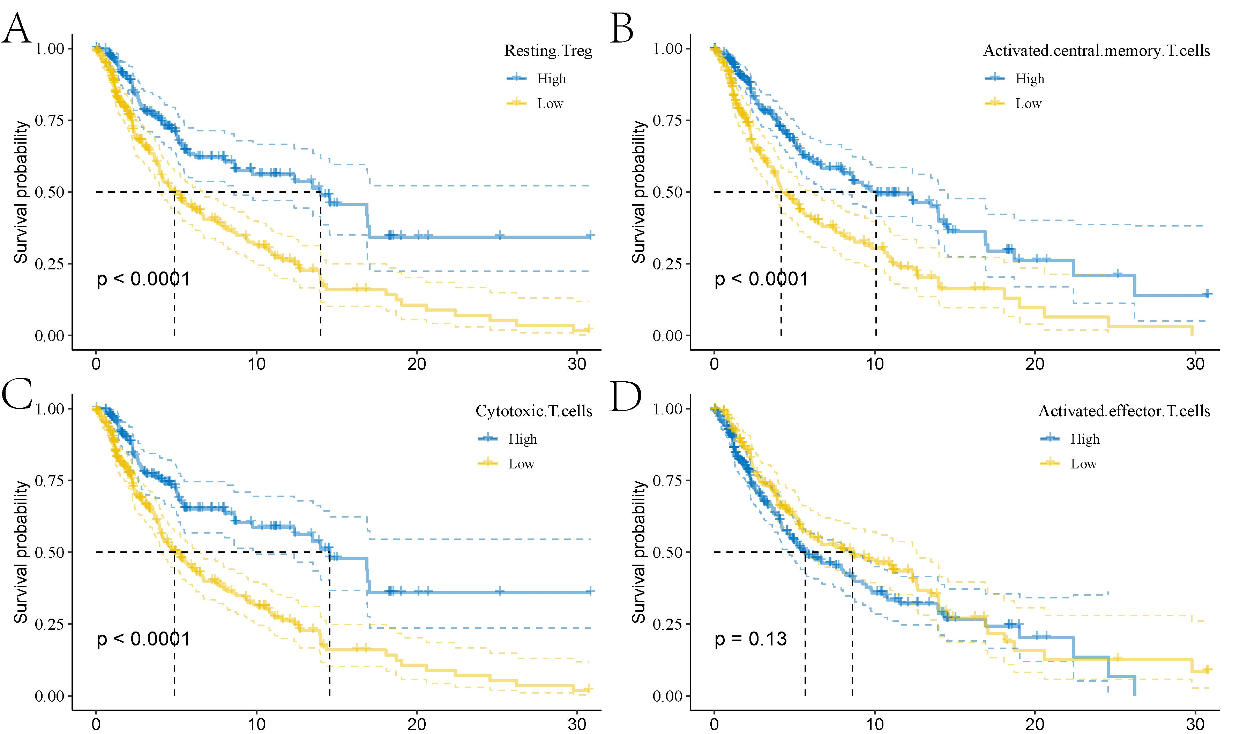
Figure S2 Kaplan-Meier survival curves for resting Treg, activated central memory T cells, cytotoxic T cells, and activated effector T cells.
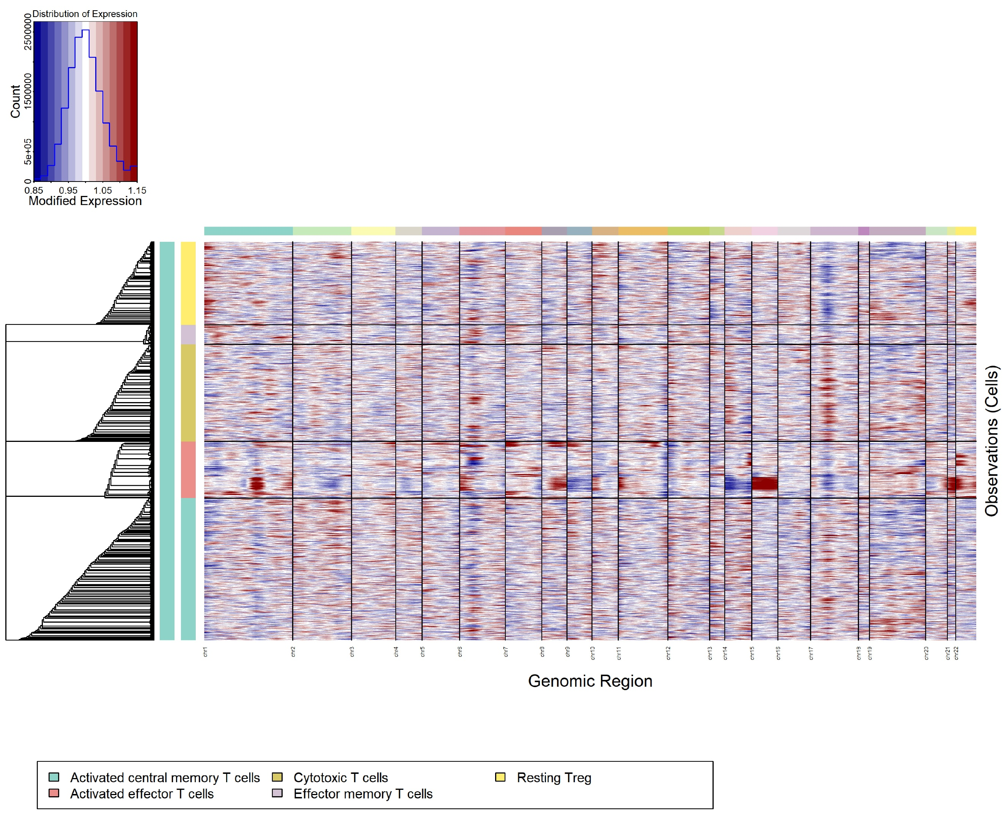
Figure S3 Gene expression patterns of different T cell subsets in melanoma samples as revealed by consensus clustering analysis (CNV).
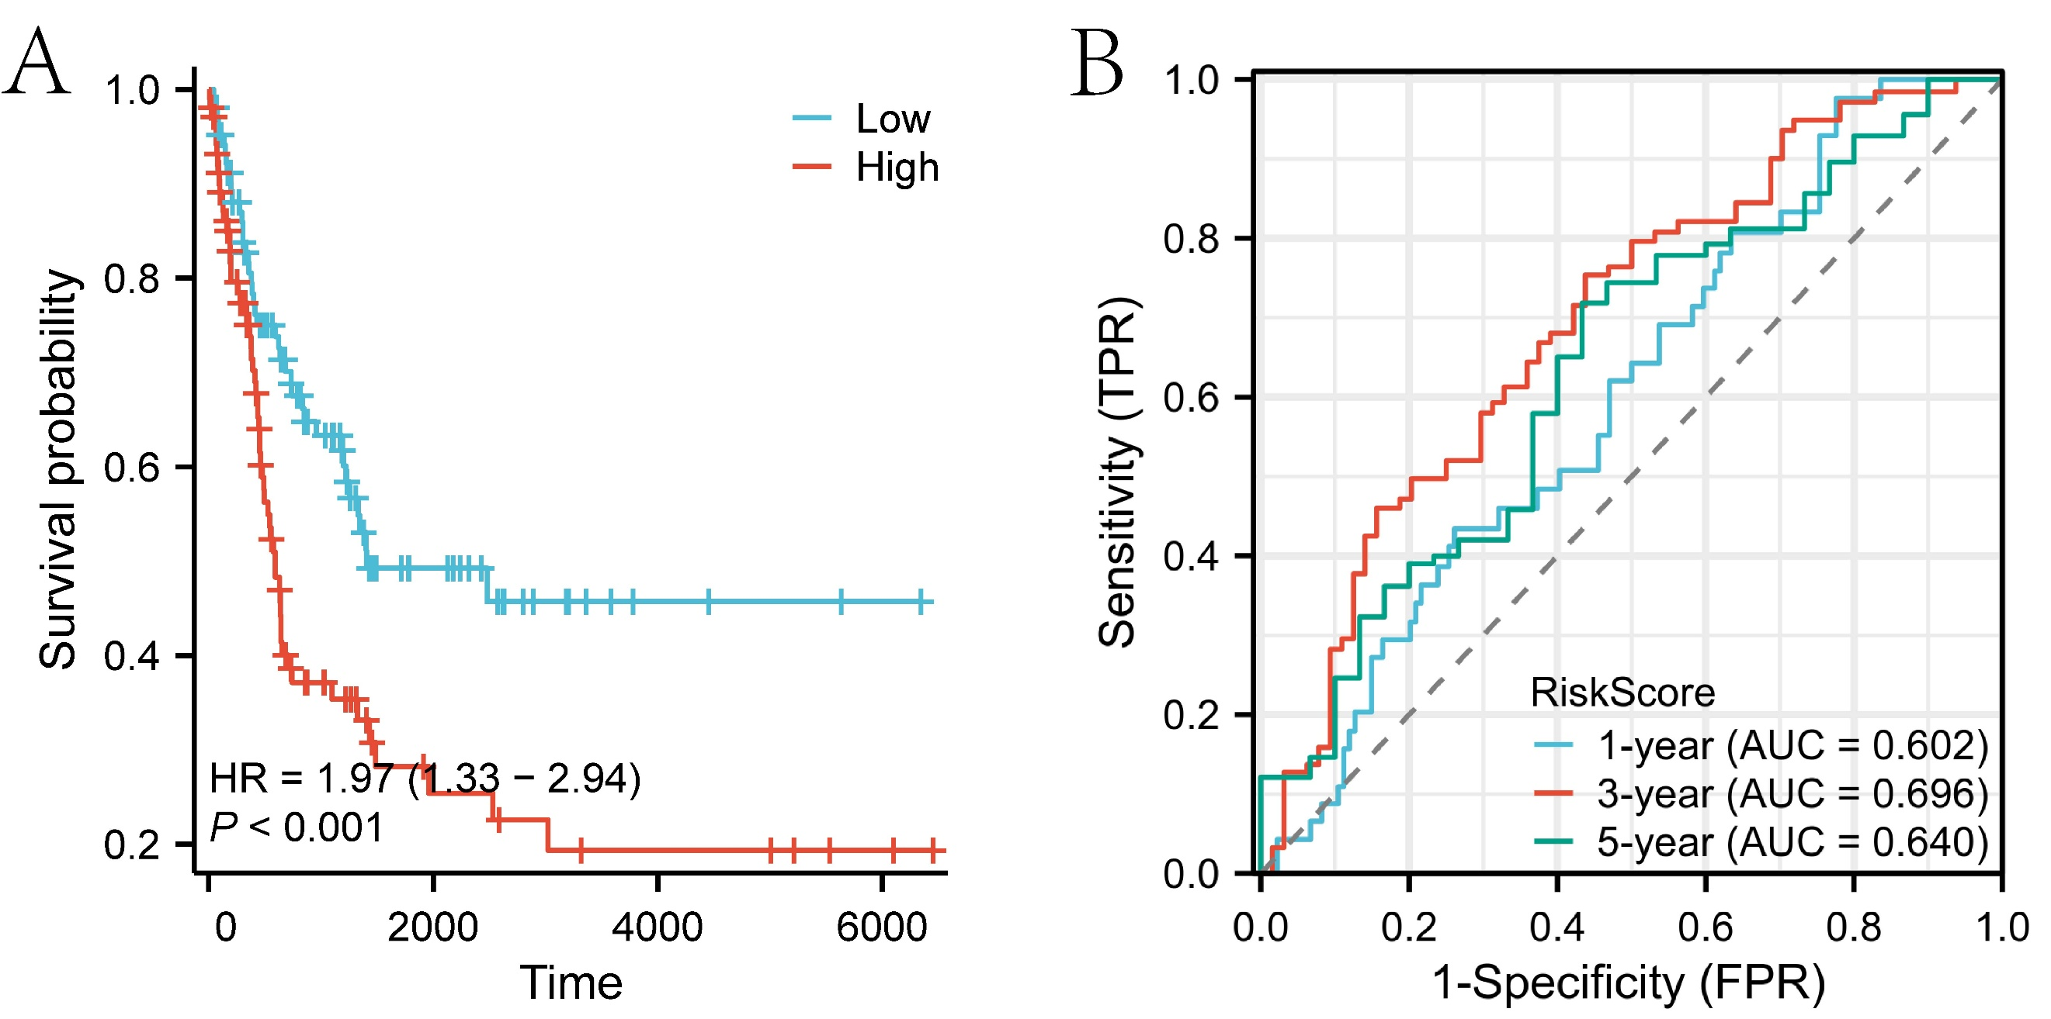
Figure S4 Validation of the prognostic model in an external test cohort (GSE65904). (A) Kaplan-Meier survival curves between high- and low-risk groups in the external test cohort. (B) ROC curves for the model's prediction of 1-year, 3-year, and 5-year survival of patients in the external test cohort.

