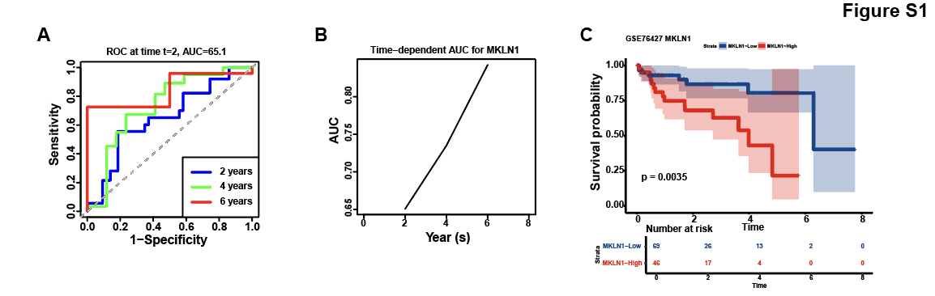
Figure S1. Prognostic validation of MKLN1-AS in the GEO GSE76427 external cohort. (A) ROC curve for 2, 4 and 6-year overall survival (OS); (B) Time-dependent AUC curve showing the increase of predictive efficacy for 2, 4 and 6 years; (C) Kaplan-Meier survival curve comparing OS between MKLN1-AS high- and low-expression groups (p = 0.0035).
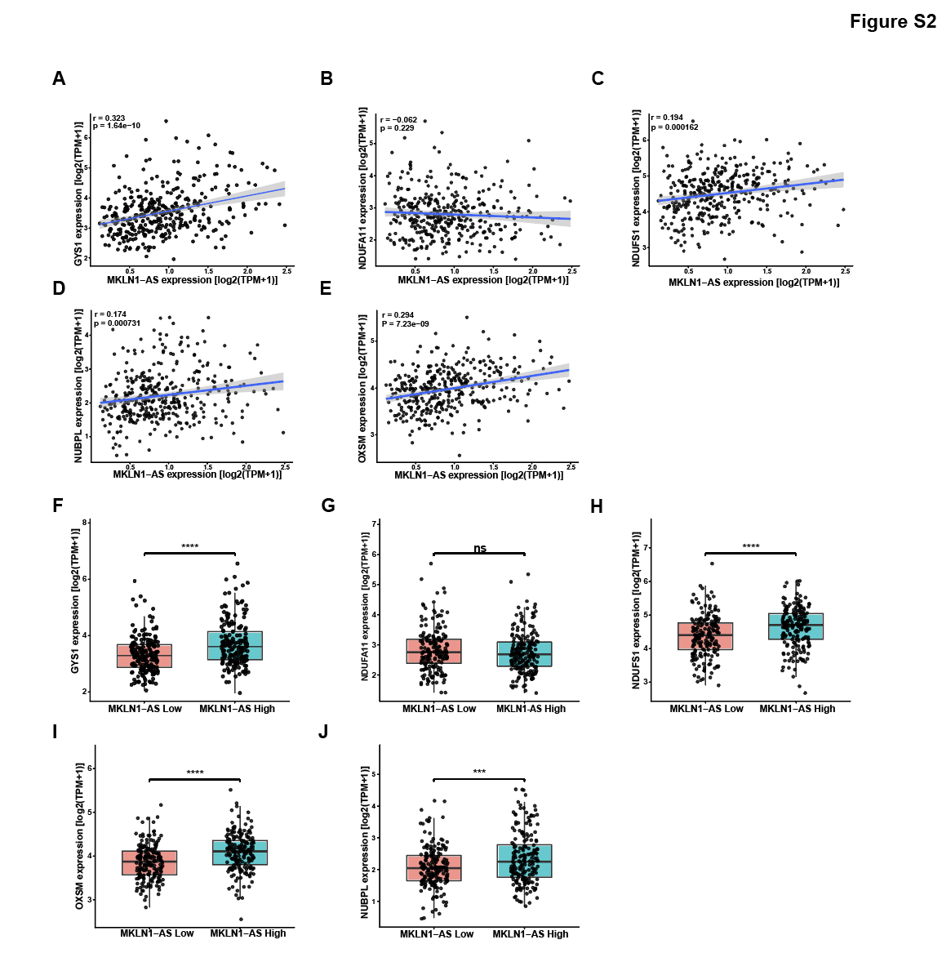
Figure S2. The correlation of MKLN1-AS with disulfidptosis-inhibiting genes. (A–E) Pearson correlation analysis between MKLN1-AS and five disulfidptosis-inhibiting genes (NUBPL, NDUFA11, OXSM, NDUFS1, GYS1) in the TCGA-LIHC cohort. (F–J) Expression levels of NUBPL, NDUFA11, OXSM, NDUFS1, and GYS1 in MKLN1-AS high- and low-expression groups from the TCGA-LIHC cohort (Student’s t-test, *p < 0.05, **p < 0.01, ***p < 0.001, ****p < 0.0001).
Table S1 Sequences of oligonucleotides and primers used in this work
Official Symbol | primers
LRPPRC | F: TGCAATTGCTGAACAAACCCC
 | R: GGACAGGCTCTCCAGCATAC
MKLN1-AS | F: GTGCTGCACAAGGAATGGAA
 | R: AAAGACACTGAGCTGGGTGA
hsa-miR-139-5p | F: TCTACAGTGCACGTGTCTCC
 | R: GTGCAGGGTCCGAGGT
GAPDH | F: GGCCTCCAAGGAGTAAGACC
 | R: AGGGGAGATTCAGTGTGGTG

