Supplementary Figure 1a : Glass slides with KB cells on coverslip stained with Achridine orange and Ethididium Bromide
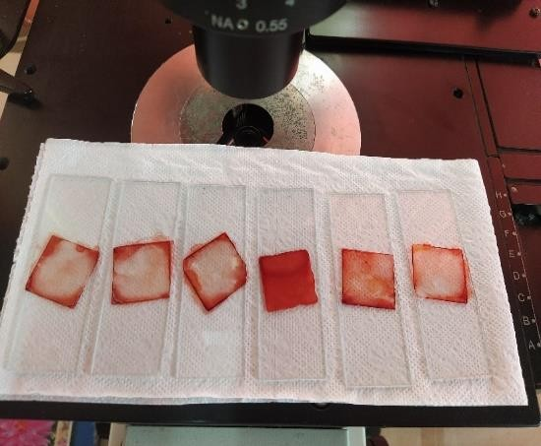
Supplementary Figure 1b : Microscopic image of cell staining (10X)
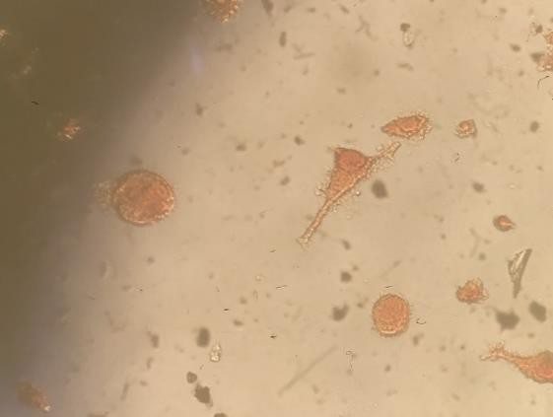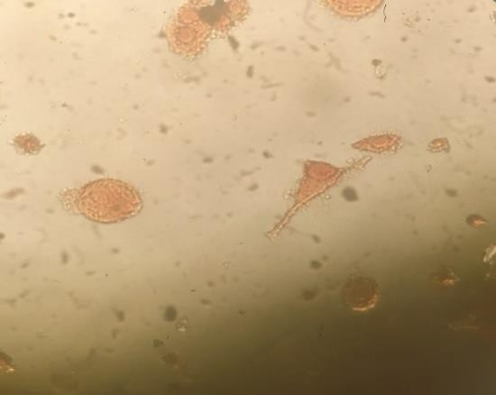

Supplementary Figure 2a. Labelled femalemiceforImmunisation (a) Labelled head marked mice for immunisation,(b) Unlabelledmicenoimmunisation asacontrol
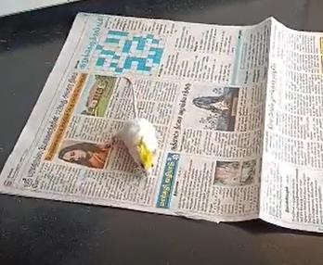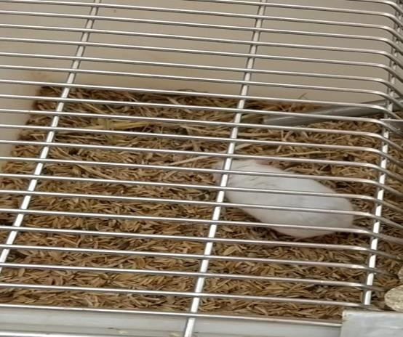
Supplementary Figure 2b. Immunisation of Balb/C female mice with KB cell in PBS and Freund’s Adjuvant- 0.4ml dose injected to both the mice animal
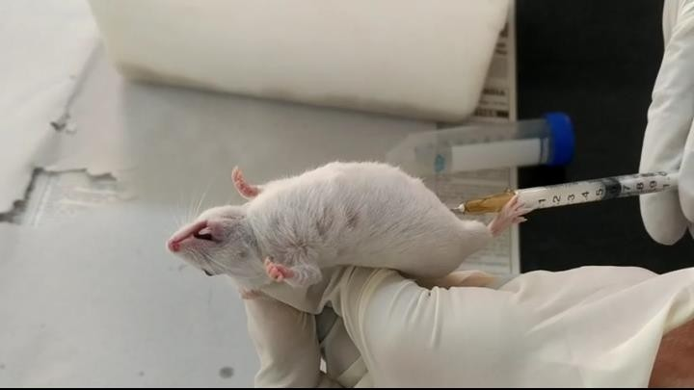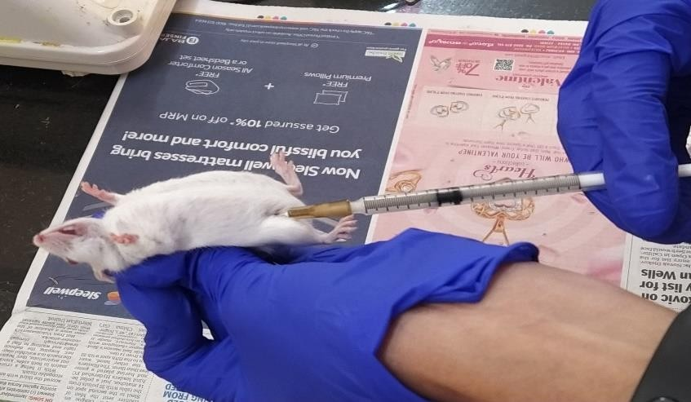

Supplementary Figure 3. Collectionof Bloodfromimmunizedmice
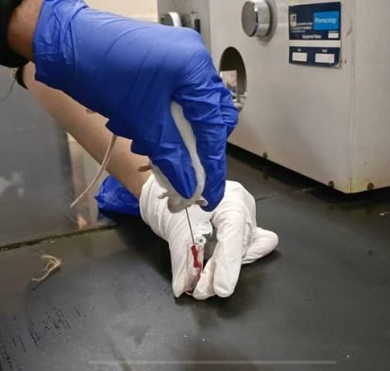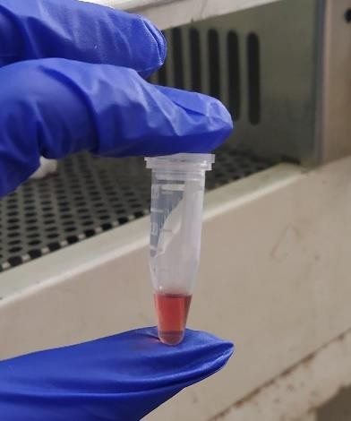

Supplementary Figure 4. Spleenscollectedfrom Unimmunizedandimmunizedmice
