Supplementary file

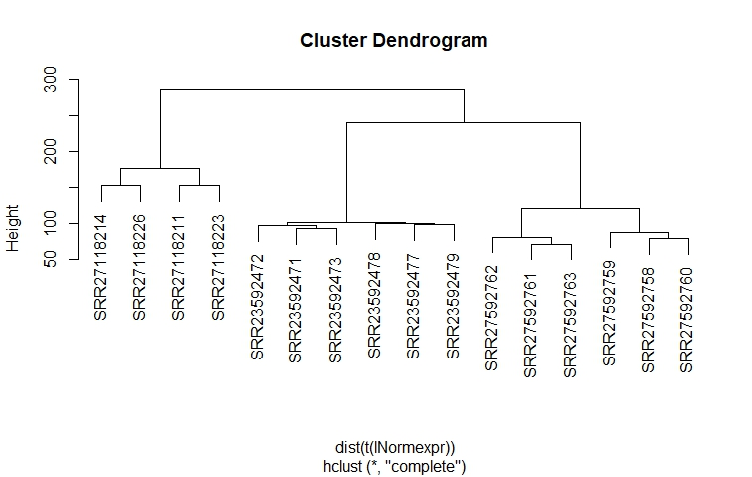
Supplementary file fig1. Cluster dendrogram plot after normalization of RNAseq data

