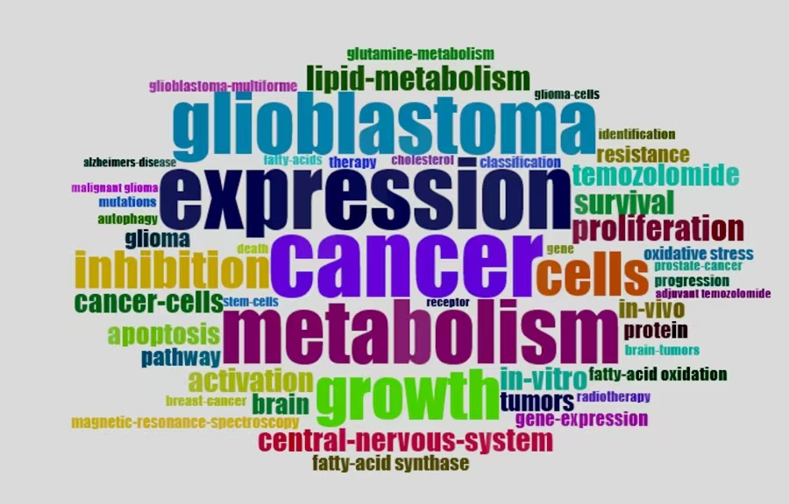
Supplementary Figure S1：The keyword word cloud of lipid metabolism on glioma.

