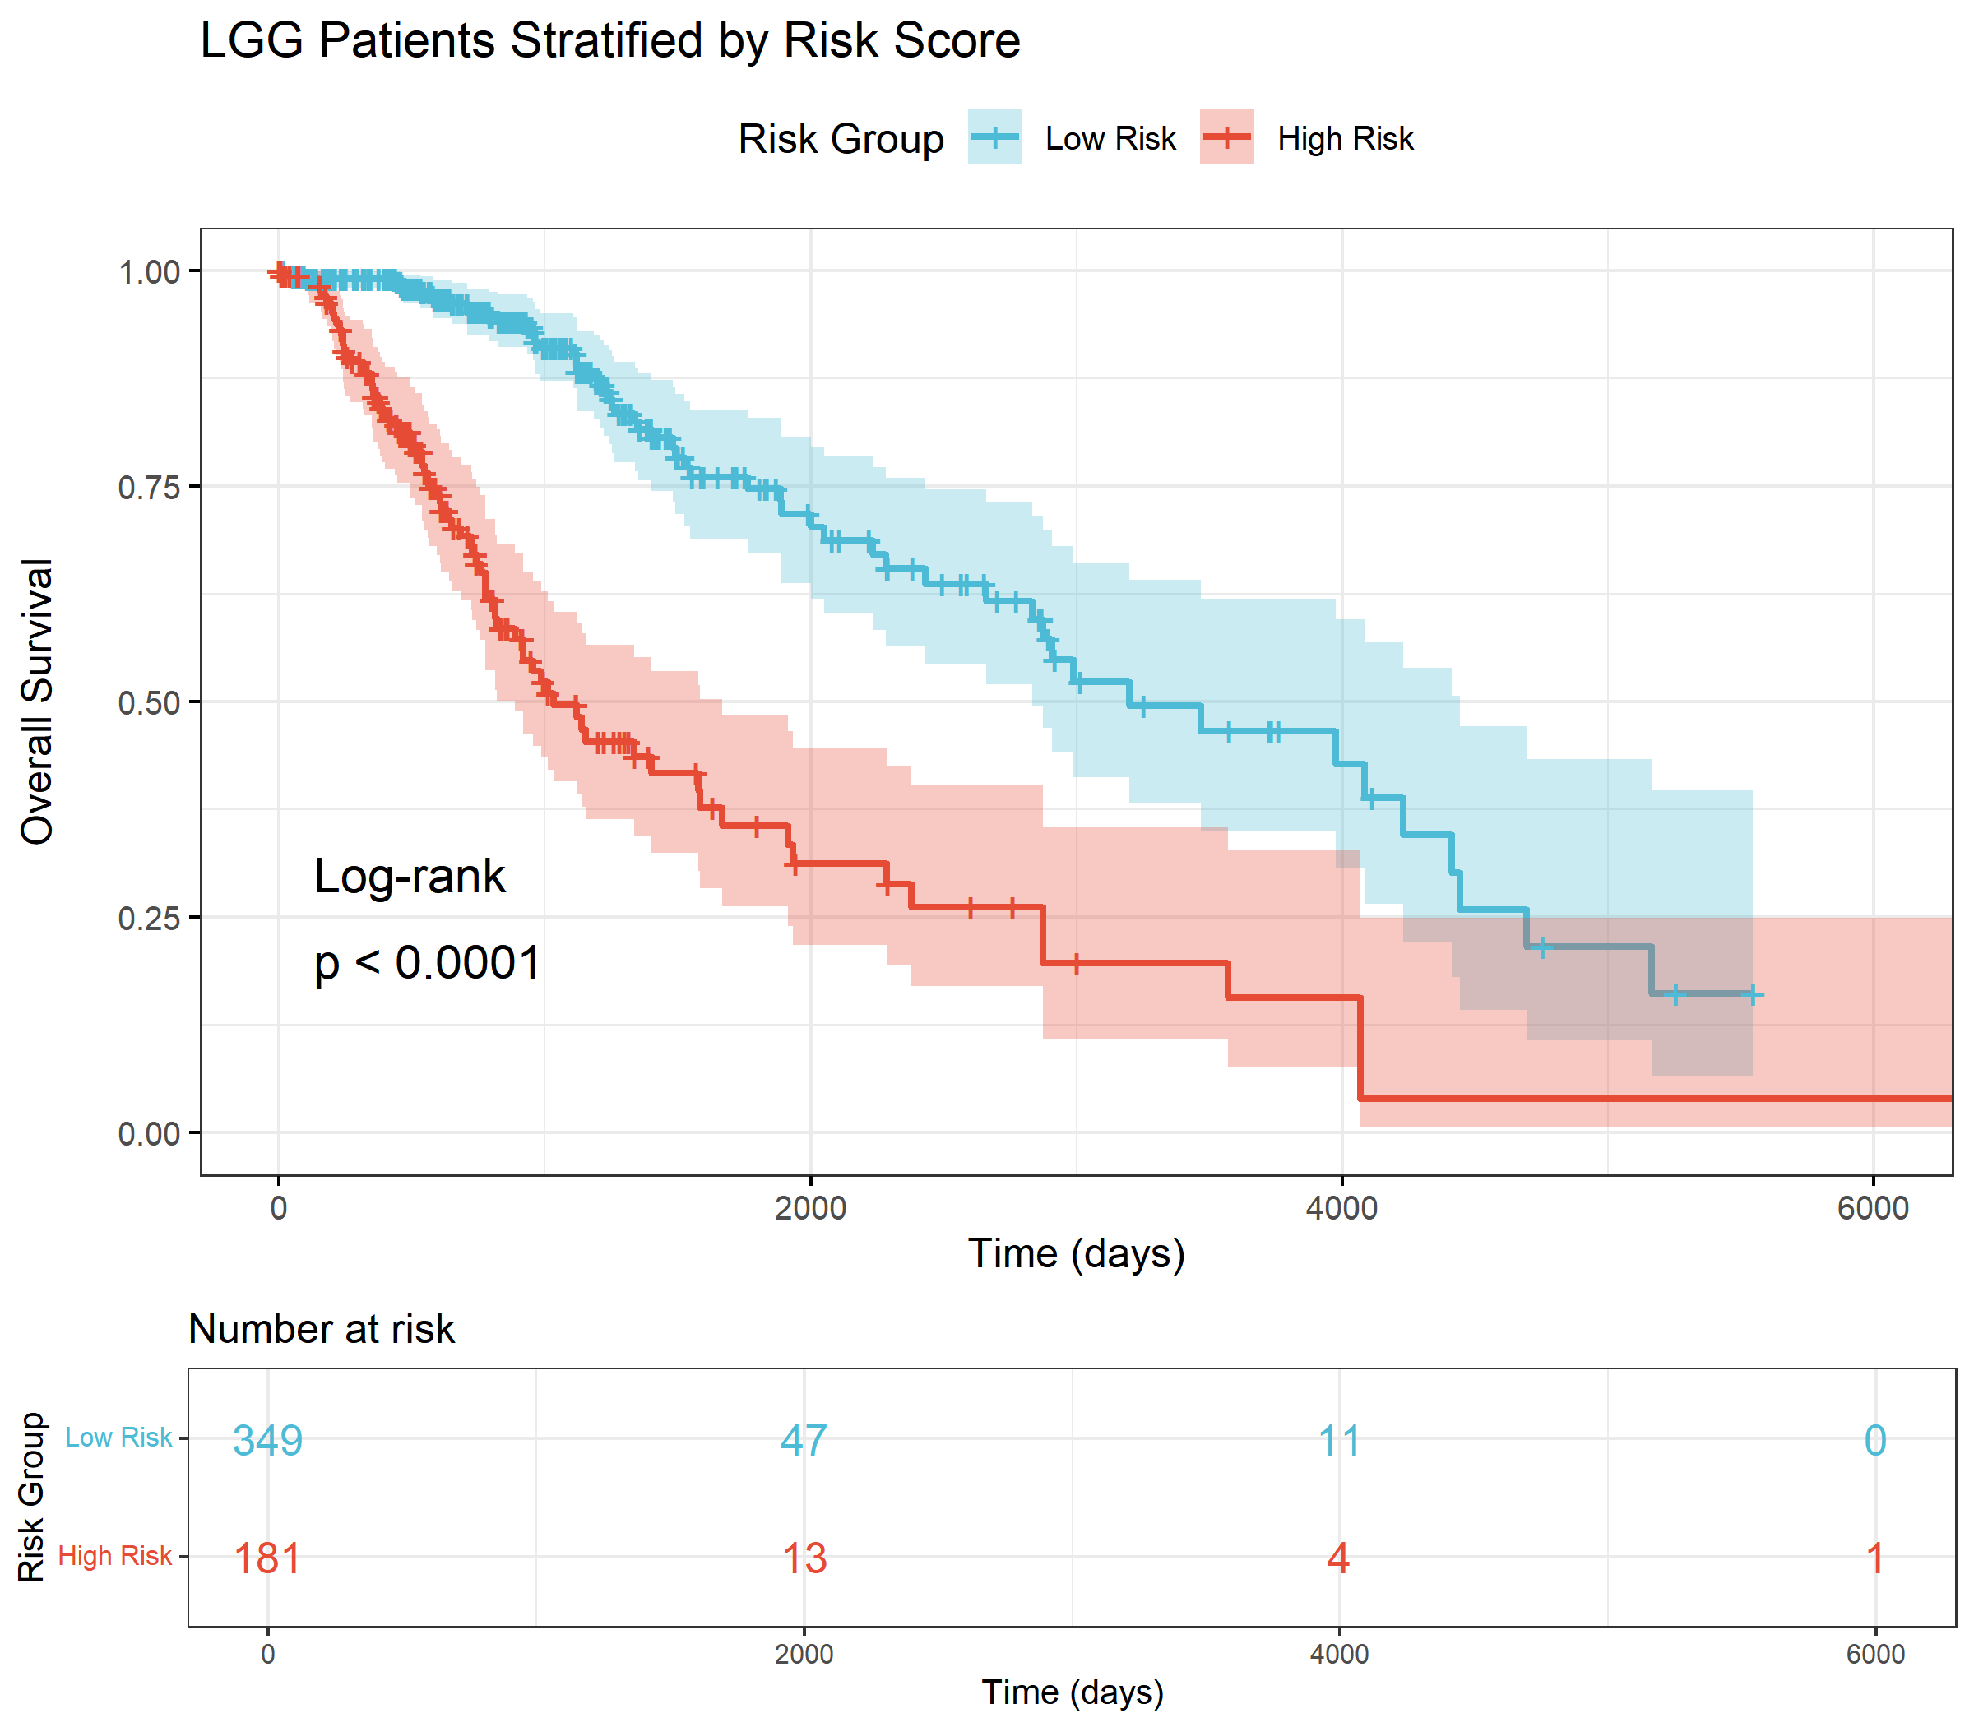
Supplementary Figure 1. Subgroup analysis of the prognostic model in LGG and GBM cohorts. Kaplan-Meier survival curves for LGG patients stratified by risk score. High-risk LGG patients (n = 181) showed significantly worse overall survival compared to low-risk patients (n = 349) (log-rank p < 0.001).
Supplementary Figure 2. External validation of the prognostic model in the independent CGGA mRNAseq_693 dataset
a. Prognostic KM curve between high- and low-risk score groups of LASSO and OS for glioma. b. Time-dependent ROC curve of glioma samples from the CGGA mRNAseq_693 dataset. c-e. 1- (c), 2- (d), and 3-year (e) calibration curve of the glioma prognostic risk model.

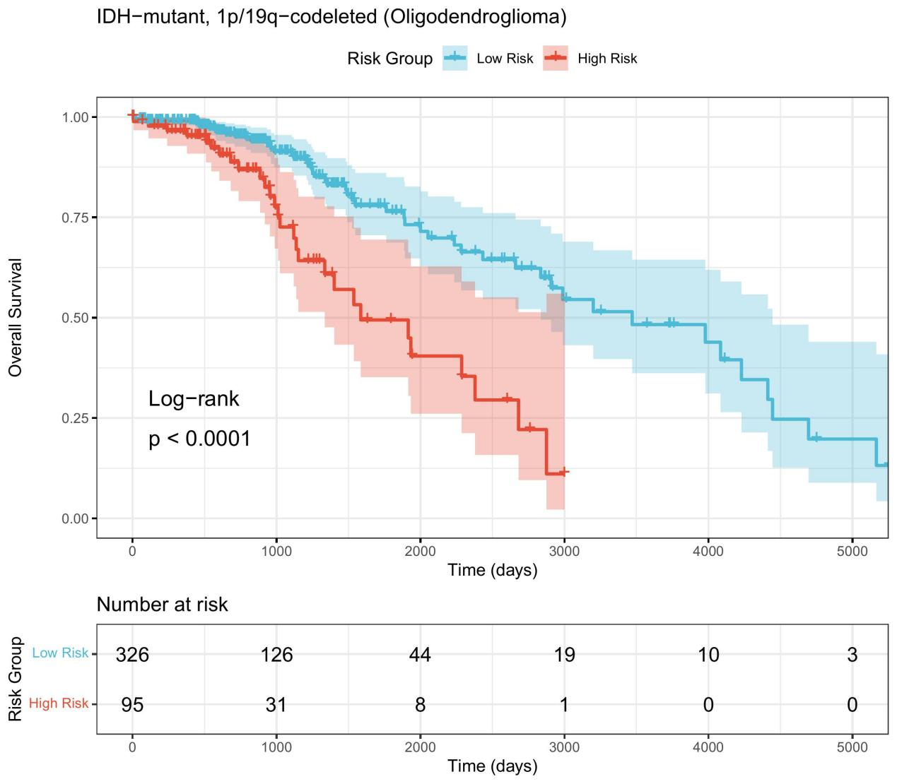
Supplementary Figure 3. Prognostic performance of the necroptosis-related risk model in molecular subtypes defined by the 2021 WHO classification. Kaplan-Meier survival curves for IDH-mutant with 1p/19q codeleted (oligodendroglioma) patients stratified by risk score. High-risk patients (n = 95) showed significantly worse overall survival compared to low-risk patients (n = 326) (HR = 2.94, 95% CI 1.81-4.77, log-rank p = 4.67 × 10⁻⁶).

Supplementary Figure 4. Expression of inflammatory factors and immune checkpoint molecules in high-risk and low-risk groups.
(A) Boxplots showing the expression levels of key inflammatory factors between high-risk and low-risk groups in the TCGA cohort. (B) Boxplots showing the expression levels of immune checkpoint molecules between risk groups. (C) Heatmap summarizing the expression patterns of all inflammatory factors and immune checkpoint molecules across risk groups. Rows are scaled to Z-scores for comparability. Red indicates high expression, blue indicates low expression. ***p < 0.001, **p < 0.01, *p < 0.05, Wilcoxon rank-sum test.

