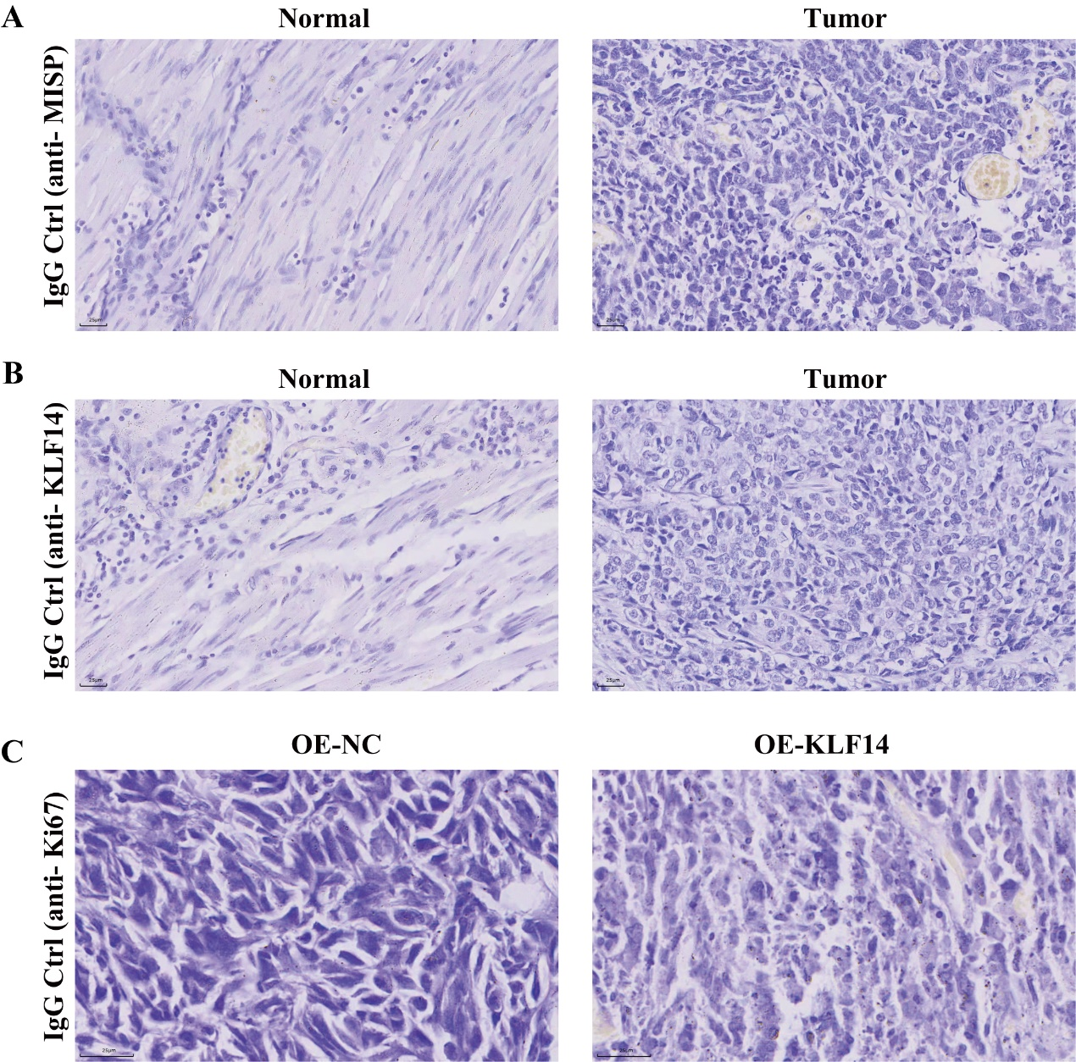
Supplementary Figure 1 Negative control staining with isotype-matched IgG controls for IHC
A: IgG control (anti-MISP) in normal and ESCC tumor tissues. No specific staining was observed, scale bar: 25 μm; B: IgG control (anti-KLF14) in normal and ESCC tumor tissues, scale bar: 25 μm; C: IgG control (anti-Ki67) in OE-NC and OE-KLF14 xenograft tumor tissues from nude mice, scale bar: 25 μm.

