The Role of Artificial Intelligence in Precision Medicine for Breast Cancer
Jun-Jie Hu¹ Zhang-Lei Ding¹ and Zhi-Chun Yang² (corresponding author)
Address:
1.Hunan University of Chinese Medicine, Changsha 410078, China
2.Department of Pharmacology, Xiangya School of Pharmaceutical Sciences, Central South University, Changsha 410078, China
Email addresses:
hujunjie0110@163.com
d1022l@126.com
yzhichun@126.com
Abstract: Breast cancer (BC) ranks among the most common malignant tumors affecting women globally. The essence of precision medicine (PM) lies in “delivering the right treatment to the right patient at the right time.” With advancements in artificial intelligence (AI) technologies such as deep learning (DL), breakthroughs have been achieved in analyzing data ranging from imaging to multi-omics. We review the latest applications and challenges of AI in PM for BC, offering insights for clinical practice and research. We also present an AI integration framework covering the entire BC care continuum. The framework systematically integrates multiple components, including imaging diagnosis, digital pathology, multi-omics analysis, treatment response prediction, surgical decision-making, clinical decision support, and clinical translation, thereby revealing the hierarchical mechanisms through which AI contributes to the precision management of BC. This paper reviews how AI can enable precise management of BC patients across different temporal and biological scales by collecting different types of data. Specifically, this encompasses precision prevention, diagnosis, and clinical management. It also highlights current research gaps and challenges, such as algorithmic bias, dataset comprehensiveness, and model interpretability. Ultimately, the paper offers valuable insights into the integration of AI throughout the entire process of precision medical management for BC patients.

KEYWORDS: ARTIFICIAL INTELLIGENCE; PRECISION MEDICINE; PATHOLOGY; BREAST CANCER; DEEP LEARNING; RADIOLOGY; MACHINE LEARNING; PRECISION ONCOLOGY; MULTI-OMICS
1. Introduction
According to Global Cancer Statistics 2020, the top three newly diagnosed cancers in the past year were BC in women (11.7%), lung cancer (11.4%), and colorectal cancer (10.0%)[1]. In 2020, there were over 2.3 million new cases of BC, with 685,000 deaths. By 2040, the burden of BC is projected to increase to over 3 million new cases and 1 million deaths annually, driven solely by population growth and aging[2]. In the United States, the incidence of BC has continued to rise, increasing by 1% annually between 2012 and 2021. In contrast, the overall BC mortality rate declined by 44% between 1989 and 2022, primarily due to advances in treatment and the widespread adoption of early screening[3]. BC exhibits unique epidemiological characteristics and significant heterogeneity, ranking among the most common malignant tumors in women worldwide, posing substantial challenges to PM[4]. The limitations of the current standardized, one-size-fits-all treatment approach are reflected in the unsatisfactory outcomes of contemporary chemotherapy. The efficacy and safety of drugs targeting specific molecular targets are often limited due to off-target side effects triggered by gene mutations, compensatory escape pathways, and cross-interference between signaling pathways[5]. Before 1970, cancer treatment primarily consisted of surgery, radiotherapy, and chemotherapy. Targeted therapy and immunotherapy emerged after 1970, mainly due to the wide variety of tumor types, the fact that most tumors harbor multiple oncogenic mutations, and the significant heterogeneity within and between tumors. Oncogenic gene alterations have multiple effects, including the activation of proliferation signals, resistance to cell death, circumvention of replication limits, and increased genomic instability[6]. Since malignant reprogramming is induced by seemingly random genomic perturbations, treatment optimization must be achieved through PM[7].
PM is a medical model supported by high-throughput biotechnology and big data analytics. It evaluates disease risks, predicts drug responses, and develops individualized intervention plans by analyzing multidimensional information including an individual's genome, clinical manifestations, and lifestyle[8]. Its core philosophy lies in shifting from the traditional “one-size-fits-all” approach to a personalized strategy, maximizing therapeutic efficacy and minimizing adverse reactions by delivering the most appropriate treatment to the right patient at the right time[9]. AI has the potential to profoundly impact nearly every aspect of oncology—from enhancing diagnostic capabilities and enabling personalized treatment to discovering novel anti-cancer drugs[10]. Driven by rapid advancements in DL and machine learning technologies, AI is emerging as a key engine propelling PM in BC. Jingwen Bai et al. note that molecular diagnostics, targeted therapies, and AI-driven imaging analysis collectively form the core framework for precision treatment in the new era of BC[11]. Therefore, utilizing AI to advance PM for BC represents a promising research direction at present. AI can advance PM by enabling earlier diagnosis, classification, and staging of patients while reducing false positive rates[10].
This paper provides a comprehensive review of the applications of AI in PM for BC, covering both temporal and spatial dimensions, and elucidates how AI is integrated into the entire journey of BC patients—from prevention through diagnosis to treatment. Based on clinical pathways in PM, we have outlined a comprehensive framework for the management of BC that integrates AI. This framework integrates imaging, digital pathology, omics data, clinical information, and surgical decision-making into a unified logical system. Furthermore, it identifies the shortcomings and challenges of current research, offering insights for the advancement of PM in BC. It also discusses current challenges, such as interpretability, generalizability, privacy protection, prospective validation, and on-premises deployment. A comprehensive selection of representative papers on the application of AI in BC was made from the Web of Science and PubMed databases.
Given this clinical heterogeneity, BC provides a representative setting in which AI can be evaluated not as an isolated diagnostic tool, but as an enabling technology across the full PM pathway.

2. AI in the early management of BC
Accurate early diagnosis and staging of BC are crucial for effective patient management. One effective way of reducing the incidence of BC is to identify high-risk groups and implement preventive measures (Fig. 1). In this section, early management refers not only to screening and early diagnosis, but also to the upstream molecular and pathological characterization that enables early risk stratification and subtype-specific management.
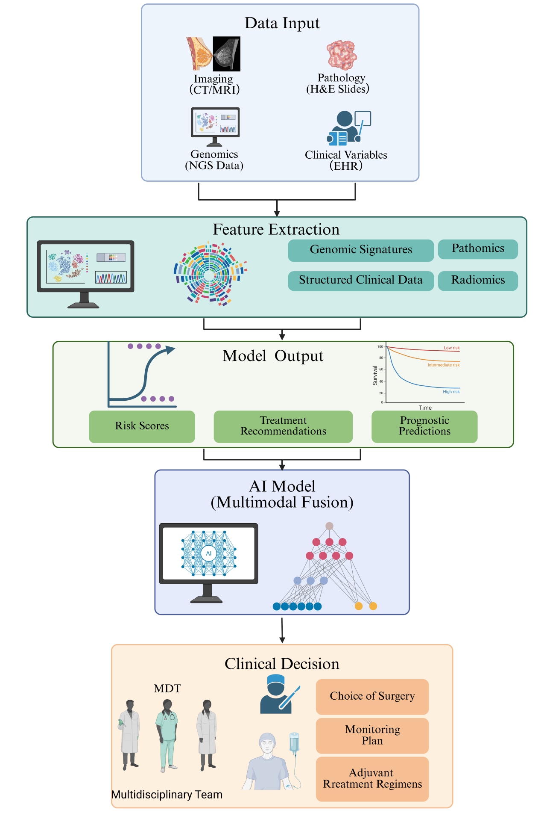
Figure 1. The process of building an AI model
This figure illustrates the entire process of an AI model, from data input and data analysis to its application in clinical decision-making. The entire workflow, from the input of clinical data—such as imaging, pathology, and genetic test results—to data fitting and the output of results. (Created in BioRender.com)
2.1 AI in Radiology
At the imaging level, radiomics achieves a leap from qualitative to quantitative analysis by extracting high-throughput quantitative features from breast images, while image-multiomics integration helps bridge the gap between phenotypic and microscopic-scale information[12]. Similarly, quantitative imaging data converts medical images into quantitative data to extract biological information and enable radiation phenotyping analysis for diagnosis, treatment, decision support, and monitoring[13]. These advances provide a foundation for the future development of radiomics.
In BC screening, mammography is the most effective method for detecting the disease at an early stage and reducing mortality rates[14]. AI can assist radiologists in interpreting images, thereby reducing the rates of false positives and false negatives[15]. In a comparison of an independent AI system used for BC detection in mammography versus 101 radiologists, the AI system's performance was statistically non-inferior to the average performance of the 101 radiologists. The AI system's area under the ROC curve was 0.840 (95% confidence interval [CI] = 0.820 to 0.860), compared to an average of 0.814 (95% CI = 0.787 to 0.841) for radiologists (difference 95% CI = -0.003 to 0.055). The AI system's AUC exceeded that of 61.4% of radiologists[16]. In another study, researchers compared AI-assisted reading with a non-AI-assisted group. On average, the AUC was higher with AI support than without (0.89 vs. 0.87; P = .002). Sensitivity improved with AI support (86% [86/100] vs. 83% [83/100]; P = .046), while specificity showed a trend toward improvement (79% [111/140] vs. 77% [108/140]; P = .06). Reading time per case was comparable (146 seconds without assistance vs. 149 seconds with AI support; P = 0.15). The AUC achieved using the AI system alone was similar to the radiologists’ mean AUC (0.89 vs. 0.87). Radiologists demonstrated improved cancer detection capabilities in mammograms when using AI-assisted systems, without requiring additional reading time[17].
Beyond mammography, AI has also been extended to MRI-based lesion characterization, lymph node assessment, and treatment-response prediction, thereby expanding its role from screening support to precision risk stratification. DL stands as one of the most powerful data-driven machine learning techniques within AI. Xue Zhao et al. summarize the multifaceted applications of DL models in breast MRI for lesion diagnosis, molecular subtyping, and prediction of response to neoadjuvant chemotherapy (NAC). They propose that optimizing data preprocessing and segmentation strategies is essential to enhance model robustness[18]. Yu et al. developed a model using support vector machines (SVMs) that accurately assesses eligibility for axillary lymph node (ALN) dissection exemption. This model integrates radiomics features from baseline and two-cycle dynamic contrast-enhanced MRI (DCE-MRI), DL features, and clinical indicators, providing non-invasive support for dynamic treatment strategies[19]. These findings establish the foundation for AI-driven BC risk stratification, providing actionable tools for precision primary prevention. In the ScreenTrustMRI randomized trial, Mattie Salim et al. employed AI to risk-score negative mammography screening images, selecting the top 6.9% of participants to receive either supplemental MRI or no additional screening. This strategy increased the “number of cancers detected per thousand MRIs” by approximately fourfold compared to the conventional approach using breast density screening, demonstrating significantly improved cost-effectiveness (NCT04832594, 2023-10-05)[20].
Al-Antari et al. found that an integrated computer-aided diagnostic system combining YOLO object detection, full-resolution convolutional network segmentation, and an InceptionResNet-V2 classifier achieved an average accuracy of 95.32% when processing the INbreast database. This performance was significantly better than that achieved using conventional convolutional networks or the ResNet-50 model[21]. Koushlendra Kumar Singh et al. used convolutional neural networks (CNNs) for the automatic, DL-based detection and classification of microcalcifications. After applying four different optimizers — ADAM, ADAGrad, ADADelta and RMSProp — they discovered that their proposed classification scheme outperformed all previous DL methods and classical machine learning approaches[22]. Elarde et al. argue that deep neural network models that perform as well as or better than human experts on internal test data tend to perform poorly when confronted with large, heterogeneous external datasets, such as the OMI-DB. These models are also unable to match the sensitivity of independent radiologists in real-world settings[23].
With the application of AI, the false negative rate in radiological examinations can be effectively reduced, providing patients with a non-invasive method for assessment. However, further research on explainability is still needed, including the development of tools such as visual heatmaps and quantitative uncertainty assessments, to enhance radiologists' trust in and adoption of AI results.
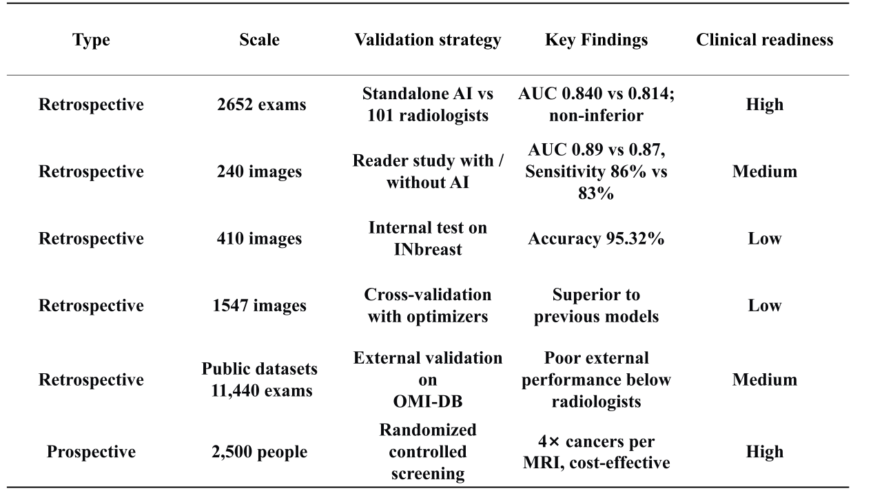
Table 1. AI in BC Radiology
This table summarizes and extracts relevant findings from the papers discussed in this article concerning AI in radiology.
Reference:[16, 17, 20-23]
2.2 Digital Pathology and AI-Assisted Diagnosis System
With the advent of whole-slide digital scanning technology and the advancement of precision pathology, the use of AI to analyze whole-slide images (WSIs) can effectively enhance the efficiency and accuracy of pathological examinations[24]. In a recent study, researchers compared AI and pathologist assessments of WSI Nottingham grading for BC and found moderate agreement between pathologists and AI observers (κ = 0.471). Consensus for grades 1, 3, and 2 was good (κ = 0.681), moderate (κ = 0.442), and fair (κ = 0.368), respectively. Observer agreement between AI and individual pathologists ranged from fair to good (κ = 0.313–0.606). Complete agreement was observed in 25 cases (27.4%). Component-specific inter-observer agreement was highest for the overall score (κ = 0.471), followed by nuclear pleomorphism (κ= 0.342), and lowest for mitotic count (κ = 0.233). No significant differences in agreement were observed between individual pathologists and the AI system[25]. Pathologists use the Nottingham criteria to grade the microscopic morphology of breast tissue. This grading system is a qualitative assessment and does not take into account non-neoplastic components within the tumor microenvironment. The Histological Prognostic Score (HiPS) is a comprehensive and easily interpretable morphological survival risk score designed for the breast tumor microenvironment. Utilizing DL technology, HiPS is capable of accurately mapping cellular and tissue structures, and measuring characteristics of epithelial, stromal, immune and spatial interactions. This study was developed using the population-based cohort from the Cancer Prevention Study II and validated using data from three independent cohorts, including the Prostate, Lung, Colorectal and Ovarian Cancer Trial, the Cancer Prevention Study-3 and the Cancer Genome Atlas. Researchers claim that this model consistently outperforms pathologists in predicting survival outcomes, and that its results are unaffected by tumor node metastasis staging and related variables[26]. Although the study results demonstrate the superiority of AI in pathological examination, further evidence is required to validate its efficacy.
Intra-tumor heterogeneity (ITH) is a fundamental characteristic of BC, influencing tumor progression, prognosis, and treatment response. A study employing DL techniques to analyze WSIs quantified 162 features, revealing significant associations between high ITH, larger tumor volume, poorly differentiated tumors, highly proliferative tumors, tumors of no special type (NST), and low estrogen receptor (ER) expression[27]. Tumor-infiltrating lymphocytes (TILs) serve as prognostic parameters in triple-negative breast cancer (TNBC) and human epidermal growth factor receptor 2 (HER2)-positive BC. In the study by Li, JJ et al., researchers employed a two-stage DL model integrating multi-scale feature maps and a recurrent attention model (RAM). With WSI-based assistance, this approach simulated the diagnostic process of a pathologist by focusing on a series of local features within pathological images and synthesizing relevant information. This enabled accurate classification of BC into its histological subtypes, which is crucial for treatment and prognosis[28]. Yini Huang et al. developed a deep learning radiopathology (DLRP) model based on preoperative ultrasound images and hematoxylin and eosin (H&E)-stained biopsy sections. Results showed an AUC of 0.929 (95% CI 0.865–0.968) in the internal validation cohort, and 0.900 (95% CI 0.819–0.953) in the external validation cohort. The DLRP also outperformed a DLRP model based solely on US images (AUC 0.815 [0.719–0.889], P = 0.027) and the DL pathological model based solely on WSI (AUC 0.802 [0.704–0.878], P = 0.013) in the external validation cohort, indicating that DLRP effectively distinguishes early-stage BC from non-ductal BC and provides a tool for treatment decision-making in early-stage BC[29].
Shamshiri MA et al. posit that the utilization of histopathology datasets from analogous domains for transfer learning can surmount the inherent disparities between natural images and medical images. Compared with conventional machine learning techniques and previous DL methods, their model improved classification accuracy by 6%–17% and approximately 7%, respectively, attaining a validation accuracy of 98.73% with minimal annotated data[30]. To address the severe class imbalance present in many existing datasets, Rishav Singh et al. developed a VGG-19-based system incorporating several state-of-the-art techniques to address the severe class imbalance that afflicts them. The validation of the superiority of their algorithm was achieved through experimentation on a large-scale dataset comprising 277,524 images[31]. In their study, Tang et al. acknowledged the high intra-species diversity of mitotic cells and the significant morphological overlap with similar cell structures. They then went on to identify mitotic cells and their mimics by isolating them from the background as candidate objects. This approach resulted in a significant reduction in false negatives during the candidate screening process[32].
Based on AI recognition of specific tumor characteristics, precisely stratifying patients with benign and malignant prognoses will be a crucial step in advancing PM. Future research should focus on enhancing model interpretability and developing visualization analysis methods that establish one-to-one correspondence with pathological features, thereby promoting complementary collaboration between AI and pathologists.
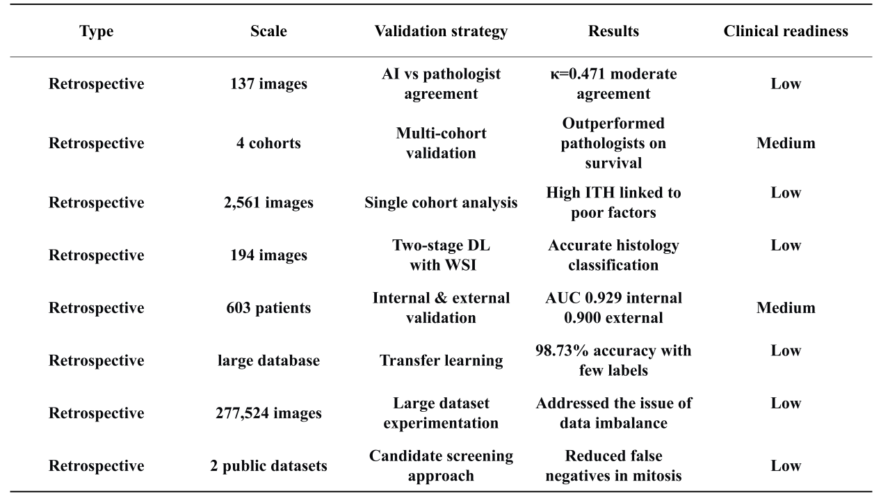
Table 2. AI in BC Pathology Research
This table briefly summarizes the relevant research papers reviewed in this article, listing the methods employed, standards established, and research findings.
Reference: [25-32]
2.3 AI in Multi-Omics Analysis
Cancer is a complex and heterogeneous disease characterized by the accumulation of genetic and epigenetic alterations that drive uncontrolled cell proliferation and survival. Multi-omics integration, which encompasses genomic, transcriptomic, proteomic, and epigenomic data, enables the identification of novel driver mutations, functional interactions and tumor-specific vulnerabilities[33]. Recent advances in sequencing and computational technologies have enabled researchers to analyze even the faintest genomic signals and the most complex datasets in cancer genetics. Tumors can be examined for low-frequency mutations in tissue-derived or circulating tumor DNA, and these results can be considered alongside multi-omics and clinical data[34]. Leveraging AI's data processing capabilities, researchers have developed multiple intelligent algorithms based on large-scale multi-omics databases, digital pathology images, and clinical information, providing new insights for BC genomic research. Bryan He et al. developed a DL model to predict the localized expression of over 100 genes from routine HE-stained sections, achieving 100 µm spatial resolution. The model demonstrated strong generalization performance in the TCGA cohort and proved highly adaptable to TCGA and other BC gene expression datasets without retraining[35]. Poirion, OB et al. developed the DeepProg framework, validating it across 32 cancer types using multi-omics data. It identified two optimal survival subtypes in most cancers and demonstrated significantly superior risk stratification compared to other multi-omics integration methods, achieving a C-index of 0.68–0.73 in BC datasets[36]. Mo, ZC et al. conducted a multi-omics analysis of tumor samples from 149 Chinese BC patients, covering ER-HER2+, ER+HER2+, and ER-HER2- subtypes. Outcomes following adjuvant therapy were categorized as pathological complete response (pCR; n = 81) or residual disease (RD; n = 68). Using their developed MOPCR model, they identified elevated cell proliferation in ER-HER2- pCR patients, increased CDKN2A methylation in ER-HER2- RD patients, ER-HER2+ RD patients showed increased KIT methylation, and ER+HER2+ RD patients exhibited high MAP4K1 methylation[37].
In a multimodal, multi-view DL approach, researchers achieved non-invasive classification of breast lesions as malignant or benign by integrating full-field digital mammography (FFDM) and contrast-enhanced spectral mammography (CESM). Results demonstrate that generative AI effectively addresses the missing-modality challenge in BC diagnosis by synthesizing CESM images to enhance the FFDM-based virtual biopsy pipeline[38]. The Multi-modal Response Prediction (MRP) system extracts cross-modal and temporal information from longitudinal multi-modal imaging to accurately predict pCR following neoadjuvant therapy. It demonstrates superior diagnostic efficacy compared to breast imaging specialists during the preoperative phase, providing quantitative evidence to guide decisions on expanding or reducing surgical margins[39].
AI has also advanced bioinformatics, and by integrating bioinformatics with machine learning, it offers unique insights for PM management in BC. Das, SC et al. utilized TCGA transcriptomic data to construct BC staging models using Random Forest and XGBoost algorithms. The Random Forest approach achieved 97.19% accuracy, while the XGBoost algorithm reached 95.23%. The analysis also identified potential targets associated with staging, including MYH2 and MYL2[40]. Li, FR et al. integrated single-cell and bulk transcriptomic data using the 101-combination machine learning framework to construct a nine-gene multivariate prediction and risk score (MVPRS) targeting stromal cell marker genes. This revealed the heterogeneity of the TNBC microenvironment and introduced prognostic features based on myCAF, VSMC, and pericyte marker genes. FN1 was identified as a key oncogene, highly expressed in TNBC tissues and cell lines, promoting proliferation and migration while suppressing apoptosis[41]. Görtler, F et al. proposed the Adaptive Digital Tissue Deconstruction (ADTD) method, which adaptively corrects reference expression profiles in the presence of unknown cellular backgrounds. This approach enables more precise estimation of cellular composition and captures subtype-specific regulation from bulk and spatial transcriptomic data. When applied to large-scale transcriptomic data from BC patients, ADTD provided insights into cell type-specific molecular differences between BC subtypes[42].
Multi-omics and multi-modal data typically constitute heterogeneous datasets. These datasets exhibit significant differences in terms of dimensionality, data structure — for example, unstructured image pixels and high-dimensional structured gene expression profiles — and noise distribution. Traditional statistical methods struggle to align and process this cross-modal heterogeneity directly. Tongxin Wang et al. have proposed a novel multi-omics integration method called MOGONET. Using mRNA, DNA methylation and microRNA expression data, MOGONET outperforms other advanced supervised multi-omics integration methods applied across various biomedical domains. Furthermore, MOGONET can identify key biomarkers relevant to the biomedical problem under investigation across different types of omics data[43]. Richard J. Chen et al. proposed 'pathological fusion', an interpretable strategy for the end-to-end fusion of histological images and genomic features (e.g. mutations, copy number variations (CNVs), RNA sequencing (RNA-Seq)) to predict survival outcomes. Results from 15-fold cross-validation showed that this multimodal fusion approach improves prognostic assessment compared with tumor grading and molecular subtyping, as well as with monomodal deep neural networks that are trained solely on histological and genomic data[44]. Zhi Huang et al. used an algorithm called SALMON (Survival Analysis Learning for Multi-omics Neural Networks) to investigate whether gene expression data could predict survival in BC patients by using Cox regression. Their results showed that incorporating more omics data into the model improved performance[45].
However, the DL network developed by Baizhou Li et al. based on a multi-level Transformer architecture can achieve robust intra-modal molecular subtyping when processing tissue microarrays. Nevertheless, the model's performance declines significantly when applied directly to cross-modal validation of WSI[46]. In the field of molecular profiling, Qian Wang et al. discovered that a dual-modality virtual biopsy system integrating MRI and mammography could effectively distinguish the HER2 expression status in most cases. However, these fusion characteristics did not demonstrate significant differences between the HER2-negative and low-expression groups[47]. Conventional radiomics and genomics studies have a propensity to establish straightforward one-to-one mappings. In their seminal study, Shuyu Liang et al. advanced the field of research in BC by identifying multi-directional associations in BC subtypes. This pioneering achievement was made possible by the construction of a radiogenomic framework that seamlessly linked images, genes, and gene sets, thereby addressing a significant gap in existing research[48].
Overall, integrative analysis converts heterogeneous cancer data into actionable biomarkers and decision rules by linking molecular patterns to diagnosis, prognosis and treatment response. In the case of BC, AI-driven multi-omics and multimodal models can identify subtype-specific alterations, predict survival risk, infer gene expression from pathology and classify lesions or treatment outcomes without the need for invasive procedures. These outputs become clinically useful when translated into measurable indicators, such as methylation signatures, gene panels, imaging-derived features or composite risk scores, which support patient stratification and therapeutic selection. Crucially, such frameworks shift the focus from descriptive data integration to practical precision oncology, facilitating earlier detection, more accurate prognostic assessment, and personalized treatment planning based on biologically informed, data-driven principles.
While multi-omics models reveal biological susceptibility and subtype-specific vulnerabilities, population-level prevention requires these molecular insights to be integrated with imaging, lifestyle, and longitudinal screening data.
2.4 AI in Precision Prevention of BC
Accurate risk assessment is crucial to the success of BC screening programs. This remains one of the key challenges in BC prevention. Unlike diagnostic AI, which aims to identify existing lesions, prevention-oriented AI estimates future BC risk and supports individualized screening intervals, supplemental imaging, and lifestyle intervention. Big data analysis enabled by AI offers unique insights into addressing this issue. Adam Yala et al. validated the AI-based model Mirai in a globally diverse screening population. The Mirai model directly analyzes mammography screening images through DL, simultaneously outputting 1–5-year BC incidence probabilities. It demonstrated cross-cohort robustness with C-index values ranging from 0.75 to 0.84 during external validation on over 129,000 screening images from seven institutions across the United States, Israel, Sweden, Taiwan, and Brazil[49]. Jon Donnelly et al. further revealed that the model primarily relies on the asymmetry characteristics of bilateral breast tissue. The interpretable variant AsymMirai, constructed based on this insight, maintained Mirai's prediction accuracy at 0.79 AUC at 1 year and 0.66 AUC at 5 years across over 210,000 images[50]. Zan Klanecek et al. noted that Mirai is sensitive to acquisition conditions such as patient position, rotation, and pectoral muscle integrity. The 1-5-year risk prediction for individual subjects may exhibit variations of ±0.1, indicating that strict quality control is required in clinical applications[51]. Although AI has shown promising results in BC risk prediction, public acceptance remains an issue. Alison Pearce et al. investigated the preferences of 802 women eligible for screening through a discrete choice experiment. They found that the public is more likely to accept hybrid models in which AI enhances accuracy while retaining at least one radiologist's involvement. However, if AI completely replaces dual reading, screening participation rates could decline by 22%[52]. An algorithm named Center DOT AI utilizes mammography data, achieving a 5-year receiver operating characteristic area under the curve ranging from 0.63 to 0.79. It outperforms clinical risk prediction models and holds potential to enhance performance equity and reduce misclassification of risk among women from underrepresented racial and ethnic groups[53].
The ASCAPE project continuously collects patients' physiological signals, physical activity, and emotional states through mobile applications and wearable sensors. Leveraging machine learning models, it predicts changes in quality of life and complication risks following treatment. The platform also delivers personalized intervention recommendations to clinicians, providing preliminary validation of the feasibility of an intelligent follow-up model based on real-time lifestyle data for enhancing patient care quality (NCT04879563, 2024-11-19)[54]. Yufan Cai et al. employed machine learning to conduct a joint modeling of sleep duration and depressive states, revealing a significant positive correlation between depression and BC incidence, while sleep duration was not an independent risk factor. The AdaBoost algorithm achieved an AUC of 0.84 in a multivariate setting, validating the effectiveness of AI algorithms for predicting risks associated with lifestyle variables[55].
A retrospective cohort study found that among women undergoing regular mammography screening, BC detection rates increased based on mammograms performed 4 to 6 years prior to diagnosis. Commercial AI algorithms may identify women at high risk for future BC diagnoses, offering a pathway for risk-based screening to facilitate earlier detection[56]. Another commercial AI system re-stratifies women at intermediate risk by assessing the probability of malignancy in conventional mammograms, recommending supplemental MRI only for high-risk individuals. With a threshold set at 5 points, it detects 84% of BC cases while reducing MRI examinations by approximately 50%. Among these, 68% are occult cancers difficult to visualize on mammography, demonstrating AI's potential for optimizing screening pathways and reducing costs[57]. Eun Young Kim et al. conducted a four-quadrant concordance analysis comparing radiologists' screening results with an independently operated commercial AI system. When both the radiologists and the AI system indicated positive results, the five-year BC incidence rate rose to 3.74%, exceeding the threshold recommended for chemoprevention and supplemental imaging[58].
However, Philippe Autier and colleagues posit that many current studies on AI-assisted image interpretation are limited by methodological shortcomings. The absence of biopsy verification for AI-negative radiological cases may overestimate diagnostic performance and increase the risk of overdiagnosis[59]. Yuanhong Chen et al. posit that there is a contradiction between the prevalence of incomplete or poorly labeled data in real-world datasets and the reliance of model training on high-quality, precise labels. This contradiction directly affects the accuracy of AI in detecting malignant lesions[60]. With regard to prevention, the lack of generalizability and transparency of AI models across international datasets remains a major barrier to clinical translation. In a seminal study, Jakub Chłędowski et al. developed a meta-database for reproducible benchmarking of AI classifiers in mammography-based BC screening. The database incorporates five open-source models and evaluates them across seven international datasets, thereby addressing key challenges related to model generalization and transparency[61].
To truly integrate AI models into clinical risk prediction, future studies should conduct in-depth research on the applicability and fairness of AI risk models across different ages, ethnicities, and BC types. Systematically evaluate public acceptance of AI-driven screening programs and develop corresponding health education and informed consent strategies to enhance screening adherence.
3. AI in PM Management
In addition to the early management of BC, providing precision-based treatment for patients who have already received a diagnosis is also a key aspect of BC management (Fig. 2). After AI contributes to risk assessment, diagnosis, and molecular stratification, the next step in PM is to translate these predictions into individualized therapeutic decisions for patients with confirmed BC.
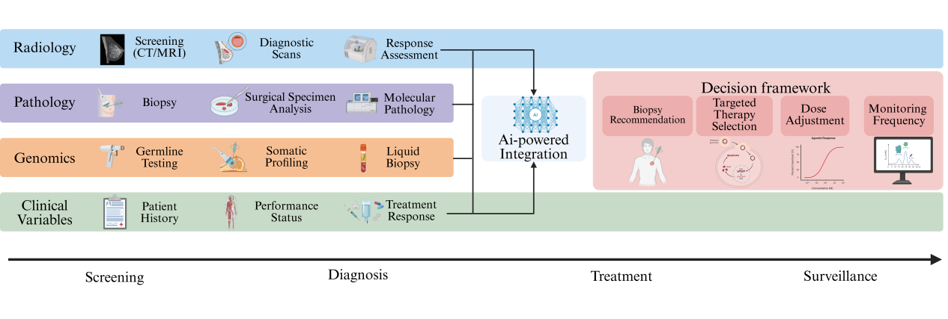
Figure 2. Process for establishing an AI-driven decision-making framework
This figure illustrates how AI generates AI-driven decision-making recommendations through examination, diagnosis and treatment, incorporating imaging, pathology, genetics and clinical variables to ultimately form a unified decision-making framework.(Created in BioRender.com)
3.1 Treatment Response Prediction and Plan Development
In the era of rapidly advancing targeted therapies, innovative drugs such as CDK4/6 inhibitors, PARP inhibitors, ADCs, and immune checkpoint inhibitors have significantly improved outcomes for patients with different molecular subtypes. However, treatment disparities and resistance issues remain prominent. PM has the potential to transform BC care by delivering more effective, personalized, and less invasive treatment strategies[11]. AI, with its deep mining capabilities for multimodal big data, is emerging as a key force in reshaping targeted treatment strategies for BC[62].
Sammut et al. successfully predicted pCR following NAC and HER2-targeted therapy by integrating genetic mutations, copy number variations, proliferation indices, and immune infiltration features through machine learning. The AUC in the external validation cohort reached 0.87, indicating that baseline tumor ecosystem characteristics can accurately guide personalized treatment[63]. This approach may also be applicable for developing predictive factors in other cancers. The DeepHRD DL platform developed by Bergstrom et al. can assess homologous recombination repair deficiency status using conventional HE-stained slides alone, achieving accuracy comparable to molecular diagnostics while significantly predicting response to platinum-based regimens and PARP inhibitors[64]. For immunotherapy, Liu et al. combined single-cell and spatial omics with machine learning to propose the M.Sig predictive model. Their analysis revealed that the interaction between APOE⁺ macrophages and CD8⁺ exhausted T cells exerts an inhibitory effect in regulating sensitivity to immune checkpoint inhibitors[65]. Fang, YT et al. used natural killer cell-associated genes as candidate features, integrating 12 machine learning algorithms to identify an optimal random forest diagnostic model. They discovered that patients in the high-risk group exhibited increased tumor proliferation, elevated immune escape rates, and reduced immune cell infiltration, which correlated with poorer prognosis and lower immunotherapy response rates. Additionally, drug sensitivity analysis suggested that tumors in the high-risk group may be more sensitive to Thapsigargin, Docetaxel, AKT Inhibitor VIII, Pyromethamine, and Epothilone B, while demonstrating higher resistance to I-BET-762, PHA-665752, and Belinostat[66]. In the field of targeted and epigenetic therapies, Schade et al. discovered that AKT inhibitors synergistically induce TNBC differentiation and trigger “de-mammary” cell death when combined with EZH2 inhibitors. They further developed a sensitivity classifier using machine learning, laying the groundwork for precision drug administration in clinical settings[67].
Li et al. developed a multi-task AI system capable of distinguishing residual cancer burden (RCB) III from non-RCB III cases based solely on mid-course MRI during NAC for BC. The system achieved an AUC of 0.923 in an external validation cohort, providing a time window for adjusting treatment regimens and avoiding ineffective therapy[68]. Shilong Jiang et al. employed AI, molecular docking, and molecular dynamics simulations to validate that bufalin acts as a molecular glue to promote ERα degradation, thereby reversing tamoxifen resistance[69]. Zhu, HX et al. constructed an eleven-gene risk model using LASSO-Cox regression around protein palmitoylation-related genes, associated with differences in chemotherapy and immunotherapy responses, and developed an online tool for clinical use[70].
AI also plays a significant role in the development of new targets and drug discovery. Ling, J et al. conducted virtual screening using a library of synthetic molecules generated via generative DL methods to identify and evaluate YH395A, a novel tetrahydro-β-carboxylic acid derivative derived from the lead compound YR-290. In vitro studies demonstrated that YH395A dose-dependently inhibited migration and invasion in TNBC cells[71]. Boshu Ouyang et al. developed a biological factor-regulated neural network based on thousands of TNBC omics data and drug databases, rapidly identifying a pyroptosis treatment combination of mitoxantrone and curcumin. They validated its immune-activating effects in TNBC models using a biomimetic nanocrystal delivery system[72]. However, in treatment-response prediction, Vladimir Cardenas et al. observed that, in the context of utilizing electronic health records for the purpose of predicting remission in BC, race-specific models for non-Hispanic Blacks and other racial and ethnic groups exhibited inferior performance in comparison to race-neutral models[73]. These studies indicate that AI is most clinically valuable when its predictions are linked to actionable treatment decisions, such as treatment escalation, de-escalation, drug selection, or early regimen adjustment.
By analyzing data from various groups of BC patients using AI, we can predict treatment efficacy and enable precise drug selection. This approach prevents disease progression caused by ineffective treatments while enhancing patient comfort during therapy. It also reduces the financial burden on patients from unnecessary treatments and tests, offering unique insights for PM management in BC.

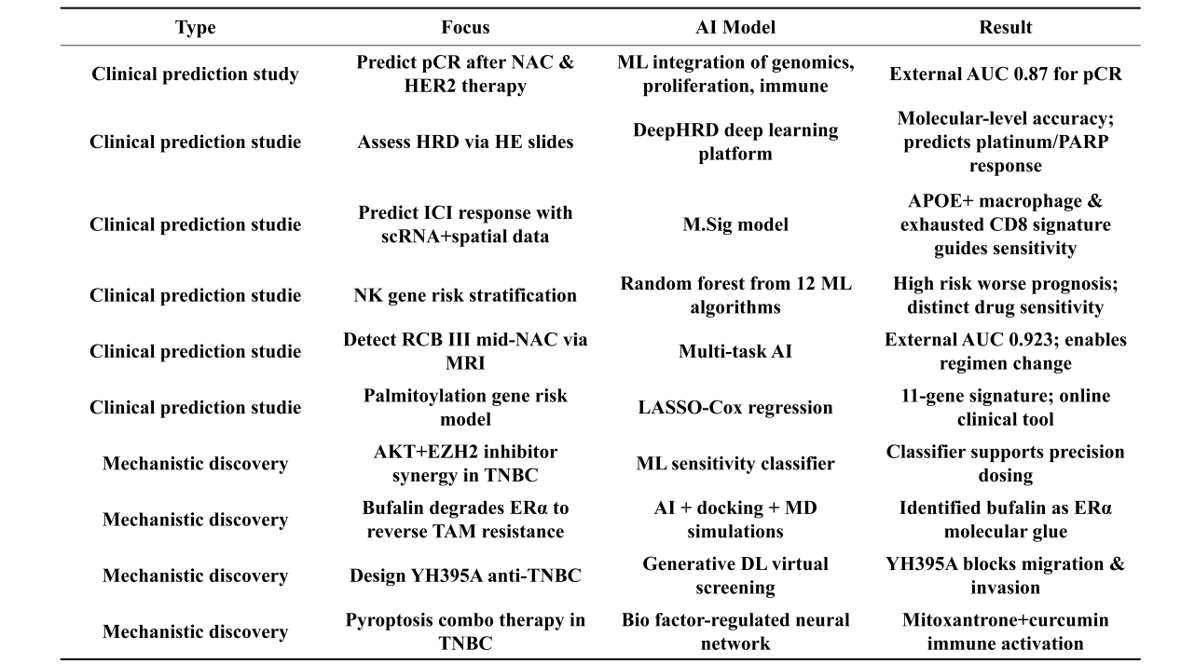
Table 3. Representative AI Work in Treatment Response Prediction and Drug Discovery
This table presents representative literature on AI and drug response prediction and development from the studies reviewed in this paper, listing authors, research focus, models employed, and findings.
Reference: [63-72]
3.2 AI in BC Surgery
Treatment-response prediction is particularly relevant to surgical planning, because accurate identification of pCR and nodal response can directly influence the extent of breast and axillary surgery. For patients with de novo metastatic breast cancer (dnMBC), Li, CF et al. employed a 1:1:2 propensity score matching (PSM) analysis comparing patients who received neoadjuvant systemic therapy followed by surgery (NS), surgery followed by chemotherapy (SC), or chemotherapy without surgery (CW). They developed two AI-assisted surgical decision models to support clinicians in delivering PM while improving survival rates for dnMBC patients[74]. Jionghui Gu et al. proposed that DL radiomics models can independently predict pCR in response to NAC and ALN status, providing personalized guidance for selecting between breast-conserving surgery and chest wall resection[75]. Xueyi Zheng et al. predicted ALN status in patients with early-stage BC using DL radiomics and shear-wave elastography features derived from conventional ultrasound. This approach provides a non-invasive imaging biomarker for predicting the extent of ALN metastasis in early-stage BC patients, thereby avoiding unnecessary axillary surgery and complications[76]. The Information Sharing-Private (iShape) model integrates longitudinal primary tumor and axillary ultrasound images through a shared-specific feature learning framework. External validation yielded a stable AUC of approximately 0.95, reducing the false-negative rate of sentinel lymph node biopsy from 13% to ≈4%. This facilitates personalized decision-making and significantly reduces unnecessary ALN dissections[77]. The Fully Automated Deep Learning Integrated System (FAIS-DL) integrates multi-region DCE-MRI segmentation and prediction modules. External and prospective validation achieved AUCs of 0.95, 0.93, and 0.94, reducing unnecessary ALN dissection rates from 47.9% to 6.8% and increasing the benefit rate from 52.2% to 86.5%[78]. The introduction of multi-factor AI-assisted surgery integrating longitudinal MRI features and clinical variables reduced the FNR in the primary cohort from 14.88% (18/121) to 4.13% (5/121). In the external validation cohort, the FNR decreased from 16.55% (49/296) to 4.05% (12/296), and the prospective cohort from 13.64% (3/22) to 4.55% (1/22). Notably, when removing more than two SLNs, the FNR further decreased to 2.78% (2/72) in the primary cohort, 2.38% (4/168) in the external validation cohort, and 0% (0/15) in the prospective cohort[79]. Martina Cossu et al. evaluated whether an AI assistant (BREAST AI-PLAN) for immediate planning could replicate multidisciplinary teams (MDT) decisions and aesthetic scores from routine clinical data. Results showed excellent agreement for neoadjuvant therapy (κ = 0.91; 96.7% observed); consistency for planned surgery (κ = 0.58; 70.0% observed), surgical approach (κ = 0.43; 60.0% observed), reconstruction (κ = 0.36; 57.1% observed), and adjuvant therapy (κ = 0.29; 64.3% observed). Aesthetic scores showed high observed agreement (0.778–0.896), but weighted κ values varied only slightly (0.14–0.16)[80]. However, Laudo et al. found that, when developing predictive models for skin deformation following breast reconstruction, it is difficult to achieve fully personalized and accurate predictions, even when using Gaussian process surrogates. This is attributable to the elevated level of uncertainty surrounding treatment regimens, tissue mechanical properties and biological parameters[81].
The timing of surgery and extent of resection for BC patients remain widely debated topics. AI-assisted surgical decision-making offers a potential approach to addressing these challenges. By providing clinicians with AI-powered decision support tools, it enables more personalized and precise surgical approaches, thereby avoiding overtreatment and unnecessary lymph node dissections.
3.3 AI in Clinical Decision-Making
Appropriate clinical recommendations and decision-making are central to PM-based management of BC patients. In many countries, the management of cancer patients must be discussed by MDT. Akram Redjdal et al. trained multiple algorithms using abstract data from 298 BC cases. The F1 scores for XGBoost and multilayer perceptrons reached 83%, enabling relatively accurate differentiation between “routine” and “complex” cases[82]. Using DL to identify tumor-containing axial slices in breast MRI images from 273 patients with unilateral BC yielded a sensitivity of 89.5% and a specificity of 94.3%. Readers required 3–45 seconds to identify tumor-containing slices without DL assistance, proving highly useful during non-systematic image review, such as during MDT meetings[83]. Loic Ah-Thiane et al. utilized anonymous patient BC medical records presented during MDTs from January to April 2024. Three generative AI models (Claude3-Opus, GPT4-Turbo, and LLaMa3-70B) were employed to generate treatment recommendations, which were compared against expert decisions. The rates of appropriate recommendations for Claude3-Opus, GPT4-Turbo, and LLaMa3-70B were 86.6% (97/112), 85.7% (96/112), and 75.0% (84/112), respectively. However, they tended to overestimate the necessity of adjuvant radiotherapy and showed inconsistent performance when recommending adjuvant chemotherapy and genomic testing[84]. In another study where GPT-4 generated independent treatment plans for 60 randomly selected patient cases from gynecological and geriatric MDTs, results indicated that iterative prompts significantly improved both types of treatment recommendations. This elevated consistency with MDT decisions to as high as 84% in geriatric cases[85]. The Chinese Society of Clinical Oncology AI System (CSCO AI) serves as a clinical decision support system developed based on Chinese BC data. Among all BC patients, the consistency between actual treatment regimens and CSCO AI recommendations reached 80.4%. When comparing MDT-recommended treatments with CSCO AI decisions, overall acceptance rates reached 92.4%. This suggests that localized AI systems may demonstrate higher adaptability[86].
However, an analysis of 362 tumor board cases by Ning Liao et al. revealed that only 46% of ChatGPT-generated content fully aligned with BC specialists' recommendations, and only 39% of ChatGPT responses demonstrated similar reasoning[87]. Sebastian Griewing et al. compared the treatment recommendations of the popular large language model ChatGPT 3.5 with those of the MDT. The LLM agreed with the MTB recommendations in approximately half of the patient profiles, including those with precancerous lesions. When evaluating the spectrum of invasive BCs, this proportion reached 58.8%[88]. Stefan Lukac et al. conducted a preliminary study in January 2023 involving 10 consecutive BC patients discussed in an MDT. ChatGPT incorrectly identified patients with HER2 1+ and 2+ (FISH-negative) as requiring antibody therapy, used the less precise term “hormone therapy” instead of “endocrine therapy” and provided only generic answers[89].
However, the future of AI models assisting clinical decision-making still faces numerous challenges. Key issues include constructing specialized training datasets that encompass local guidelines, healthcare reimbursement policies, and real-world pathways to enhance the model's alignment with local clinical practices. Additionally, it is essential to systematically evaluate the safety and bias risks associated with LLM recommendations, develop interpretability and uncertainty quantification modules, and prevent overtreatment or undertreatment. Although these systems show promise in controlled retrospective comparisons, their real-world value depends on whether they can be safely integrated into clinical workflows, regulatory pathways, and hospital information systems.
4. AI in Clinical Translation
The explosive growth in high-dimensional molecular and clinical data has created fertile ground for the application of AI and machine learning in oncology. Predictive models trained on large datasets are capable of identifying subtle biomarker patterns associated with drug response or toxicity, thereby driving treatment recommendations that evolve as new real-world evidence accumulates. However, these models are constrained by the lack of robust analytical and clinical validation for many candidate biomarkers, while the high cost and complex logistics of multi-omics testing limit their widespread adoption[90]. Pesapane F et al. note that, in the field of BC screening, AI-driven predictive tools are driving a shift from traditional, age-based standardized protocols towards personalized risk stratification. Multimodal AI risk models that integrate genetic, clinical and imaging data outperform classical models in terms of discriminatory power. However, there remains an urgent need for prospective trials designed to confirm clinical benefits and establish appropriate adjustments to screening intervals[91]. Lång et al. conducted the Mammography Screening with AI trial, a prospective randomized controlled trial. The study randomly assigned over 80,000 women to either an AI-assisted reading group or a conventional double-blind manual reading group. The results showed that the AI-assisted group increased the BC detection rate by 20% without increasing the false-positive rate, while significantly reducing the radiologists’ workload by 44% (NCT04838756, 2021-04-12)[92].
The reality of the clinical setting is far more complex than the ideal conditions found in research. Anthony Yang et al. evaluated the impact of two commercial deep learning reconstruction (DLR) algorithms on the efficiency of MRI examinations in a large multi-centre outpatient setting. They found that DLR methods were associated with reductions in scan and room time, although these varied depending on the type of examination. Potential adopters should therefore carefully consider their patient mix when determining the implications of integrating these tools[93]. Finlayson et al. have identified a key cause of failure in AI systems known as ‘Dataset Shift’; this refers to situations where machine learning systems perform poorly because the dataset used during development does not match the data encountered in deployment. Clinicians should therefore be alert to any discrepancies between model predictions and their own clinical judgments, and AI governance teams must make appropriate adjustments as necessary[94].
Although numerous studies have demonstrated the potential advantages of AI, substantial barriers remain before its widespread clinical translation. The barriers encountered during clinical translation can be grouped into several recurring domains: data quality, generalizability, interpretability, fairness, privacy protection, and workflow integration. These issues are discussed in detail below.
5. Limitations and Challenges
With regard to data limitations, data quality and availability remain major bottlenecks. AI models require large-scale, well-annotated, representative datasets, but BC data are heterogeneous across imaging devices, pathology staining protocols, sequencing platforms, and clinical documentation systems. Qi et al. argue that collecting and annotating sufficient histological data requires extensive involvement from specialist pathologists. This process is laborious, time-consuming and extremely costly. They reduced annotation costs by up to 66.67% compared to random selection by designing and implementing a deep active learning framework[95]. Training DL networks from scratch or fine-tuning pre-trained models for medical image classification requires labeled, task-specific datasets. Dyke Ferber et al. proposed a model that learns from prompts, thereby eliminating the need for parameter updates. Their results demonstrate that context-based learning can rival or even outperform neural networks that have been specifically trained for a particular task, while requiring only a minimal number of samples[96].
In terms of generalizability, many models are trained on retrospective or single-center datasets and may show performance degradation when deployed in different countries, ethnic groups, institutions, or equipment settings. Dataset shift is particularly important in mammography, MRI, digital pathology, and multi-omics analysis. Multicenter, multinational, prospective validation and post-deployment monitoring are therefore necessary. Takeshi Yamaguchi et al. observed that, although artificial Intelligence-computer-aided diagnosis (AI-CADx) systems for mammography are widely used in Western countries, their effectiveness in Japanese women has yet to be fully validated. They therefore conducted a study in Japan to verify the systems' generalizability[97].
To improve interpretability, Mikel Carrilero-Mardones et al. trained deep neural networks using standardized Breast Imaging Reporting and Data System (BI-RADS) descriptors. This approach enabled interpretable classification of malignant tumors without compromising diagnostic accuracy[98]. R. Ricciardi et al. used visualisation techniques, such as gradient-weighted activation mapping, to clearly indicate lesion locations within image slices. This significantly enhanced the transparency of the decision-making process in deep convolutional neural networks[99]. Interpretability and clinical trust remain insufficient. Although heatmaps, BI-RADS-based descriptors, and feature attribution methods can improve transparency, they do not always provide causal or biologically meaningful explanations. Future models should provide uncertainty estimation and outputs that can be linked to recognizable radiological, pathological, and molecular features.
Algorithmic bias and fairness issues urgently require greater attention. Certain populations—including young women, elderly patients, ethnic minorities, patients with rare molecular subtypes, and those from resource-limited regions—are underrepresented in the data, which may lead to reduced predictive performance of the models in these groups. Validation for specific subpopulations should become a standard reporting requirement. Vladimir Cardenas et al. found that when using electronic health records to predict BC remission. AI models showed reduced predictive performance in certain ethnic groups[73].
Privacy protection and data governance are essential. Federated learning and privacy-preserving computation may enable multicenter collaboration without centralized data sharing, but they also introduce challenges in standardization, model updating, cybersecurity, and accountability. Selvakanmani et al. point out that the healthcare sector's need for training on large-scale, centralized datasets inevitably increases the risk of patient data breaches. However, adopting a federated learning framework enables multi-centre healthcare institutions to improve classification accuracy and model generalization while maintaining strict data decentralisation[100].
Integrating clinical workflows remains challenging. Any deviation in the clinical decision tree can alter the AI’s assessment of the outcome. Moreover, the decisions generated by AI are typically based on its learning from the treatment plans provided by clinicians, and these plans are not entirely consistent across different doctors. Solène Delourme and colleagues found that while large language models perform well in medical question-answering tasks, they still lack reliability when handling complex medical contexts and cannot be effectively used as decision support systems[101]. Before AI can serve as a clinical decision-making system, its effectiveness, safety, and reliability must be further validated.
In summary, the application of AI in PM for BC still has a long way to go. Currently, a large number of studies are based on retrospective cohort studies, and researchers are more focused on developing AI algorithms with superior performance without conducting relevant tests to determine their clinical feasibility. Therefore, more prospective clinical trials are needed. Future research should not only evaluate the accuracy of the models but also address the issues currently highlighted, such as data representativeness, dataset processing, reproducibility of results, and whether desirable outcomes can be achieved in clinical practice.
6. Conclusions and Prospects
In the early management of BC, AI applications in pathology and radiology have been extensively validated. Thanks to the use of WSIs and cloud-based imaging platforms, researchers have been able to rapidly advance the application of AI in diagnosis. Currently, AI not only assists researchers in image interpretation and reduces false-negative rates but, under specific conditions, has already demonstrated performance on par with specialist physicians. It is believed that AI-assisted image interpretation systems are likely to be widely adopted in the near future. However, in the realm of precision prevention, commercially available systems currently face challenges due to differences in datasets across countries. Wearable devices also require further research investment, and AI in precision prevention may necessitate additional research resources.
In the precision management of patients with confirmed BC, AI can predict treatment responses, recommend treatment regimens, and assist in MDT decision-making for specific subtypes of BC. At the surgical level, it can advance the development of non-invasive biopsy techniques and support the development of personalized surgical plans. In future research, addressing the issues of generalizability, interpretability, and stability of AI in clinical applications will be a key focus. More prospective validation studies should be conducted.
In summary, AI should not be viewed in isolation across the various fields of PM for BC. AI has become integral to every stage of PM-based management for BC patients, including disease prevention, precise diagnosis, classification, staging, subtyping, treatment selection, treatment-response assessment, and prognostic evaluation. The future direction should be to create an AI system that integrates clinical data, pathology reports, radiology findings and patient lifestyle data, in order to enable precise patient management. This approach aims to reduce the incidence of BC, improve survival rates, and enhance the patient experience.
Declarations
Ethical Approval: Not applicable. This is a review article and does not involve any ethical review.
Consent to Participate: Jun-Jie Hu and Zhi-Chun Yang wrote the main manuscript text and tables in this paper, Zhang-Lei Ding prepared the figures, and all authors reviewed the manuscript.
Consent to Publish: All authors agree to the publication.
Data Availability Statement
Not applicable
Funding
The authors declare that this article received support from University-level Scientific Research Project of Hunan University of Chinese Medicine (X202410541213).
Abbreviations
BC, breast cancer; AI, artificial intelligence; PM, Precision Medicine; FFDM, full-field digital mammography; CESM, contrast-enhanced spectral mammography; DL, deep learning; SVMs, support vector machines; DCE-MRI, dynamic contrast-enhanced MRI; WSIs, whole-slide images; HiPS, Histological Prognostic Score; ITH, intra-tumor heterogeneity; NST, tumors of no special type; ER, estrogen receptor; TILs, Tumor-infiltrating Lymphocytes; TNBC, Triple-Negative Breast cancer; HER2, Human Epidermal Growth Factor Receptor 2; RAM, recurrent attention model; DLRP, deep learning radiopathology; H&E, hematoxylin and eosin; RCB, residual cancer burden; NAC, neoadjuvant chemotherapy; MVPRS, multivariate prediction and risk score; ADTD, Adaptive Digital Tissue Deconstruction; dnMBC, de novo metastatic breast cancer; PSM, propensity score matching; NS, neoadjuvant systemic therapy followed by surgery; SC, surgery followed by chemotherapy; CW, chemotherapy without surgery; MRP, Multi-modal Response Prediction; pCR, pathological complete response; RD, residual disease; ALN, axillary lymph node; iShape, Information Sharing-Private; FAIS-DL, Fully Automated Deep Learning Integrated System; MDT, multidisciplinary teams; CSCO AI, Chinese Society of Clinical Oncology AI System; DLR, deep learning reconstruction; CNNs, convolutional neural networks; AI-CADx, artificial intelligence-computer-aided diagnosis
References
1. Sung H, Ferlay J, Siegel RL, Laversanne M, Soerjomataram I, Jemal A, Bray F: Global cancer statistics 2020: GLOBOCAN estimates of incidence and mortality worldwide for 36 cancers in 185 countries. Ca-a Cancer Journal for Clinicians 2021, 71(3):209–249.
2. Arnold M, Morgan E, Rumgay H, Mafra A, Singh D, Laversanne M, Vignat J, Gralow JR, Cardoso F, Siesling S et al: Current and future burden of breast cancer: Global statistics for 2020 and 2040. Breast (Edinburgh, Scotland) 2022, 66:15–23.
3. Giaquinto AN, Sung H, Newman LA, Freedman RA, Smith RA, Star J, Jemal A, Siegel RL: Breast cancer statistics 2024. Ca-a Cancer Journal for Clinicians 2024, 74(6):477–495.
4. Xiong X, Zheng LW, Ding Y, Chen YF, Cai YW, Wang LP, Huang L, Liu CC, Shao ZM, Yu KD: Breast cancer: pathogenesis and treatments. Signal transduction and targeted therapy 2025, 10(1):49.
5. Rahman M, Hasan MR: Cancer Metabolism and Drug Resistance. Metabolites 2015, 5(4):571–600.
6. Sonkin D, Thomas A, Teicher BA: Cancer treatments: Past, present, and future. Cancer Genetics 2024, 286:18–24.
7. Carels N, Spinassé LB, Tilli TM, Tuszynski JA: Toward precision medicine of breast cancer. Theoretical Biology and Medical Modelling 2016, 13.
8. Precision Medicine. Health affairs (Project Hope) 2018, 37(5):688–689.
9. Akdis CA, Ballas ZK: Precision medicine and precision health: Building blocks to foster a revolutionary health care model. The Journal of allergy and clinical immunology 2016, 137(5):1359–1361.
10. Bhinder B, Gilvary C, Madhukar NS, Elemento O: Artificial Intelligence in Cancer Research and Precision Medicine. Cancer Discovery 2021, 11(4):900–915.
11. Bai J, Gao Y, Zhang G: The treatment of breast cancer in the era of precision medicine. Cancer Biol Med 2025, 22(4):322–347.
12. Qi YJ, Su GH, You C, Zhang X, Xiao Y, Jiang YZ, Shao ZM: Radiomics in breast cancer: Current advances and future directions. Cell reports Medicine 2024, 5(9):101719.
13. Rogers W, Thulasi Seetha S, Refaee TAG, Lieverse RIY, Granzier RWY, Ibrahim A, Keek SA, Sanduleanu S, Primakov SP, Beuque MPL et al: Radiomics: from qualitative to quantitative imaging. The British journal of radiology 2020, 93(1108):20190948.
14. Coleman C: EARLY DETECTION AND SCREENING FOR BREAST CANCER. Seminars in Oncology Nursing 2017, 33(2):141–155.
15. Ding R, Xiao Y, Mo M, Zheng Y, Jiang YZ, Shao ZM: Breast cancer screening and early diagnosis in Chinese women. Cancer Biology & Medicine 2022, 19(4):450–467.
16. Rodriguez-Ruiz A, Lång K, Gubern-Merida A, Broeders M, Gennaro G, Clauser P, Helbich TH, Chevalier M, Tan T, Mertelmeier T et al: Stand-Alone Artificial Intelligence for Breast Cancer Detection in Mammography: Comparison With 101 Radiologists. Jnci-Journal of the National Cancer Institute 2019, 111(9):916–922.
17. Rodriguez-Ruiz A, Krupinski E, Mordang JJ, Schilling K, Heywang-Köbrunner SH, Sechopoulos J, Mann RM: Detection of Breast Cancer with Mammography: Effect of an Artificial Intelligence Support System. Radiology 2019, 290(2):305–314.
18. Zhao X, Bai JW, Guo Q, Ren K, Zhang GJ: Clinical applications of deep learning in breast MRI. Biochimica et biophysica acta Reviews on cancer 2023, 1878(2):188864.
19. Yu Y, Chen R, Yi J, Huang K, Yu X, Zhang J, Song C: Non-invasive prediction of axillary lymph node dissection exemption in breast cancer patients post-neoadjuvant therapy: A radiomics and deep learning analysis on longitudinal DCE-MRI data. Breast (Edinburgh, Scotland) 2024, 77:103786.
20. Salim M, Liu Y, Sorkhei M, Ntoula D, Foukakis T, Fredriksson I, Wang Y, Eklund M, Azizpour H, Smith K et al: AI-based selection of individuals for supplemental MRI in population-based breast cancer screening: the randomized ScreenTrustMRI trial. Nature medicine 2024, 30(9):2623–2630.
21. Al-Antari MA, Al-Masni MA, Kim TS: Deep Learning Computer-Aided Diagnosis for Breast Lesion in Digital Mammogram. Advances in experimental medicine and biology 2020, 1213:59–72.
22. Kumar Singh K, Kumar S, Antonakakis M, Moirogiorgou K, Deep A, Kashyap KL, Bajpai MK, Zervakis M: Deep Learning Capabilities for the Categorization of Microcalcification. International journal of environmental research and public health 2022, 19(4).
23. Velarde OM, Lin C, Eskreis-Winkler S, Parra LC: Robustness of Deep Networks for Mammography: Replication Across Public Datasets. Journal of imaging informatics in medicine 2024, 37(2):536–546.
24. Bera K, Schalper KA, Rimm DL, Velcheti V, Madabhushi A: Artificial intelligence in digital pathology — new tools for diagnosis and precision oncology. Nature Reviews Clinical Oncology 2019, 16(11):703–715.
25. Mantrala S, Ginter PS, Mitkari A, Joshi S, Prabhala H, Ramachandra V, Kini L, Idress R, D'Alfonso TM, Fineberg S et al: Concordance in Breast Cancer Grading by Artificial Intelligence on Whole Slide Images Compares With a Multi-Institutional Cohort of Breast Pathologists. Archives of Pathology & Laboratory Medicine 2022, 146(11):1369–1377.
26. Amgad M, Hodge JM, Elsebaie MAT, Bodelon C, Puvanesarajah S, Gutman DA, Siziopikou KP, Goldstein JA, Gaudet MM, Teras LR et al: A population-level digital histologic biomarker for enhanced prognosis of invasive breast cancer. Nature medicine 2024, 30(1):85–97.
27. Lashen AG, Wahab N, Toss M, Miligy I, Ghanaam S, Makhlouf S, Atallah N, Ibrahim A, Jahanifar M, Lu WQ et al: Characterization of Breast Cancer Intra-Tumor Heterogeneity Using Artificial Intelligence. Cancers 2024, 16(22).
28. Li JJ, Mi WM, Guo YC, Ren XY, Fu H, Zhang T, Zou H, Liang ZY: Artificial intelligence for histological subtype classification of breast cancer: combining multi-scale feature maps and the recurrent attention model. Histopathology 2022, 80(5):836–846.
29. Huang Y, Yao Z, Li L, Mao R, Huang W, Hu Z, Hu Y, Wang Y, Guo R, Tang X et al: Deep learning radiopathomics based on preoperative US images and biopsy whole slide images can distinguish between luminal and non-luminal tumors in early-stage breast cancers. EBioMedicine 2023, 94:104706.
30. Shamshiri MA, Krzyżak A, Kowal M, Korbicz J: Compatible-domain Transfer Learning for Breast Cancer Classification with Limited Annotated Data. Computers in biology and medicine 2023, 154:106575.
31. Singh R, Ahmed T, Kumar A, Singh AK, Pandey AK, Singh SK: Imbalanced Breast Cancer Classification Using Transfer Learning. IEEE/ACM transactions on computational biology and bioinformatics 2021, 18(1):83–93.
32. Tang Q, Cai Y: Deep radial basis function networks with subcategorization for mitosis detection in breast histopathology images. Medical image analysis 2024, 95:103204.
33. Ubaid S, Kushwaha R, Kashif M, Singh V: Comprehensive analysis of oncogenic determinants across tumor types via multi-omics integration. Cancer Genetics 2025, 298:44–62.
34. Liu H-R: Liquid biopsy–driven cancer genetics in the ultrasensitive and hyper-data-integration eras. Cancer Adv 2026, 9:e26005.
35. He B, Bergenstråhle L, Stenbeck L, Abid A, Andersson A, Borg Å, Maaskola J, Lundeberg J, Zou J: Integrating spatial gene expression and breast tumour morphology via deep learning. Nature biomedical engineering 2020, 4(8):827–834.
36. Poirion OB, Jing Z, Chaudhary K, Huang SJ, Garmire LX: DeepProg: an ensemble of deep-learning and machine-learning models for prognosis prediction using multi-omics data. Genome Medicine 2021, 13(1).
37. Mo ZC, Yang M, Zhu ZH, Wang MH, Wang HY, Zhang ZY, Lyu S, Xu FP, Shang HX, Lin H et al: Multiomic integration reveals subtype-specific predictors of neoadjuvant treatment response in breast cancer. Science Advances 2025, 11(27).
38. Rofena A, Piccolo CL, Zobel BB, Soda P, Guarrasi V: Augmented intelligence for multimodal virtual biopsy in breast cancer using generative artificial intelligence☆. Journal of Biomedical Informatics 2026, 174.
39. Gao Y, Ventura-Diaz S, Wang X, He M, Xu Z, Weir A, Zhou HY, Zhang T, van Duijnhoven FH, Han L et al: An explainable longitudinal multi-modal fusion model for predicting neoadjuvant therapy response in women with breast cancer. Nat Commun 2024, 15(1):9613.
40. Das SC, Tasnim W, Rana HK, Acharjee UK, Islam MM, Khatun R: Comprehensive bioinformatics and machine learning analyses for breast cancer staging using TCGA dataset. Briefings in Bioinformatics 2024, 26(1).
41. Li FR, Jin CN, Pan YC, Zhang Z, Wang LY, Deng JQ, Zhou YF, Guo BB, Zhang SH: Construction of a stromal cell-related prognostic signature based on a 101-combination machine learning framework for predicting prognosis and immunotherapy response in triple-negative breast cancer. Frontiers in Immunology 2025, 16.
42. Görtler F, Mensching-Buhr M, Skaar O, Schrod S, Sterr T, Schäfer A, Beissbarth T, Joshi A, Zacharias HU, Grellscheid SN et al: Adaptive digital tissue deconvolution. Bioinformatics 2024, 40:i100–i109.
43. Wang T, Shao W, Huang Z, Tang H, Zhang J, Ding Z, Huang K: MOGONET integrates multi-omics data using graph convolutional networks allowing patient classification and biomarker identification. Nat Commun 2021, 12(1):3445.
44. Chen RJ, Lu MY, Wang J, Williamson DFK, Rodig SJ, Lindeman NI, Mahmood F: Pathomic Fusion: An Integrated Framework for Fusing Histopathology and Genomic Features for Cancer Diagnosis and Prognosis. IEEE transactions on medical imaging 2022, 41(4):757–770.
45. Huang Z, Zhan X, Xiang S, Johnson TS, Helm B, Yu CY, Zhang J, Salama P, Rizkalla M, Han Z et al: SALMON: Survival Analysis Learning With Multi-Omics Neural Networks on Breast Cancer. Frontiers in genetics 2019, 10:166.
46. Li B, Zhong Y, Xing Z, Zhou J, Li H, Yang L, Chen W: Hierarchical image pyramid transformer framework for automated breast cancer molecular subtyping using tissue microarrays. J Pathol 2026, 268(4):460–476.
47. Wang Q, Zhang ZQ, Huang CC, Xue HW, Zhang H, Bo F, Guan WT, Zhou W, Bai GJ: Dual-Modality Virtual Biopsy System Integrating MRI and MG for Noninvasive Predicting HER2 Status in Breast Cancer. Acad Radiol 2025, 32(7):3858–3869.
48. Liang S, Xu S, Zhou S, Chang C, Shao Z, Wang Y, Chen S, Huang Y, Guo Y: IMAGGS: a radiogenomic framework for identifying multi-way associations in breast cancer subtypes. J Genet Genomics 2024, 51(4):443–453.
49. Yala A, Mikhael PG, Strand F, Lin G, Satuluru S, Kim T, Banerjee I, Gichoya J, Trivedi H, Lehman CD et al: Multi-Institutional Validation of a Mammography-Based Breast Cancer Risk Model. Journal of clinical oncology : official journal of the American Society of Clinical Oncology 2022, 40(16):1732–1740.
50. Donnelly J, Moffett L, Barnett AJ, Trivedi H, Schwartz F, Lo J, Rudin C: AsymMirai: Interpretable Mammography-based Deep Learning Model for 1-5-year Breast Cancer Risk Prediction. Radiology 2024, 310(3):e232780.
51. Klanecek Z, Wang YK, Wagner T, Cockmartin L, Marshall N, Schott B, Deatsch A, Studen A, Jarm K, Krajc M et al: Sensitivity of a deep-learning-based breast cancer risk prediction model. Physics in medicine and biology 2025, 70(8).
52. Pearce A, Carter S, Frazer HM, Houssami N, Macheras-Magias M, Webb G, Marinovich ML: Implementing artificial intelligence in breast cancer screening: Women's preferences. Cancer 2025, 131(9):e35859.
53. Lowry KP, Zuiderveld CC: Artificial Intelligence for Breast Cancer Risk Assessment. Radiologic Clinics of North America 2024, 62(4):619–625.
54. Tzelves L, Manolitsis I, Varkarakis I, Ivanovic M, Kokkonidis M, Useros CS, Kosmidis T, Muñoz M, Grau I, Athanatos M et al: Artificial intelligence supporting cancer patients across Europe-The ASCAPE project. PloS one 2022, 17(4):e0265127.
55. Cai Y, Zhaoxiong Y, Zhu W, Wang H: Association between sleep duration, depression and breast cancer in the United States: a national health and nutrition examination survey analysis 2009-2018. Annals of medicine 2024, 56(1):2314235.
56. Gjesvik J, Moshina N, Lee CI, Miglioretti DL, Hofvind S: Artificial Intelligence Algorithm for Subclinical Breast Cancer Detection. Jama Network Open 2024, 7(10).
57. van Winkel SL, Samperna R, Loehrer EA, Kroes J, Rodriguez-Ruiz A, Mann RM: Using AI to Select Women with Intermediate Breast Cancer Risk for Breast Screening with MRI. Radiology 2025, 314(2):e233067.
58. Kim EY, Park EK, Kwon MR, Kim M, Park J, Kang J, Cho Y, Lee S, Song M, Kim KH et al: Radiologist and AI Concordance in Screening Mammography and Association with Future Breast Cancer Risk. Radiology Artificial intelligence 2025, 7(6):e240804.
59. Autier P, Burrion JB, Grivegnée AR: AI for reading screening mammograms: the need for circumspection. In: Eur Radiol. Volume 30, edn. Germany; 2020: 4783–4784.
60. Chen Y, Liu Y, Wang C, Elliott M, Kwok CF, Peña-Solorzano C, Tian Y, Liu F, Frazer H, McCarthy DJ et al: BRAIxDet: Learning to detect malignant breast lesion with incomplete annotations. Medical image analysis 2024, 96:103192.
61. Chłędowski J, Stadnick B, Witowski J, Rajiv V, Shamout FE, Cho K, Geras KJ: Meta-Repository of Screening Mammography Classifiers. Studies in health technology and informatics 2025, 329:1884–1885.
62. Jiang Y, Wang C, Zhou S: Artificial intelligence-based risk stratification, accurate diagnosis and treatment prediction in gynecologic oncology. Seminars in cancer biology 2023, 96:82–99.
63. Sammut SJ, Crispin-Ortuzar M, Chin SF, Provenzano E, Bardwell HA, Ma W, Cope W, Dariush A, Dawson SJ, Abraham JE et al: Multi-omic machine learning predictor of breast cancer therapy response. Nature 2022, 601(7894):623–629.
64. Bergstrom EN, Abbasi A, Díaz-Gay M, Galland L, Ladoire S, Lippman SM, Alexandrov LB: Deep Learning Artificial Intelligence Predicts Homologous Recombination Deficiency and Platinum Response From Histologic Slides. Journal of clinical oncology : official journal of the American Society of Clinical Oncology 2024, 42(30):3550–3560.
65. Liu C, Xie J, Lin B, Tian W, Wu Y, Xin S, Hong L, Li X, Liu L, Jin Y et al: Pan-Cancer Single-Cell and Spatial-Resolved Profiling Reveals the Immunosuppressive Role of APOE+ Macrophages in Immune Checkpoint Inhibitor Therapy. Advanced science (Weinheim, Baden-Wurttemberg, Germany) 2024, 11(23):e2401061.
66. Fang YT, Zheng RJ, Xiao YF, Zhang QC, Liu JP, Wu JD: Machine learning-based diagnostic and prognostic models for breast cancer: a new frontier on the clinical application of natural killer cell-related gene signatures in precision medicine. Frontiers in Immunology 2025, 16.
67. Schade AE, Perurena N, Yang Y, Rodriguez CL, Krishnan A, Gardner A, Loi P, Xu Y, Nguyen VTM, Mastellone GM et al: AKT and EZH2 inhibitors kill TNBCs by hijacking mechanisms of involution. Nature 2024, 635(8039):755–763.
68. Li W, Huang YH, Zhu T, Zhang YM, Zheng XX, Zhang TF, Lin YY, Wu ZY, Liu ZY, Lin Y et al: Noninvasive Artificial Intelligence System for Early Predicting Residual Cancer Burden During Neoadjuvant Chemotherapy in Breast Cancer. Annals of surgery 2025, 281(4):645–654.
69. Jiang S, Liu K, Jiang T, Li H, Wei X, Wan X, Zhong C, Gong R, Chen Z, Zou C et al: Harnessing artificial intelligence to identify Bufalin as a molecular glue degrader of estrogen receptor alpha. Nat Commun 2025, 16(1):7854.
70. Zhu HX, Hu HH, Hao B, Zhan WD, Yan T, Zhang JD, Wang SY, Hu HJ, Zhang TL: Insights into a Machine Learning-Based Palmitoylation-Related Gene Model for Predicting the Prognosis and Treatment Response of Breast Cancer Patients. Technology in Cancer Research & Treatment 2024, 23.
71. Ling J, Zhang J, Wang BZ, Jing FS, Li T, Chen J: Artificial intelligence-driven discovery of YH395A: A novel TGFβR1 inhibitor with potent anti-tumor activity against triple-negative breast cancer. Cell Communication and Signaling 2025, 23(1).
72. Ouyang B, Shan C, Shen S, Dai X, Chen Q, Su X, Cao Y, Qin X, He Y, Wang S et al: AI-powered omics-based drug pair discovery for pyroptosis therapy targeting triple-negative breast cancer. Nat Commun 2024, 15(1):7560.
73. Cardenas V, Li Y, Shrestha S, Xue H: Prediction of Breast Cancer Remission. Qual Manag Health Care 2025, 34(2):173–180.
74. Li C, Wang Y, Bai H, Liu M, Cai Y, Zhang Y, Jia Y, Qu J, Zhang S, Du C: Deep neural network provides personalized treatment recommendations for de novo metastatic breast cancer patients. Journal of Cancer 2024, 15(20):6668–6685.
75. Gu J, Tong T, Xu D, Cheng F, Fang C, He C, Wang J, Wang B, Yang X, Wang K et al: Deep learning radiomics of ultrasonography for comprehensively predicting tumor and axillary lymph node status after neoadjuvant chemotherapy in breast cancer patients: A multicenter study. Cancer 2023, 129(3):356–366.
76. Zheng X, Yao Z, Huang Y, Yu Y, Wang Y, Liu Y, Mao R, Li F, Xiao Y, Wang Y et al: Deep learning radiomics can predict axillary lymph node status in early-stage breast cancer. Nat Commun 2020, 11(1):1236.
77. Liu Y, Wang Y, Huang J, Pei S, Wang Y, Cui Y, Yan L, Yao M, Wang Y, Zhu Z et al: Deep learning-based prediction of axillary pathological complete response in patients with breast cancer using longitudinal multiregional ultrasound. EBioMedicine 2025, 119:105896.
78. Li Z, Gao J, Zhou H, Li X, Zheng T, Lin F, Wang X, Chu T, Wang Q, Wang S et al: Multiregional dynamic contrast-enhanced MRI-based integrated system for predicting pathological complete response of axillary lymph node to neoadjuvant chemotherapy in breast cancer: multicentre study. EBioMedicine 2024, 107:105311.
79. Zhu T, Huang YH, Li W, Zhang YM, Lin YY, Cheng MY, Wu ZY, Ye GL, Lin Y, Wang K: Multifactor artificial intelligence model assists axillary lymph node surgery in breast cancer after neoadjuvant chemotherapy: multicenter retrospective cohort study. International journal of surgery (London, England) 2023, 109(11):3383–3394.
80. Cossu M, Cuniolo L, Diaz R, Oliva M, Cornacchia C, Murelli F, Depaoli F, Gipponi M, Margarino C, Boccardo C et al: BREAST AI-PLAN: Prompt-Driven AI Assistance for Breast Surgery Planning - A Retrospective Single-center Study. In vivo (Athens, Greece) 2025, 39(6):3271–3277.
81. Laudo J, Han T, Ledwon J, Figueroa AE, Gosain AK, Lee T, Tepole AB: Predictive Modeling of Human Skin Deformation and Growth During Tissue Expansion in Postmastectomy Breast Reconstruction. J Biomech Eng 2025, 147(7).
82. Redjdal A, Bouaud J, Gligorov J, Seroussi B: Using Machine Learning and Deep Learning Methods to Predict the Complexity of Breast Cancer Cases. Studies in health technology and informatics 2022, 294:78–82.
83. Eskreis-Winkler S, Onishi N, Pinker K, Reiner JS, Kaplan J, Morris EA, Sutton EJ: Using Deep Learning to Improve Nonsystematic Viewing of Breast Cancer on MRI. Journal of breast imaging 2021, 3(2):201–207.
84. Ah-Thiane L, Heudel PE, Campone M, Robert M, Brillaud-Meflah V, Rousseau C, Le Blanc-Onfroy M, Tomaszewski F, Supiot S, Perennec T et al: Large Language Models as Decision-Making Tools in Oncology: Comparing Artificial Intelligence Suggestions and Expert Recommendations. JCO clinical cancer informatics 2025, 9:e2400230.
85. Meyer B, Kfuri-Rubens R, Schmidt G, Tariq M, Riedel C, Recker F, Riedel F, Kiechle M, Riedel M: Exploring the potential of AI-powered applications for clinical decision-making in gynecologic oncology. International journal of gynaecology and obstetrics: the official organ of the International Federation of Gynaecology and Obstetrics 2025, 171(2):698–704.
86. Xu W, Wang X, Yang L, Meng M, Sun C, Li W, Li J, Zheng L, Tang T, Jia W et al: Consistency of CSCO AI with Multidisciplinary Clinical Decision-Making Teams in Breast Cancer: A Retrospective Study. Breast cancer (Dove Medical Press) 2024, 16:413–422.
87. Liao N, Li C, Gradishar WJ, Klimberg VS, Roshal JA, Yuan T, Agarwala SS, Valero VK, Swain SM, Margenthaler JA et al: Accuracy and Reproducibility of ChatGPT Responses to Breast Cancer Tumor Board Patients. JCO clinical cancer informatics 2025, 9:e2500001.
88. Griewing S, Gremke N, Wagner U, Lingenfelder M, Kuhn S, Boekhoff J: Challenging ChatGPT 3.5 in Senology-An Assessment of Concordance with Breast Cancer Tumor Board Decision Making. Journal of personalized medicine 2023, 13(10).
89. Lukac S, Dayan D, Fink V, Leinert E, Hartkopf A, Veselinovic K, Janni W, Rack B, Pfister K, Heitmeir B et al: Evaluating ChatGPT as an adjunct for the multidisciplinary tumor board decision-making in primary breast cancer cases. Archives of gynecology and obstetrics 2023, 308(6):1831–1844.
90. Liu HR, Karsidag I, Golin R, Wu GZ: Bridging Discovery and Treatment: Cancer Biomarker. Cancers 2025, 17(22).
91. Pesapane F, Nicosia L, D'Amelio L, Quercioli G, Pannarale MR, Priolo F, Marinucci I, Farina MG, Penco S, Dominelli V et al: Artificial Intelligence-Driven Personalization in Breast Cancer Screening: From Population Models to Individualized Protocols. Cancers (Basel) 2025, 17(17).
92. Lång K, Josefsson V, Larsson AM, Larsson S, Högberg C, Sartor H, Hofvind S, Andersson I, Rosso A: Artificial intelligence-supported screen reading versus standard double reading in the Mammography Screening with Artificial Intelligence trial (MASAI): a clinical safety analysis of a randomised, controlled, non-inferiority, single-blinded, screening accuracy study. The Lancet Oncology 2023, 24(8):936–944.
93. Yang A, Finkelstein M, Koo C, Doshi AH: Impact of Deep Learning Image Reconstruction Methods on MRI Throughput. Radiology Artificial intelligence 2024, 6(3):e230181.
94. Finlayson SG, Subbaswamy A, Singh K, Bowers J, Kupke A, Zittrain J, Kohane IS, Saria S: The Clinician and Dataset Shift in Artificial Intelligence. The New England journal of medicine 2021, 385(3):283–286.
95. Qi Q, Li Y, Wang J, Zheng H, Huang Y, Ding X, Rohde GK: Label-Efficient Breast Cancer Histopathological Image Classification. IEEE journal of biomedical and health informatics 2019, 23(5):2108–2116.
96. Ferber D, Wölflein G, Wiest IC, Ligero M, Sainath S, Ghaffari Laleh N, El Nahhas OSM, Müller-Franzes G, Jäger D, Truhn D et al: In-context learning enables multimodal large language models to classify cancer pathology images. Nat Commun 2024, 15(1):10104.
97. Yamaguchi T, Koyama Y, Inoue K, Ban K, Hirokaga K, Kujiraoka Y, Okanami Y, Shinohara N, Tsunoda H, Uematsu T et al: Development of a deep learning-based automated diagnostic system (DLADS) for classifying mammographic lesions - a first large-scale multi-institutional clinical trial in Japan. Breast cancer (Tokyo, Japan) 2025, 32(5):1115–1124.
98. Carrilero-Mardones M, Parras-Jurado M, Nogales A, Pérez-Martín J, Díez FJ: Deep Learning for Describing Breast Ultrasound Images with BI-RADS Terms. Journal of imaging informatics in medicine 2024, 37(6):2940–2954.
99. Ricciardi R, Mettivier G, Staffa M, Sarno A, Acampora G, Minelli S, Santoro A, Antignani E, Orientale A, Pilotti IAM et al: A deep learning classifier for digital breast tomosynthesis. Physica medica : PM : an international journal devoted to the applications of physics to medicine and biology : official journal of the Italian Association of Biomedical Physics (AIFB) 2021, 83:184–193.
100. S S, Dharani Devi G, V R, Jeyalakshmi J: Privacy-Preserving Breast Cancer Classification: A Federated Transfer Learning Approach. Journal of imaging informatics in medicine 2024, 37(4):1488–1504.
101. Delourme S, Redjdal A, Bouaud J, Seroussi B: Leveraging Guideline-Based Clinical Decision Support Systems with Large Language Models: A Case Study with Breast Cancer. Methods Inf Med 2024, 63(3-04):85–96.

