Supplementary Materials
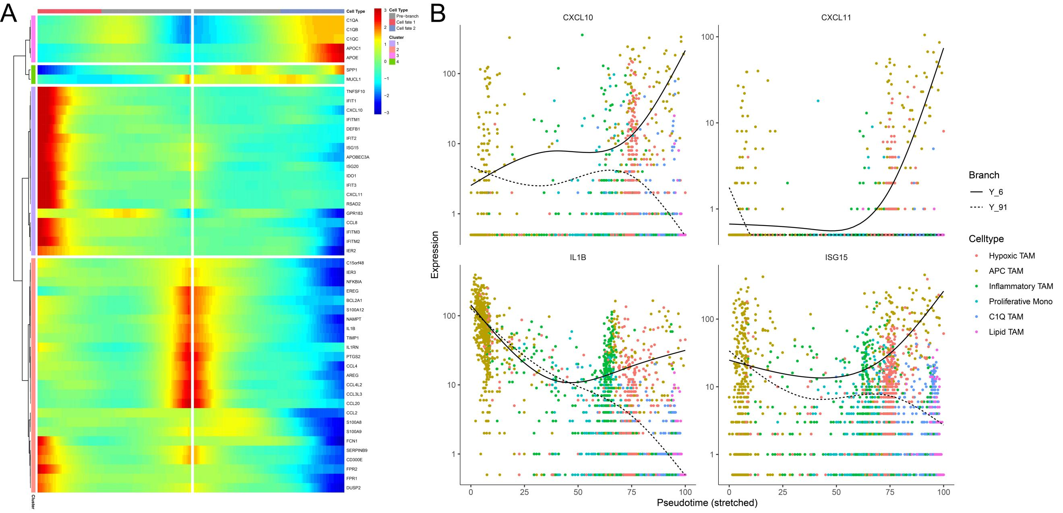
Figure S1 Identification of key regulatory genes at the primary branch point of TAM differentiation. (A) Branched Expression Analysis Modeling (BEAM) heatmap illustrating the expression dynamics of the top 50 significant fate-determining genes across the primary developmental branch point. The heatmap visualizes the transcriptional transition from the pre-branch state toward two distinct cell fates (Cell fate 1 and Cell fate 2), with genes hierarchically grouped into four functional clusters. (B) Pseudotime expression kinetics of representative key differentially expressed genes (IL1B, ISG15, CXCL10, and CXCL11) at the branch point. The divergent solid and dashed lines represent the distinct expression trajectories toward different cell fates, with individual cells colored according to their TAM subtype annotations.

