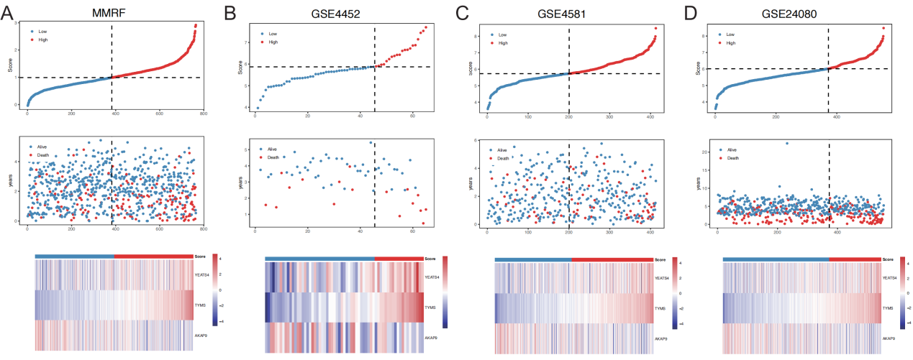
Supplementary Figure 1 Triple plot of sample risk score distribution (ABCD represents different data sets, and each data set is divided into upper, middle and lower figures, where the abscissa represents the samples and is sorted according to the risk score from small to large. The vertical axis of the top panel shows the risk score, the vertical axis of the middle panel shows the survival time, and the bottom panel shows the z-score normalized heat map of factor expression, with the increase of the risk score of the sample, the trend of each factor expression increases/decreases).
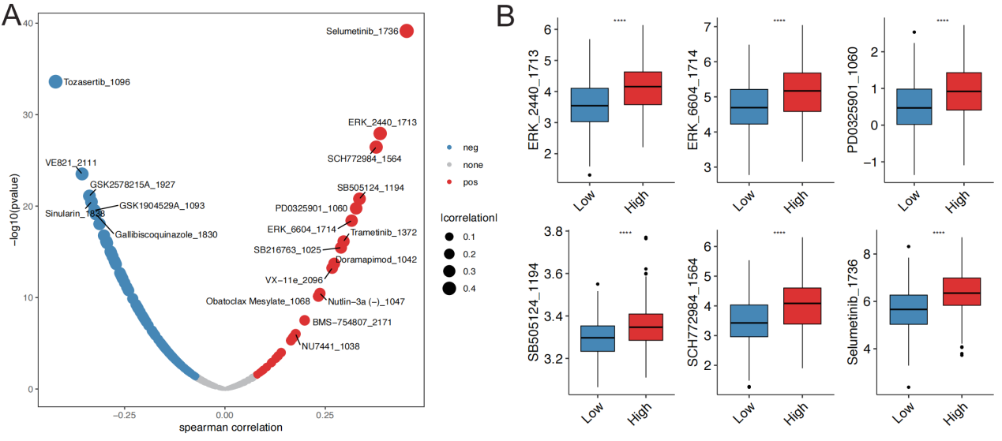
Supplementary Figure 2 Prognostic signature and drug small molecules (A: dot-plot of correlation between prognostic score and IC50 of each drug small molecule; B: distribution of IC50 of top6 positively related drugs in different risk groups in the training set)
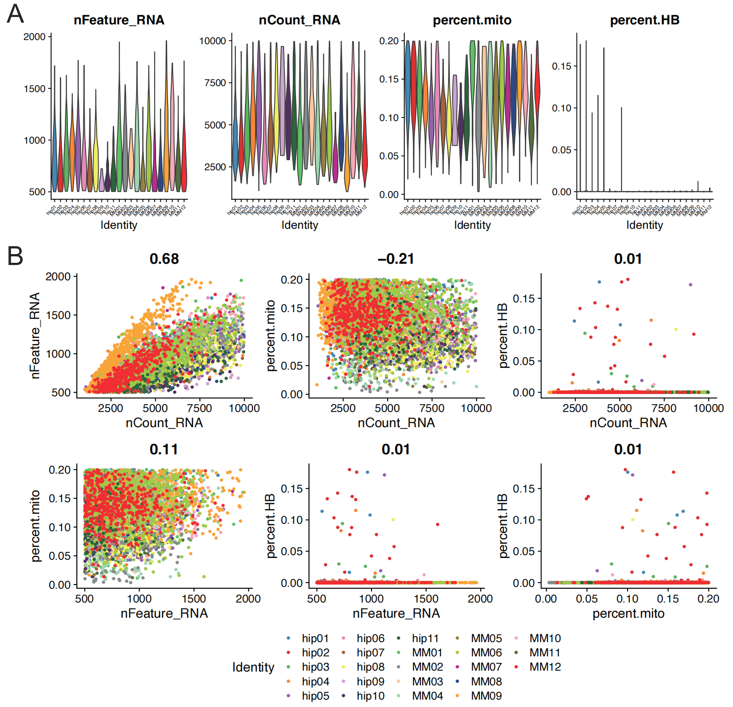
Supplementary Figure 3 Quality control of single cell data (A: violin plot; B: Scatter plot)
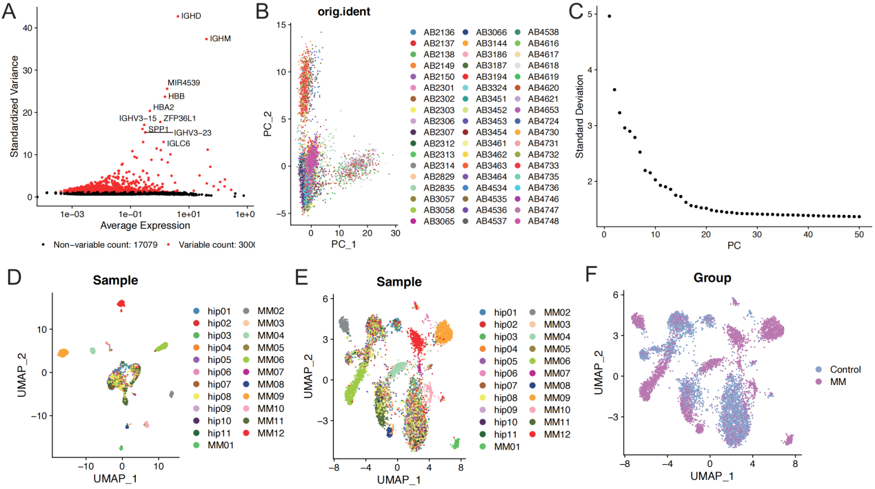
Supplementary Figure 4 Single cell data preprocessing (A: Scatter plot of hypervariable genes; B: scatter plot of PCA analysis; C: ElbowPlot of principal component analysis; D: UMAP distribution of sample cells before batch effect removal; E: UMAP distribution of sample cells after batch effect removal; E: UMAP distribution of grouped cells after batch effect removal)
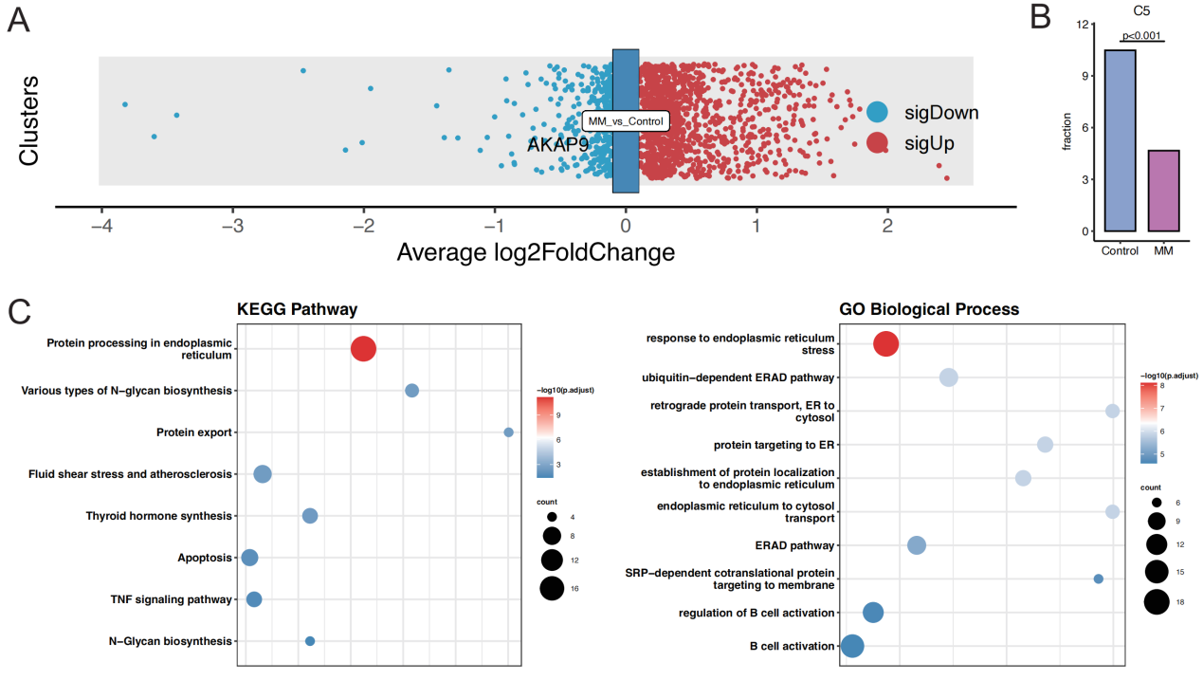
Supplementary Figure 5 Gene expression and subset function (A: volcano plot of expression difference of all plasma cells in MM vs Control samples; B: proportion distribution of C5 cell subsets in MM vs Control samples; C: KEGG and GOBP functional enrichment analysis bubble plot of C5 cell subsets)

