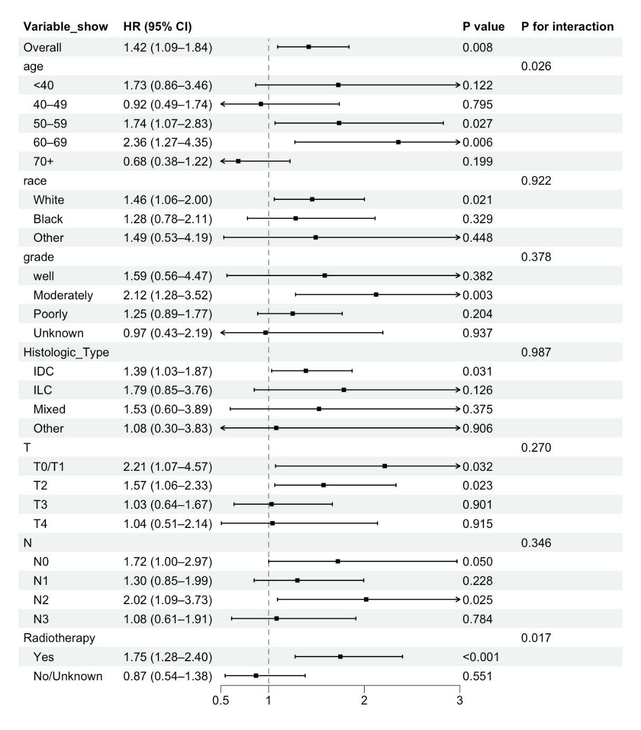
Supplementary Material 3. Forest plot of subgroup analyses for the association between neoadjuvant chemotherapy and overall survival in the propensity score–matched ER+/PR−/HER2− cohort

