Supplementary Materials

Supplemental Table S1 Primer sequences used for PCR
Gene | Forward primer (5’→3’) | Reverse primer (5’→3’)
DLGAP1-AS2 | ACATCGTGGCTGAATGAACA | ATCAGTGGGGAGGAAGGAGT
GAPDH | ATGACATCAAGAAGGTGGTG | CATACCAGGAAATGAGCTTG
miR-101-3p | TACAGTACTGTGATAACTGAA | GCAGGGTCCGAGGTATTC
U6 | TGCGGGTGCTCGCTTCGGCAGC | CCAGTGCAGGGTCCGAGGT
EZH2 | CCAGACTGGTGAAGAGTTGTTTT | CAAGGGATTTCCATTTCTCG
E-cadherin | TCACTGCCCAGGAGCCAGA | TGGCACCAGTGTCCGGATTA
N-cadherin | ATCCTACTGGACGGTTCG | TTGGCTAATGGCACTTGA
Vimentin | CCGACACTCCTACAAGATTTAGA | CAAAGATTTATTGAAGCAGAACC
SLC7A11 | TGTGTGGGGTCCTGTCACTA | CCTCCAAGAAGGGCCAGTTC
GPX4 | ACAAGAACGGCTGCGTGGTGAA | GCCACACACTTGTGGAGCTAGA
PTGS2 | TGAGCATCTACGGTTTGCTG | TGCTTGTCTGGAACAACTGC

Supplementary Figure S1. ESCCdb-based expression analysis of DLGAP-AS2, EZH2, and miR-101-3p in ESCC. The ESCCdb platform was queried to validate the expression of the three genes in ESCC-specific datasets. A. DLGAP1-AS2 was consistently upregulated across 13 datasets, with 7 showing statistical significance. B. EZH2 showed an upregulation trend across 3 datasets, reaching statistical significance. C. miR-101-3p showed a downregulation trend across 3 datasets, with 2 reaching statistical significance. Although the number of available datasets for EZH2 and miR-101-3p is limited, the observed trends are consistent with our experimental findings and the overall direction of the regulatory axis.

Supplementary Figure S2. Kaplan-Meier curves for overall survival in ESCC patients stratified by DLGAP1-AS2 expression (high vs. low, based on the median expression value). The log-rank test was used to compare the survival difference between the two groups.

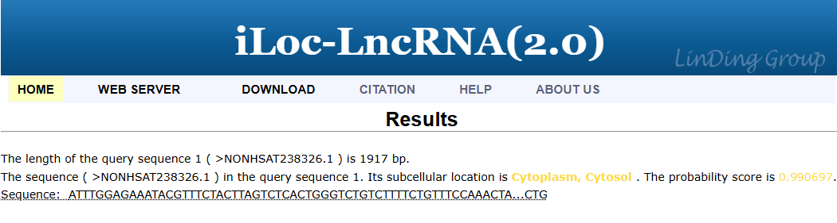
Supplementary Figure S3. Subcellular localization of DLGAP1-AS2 predicted by iLoc-LncRNA (2.0), indicating a predominantly cytoplasmic distribution.

Supplementary Figure S4. Screening for DLGAP1-AS2-targeting miRNA in ESCA. A. Venn diagram of miRNAs targeting DLGAP1-AS2 predicted by LncRNASNP2 and LncBook2. B. Venn diagram showing the intersection of target miRNAs, dbDEMC2.0 differential miRNAs, and UALCAN prognostic miRNAs in ESCA, identifying miR-101-3p.

Supplementary Figure S5. A dual-luciferase assay was performed to evaluate the effect of miR-101-3p mimic on luciferase activity in Eca-109 (A) and KYSE-510 (B) cells transfected with wild-type (WT) or mutant (Mut) DLGAP1-AS2. **** P < 0.0001

Supplementary Figure S6. A dual-luciferase assay was performed to evaluate the effect of miR-101-3p mimic on luciferase activity in Eca-109 (A) and KYSE-510 (B) cells transfected with wild-type (WT) or mutant (Mut) EZH2. **** P < 0.0001

Supplementary Figure S7. Pearson correlation analysis revealed a significant positive correlation between DLGAP1-AS2 and EZH2 mRNA expression levels in ESCC tumor tissues.

Supplementary Figure S8. RT-qPCR analysis of EZH2 mRNA expression in Eca-109 and KYSE-510 cells transfected with an EZH2 overexpression plasmid. **** P < 0.0001.

