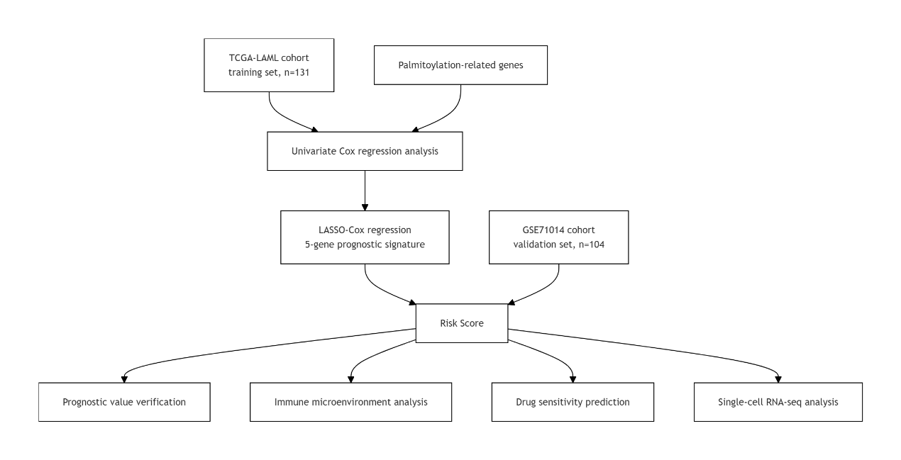
FigS1 Study flowchart
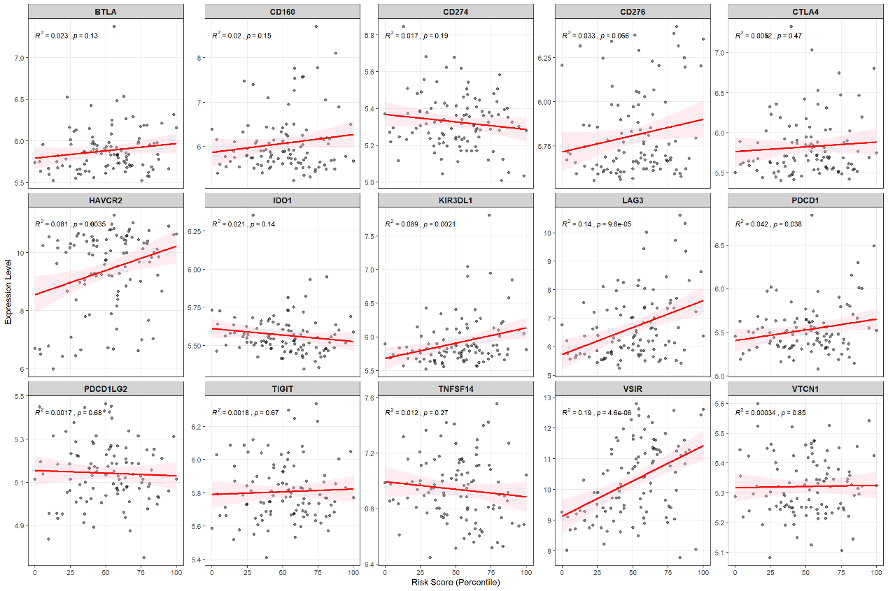
FigS2 Correlation between the expression of immune checkpoints and the risk score
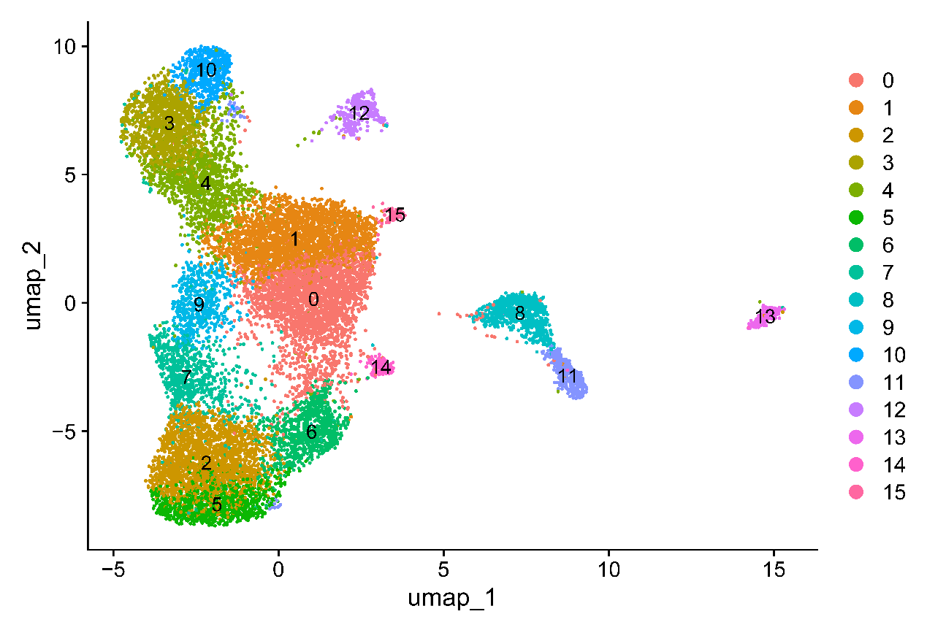
FigS3 UMAP of preliminary clustering before annotation
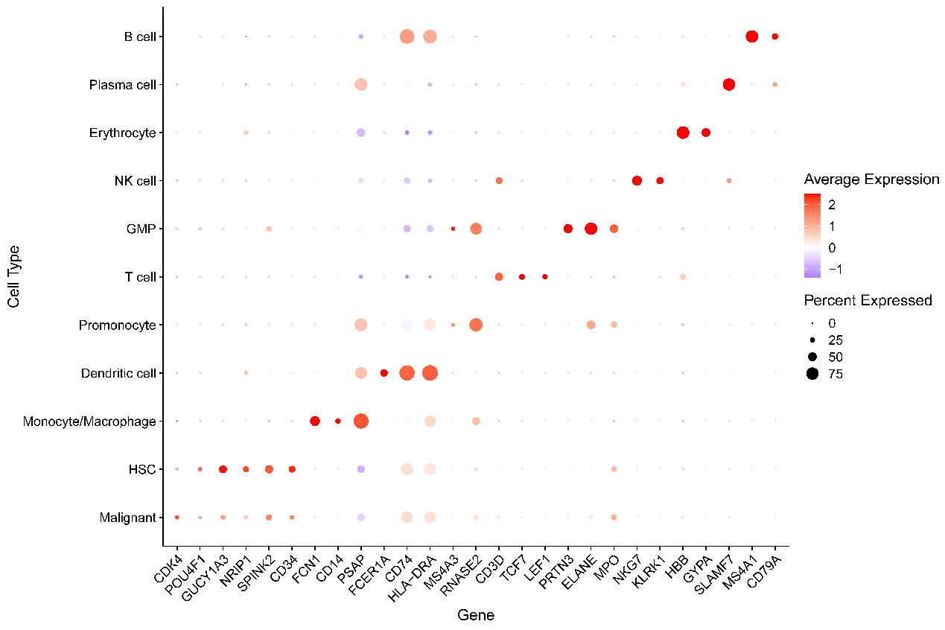
FigS4 Bubble plot of marker gene expression per cluster
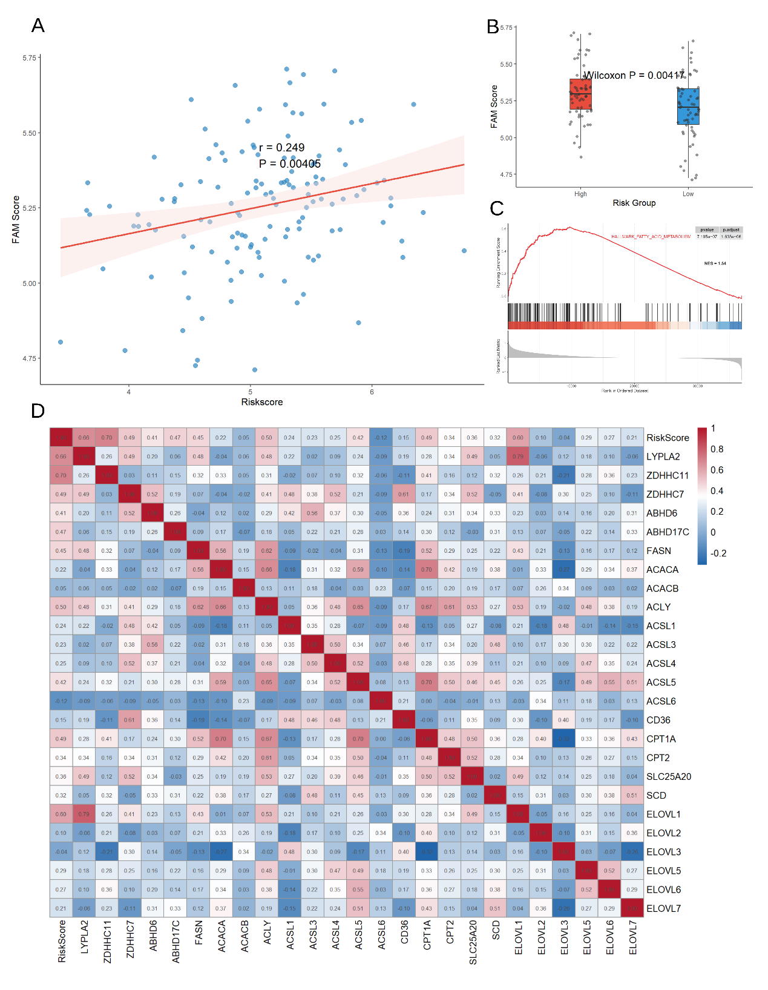
FigS5 Association between the palmitoylation-related risk score and fatty acid metabolism pathways. (A) Scatter plot showing the Spearson correlation between the risk score and the fatty acid metabolism (FAM) pathway enrichment score calculated by GSVA in the TCGA-LAML cohort. (B) Box plot comparing the FAM pathway enrichment scores between high- and low-risk groups. (C) GSEA enrichment plot showing that the Hallmark fatty acid metabolism gene set was significantly enriched in the high-risk group. (D) Spearman correlation heatmap depicting the co-expression relationships among the five signature genes and key regulators of palmitoyl-CoA availability and fate.

