Supplementary Table S1 Baseline characteristics of the TCGA training and internal validation sets
Characteristic | Level | Training | Internal validation | P value
Age, years | Median (IQR) | 67.0 (60.0–73.0) | 68.0 (59.5–73.0) | 0.951
Sex | Male | 418 (60.1%) | 173 (58.6%) | 0.731
 | Female | 278 (39.9%) | 122 (41.4%)
AJCC pathologic stage | I | 362 (52.0%) | 158 (53.6%) | 0.500
 | II | 190 (27.3%) | 88 (29.8%)
 | III | 119 (17.1%) | 41 (13.9%)
 | IV | 25 (3.6%) | 8 (2.7%)
Pathologic T category | T1 | 201 (28.9%) | 80 (27.1%) | 0.348
 | T2 | 389 (55.9%) | 165 (55.9%)
 | T3 | 73 (10.5%) | 41 (13.9%)
 | T4 | 30 (4.3%) | 9 (3.1%)
 | TX | 3 (0.4%) | 0 (0.0%)
Pathologic N category | N0 | 441 (63.4%) | 200 (67.8%) | 0.268
 | N1 | 153 (22.0%) | 65 (22.0%)
 | N2 | 84 (12.1%) | 23 (7.8%)
 | N3 | 4 (0.6%) | 3 (1.0%)
 | NX | 14 (2.0%) | 4 (1.4%)
Pathologic M category | M0 | 520 (74.7%) | 221 (74.9%) | 0.829
 | M1 | 24 (3.4%) | 8 (2.7%)
 | MX | 152 (21.8%) | 66 (22.4%)
Data are median (IQR) or n (%) for matched cases (training, n = 696; validation, n = 295). AJCC pathologic stages were grouped as I-IV. P values used Wilcoxon rank-sum or Pearson chi-square tests, with Monte Carlo estimates for sparse tables.
Supplementary Figure S1 Histology-specific validation in TCGA-LUAD and TCGA-LUSC
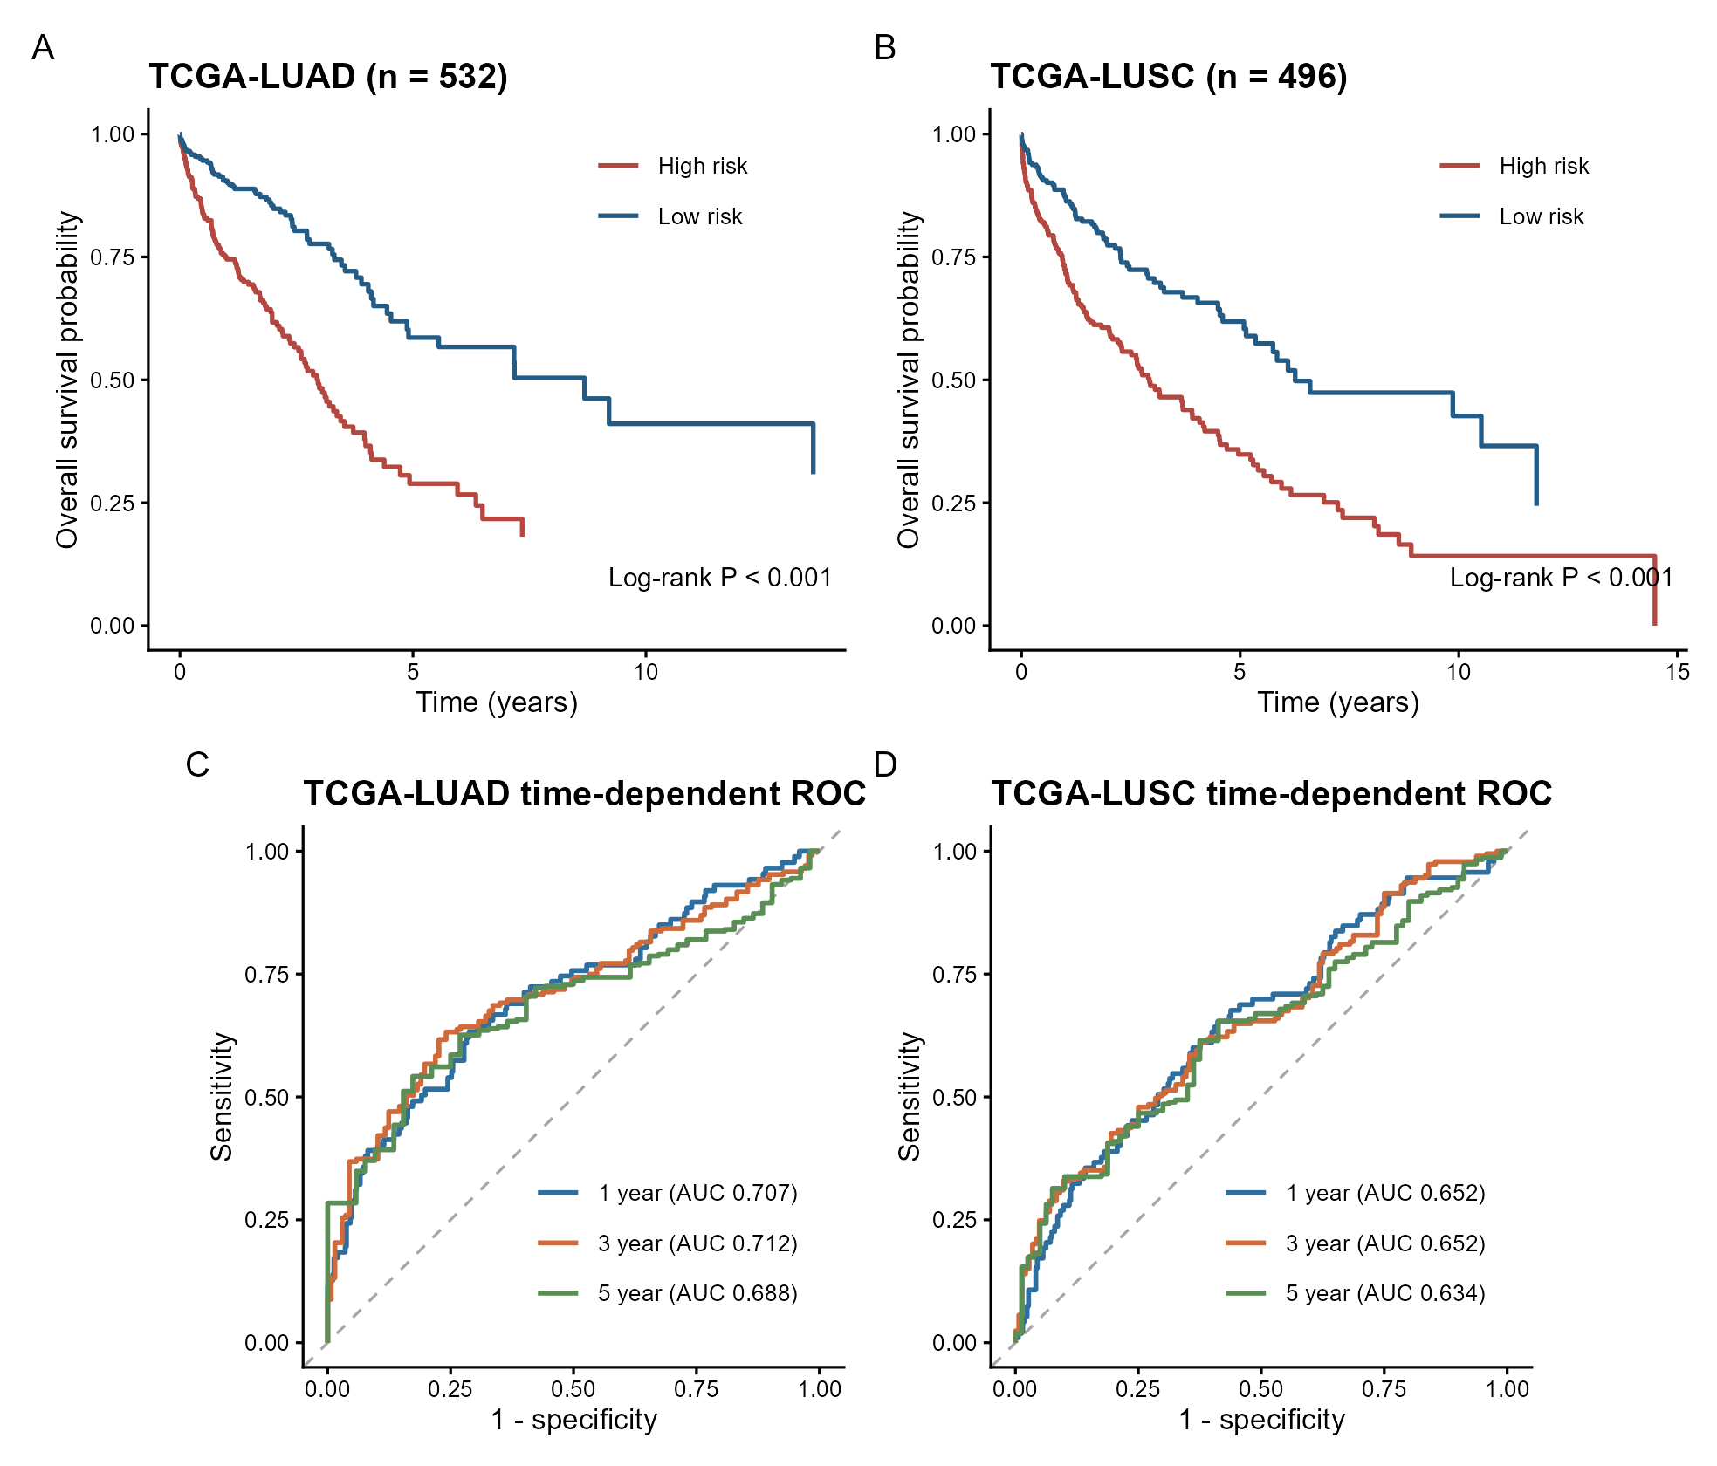
(A-B) Overall-survival curves for high- and low-risk groups defined by the median risk score within each histological subtype. (C-D) Time-dependent ROC curves at 1, 3, and 5 years. LUAD, lung adenocarcinoma; LUSC, lung squamous cell carcinoma.

