Supplementary Table 1. Correlation analysis of MIR210HG expression with miR210/HIF-1α pathway-related target genes
Target gene | Pathway Category | r | P value
ENO1 | HIF-1α core target gene | 0.46 | 9.58E-24
BNIP3 | HIF-1α core target gene | 0.455 | 3.08E-23
LDHA | HIF-1α core target gene | 0.45 | 1.22E-22
VEGFA | HIF-1α core target gene | 0.439 | 1.45E-21
SLC2A1（GLUT1） | HIF-1α core target gene | 0.432 | 6.85E-21
ANGPTL4 | HIF-1α core target gene | 0.396 | 1.62E-17
HK2 | HIF-1α core target gene | 0.376 | 8.94E-16
CA9 | HIF-1α core target gene | 0.339 | 6.23E-13
SDHB | miR210 core target gene | 0.333 | 1.51E-12
MAPK3 | Combined pathway associated gene | 0.289 | 1.11E-09
AKT1 | Combined pathway associated gene | 0.242 | 4.33E-07
VHL | Combined pathway associated gene | 0.239 | 5.63E-07
PTPN1 | miR210 core target gene | 0.222 | 0.0000035
EFNA3 | miR210 core target gene | 0.22 | 0.0000043
HIF1A | Combined pathway associated gene | 0.219 | 4.75E-06
MYOD1 | miR210 core target gene | 0.202 | 2.72E-05
SDHC | miR210 core target gene | 0.201 | 2.93E-05
CXCR4 | HIF-1α core target gene | 0.198 | 3.66E-05
ISCU | miR210 core target gene | 0.162 | 0.000751
FOXO3 | miR210 core target gene | 0.138 | 0.00426
KDR | HIF-1α core target gene | 0.128 | 0.00815
EPAS1 | Combined pathway associated gene | 0.113 | 0.019
MIR210 | Combined pathway associated gene | 0.103 | 0.0338
TPM1 | miR210 core target gene | 0.0786 | 0.105
E2F3 | miR210 core target gene | 0.0716 | 0.14
HOXA1 | miR210 core target gene | -0.000614 | 0.99

Supplementary Figure 1. Correlation analysis of MIR210HG expression
and signature_A score in ovarian cancer and normal ovarian tissues. Signature_A score was calculated by ssGSEA to represent the activity of the miR210/HIF-1α pathway (26 core genes). Green dots = ovarian cancer tumor samples, blue dots = normal ovarian tissues (GTEx). Pearson correlation analysis revealed a significant positive correlation between MIR210HG (log₂(TPM+1)) and signature_A score, with higher MIR210HG expression and more heterogeneous signature_A activity observed in ovarian cancer samples.

a b
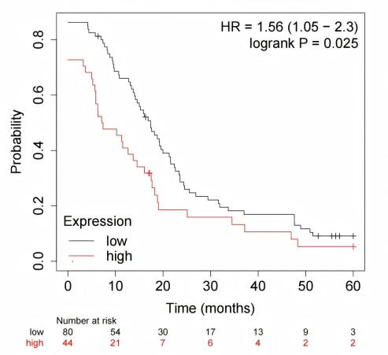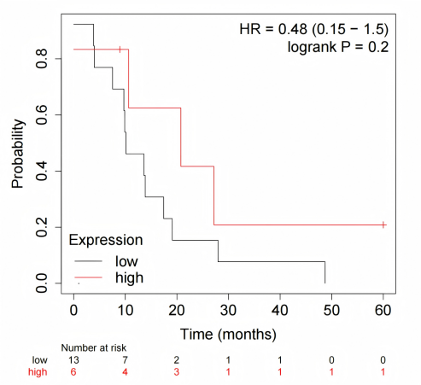
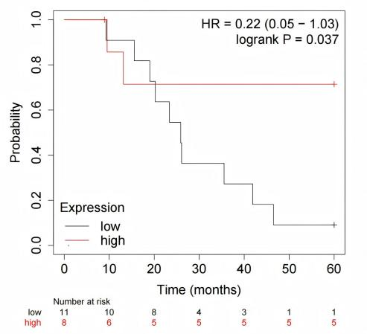
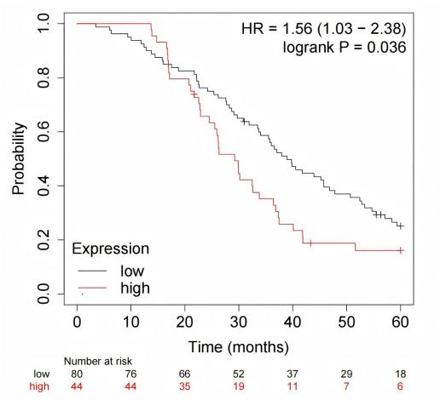
c d

Supplementary Figure 2. MIR210HG expression was significantly correlated with 5-year PFS (a) and 5-year OS (c) in the TP53-mutant subgroup and with 5-year PFS (b) and 5-year OS (d) in the TP53-wild-type subgroup.

Supplementary Table 2. Univariate logistic regression analysis of factors associated with FIGO stage in HGSOC patients (ordinal vs. multinomial logistic regression)
Variable | Category/Comparison | Statistical Method | β | OR | 95%CI | P value
CA125(U/ml) | ≤35 vs >35 (Ref.) | Ordinal Logistic | -0.423 | 0.655 | (0.135, 0.847) | 0.601
HE4(pmol/L) | ≤140 vs >140 (Ref.) | Ordinal Logistic | -0.593 | 0.553 | (0.233, 0.763) | 0.178
MIR210HG expression | Low vs High (Ref.) | Ordinal Logistic | -2.176 | 0.113 | (0.025, 0.368) | <0.001***
Ascites carcinoma cells | No (Ref.) vs Yes | Ordinal Logistic | 1.324 | 3.758 | (1.071, 13.18) | 0.039*
BMI | ≤24 vs >24 (Ref.) | Ordinal Logistic | 0.046 | 1.047 | (0.637, 1.723) | 0.856
Lymph node metastasis | FIGO Ⅱ vs Ⅰ (Ref.) | Multinomial Logistic | 0.000 | 1.000 | - | >0.05
 | FIGO Ⅲ vs Ⅰ (Ref.) | Multinomial Logistic | 19.868 | >1000 | >1000 | <0.001***
 | FIGO Ⅳ vs Ⅰ (Ref.) | Multinomial Logistic | 19.543 | >10^6 | >10^6 | <0.001***
***P < 0.001, **P < 0.01, *P < 0.05. Abbreviations: CA125: Recombinant carbohydrate antigen 125. HE4: Human epididymis protein 4. BMI: Body mass index. OR: odds ratio. CI: confidence interval. β: regression coefficient. Ref.: Reference group. Extreme OR values (>1000) were abbreviated due to computational overflow. For ordinal logistic regression, the reference group was the low-level category of each variable. For multinomial logistic regression, FIGO stage Ⅰ was set as the reference category. Extreme OR and 95% CI values (>1000 or >10^6) were abbreviated due to complete separation in the data (lymph node metastasis was almost exclusively observed in advanced FIGO stages), leading to computational overflow in the statistical software. The proportional odds assumption was violated when lymph node metastasis was analyzed using ordinal logistic regression, as P < 0.05 by the test of parallel lines. Even after adjusting, the assumption still did not hold. Therefore, multinomial logistic regression was employed, treating FIGO stage as a nominal categorical variable with stage I as the reference category.

Supplementary Table 3. Multivariate logistic regression analysis of factors associated with FIGO stage in HGSOC patients
Variable | Category/Level | Stage II OR (95% CI) | P value | Stage III OR (95% CI) | P value | Stage IV OR (95% CI) | P value | Overall P value (LRT)
MIR210HG expression | Low | 0.980(NE) | - | <0.001 (NE) | 0.995 | <0.001 (NE) | 0.995 | 0.016*
 | High (Ref.) | 1.000 | - | 1.000 | - | 1.000 | -
Ascites carcinoma cells | No (Ref.) | 1.000 | - | 1.000 | - | 1.000 | - | 0.460
 | Yes | 0.917(0.128-6.556) | 0.931 | 5.137(0.337-78.284) | 0.239 | 1.842(0.081 to 41.686） | 0.701
Lymph node metastasis | No (Ref.) | 1.000 | - | 1.000 | - | 1.000 | - | <0.001***
 | Yes | 0.998(NE) | 1.000 | 3.23×10⁸ (7.51×10⁷–1.39×10⁹) | <0.001*** | 1.71×10⁸ (NE) | -
***P < 0.001, **P < 0.01, *P < 0.05. Abbreviations: OR: odds ratio. CI: confidence interval. β: regression coefficient. Ref.: Reference group. NE: Due to complete separation in the data, the odds ratio and 95% confidence interval could not be estimated. Extreme odds ratios are a result of quasi-complete separation. Multinomial logistic regression with FIGO stage I as the reference category. Overall significance assessed by LRT (Likelihood Ratio Test).

Supplementary Table 4. Univariate ordinal logistic regression analysis of factors associated with poor clinical endpoints in HGSOC patients
Variable | β | OR | 95%CI | P value
BMI
≤24 | -0.422 | 0.656 | (0.285, 1.511) | 0.322
＞24 (Ref.) |  | 1.000
CA125(U/ml)
≤35 | -1.349 | 0.259 | (0.093, 0.724) | 0.010*
＞35 (Ref.) |  | 1.000
HE4(pmol/L)
≤140 | -0.570 | 0.566 | (0.307, 1.040) | 0.067
>140 (Ref.) |  | 1.000
MIR210HG expression
Low | -0.476 | 0.621 | (0.238, 1.623) | 0.331
High (Ref.) |  | 1.000
FIGO stage
I | -1.139 | 0.320 | (0.086, 1.191) | 0.089
II | -1.317 | 0.268 | (0.083, 0.862) | 0.027*
III | -0.408 | 0.665 | (0.226, 1.958) | 0.459
IV (Ref.) |  | 1.000
***P < 0.001, **P < 0.01, *P < 0.05. Abbreviations: CA125: Recombinant carbohydrate antigen 125. HE4: Human epididymis protein 4. BMI: Body mass index. OR: odds ratio. CI: confidence interval. β: regression coefficient. Ref.: Reference group.

