Supplementary data

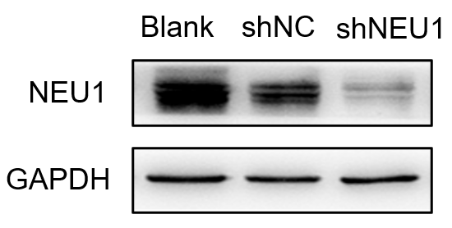
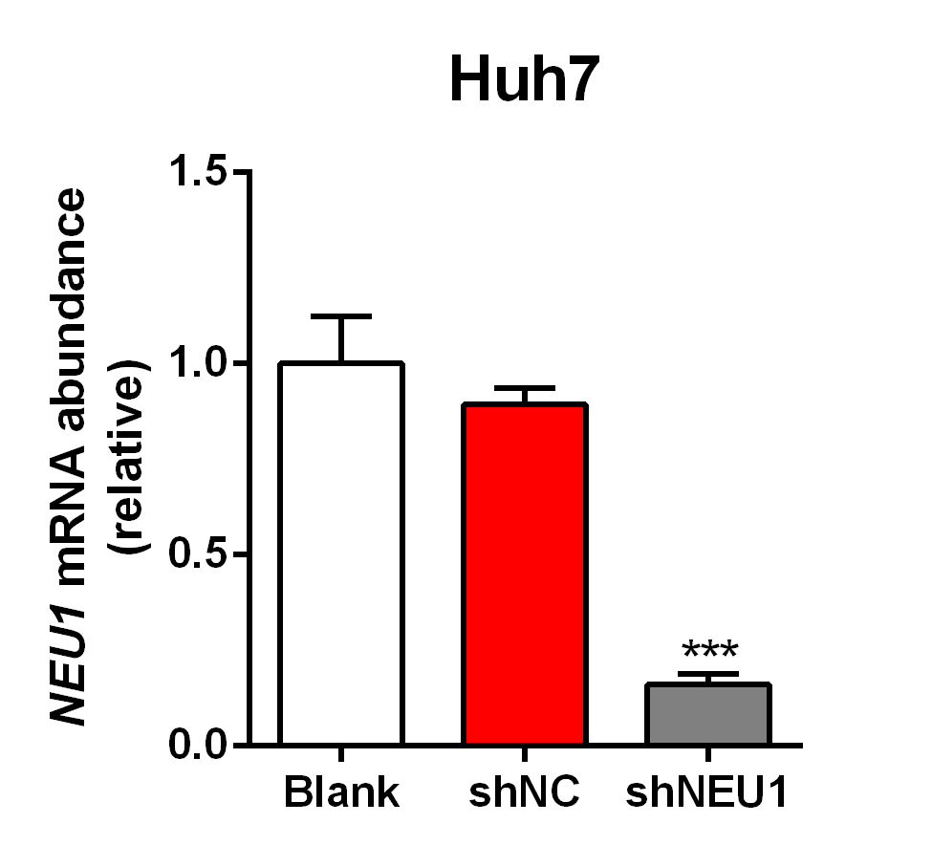
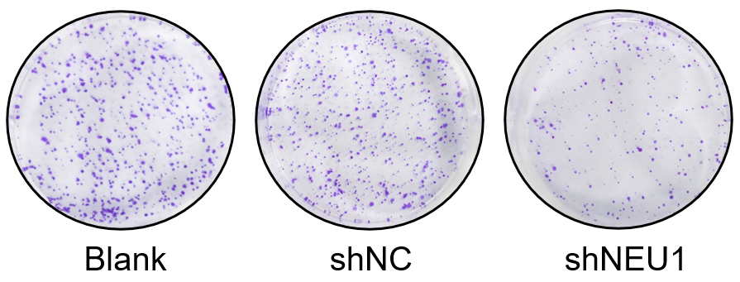
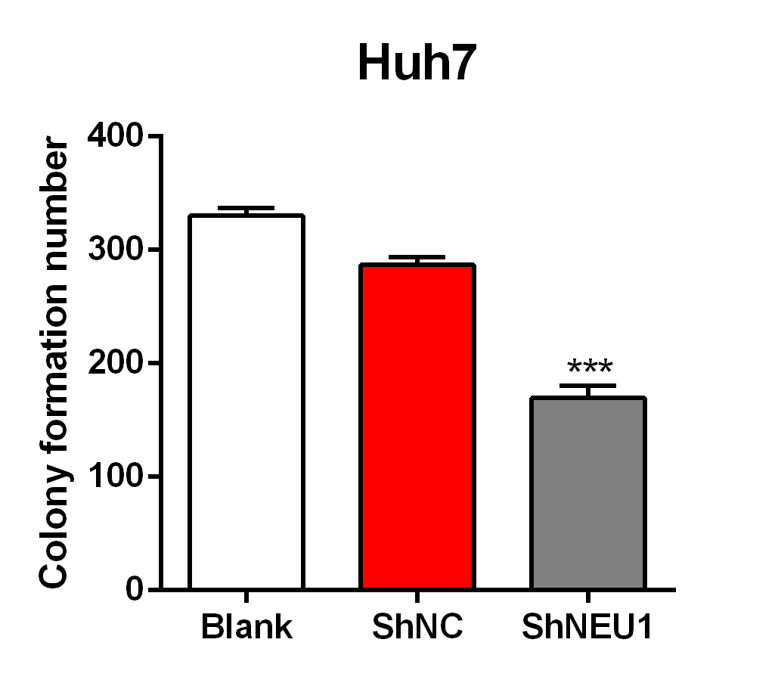
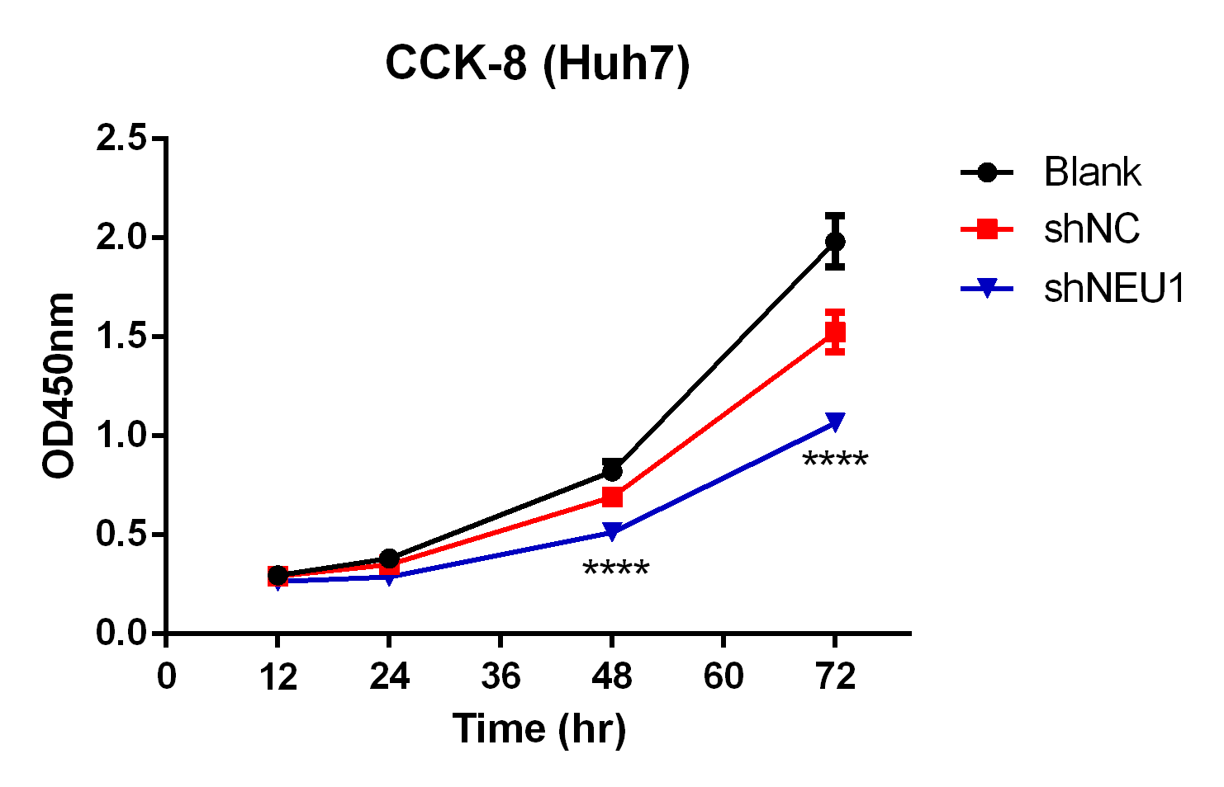
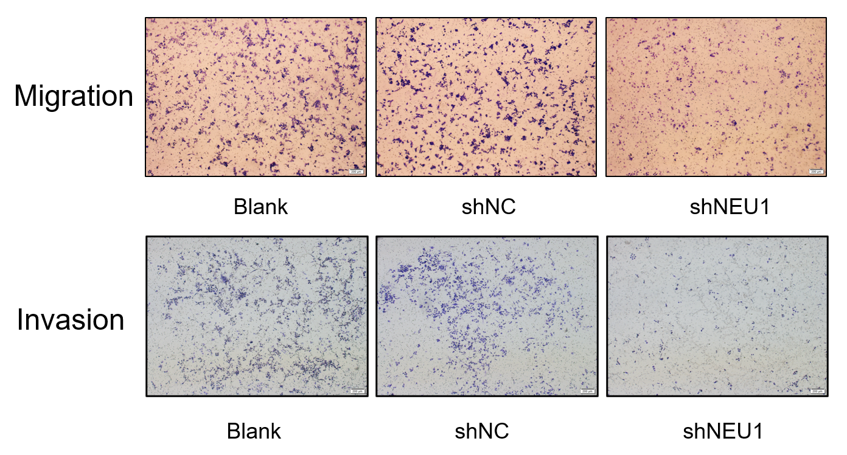
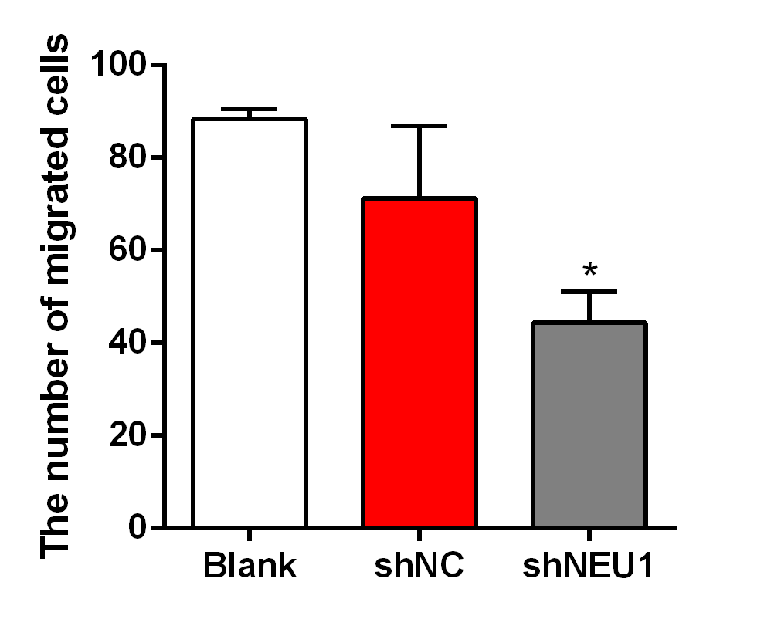
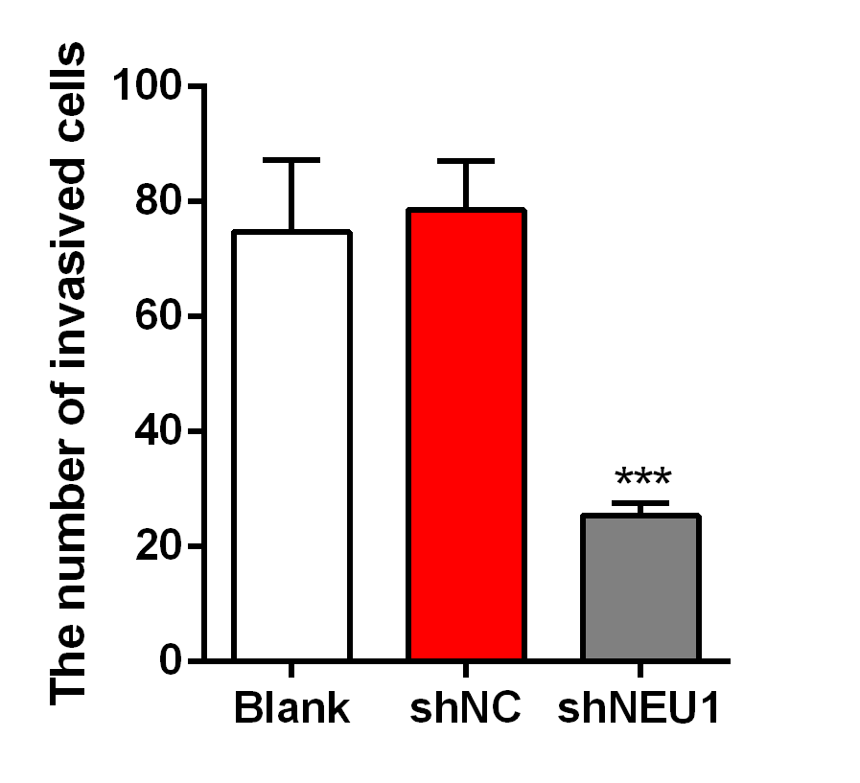
A.
B.
Migration
Invasion
C
D
E
F

FigureS1 Effects of NEU1 deficient on proliferation, migration and invasion of hepatocellular carcinoma cell line Huh7
A and B. Verification of knockout efficiency after lentivirus-ShNEU1 infection of Huh7 (n = 4). C. The effect of NEU1 knockout on Huh7 cell proliferation via CCK-8 assay (n = 8); D. The effect of NEU1 knockout on Huh7 cell colony formation by plate cloning assay (n = 3); E and F. Migration and invasion abilities of NEU1 knockout Huh7 cell were reduced (n = 3). Data are expressed as Mean ± S.EM., *P < 0.01**P < 0.01; ***P < 0.001 VS sh
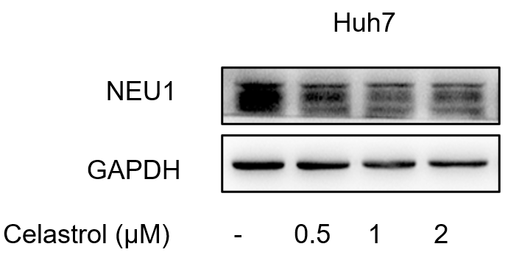
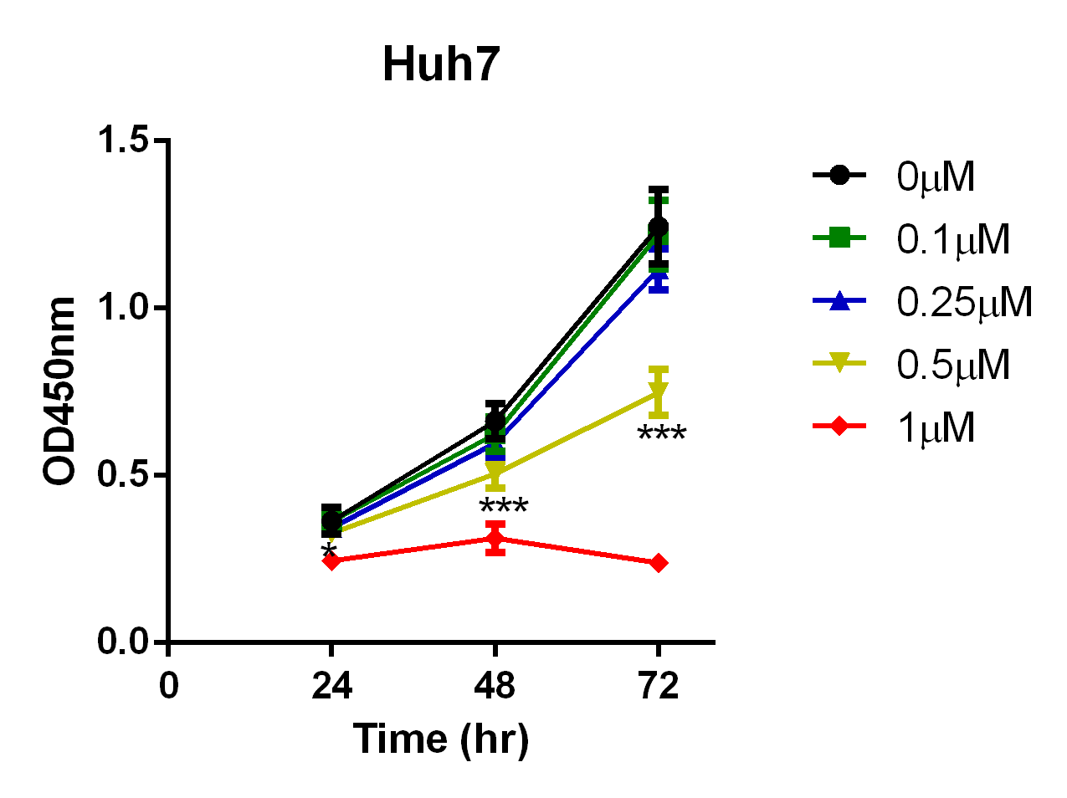
A
B

FigureS2 Celastrol inhibited growth of Huh7 cells by decrease NEU1 expression
A. celastrol inhibited NEU1 expression in Huh7 cells; D. Effect of different concentrations of celastrol on the proliferation of Huh7 cells; Data are expressed as Mean ± S.EM., *P < 0.05; ***P < 0.001
Table S1 Binding energy of natural product with Neu1
CAS No. | Name | Docking Score (kcal/mol)
28957-04-2 | Oridonin | -11.1
471-66-9 | α-Boswellic acid | -11.1
510-30-5 | Echinocystic acid | -10.9
6246-46-4 | Ursonic acid | -10.9
15291-77-7 | Ginkgolide B | -10.8
34157-83-0 | Celastrol | -10.6
1362-42-1 | Absinthin | -10.6
465-99-6 | Hederagenin | -10.6

Original WB gel
