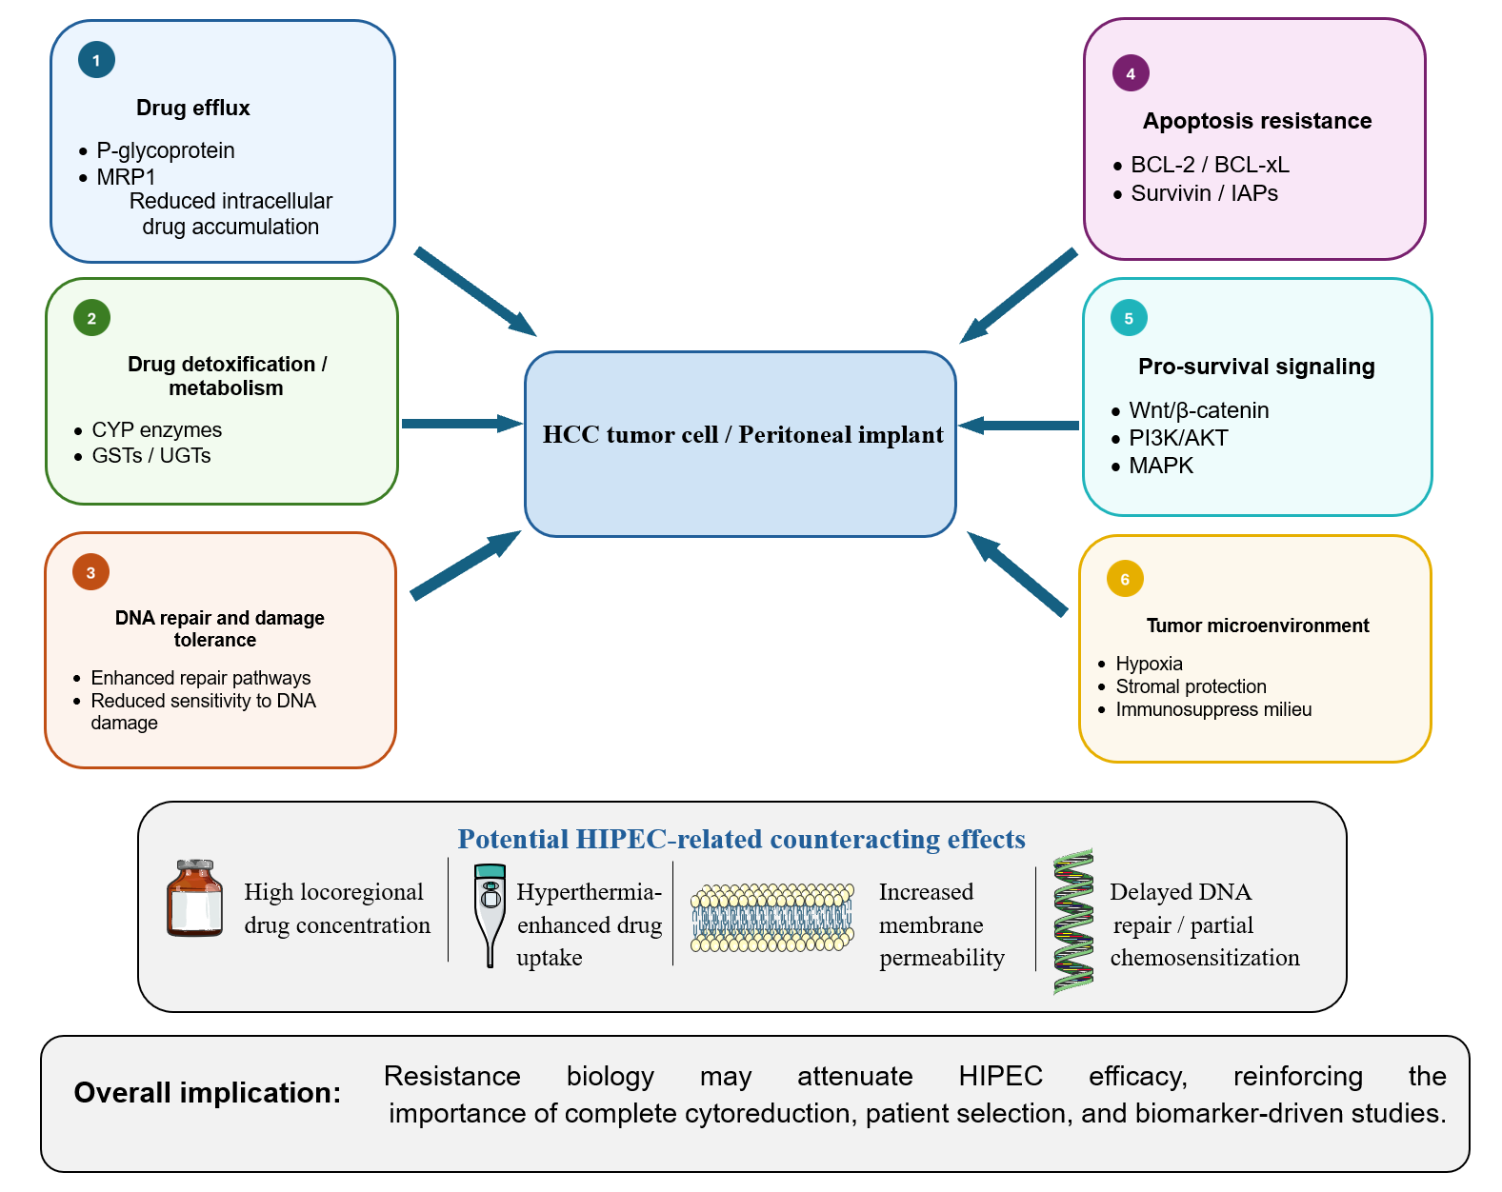
Supplementary Figure S1. Major mechanisms of chemotherapy and immunotherapy resistance in HCC and potential implications for HIPEC. The figure summarizes selected resistance mechanisms and potential heat-mediated effects relevant to investigational HIPEC strategies. The mechanisms shown are based predominantly on preclinical or indirect evidence and have not been demonstrated to translate into clinical efficacy in HCC-PM. Some icons were adapted from Servier Medical Art, provided by Servier, under the Creative Commons Attribution 4.0 International License.
Abbreviations: BCL-2, B-cell lymphoma 2; BCL-xL, B-cell lymphoma-extra large; CYP, cytochrome P450; GST, glutathione S-transferase; HCC, hepatocellular carcinoma; HIPEC, hyperthermic intraperitoneal chemotherapy; IAPs, inhibitor of apoptosis proteins; MAPK, mitogen-activated protein kinase; MRP1, multidrug resistance-associated protein 1; PI3K/AKT, phosphoinositide 3-kinase/protein kinase B; UGT, UDP-glucuronosyltransferase.

