Supplementary Fig. S1 Proportional hazards assumption evaluation. (A) Log-minus-log plots. Non-parallel curves confirm time-varying hazard ratios (Schoenfeld residual tests: all p<0.05); Cox HRs are time-averaged estimates. (B–C) Landmark Kaplan-Meier BCSS curves for PMC vs. IDC confirming persistence of PMC's advantage across follow-up periods.
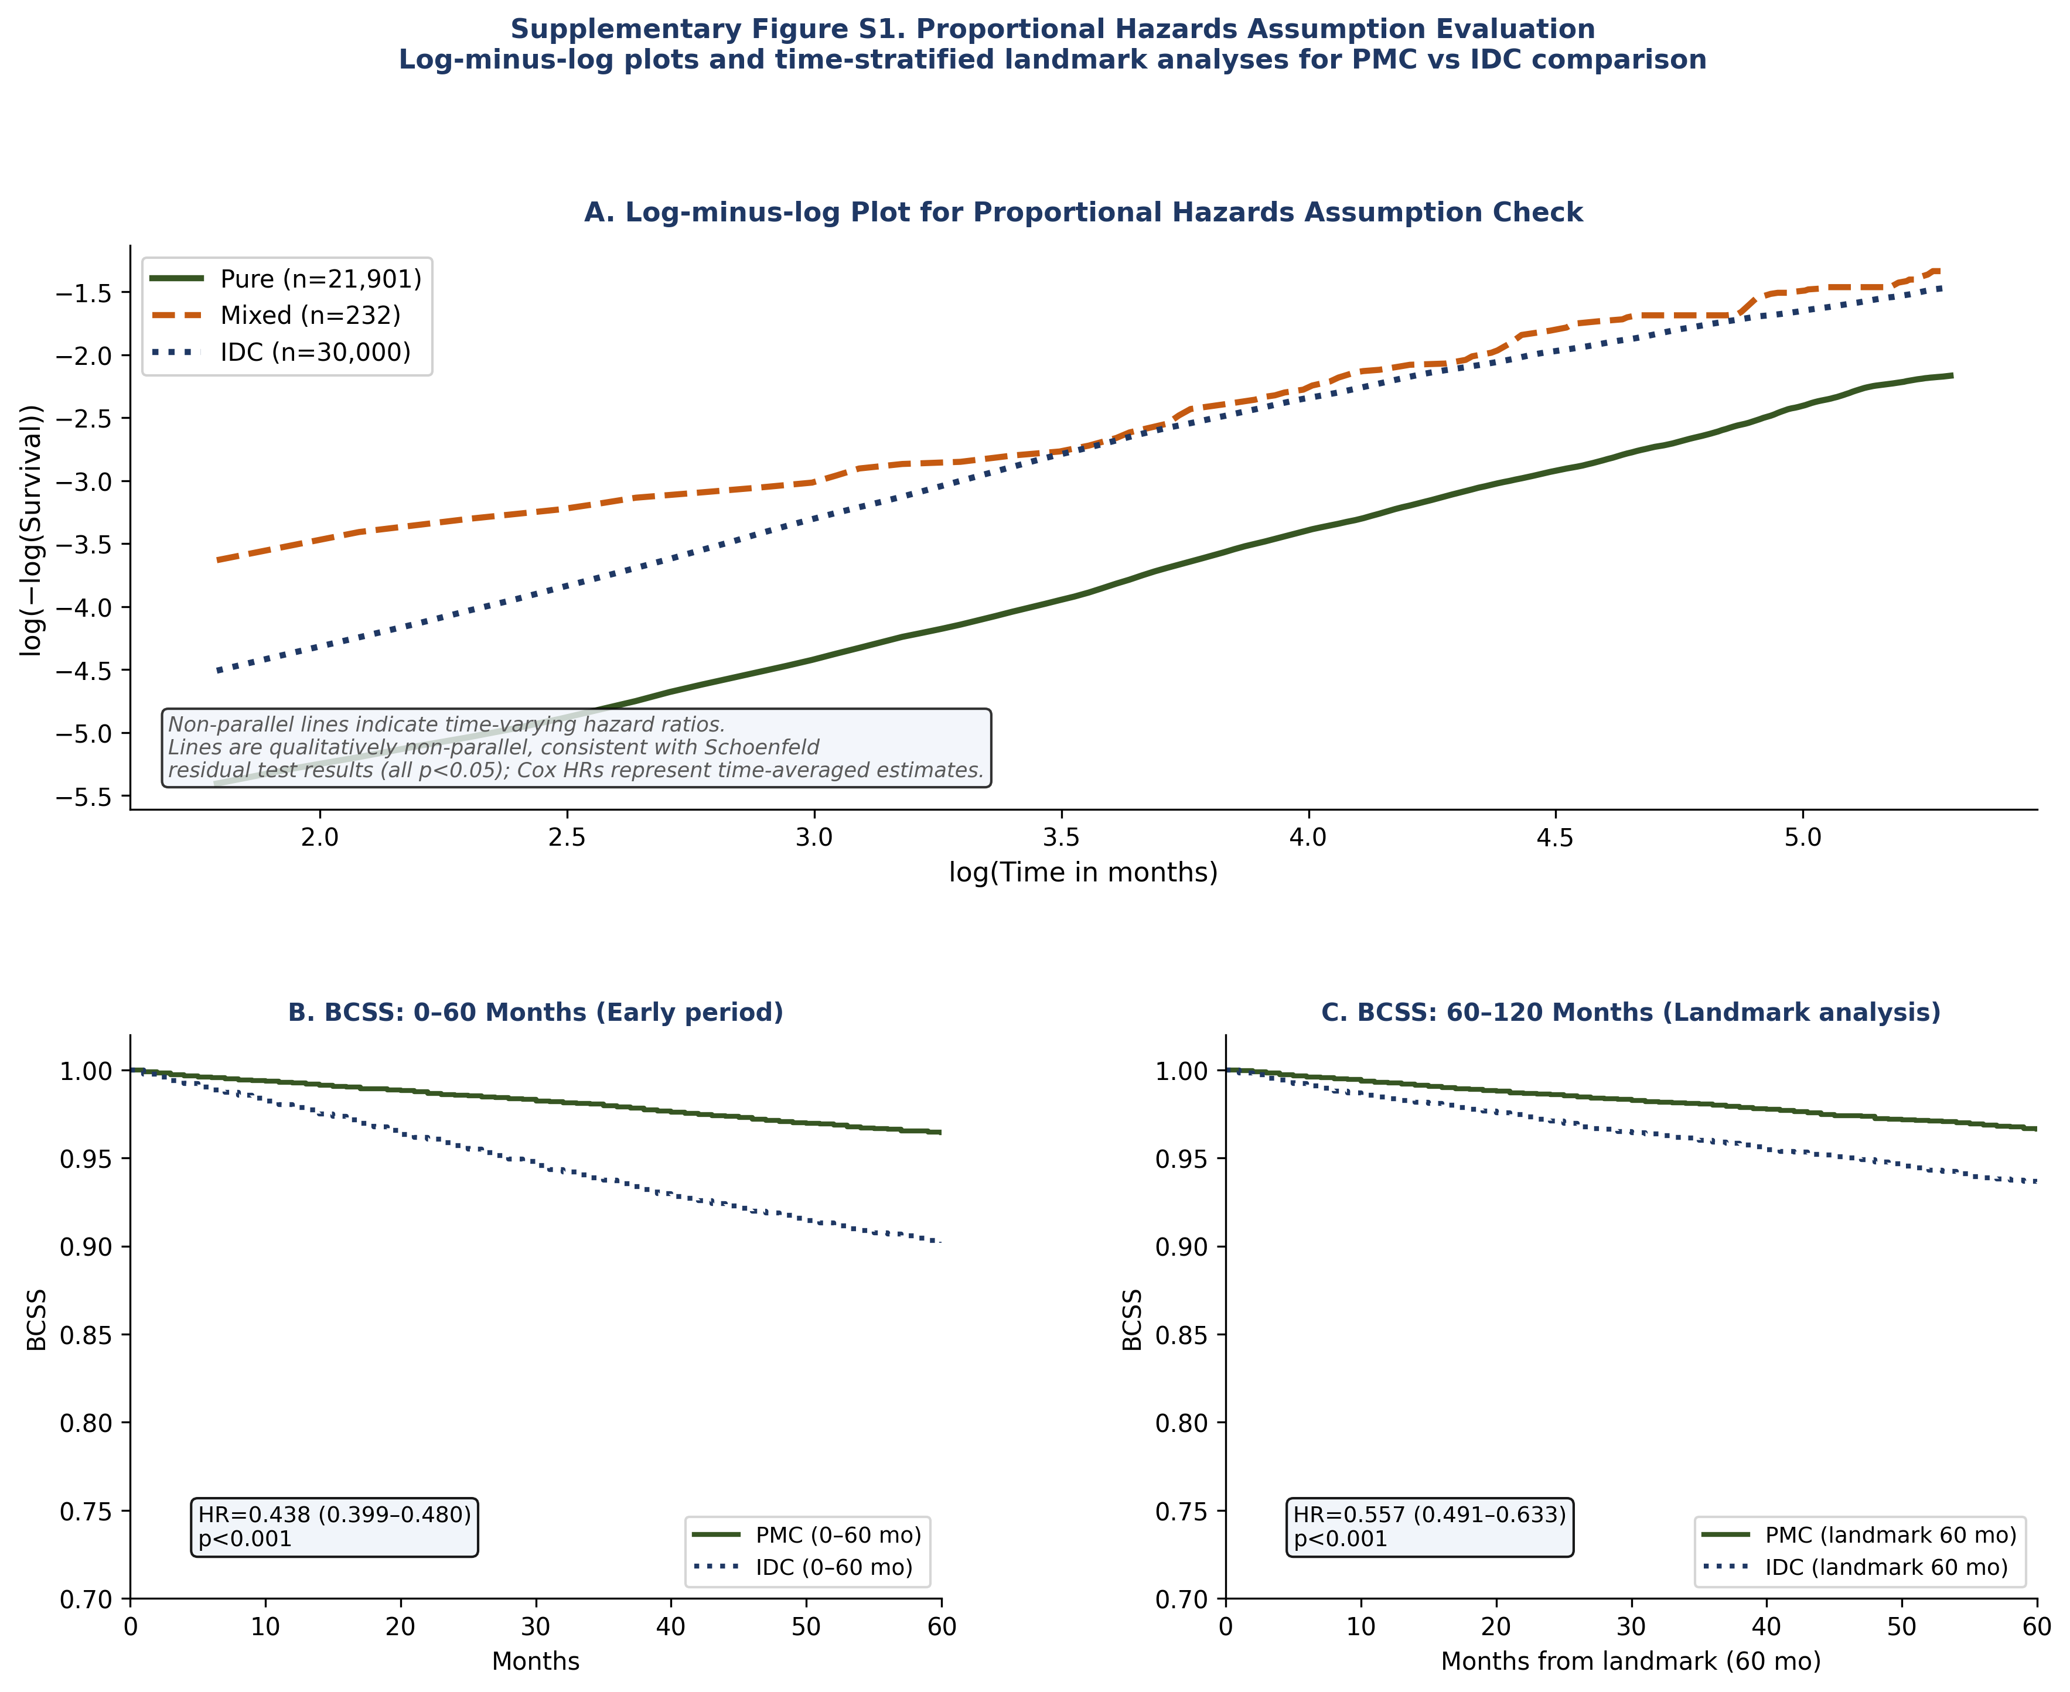
Supplementary Methods: Full statistical analysis details
IDC random sampling: A random sample of 30,000 IDC patients (seed=42) was used with penalized Cox regression (λ=0.10) due to computational constraints of the lifelines library with the full 822,563-patient cohort. Sampling stability was confirmed across 50 independent replications (seeds 0–49; HR mean=0.790, SD=0.010, range 0.774–0.823). An unpenalized Cox model fitted to the full IDC cohort (stage-complete n=397,490) yielded HR=0.634 (95% CI 0.592–0.679, p<0.001); the difference from the primary model HR (0.792) reflects distinct covariate compositions of the stage-complete subsets in each analysis. Both estimates consistently demonstrate an independent association between PMC and superior BCSS.

Proportional hazards assessment: Schoenfeld residuals (cox.zph, R v4.6) indicated statistical evidence of non-proportional hazards for all covariates (all p<0.05). Cox HRs are interpreted as time-averaged hazard ratios across the full follow-up period. Landmark Cox analyses were performed at 60-month and 120-month landmarks to quantify time-period-specific effects. Log-minus-log plots are provided in Supplementary Fig. S1.

