Supplementary Information to: Using the novel alkynyl-substituted rhenium(I) complex (4,4’-bisphenylethynyl-2,2’-bipyridyl)Re(CO)₃Cl as catalyst for CO₂ reduction – Synthesis, Characterization and Application
Engelbert Portenkirchner,^{a*} Stefanie Schlager,ª Dogukan Apaydin,ª Kerstin Oppelt,^{b} Markus Himmelsbach,^{c} Daniel A. M. Egbe,ª Helmut Neugebauer,ª Günther Knör,^{b} Tsukasa Yoshida,^{d} Niyazi Serdar Sariciftciª
a Linz Institute for Organic Solar Cells (LIOS), Physical Chemistry, Johannes Kepler University Linz , Altenbergerstr. 69, A-4040 Linz, Austria
b Institute of Inorganic Chemistry, Center for Nanobionics and Photochemical Sciences (CNPS), Johannes Kepler University Linz , Altenbergerstr. 69, A-4040 Linz, Austria
c Institute of Analytical Chemistry, Johannes Kepler University Linz , Altenbergerstr. 69, A-4040 Linz, Austria
d Research Center for Organic Electronics (ROEL), Yamagata University, 992-8510 Yonezawa, Japan

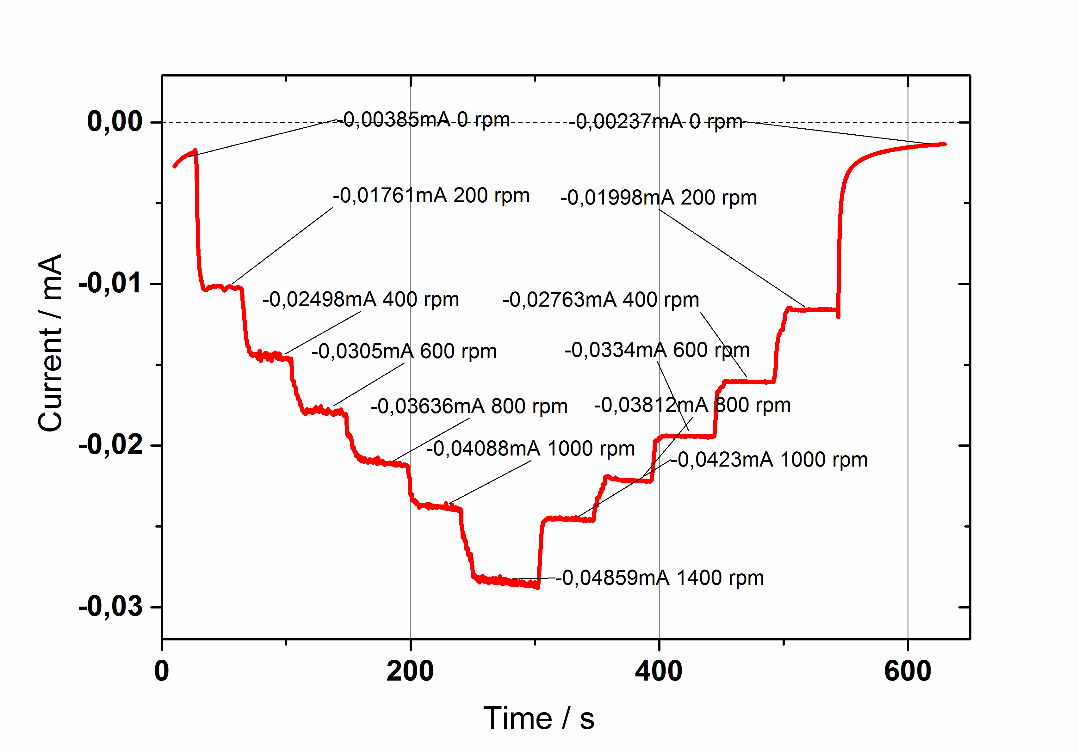
Figure S1. Rotating disk measurements with a stepwise increase of the rotation rate from 0 to
1400 rpm respectively and a decrease to 0 rpm again at constant potential of -1.3 V vs. Ag/AgCl. For the construction of the Levich Plot the mean values of the increasing and decreasing steps were taken. Measurements are taken in DMF with 0.5 mM rhenium complex (4,4’-bisphenylethynyl-2,2’-bipyridyl)Re(CO)₃Cl (1), 0.1 M TPABF₄, a glassy carbon working electrode, platinum wire counter electrode, and Ag/AgCl reference electrode with internal ferrocene as additional reference.

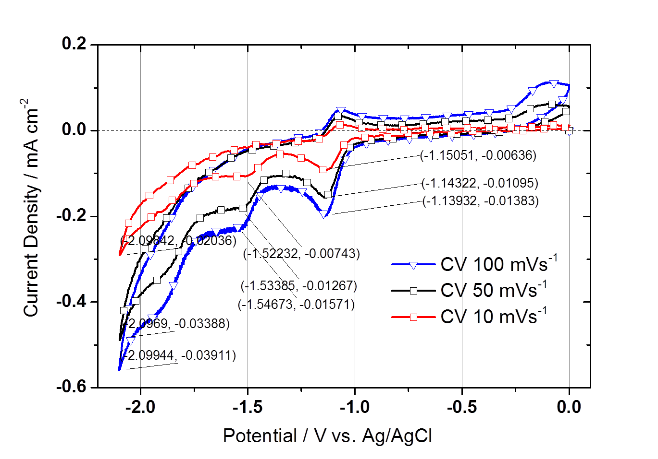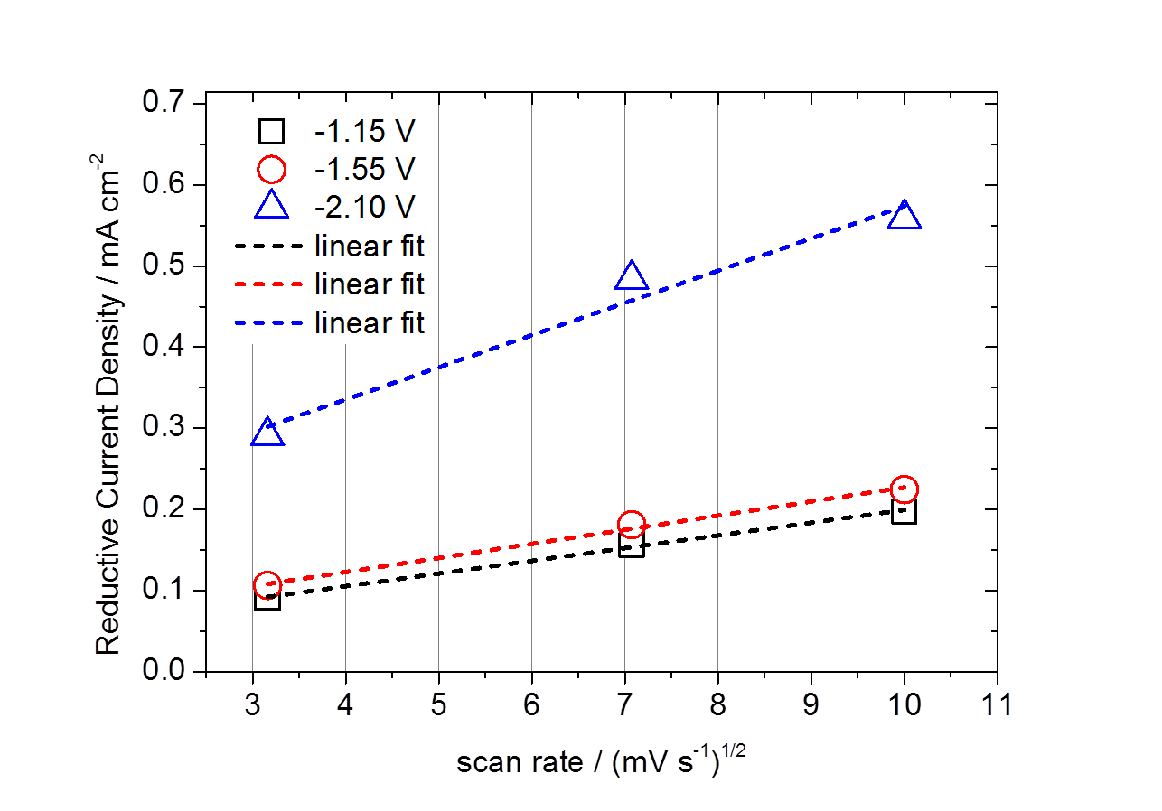
Figure S2. (a) Scan rate dependent cyclic voltammograms of a homogeneous solution of (4,4’-bisphenylethynyl-2,2’-bipyridyl)Re(CO)₃Cl (1) in CO₂ saturated electrolyte solution on glassy carbon working electrode at 10, 50 and 100 mV s⁻¹ in DMF with 0.1M TPABF₄ and (b) a plot of the linear dependence of the cathodic peak current density with the square root of the scan rate for -1.15,
-1.55 and -2.10 V (right), respectively.

(4,4’-bisphenylethynyl-2,2’-bipyridyl)Re(CO)₃Cl
time / h | peak area /  mV*min | conc. /  vol% | Coulomb passed /  As | Faradaic eff. /  % | Corresponding  TON
1h 04min | 11.91 | 0.051 | 1.687 | 9.5 | 0.04
1h 54min | 17.97 | 0.078 | 2.879 | 8.6 | 0.06
3h 35min | 43.36 | 0.187 | 5.325 | 11.1 | 0.15
5h 00min | 70.14 | 0.302 | 7.514 | 12.7 | 0.24

Table S1. Summary of controlled potential electrolysis experiments shown in Figure 11 in the main text and the corresponding calculated faradaic efficiencies and TONs. The TON is considered merely as the number of turnovers completed at the moment when the amount of CO was quantified.

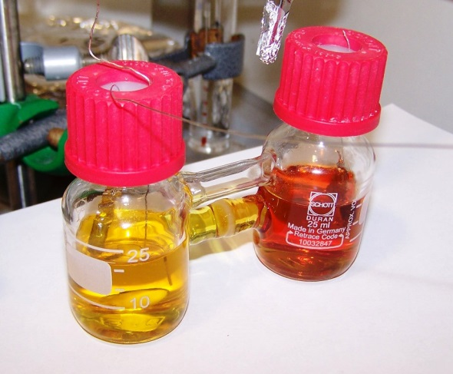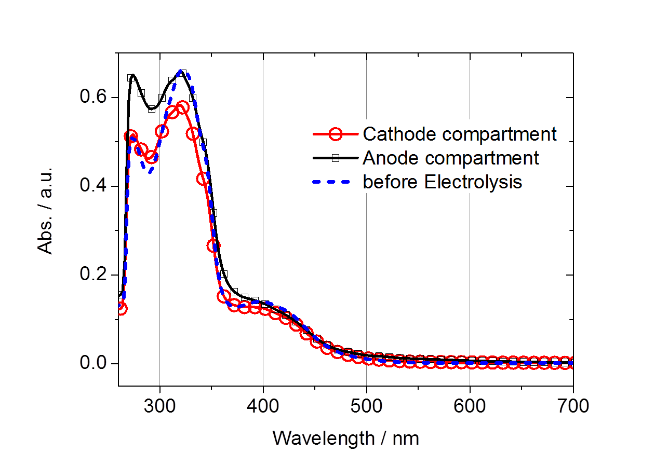
Figure S3. Photo of the H-cell containing 0.5 mM of (4,4’-bisphenylethynyl-2,2’-bipyridyl)Re(CO)₃Cl (1) in DMF (0.1 M TBAPF₆) after 5h of electrolysis time as shown in Figure 11 in the main text (a), and UV-Vis absorption spectroscopy of 100 ul of anode and cathode compartment respectively in 3 ml DMF, cathode compartment (red line with circles), anode compartment (black line with squares), and the UV-Vis absorption spectra of pristine (4,4’-bisphenylethynyl-2,2’-bipyridyl)Re(CO)₃Cl (1) in DMF (blue dashed line) in (b).

Figure S4. UV-Vis absorption spectra of (4,4’-bisphenylethynyl-2,2’-bipyridyl)Re(CO)₃Cl (1) in DMF
(45 µg ml⁻¹) normalized to 1 mol l⁻¹.
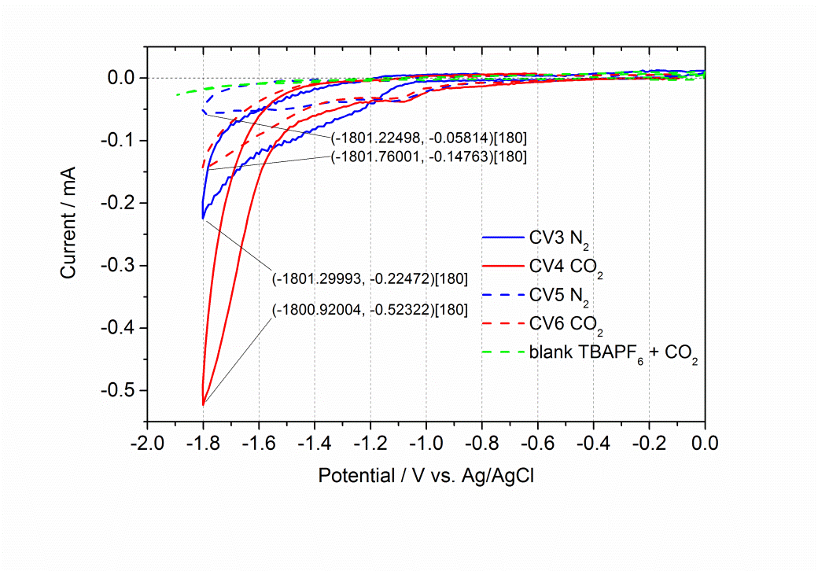
Figure S5. Cyclic Voltammograms of (4,4’-bisphenylethynyl-2,2’-bipyridyl)Re(CO)₃Cl (1) dropcast on a platinum plate electrode recorded in nitrogen (blue solid line) and CO₂ (red solid line) saturated electrolyte solution. The scan with CO₂ saturation shows a large current enhancement due to a catalytic reduction of CO₂ to CO. Measurements are taken at 50 mV s⁻¹ in ACN with 0.1M TBAPF₆, Pt working electrode, Pt counter electrode and Ag/AgCl reference electrode.

Figure S6. High resolution mass spectra of (4,4’-bisphenylethynyl-2,2’-bipyridyl)Re(CO)₃Cl (1).

