Supporting information

Estimation of nitrogen flows
Humans take up nitrogen with their food; only a very small fraction of the nitrogen intake accumulates in the human body; more than 99% of the uptake is excreted with urine (85%), faeces (11%) and transpiration (4%) (Baccini et al. 1991). To estimate the amount of nitrogen produced by humans, we assumed a per capita excretion rate (faeces and urine) of 10gN/cap/day (Barles 2007). The excrement either went into the cesspools, the sewage system or was discharged onto streets and other locations (see Fig. 8). Fig. 9 shows the share of houses connected to the combined sewage system. The houses not connected to the sewage system disposed of excrement into cesspools. The decline in the share of houses connected to the sewage system between 1890 and 1892 was due to the extension of the city boundaries. The sewage system in the incorporated municipalities was less developed than in the former area of the city. Until 1873, we assumed a yearly loss of nitrogen of 10% in the sewers due to leaching into the ground. Part of the nightsoil extracted from cesspools was discharged into the Danube or into one of the many streams (WSTP various years). We assume that this formed just a minor part of discharge before 1879. In 1879, a dumping site for nightsoil situated close to the Donaukanal was abandoned, because of the extension of the built-up area and concerns about sanitation. From then on, the nightsoil of community-cleared cesspools was loaded onto ships and discharged into the Danube downstream or discharged into sewers at the Baumgarten dumping station (see WSTP various years). For the purpose of modelling the nitrogen flows, an atmospheric loss of 30% was assumed during the storage of nightsoil in the cesspool (Hölzl et al. 2006). In the second half of the 19th century, excreta of draft animals was either collected on dung heaps and sold on markets or it was discharged directly onto the streets (WSTP various years, Kortz 1902). This was collected from the streets together with other refuse and brought to a dumping site, with a part being sold as fertiliser or being flushed into the gutters by road sprinklers. We assumed that only a small fraction (5%) of horse manure was disposed into urban waters. Based on the numbers of horses (Sandgruber 1983, MSW 1901, Sedlazek 1891) and an excretion rate of 113 gN per horse per day (Barles 2007), we estimated the amount of nitrogen disposed of by horses per year.

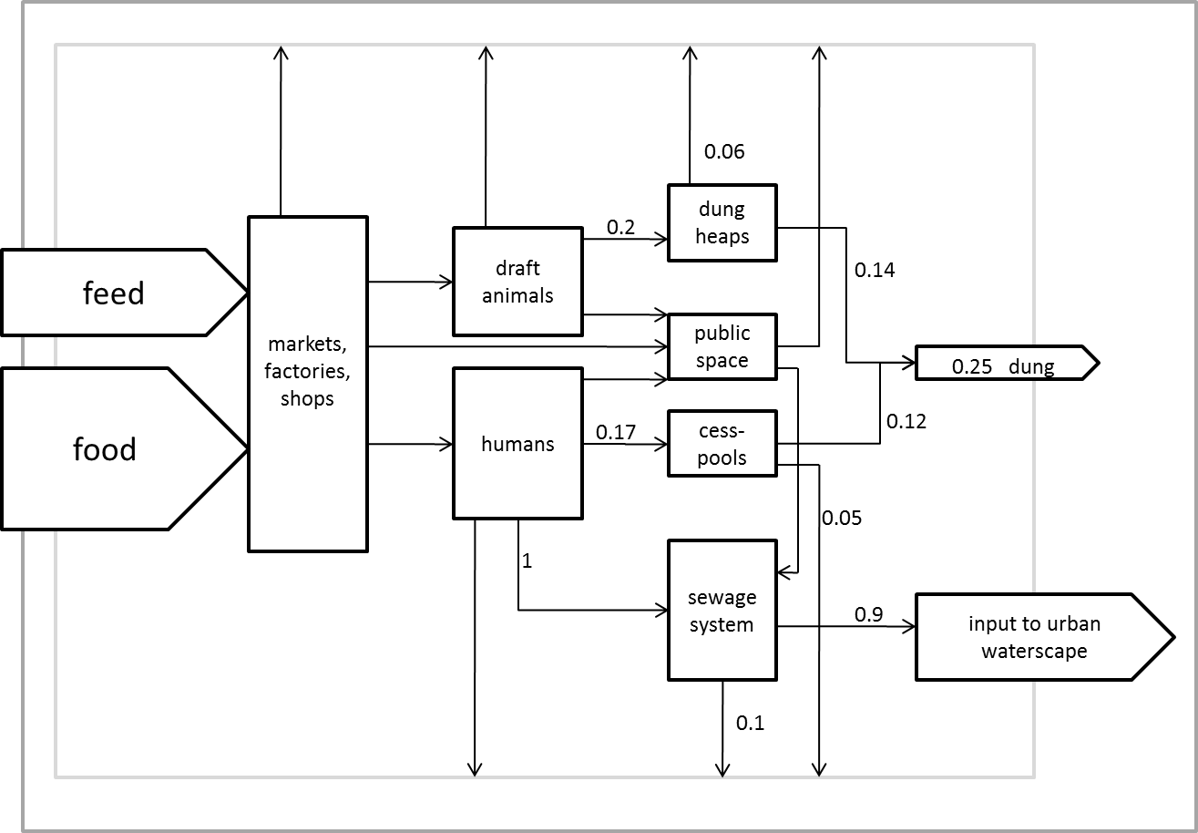

Fig. 8 Nitrogen flow diagram for Vienna in 1830 and 1910.

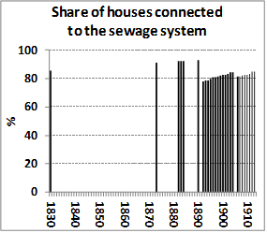
*for the year 1830, this includes streams and open channels

Fig. 9 Connection of houses to the sewage system. Share of houses connected to the sewage system. Sources: Kohl 1905, WSTP various years.

References
Baccini P, Brunner PH (1991) The metabolism of the anthroposphere. Springer, Berlin
Barles S (2007) Feeding the city: food consumption and flow of nitrogen, Paris, 1801 - 1914. Sci Total Environ 375: 48-58. doi: 10.1016/j.scitotenv.2006.12.003
Billen G, Barles S, Garnier J, Rouillard J, Benoit P (2009) The food-print of Paris: long-term reconstruction of the nitrogen flows imported into the city from its rural hinterland. Reg Environ Change 9: 13-24. doi: 10.1007/s10113-008-0051-y
Consolazio CF, Nelson RA, LeRoy OM, Harding RS, Canham JE (1963) Nitrogen excretion in wweat and its relation to nitrogen balance requirements. J Nutr 79: 399-406
Hauer F (2010) Die Verzehrungssteuer 1829 -1913 als Grundlage einer umwelthistorischen Untersuchung des Metabolismus der Stadt Wien. Social ecology working paper 129, IFF Social Ecology, Vienna
Hitschmann HH, Hitschmann R (1920) Vademekum für den Landwirt. Moritz Perles, Wien
Jönsson H, Richtert Stinzing A, Vinneras B, Salomon E (2004) Guidelines on the Use of Urine and Faeces in Crop Production. EcoSanRes Publication Series
Sandgruber R (1982) Die Anfänge der Konsumgesellschaft. Konsumgüterverbrauch, Lebensstandard und Alltagskultur in Österreich im 18. und 19. Jahrhundert. Verlag für Geschichte und Politik, Wien

Approximately 2% in the growing body (children between 2 and 17 with an average diet) and no more nutrients accumulate when the skeleton and muscles reach full size (Jönsson 2004).
The literature shows a range of human N excretion rates between 8.5g N/cap/day to 15g N/cap/day (Hitschmann 1920, Consolazio 1963, Jönsson 2004, Barles 2007, Billen et al. 2009). The excretion rate depends on the amount and composition of food intake. We do not know the actual food intake. A gross food input can be reconstructed based on data derived from city tax records (see Hauer 2010, Sandgruber 1982). A comparison with Paris for the year 1854 shows a very similar level of gross food intake (see Barles 2007, Table 4, page 53): 18.84 gN/cap/day in Vienna compared to 19.2 gN/cap/day in Paris. For that reason, we took the same rate Barles (2007) applied for 19th century Paris.
This is in line with Hitchmann (1920), who assumes the same excretion rate for horses with an average weight of 580 kg. We assume that the amount of nitrogen discharged into the waterscape from other livestock was rather small.

