A validated targeted assay for environmental DNA (eDNA) detection of the Atlantic wolffish (Anarhichas lupus)

Marion Chevrinais¹ and Geneviève J. Parent¹

¹Fisheries and Oceans Canada, Maurice Lamontagne Institute,
Mont-Joli, Quebec, Canada

Corresponding author: Marion Chevrinais marion.chevrinais@dfo-mpo.gc.ca, ORCID 0000-0002-7305-0485

Supplementary Information including 3 tables and 5 figures.

Table S1. In silico specificity assessment of the Anarhichas lupus qPCR assay using close relative and sympatric species. Nucleotide mismatches from the target species are underlined and in bold. M = total number of nucleotide mismatches with the targeted species.

Species | Genbank accession no. | Forward primer  5’-3’ | Reverse primer  5’-3’ | Probe  5’-3’ | M
Anarhichas lupus | KX117921-8005;  NC_009773 | CCCTACTGCTCAAAGAAAGGAGATTTTAACTC | TGAATACCATTGAAATGGTTAAAATAAATACATGGTGATA | TGCGCGTATGTAACTATATCATGTATGTA CTTAGTGCAT
Anarhichas minor | KX118006-22; NC_037609 | CCCTACTGCTCAAAGAAAGGAGATTTTAACTC | TGAATACCATTGAAATGGTTAAAATAAATTGTTGGTGATT | TGCGCGTATGTAACTATATCATGTATGTA CTTAGTGCAT | 4
Anarhichas denticulatus | KX118023-41; NC_037606 | CCCTACTGCTCAAAGAAAGGAGATTTTAACTC | TGAATACCATTGAAATGGTTAAAATAAATTGTTGGTGATT | TGCGCGTATGTAACTATATCATGTATGTA CTTAGTGCAT | 4

Table S2. Information of specimens used to test in vitro for specificity of qPCR assay. Cq = quantification cycle; DFO = Department of Fisheries and Oceans Canada.
Species | Source | n | Specimen ID | Year | Latitude | Longitude | Cq
Anarhichas lupus | DFO sampling program | 1 | S_18_00084 | 2018 | N48° 50.183’ | W61° 6.6166’ | 16
Anarhichas minor | DFO sampling program | 2 | S_18_00183, S_18_00184 | 2018 | N54° 27.2’ | W55° 46.2’ | No Cq
Anarhichas denticulatus | DFO sampling program | 2 | S_18_00180, S_18_00179 | 2018 | N55° 24.9’ | W56° 8.6’ | No Cq

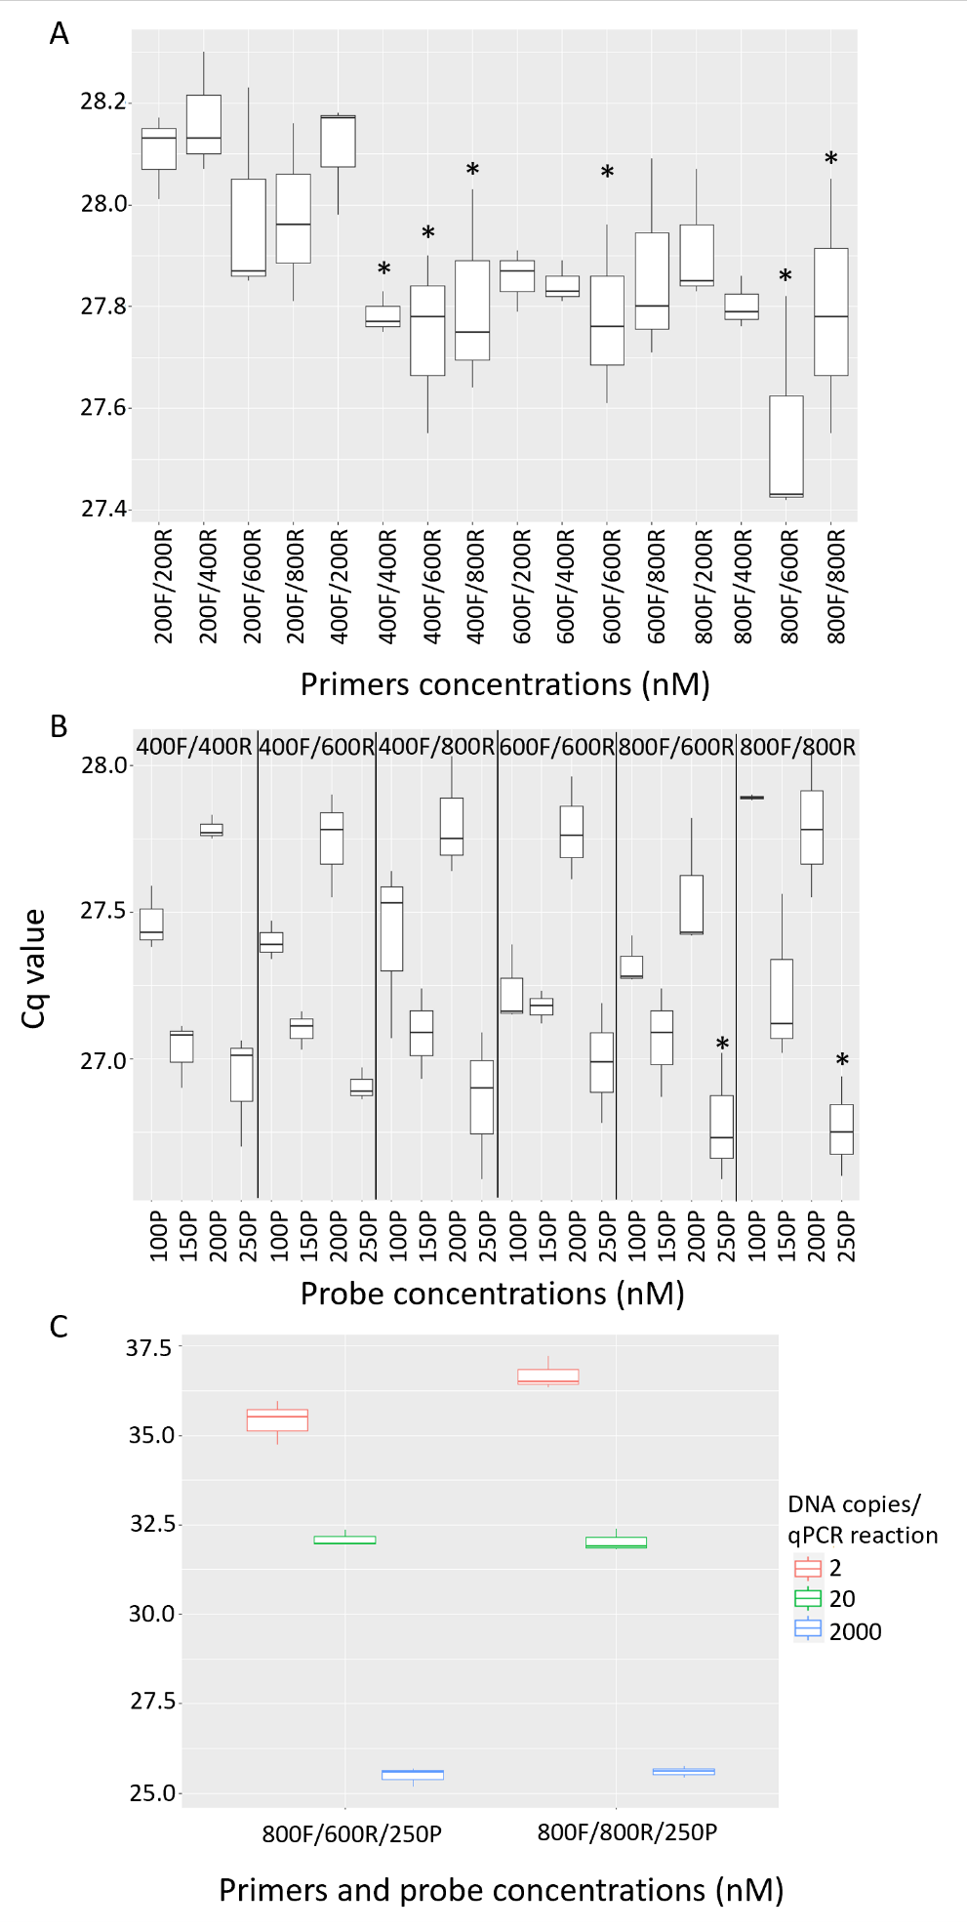

Fig. S1. Results of primers (A), probe (B), and eDNA concentration (C) optimizations. Asterisks show conditions used in subsequent analyses.

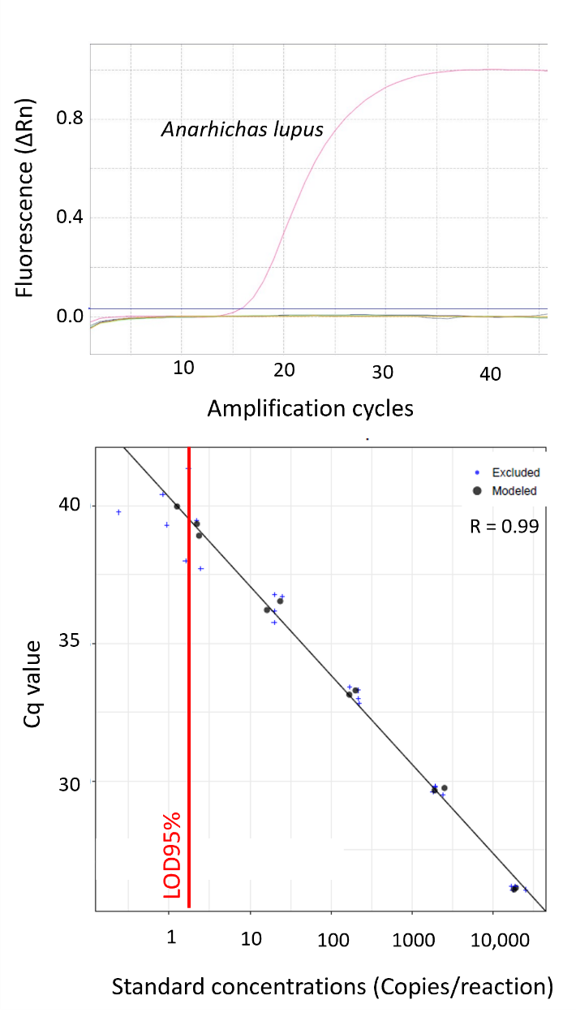

Fig. S2. qPCR assay performance including specificity (upper panel) and sensitivity (lower panel) for Anarhichas lupus. Specificity testing shows sigmoidal amplification curves with a strong exponential phase for the species of interest only (pink line), other species showing no amplification (0 in fluorescence axis, Table S2 for specimens tested). Sensitivity testing showed linear standard curves of plasmid dilution series. LOD95% line (red line) is generated with Klymus et al. (2019) script.

Table S3. Sampling stations, GPS coordinates (WGS 84).
Station | Longitude | Latitude
1 | W 57° 50.22’ | N 49° 58.91’
2 | W 58° 46.56’ | N 49° 58.52’
3 | W 58° 11.033’ | N 49° 32.133’
4 | W 58° 45.083’ | N 48° 59.066’
5 | W 64° 19.86’ | N 50° 13.2’
6 | W 64° 0.0833’ | N 49° 4.0333’

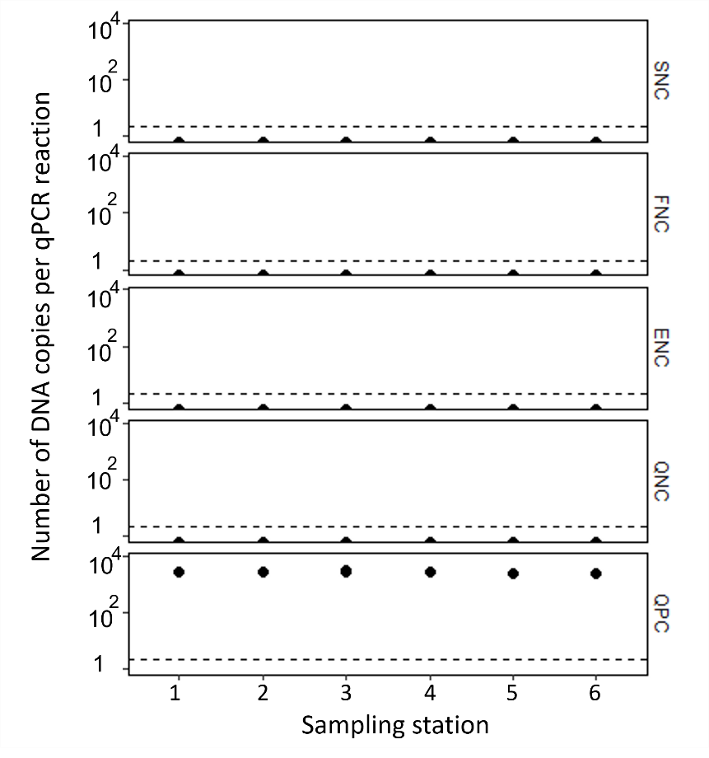
Fig. S3. Controls results for the Anarhichas lupus qPCR assay. Results for qPCR positive controls (QPC), and negative controls for sampling (SNC), filtration (FNC), extraction (ENC) and qPCR (QNC) are presented. Each dot represents a qPCR replicate result. The dashed lines represent LOD95%.

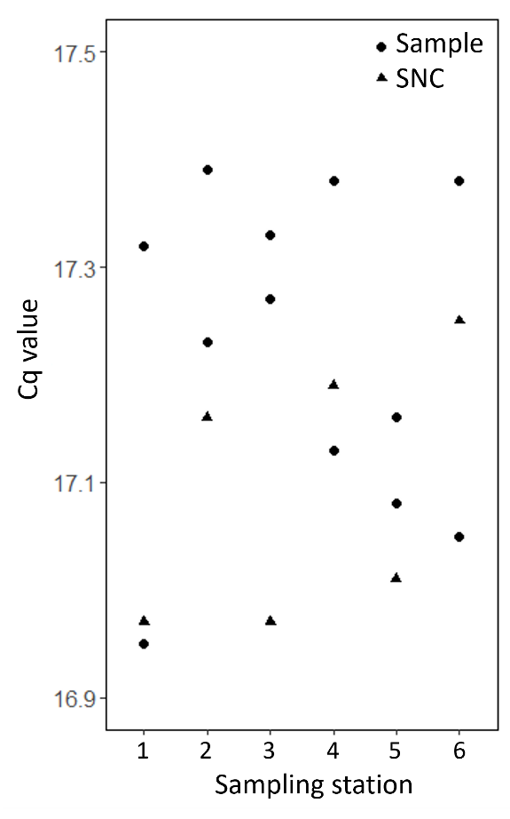
Fig. S4. Inhibition results for the Anarhichas lupus qPCR assay. Differences between quantification cycles (Cq) of samples and their respective sampling negative control were < 2 Cq.

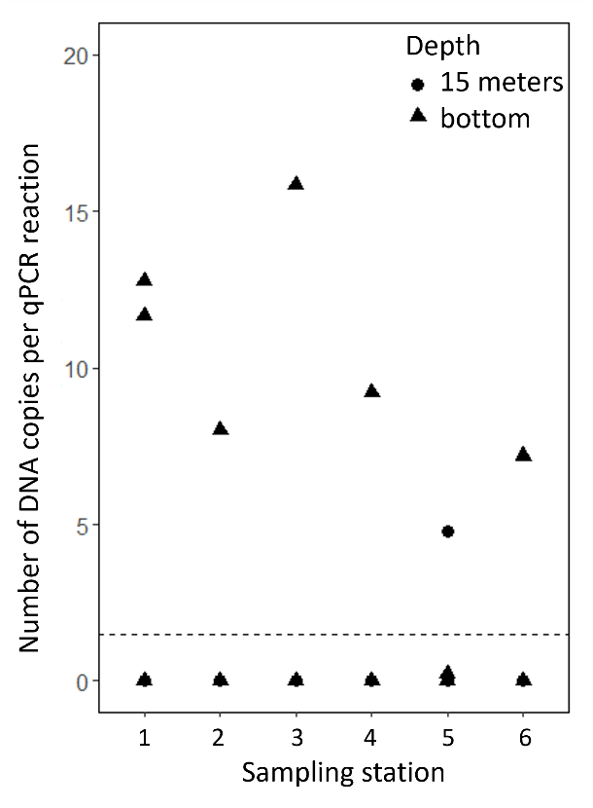
Fig. S5. eDNA detection results for the Anarhichas lupus qPCR assay. Each dot/triangle represents a qPCR replicate result. Superimposition only occurs for negative qPCR detection. The dashed line represents the LOD95%.

References
Klymus KE, Merkes CM, Allison MJ, et al (2019) Reporting the limits of detection and quantification for environmental DNA assays. Environ DNA 2:271–289

