Supplemental Information: Development of an 8K SNP chip to assess adaptive diversity and hybridization in polar bears

Joshua M Miller, René M Malenfant, L Ruth Rivkin†, Todd C Atwood, Steven Baryluk, Erik W Born, Rune Dietz, Kristin L Laidre, Jodie Pongracz, Evan S Richardson, Øystein Wiig, Corey S Davis

Author Affiliations
- JMM: San Diego Zoo Wildlife Alliance, 15600 San Pasqual Valley Road, Escondido, California, USA; Polar Bears International, Bozeman, MT, United States of America USA; MacEwan University, Edmonton, Alberta, Canada; ORCID 0000-0002-4019-7675
- RMM: Department of Biology, University of New Brunswick, Fredericton, New Brunswick, Canada; ORCID 0000-0003-1505-3669
- LRR: Department of Biological Sciences, University of Manitoba, Winnipeg, Manitoba, Canada; San Diego Zoo Wildlife Alliance, 15600 San Pasqual Valley Road, Escondido, California, USA; Polar Bears International, Bozeman, MT, USA; ORCID 0000-0003-2632-3388
- TCA: U.S. Geological Survey, Alaska Science Center, Anchorage, Alaska, USA; ORCID 0000-0002-1971-3110
- SB: Department of Environment and Climate Change, Government of the Northwest Territories, Inuvik, NT, Canada
- EWB: Greenland Institute of Natural Resources, Nuuk, Greenland; ORCID 0000-0002-8151-5481
- RDI: Institute for Ecoscience, Aarhus University, Roskilde, Denmark.
- KLL: Polar Science Center, Applied Physics Laboratory, University of Washington, Seattle WA USA; ORCID 0000-0002-2787-650X
- JP: Department of Environment and Climate Change, Government of the Northwest Territories, Inuvik, NT, Canada
- ESR: Wildlife Research Division, Science and Technology Branch, Environment and Climate Change Canada, Winnipeg, Manitoba, Canada; ORCID 0000-0003-3172-5592
- ØW: Natural History Museum, University of Oslo, Norway; ORCID 0000-0003-0395-5251
- CSD: Department of Biological Sciences, University of Alberta, Edmonton, Alberta, Canada; ORCID 0000-0003-4362-0659

†Corresponding author: L. Ruth Rivkin, ruthrivkin@gmail.com

Any use of trade, firm, or product names is for descriptive purposes only and does not imply endorsement by the U.S. Government.

Table S2. Mean ln(ProbK) and delta K values from STRUCTURE (Pritchard et al. 2000) analyses of 819 samples of polar bears (Ursus maritimus) and grizzly bears (Ursus arctos) genotyped at 1,452 species-discriminating loci (excluding mitochondrial SNPs and Y-linked chromosomes).
K | Mean (LnProbK) | SD (LnProbK) | Delta K
1 | -1574892.50 | 1.82
2 | -382462.73 | 2.04 | 579446.63
3 | -374730.19 | 3577.28 | 1.12
4 | -370986.34 | 2008.08

Table S3. Mean ln(ProbK) and delta K values from STRUCTURE (Pritchard et al. 2000) analyses of 819 samples of polar bears (Ursus maritimus) and grizzly bears (Ursus arctos) genotyped at 1,470 species-discriminating loci (excluding Y-linked chromosomes).

K | Mean (LnProbK) | SD (LnProbK) | Delta K
1 | -1589179.90 | 1.30
2 | -383685.00 | 2.58 | 464621.75
3 | -377638.33 | 4485.02 | 0.37
4 | -373102.26 | 1209.85

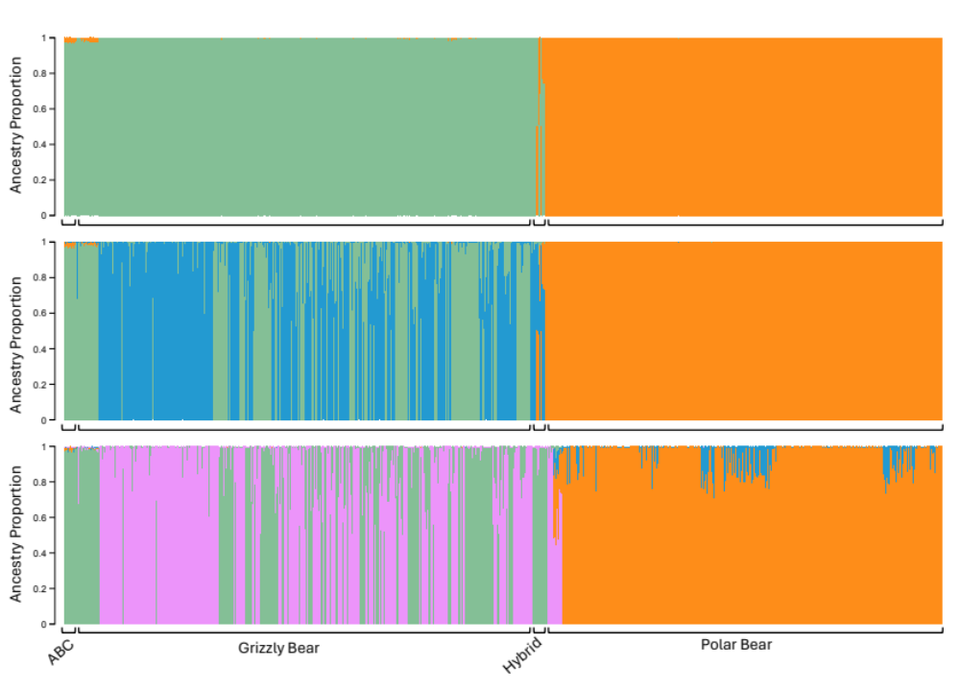
Figure S1: Ancestry bar plot from STRUCTURE (Pritchard et al. 2000) for K=2-4 for 371 polar bears (Ursus maritimus; PB), 440 grizzly bears (Ursus arctos; GB), including those from the Admiralty, Baranof, and Chichagof (ABC) Islands of Alaska, and 8 known hybrids that were genotyped at 1,470 species-discriminating loci (including mitochondrial SNPs). Each individual is represented as a vertical bar, with the proportion of colors representing their genetic assignment to the clusters.

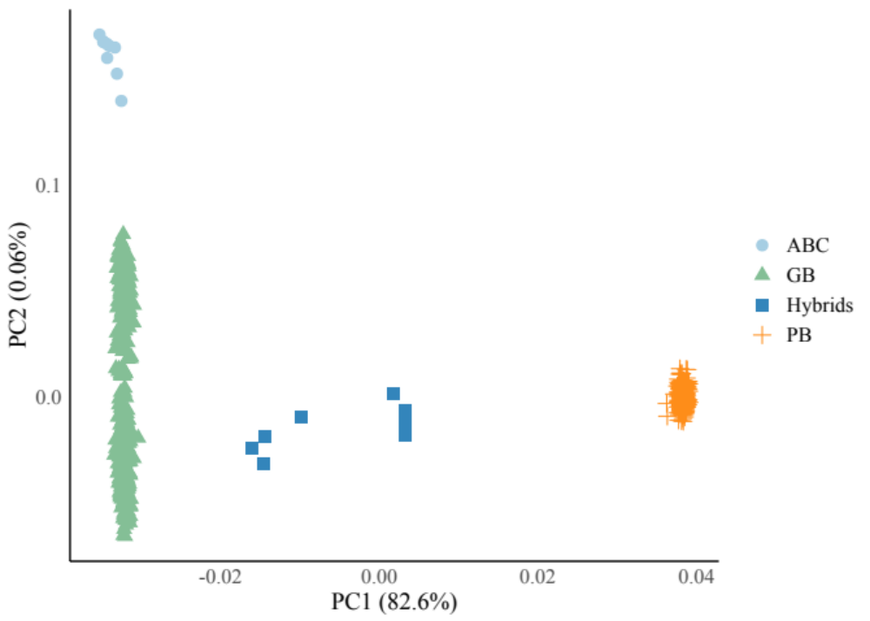Figure S2. PCA plot for the 371 samples of polar bears (Ursus maritimus; PB), 440 grizzly bears (Ursus arctos; GB), including those from the Admiralty, Baranof, and Chichagof (ABC) Islands of Alaska, and 8 hybrids that were genotyped at 1,470 species-discriminating loci (including mitochondrial SNPs). Shown are PC1 vs PC2 with each sample represented as a point.

Literature Cited

Pritchard JK, Stephens M, Donnelly P (2000) Inference of population structure using multilocus genotype data. Genetics 155:945–959

