1 SUPPLEMENTAL MATERIALS AND METHODS

2 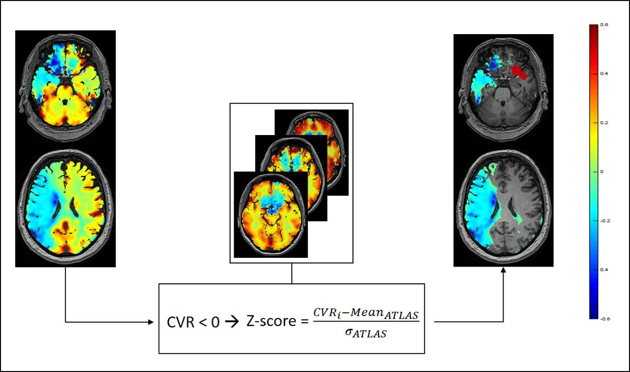

Supplementary Figure 1. BOLD-CVR associated steal phenomenon mask generation.

For each patient the relevant voxels showing negative response in the blood oxygen level
- dependent cerebrovascular reactivity (BOLD-CVR) map were selected. First, we considered
- all voxels with < 0% BOLD signal change/mmHg CO2. Then, using our healthy atlas as
- reference, a Z-score map of the CVR map was generated and the voxels with Z-score < 2
- were excluded. In this way, only those negative voxels that differed significantly from the
- healthy cohort (e.g., voxels with artefact-related negative BOLD signal in the frontobasal
- brain region, red arrow) were considered.
11

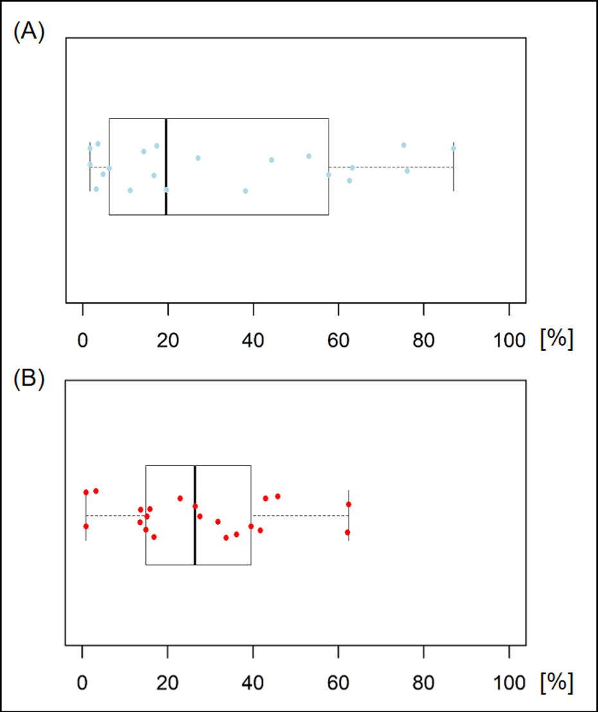
12

Supplementary Figure 2. Spatial correlation between BOLD-CVR associated steal
- phenomenon and DWI infarct lesion.

BOLD-CVR indicates blood oxygen level dependent cerebrovascular reactivity. A, a boxplot
- of the percentage of DWI infarct lesion included in the BOLD-CVR associated steal
- phenomenon; B, a boxplot of the percentage of BOLD-CVR associated steal phenomenon
- included in the DWI infarct lesion.
19

TA: 49 sec Coil Selection: Manual Voxel Size: 1.5×1.5×4.5 mm³ Acc:: 4 Rel. SNR: 1.00
\\USER\test\test\CRPPstroke20191228_32ch_New_Patients6-dwicvrt1\ep2d_diff_mddw_12_p2s2 *

Properties

Start measurement without further Off preparation
Wait for User to Start Off
Start measurements Single Measurement
Prio Recon Off
Auto Open Inline Display Off
Auto Close Inline Display Off
Load Images to MR View&GO On
Auto Store Images On Load Images to Stamp Segments Off Load Images to Graphic Segments Off Graphic segment Default
Inline Movie Off
Routine

Slice Group | 1
Slices | 32
Distance Factor | 12 %
Position | R1.0 P15.5 H21.2 mm
Orientation | T > C-12.5 > S4.7
Phase Encoding Dir. | A >> P
Phase Oversampling | 0 %
FoV Read | 240 mm
FoV Phase | 100.0 %
Slice Thickness | 4.5 mm
TR | 2500.0 ms
TE | 75.00 ms
Concatenations | 1
AutoAlign | Head > Brain
Coil Elements | HEA;HEP
Contrast - Common

TR 2500.0 ms
TE 75.00 ms
MTC Off
Magn. Preparation None
Fat-Water Contrast Fat Saturation
Fat Saturation Strong
Reconstruction Magnitude
Contrast - Dynamic

Dynamic Mode Standard
Multiple Series Off
Delay in TR 0.00 ms
Resolution - Common

FoV Read 240 mm
FoV Phase 100.0 %
Slice Thickness 4.5 mm
Base Resolution 160
Phase Resolution 100 %
Interpolation Off
Resolution - Acceleration
Acceleration mode SMS
Reference Scans EPI/Separate
Acceleration Factor PE 2
Reference Lines PE 38
SMS Factor 2
Phase Partial Fourier 6/8

Resolution - Filter

Raw Filter Off
Elliptical Filter Off
Distortion Correction Off
Normalize Prescan
Geometry - Common

Slice Group | 1
Slices | 32
Distance Factor | 12 %
Position | R1.0 P15.5 H21.2 mm
Orientation | T > C-12.5 > S4.7
Phase Encoding Dir. | A >> P
Phase Oversampling | 0 %
FoV Read | 240 mm
FoV Phase | 100.0 %
Slice Thickness | 4.5 mm
TR | 2500.0 ms
Multi-Slice Mode | Interleaved
Series | Interleaved
Concatenations | 1
Geometry - AutoAlign

Slice Group | 1
Position Orientation  Phase Encoding Dir. | R1.0 P15.5 H21.2 mm T > C-12.5 > S4.7  A >> P
AutoAlign | Head > Brain
Initial Position | L0.4 A3.2 F0.3
L | 0.4 mm
A | 3.2 mm
F | 0.3 mm
Initial Orientation | T > C
T > C | -4.40
> S | 0.10
Initial Rotation | 1.70 deg
Geometry - Navigator Geometry - Saturation
Special Saturation None

Geometry - Tim Planning Suite

Set-n-Go Protocol Off
Table Position 0 mm
Table Position H
Inline Composing Off
System - Miscellaneous

Coil Selection Manual
MSMA S - C - T
Sagittal R >> L
Coronal A >> P
Transversal F >> H
Coil Combination Adaptive Combine
Matrix Optimization Off
System - Adjustments

Adjustment Strategy Standard
B0 Shim Advanced
B1 Shim TrueForm

System - Adjustments

Adjustment Tolerance Auto
Adjust with Body Coil Off
Confirm Frequency Never
Assume Silicone Off
System - Adjust Volume

Position R1.0 P15.5 H21.2 mm
Orientation T > C-12.5 > S4.7
Rotation 3.40 deg
A >> P 240 mm
R >> L 240 mm
F >> H 161 mm
Reset Off
System - Tx/Rx

Frequency 1H 123.256368 MHz
? Ref. Amplitude 1H 0.000 V
Reset Off
Correction Factor 1.00
Image Scaling 1.000
Physio - Signal

1st Signal/Mode None
TR 2500.0 ms
Concatenations 1
Physio - PACE

Resp. Control Off
Concatenations 1
Diff

Diffusion Mode MDDW
Diff. Directions 12
Diffusion Scheme Monopolar
Diff. Weightings 2
b-value 1 0 s/mm²
b-value 2 1000 s/mm²
Averages 1 1
Averages 2 1
Dynamic Field Correction On
Invert Gray Scale Off
Diff. Weighted Images On
Trace Weighted Images On
Tensor Off
FA Maps Off
ADC Maps On
Exponential ADC Maps Off
ADC Noise Threshold 40
Noise Masking Off
Calculated Image Off
Sequence - Part 1
Sequence - Part 2

Introduction Off
Phase Correction Internal

Sequence Name epse
Excitation Standard
RF Pulse Type Normal
Gradient Mode Fast
Bandwidth 1202 Hz/Px
Echo Spacing 0.94 ms
Free Echo Spacing Off
Optimization None
EPI Factor 160

TA: 6:46 min Coil Selection: Auto Voxel Size: 3.0×3.0×3.0 mm³ Acc:: 2 Rel. SNR: 1.00
\\USER\test\test\CRPPstroke20191228_32ch_New_Patients6-dwicvrt1\CO2_bold *

Properties

Start measurement without further On preparation
Wait for User to Start Off
Start measurements Single Measurement
Prio Recon Off
Auto Open Inline Display Off
Auto Close Inline Display Off
Load Images to MR View&GO On
Auto Store Images On Load Images to Stamp Segments Off Load Images to Graphic Segments Off Graphic segment Default
Inline Movie Off
Routine

Slice Group | 1
Slices | 35
Distance Factor | 10 %
Position | R0.8 P5.9 H10.6 mm
Orientation | T > C-16.5 > S0.6
Phase Encoding Dir. | A >> P
Phase Oversampling | 0 %
FoV Read | 192 mm
FoV Phase | 100.0 %
Slice Thickness | 3.0 mm
TR | 2000.0 ms
TE | 30.00 ms
Averages | 1
Concatenations | 1
AutoAlign | Head > Brain
Coil Elements | HEA;HEP
Contrast - Common

TR 2000.0 ms
TE 30.00 ms
MTC Off
Flip Angle 85 deg
Fat-Water Contrast Fat Saturation
Reconstruction Magnitude
Contrast - Dynamic

Dynamic Mode Standard
Measurements 200
Delay in TR 0.00 ms
Resolution - Common

FoV Read 192 mm
FoV Phase 100.0 %
Slice Thickness 3.0 mm
Base Resolution 64
Phase Resolution 100 %
Interpolation Off
Resolution - Acceleration
Acceleration mode GRAPPA
Reference Scans EPI/Separate
Acceleration Factor PE 2
Reference Lines PE 32
Phase Partial Fourier Off

Resolution - Filter

Raw Filter Off
Elliptical Filter On
Hamming Off
Distortion Correction Off
Normalize Prescan
Geometry - Common

Slice Group | 1
Slices | 35
Distance Factor | 10 %
Position | R0.8 P5.9 H10.6 mm
Orientation | T > C-16.5 > S0.6
Phase Encoding Dir. | A >> P
Phase Oversampling | 0 %
FoV Read | 192 mm
FoV Phase | 100.0 %
Slice Thickness | 3.0 mm
TR | 2000.0 ms
Multi-Slice Mode | Interleaved
Series | Interleaved
Concatenations | 1
Geometry - AutoAlign

Slice Group | 1
Position Orientation  Phase Encoding Dir. | R0.8 P5.9 H10.6 mm T > C-16.5 > S0.6  A >> P
AutoAlign | Head > Brain
Initial Position | R0.8 P5.9 H10.6
R | 0.8 mm
P | 5.9 mm
H | 10.6 mm
Initial Orientation | T > C
T > C | -16.50
> S | 0.60
Initial Rotation | -1.12 deg
Geometry - Saturation

Special Saturation None
Geometry - Tim Planning Suite

Set-n-Go Protocol Off
Table Position 0 mm
Table Position H
Inline Composing Off
System - Miscellaneous

Coil Selection Auto Coil Select
MSMA S - C - T
Sagittal R >> L
Coronal A >> P
Transversal F >> H
Coil Combination Adaptive Combine
Matrix Optimization Off
System - Adjustments

Adjustment Strategy Standard
B0 Shim Standard
B1 Shim TrueForm
Adjustment Tolerance Auto

System - Adjustments

Adjust with Body Coil Off
Confirm Frequency Never
Assume Silicone Off
System - Adjust Volume

Position R0.8 P5.9 H10.6 mm
Orientation T > C-16.5 > S0.6
Rotation -1.12 deg
A >> P 192 mm
R >> L 192 mm
F >> H 116 mm
Reset Off
System - Tx/Rx

Frequency 1H 123.256368 MHz
? Ref. Amplitude 1H 0.000 V
Reset Off
Correction Factor 1.00
Image Scaling 1.000
Physio - Signal

1st Signal/Mode None
TR 2000.0 ms
Concatenations 1
BOLD
GLM Statistics Off
Ignore Meas. at Start 0
Ignore After Transition 0
Model Transition States On
Temp. Highpass Filter On
Threshold 2.50
Paradigm Size 66
Meas[1] Active
Meas[2] Active
Meas[3] Active
Meas[4] Active
Meas[5] Active
Meas[6] Active
Meas[7] Active
Meas[8] Active
Meas[9] Active
Meas[10] Active
Meas[11] Active
Meas[12] Active
Meas[13] Active
Meas[14] Active
Meas[15] Active
Meas[16] Active
Meas[17] Active
Meas[18] Active
Meas[19] Active
Meas[20] Active
Meas[21] Active
Meas[22] Active
Meas[23] Ignore
Meas[24] Ignore
Meas[25] Ignore
Meas[26] Ignore
Meas[27] Ignore
Meas[28] Ignore
Meas[29] Ignore
Meas[30] Ignore
Meas[31] Ignore

BOLD

Meas[32] Ignore
Meas[33] Ignore
Meas[34] Ignore
Meas[35] Ignore
Meas[36] Ignore
Meas[37] Ignore
Meas[38] Ignore
Meas[39] Ignore
Meas[40] Ignore
Meas[41] Ignore
Meas[42] Ignore
Meas[43] Ignore
Meas[44] Ignore
Meas[45] Active
Meas[46] Active
Meas[47] Active
Meas[48] Active
Meas[49] Active
Meas[50] Active
Meas[51] Active
Meas[52] Active
Meas[53] Active
Meas[54] Active
Meas[55] Active
Meas[56] Active
Meas[57] Active
Meas[58] Active
Meas[59] Active
Meas[60] Active
Meas[61] Active
Meas[62] Active
Meas[63] Active
Meas[64] Active
Meas[65] Active
Meas[66] Active
Motion Correction On
Spatial Filter On
Filter Width 4.0 mm
Measurements 200
Delay in TR 0.00 ms
Sequence - Part 1

Sequence Name epfid
Excitation Standard
RF Pulse Type Normal
Gradient Mode Fast*
Bandwidth 2368 Hz/Px
Echo Spacing 0.53 ms
Free Echo Spacing Off
EPI Factor 64
Sequence - Part 2

Introduction Off

TA: 8:14 min Coil Selection: Auto Voxel Size: 0.8×0.8×1.0 mm³ Acc:: 2 Rel. SNR: 1.00
\\USER\test\test\CRPPstroke20191228_32ch_New_Patients6-dwicvrt1\t1mprage_tra_HighRes_Nch_ 32ch *

Properties

Start measurement without further On preparation
Wait for User to Start Off
Start measurements Single Measurement
Prio Recon Off
Auto Open Inline Display Off
Auto Close Inline Display Off
Load Images to MR View&GO On
Auto Store Images On Load Images to Stamp Segments Off Load Images to Graphic Segments Off Graphic segment Default
Inline Movie Off
Routine

Slab Group | 1
Slabs | 1
Distance Factor | 50 %
Position | L0.0 P1.6 H13.6 | mm
Orientation | Transversal
Phase Encoding Dir. | R >> L
Slices per Slab | 176
Phase Oversampling | 10 %
Slice Oversampling | 27.3 %
FoV Read | 230 mm
FoV Phase | 100.0 %
Slice Thickness | 1.0 mm
TR | 2200.0 ms
TE | 5.17 ms
Averages | 1
Concatenations | 1
AutoAlign | Head > Brain
Coil Elements | HEA;HEP
Contrast - Common

TR 2200.0 ms
TE 5.17 ms
Magn. Preparation Non-sel. IR
TI 900 ms
Flip Angle 8 deg
Fat-Water Contrast Standard
Dark Blood Off
Reconstruction Magnitude
Contrast - Dynamic

Dynamic Mode Standard
Measurements 1
Multiple Series Each Measurement
Reordering Linear Rot.
Resolution - Common
FoV Read 230 mm
FoV Phase 100.0 %
Slice Thickness 1.0 mm
Base Resolution 288
Phase Resolution 100 %
Slice Resolution 100 %
Interpolation Off

Resolution - Acceleration

Acceleration mode GRAPPA
Reference Scans Integrated
Acceleration Factor PE 2
Reference Lines PE 24
Acceleration Factor 3D 1
Phase Partial Fourier Off
Slice Partial Fourier Off
Asymmetric Echo Allowed
Elliptical Scanning Off
Resolution - Filter

Raw Filter Off
Elliptical Filter Off
Distortion Correction 3D
Normalize Prescan
Image Filter On
Geometry - Common

Slab Group | 1
Slabs | 1
Distance Factor | 50 %
Position | L0.0 P1.6 H13.6 mm
Orientation | Transversal
Phase Encoding Dir. | R >> L
Slices per Slab | 176
Phase Oversampling | 10 %
Slice Oversampling | 27.3 %
FoV Read | 230 mm
FoV Phase | 100.0 %
Slice Thickness | 1.0 mm
TR | 2200.0 ms
Multi-Slice Mode | Single Shot
Series | Ascending
Concatenations | 1
Geometry - AutoAlign

Slab Group | 1
Position Orientation  Phase Encoding Dir. | L0.0 P1.6 H13.6 mm  Transversal R >> L
AutoAlign | Head > Brain
Initial Position | L0.0 P1.6 H13.6
R | 0.0 mm
P | 1.6 mm
H | 13.6 mm
Initial Orientation | Transversal
Initial Rotation | 91.66 deg
Geometry - Navigator Geometry - Tim Planning Suite
Set-n-Go Protocol Off
Table Position 0 mm
Table Position H
Inline Composing Off

System - Miscellaneous

Coil Selection Auto Coil Select
MSMA S - C - T

System - Miscellaneous

Sagittal R >> L
Coronal A >> P
Transversal F >> H
Coil Combination Adaptive Combine
Matrix Optimization Off
System - Adjustments

Adjustment Strategy Standard
B0 Shim Tune up
B1 Shim TrueForm
Adjustment Tolerance Auto
Adjust with Body Coil Off
Confirm Frequency Never
Assume Silicone Off
System - Adjust Volume

Position Isocenter
Orientation Transversal
Rotation 0.00 deg
A >> P 263 mm
R >> L 350 mm
F >> H 350 mm
Reset Off
System - Tx/Rx

Frequency 1H 123.256368 MHz
? Ref. Amplitude 1H 0.000 V
Reset Off
Correction Factor 1.00
Image Scaling 1.000
Physio - Signal

1st Signal/Mode None
TR 2200.0 ms
Concatenations 1
Physio - Cardiac

Fat-Water Contrast Standard
Magn. Preparation Non-sel. IR
TI 900 ms
Dark Blood Off
FoV Read 230 mm
FoV Phase 100.0 %
Phase Resolution 100 %
Dynamic Mode Standard
Physio - PACE

Resp. Control Off
Concatenations 1
Inline - Subtraction

Subtract Off
Measurements 1
StdDev Off
Save Original Images On
Inline - Cardiac
Inline - MIP

MIP Sag Off
MIP Cor Off
MIP Tra Off
MIP Time Off
Radial MIP Off
Save Original Images On
MPR Sag Off
MPR Cor Off
MPR Tra Off
Inline - Composing

Inline Composing Off
Sequence - Part 1

Sequence Name tfl_r
Dimension 3D
Excitation Slab-sel.
RF Pulse Type Fast
Gradient Mode Normal
Flow Compensation On
Reordering Linear Rot.
Bandwidth 250 Hz/Px
Echo Spacing 10.18 ms
Asymmetric Echo Allowed
Turbo Factor 317
Sequence - Part 2

Introduction On
RF Spoiling On
Incr. Gradient Spoiling On
Sequence - Assistant

SAR Assistant Off

Magn. Preparation Non-sel. IR
Save Original Images On
TE 5.17 ms
TR 2200.0 ms

