Additional file 1

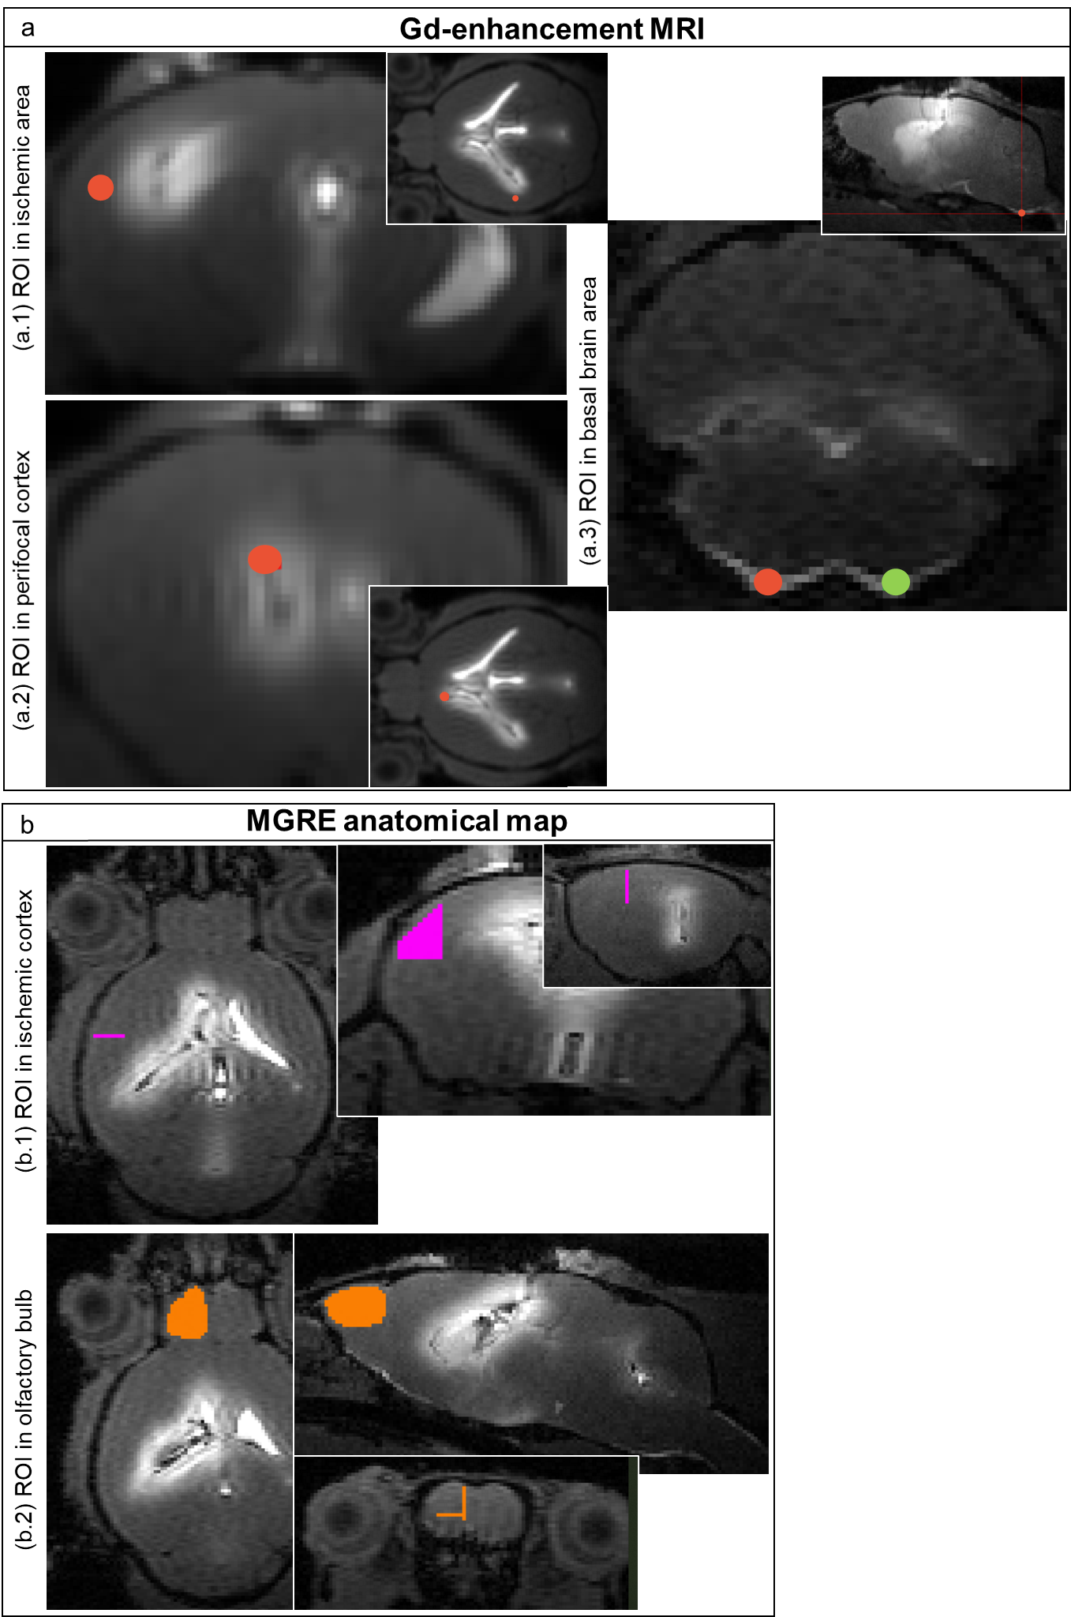
Fig: S1

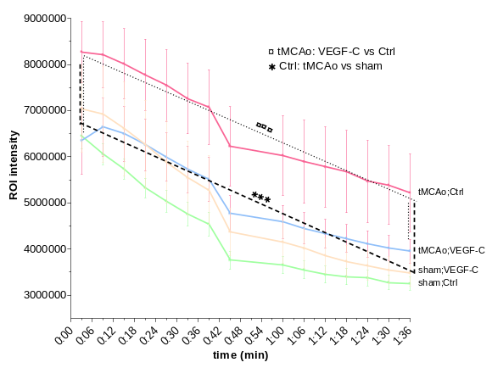
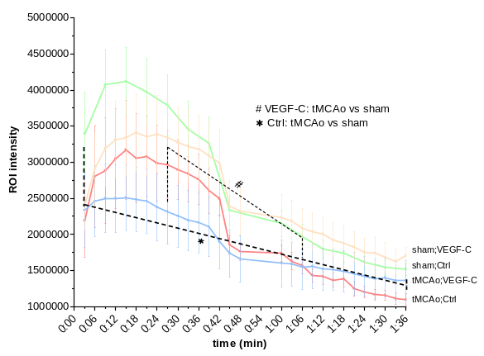
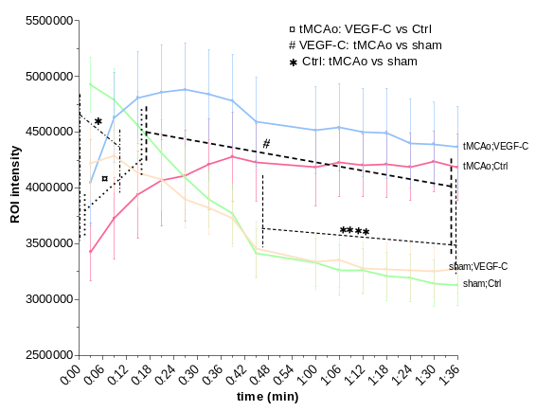
Gd-signal decay over time
Basal brain area
Infarcted cortex
Perifocal cortex
a
b
c
Fig. S2

