Online Resource S1
Title: Polarized or threshold training: is there a superior training intensity distribution to improve VO₂max, endurance capacity and mitochondrial function? A study in Wistar Rat models
Journal: Journal of Physiology and Biochemistry
Authors: Oliveira, Pedro^{1,,2,3}; Anjos, Miguel^{1, 2}; Flores, Ariane^{1,2}; Peixoto, Francisco⁴; Padrão, Ana Isabel^{1,2}; Fonseca, Hélder^{1,2}
¹Research Centre in Physical Activity, Health and Leisure (CIAFEL); Faculty of Sport of University of Porto (FADE-UP), Porto, Portugal
²Laboratory for Integrative and Translational Research in Population Health (ITR), Porto, Portugal
³Nucleus of Research in Human Motricity Sciences, Universidad Adventista de Chile, Chillán 3780000, Chile
⁴Vila Real Chemistry Center (CQVR), Biology and Environment Department, University of Trás-os-Montes and Alto Douro, 5000-801 Vila Real, Portugal
Corresponding author: Pedro Oliveira (up201807240@fade.up.pt)

Electronic Supplementary Material Appendix S1

Table S1 - O2k manual titrations of SUIT-001 O2 mt D001 protocol for skeletal and cardiac muscle tissues in O2k-sVModule - Mitochondrial Physiology Network 09.12(20):1-4 (2020).

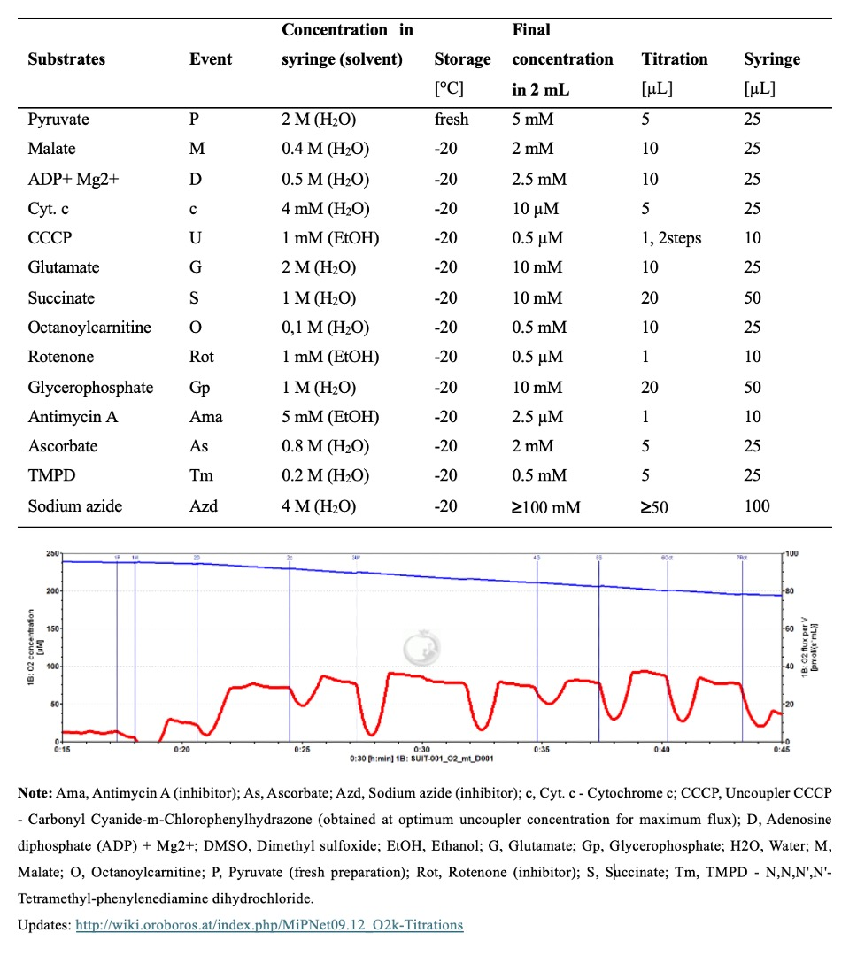
Note: Ama, Antimycin A (inhibitor); As, Ascorbate; Azd, Sodium azide (inhibitor); c, Cyt. c - Cytochrome c; CCCP, Uncoupler CCCP - Carbonyl Cyanide-m-Chlorophenylhydrazone (obtained at optimum uncoupler concentration for maximum flux); D, Adenosine diphosphate (ADP) + Mg2+; DMSO, Dimethyl sulfoxide; EtOH, Ethanol; G, Glutamate; Gp, Glycerophosphate; H2O, Water; M, Malate; O, Octanoylcarnitine; P, Pyruvate (fresh preparation); Rot, Rotenone (inhibitor); S, Succinate; Tm, TMPD - N,N,N',N'-Tetramethyl-phenylenediamine dihydrochloride.
Updates: http://wiki.oroboros.at/index.php/MiPNet09.12_O2k-Titrations

