Online Resource S3
Title: Polarized or threshold training: is there a superior training intensity distribution to improve VO₂max, endurance capacity and mitochondrial function? A study in Wistar Rat models
Journal: Journal of Physiology and Biochemistry
Authors: Oliveira, Pedro^{1,2,3}; Anjos, Miguel^{1, 2}; Flores, Ariane^{1,2}; Peixoto, Francisco⁴; Padrão, Ana Isabel^{1,2}; Fonseca, Hélder^{1,2}
¹Research Centre in Physical Activity, Health and Leisure (CIAFEL); Faculty of Sport of University of Porto (FADE-UP), Porto, Portugal
²Laboratory for Integrative and Translational Research in Population Health (ITR), Porto, Portugal
³Nucleus of Research in Human Motricity Sciences, Universidad Adventista de Chile, Chillán 3780000, Chile
⁴Vila Real Chemistry Center (CQVR), Biology and Environment Department, University of Trás-os-Montes and Alto Douro, 5000-801 Vila Real, Portugal
Corresponding author: Pedro Oliveira (up201807240@fade.up.pt)

Electronic Supplementary Material Appendix S3. Loading control of Ponceau S staining of Mfn1, Mfn2, PGC-1𝛼, TFAM, DRP1, OPA1 and TOM20 for left myocardium ventricle, diaphragm, soleus and, tibialis anterior.

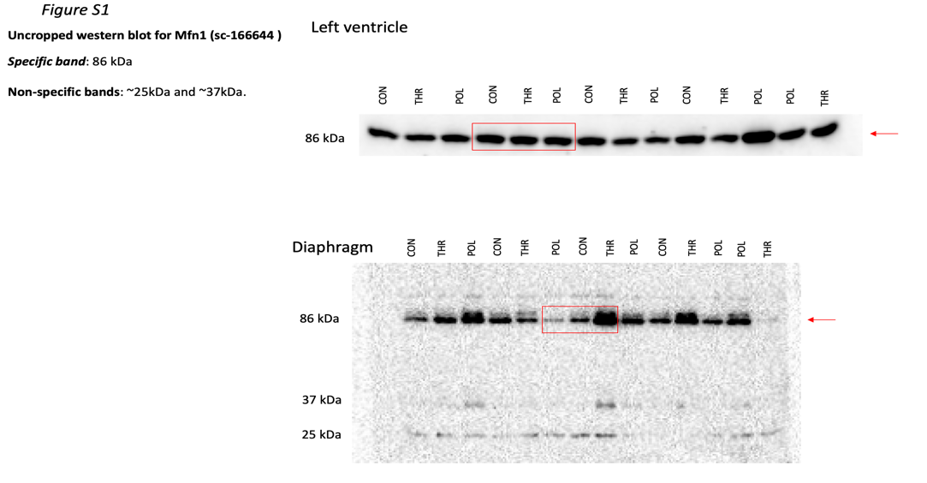
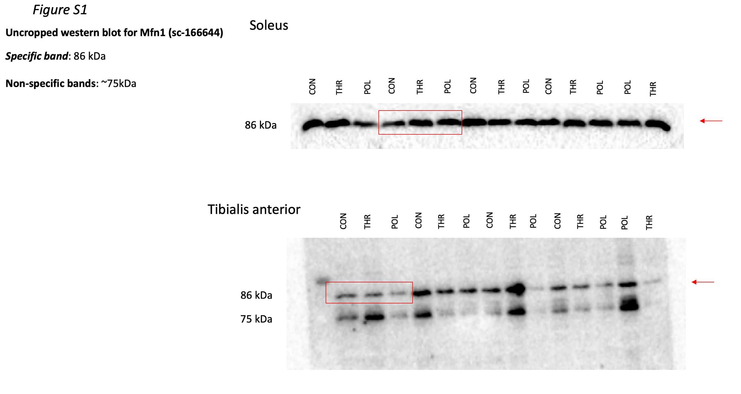

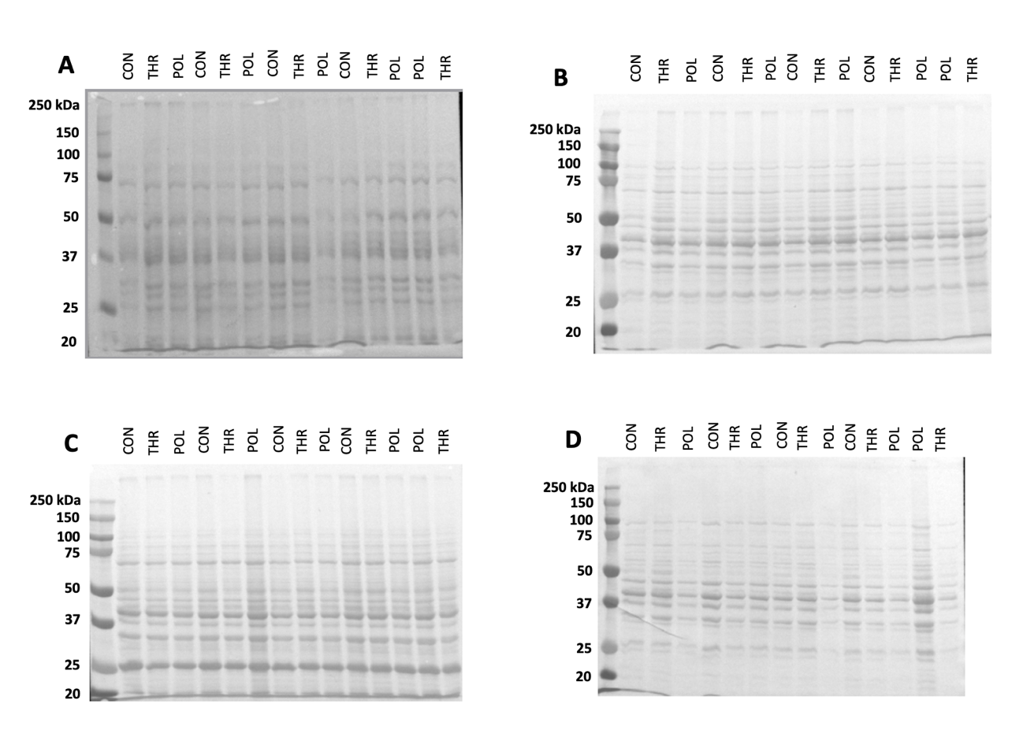
Figure S1 – Loading control of Ponceau S staining of (A: Left myocardium ventricle; B: Diaphragm; C: Soleus; D: Tibialis anterior) Mfn1 (86 kDa).

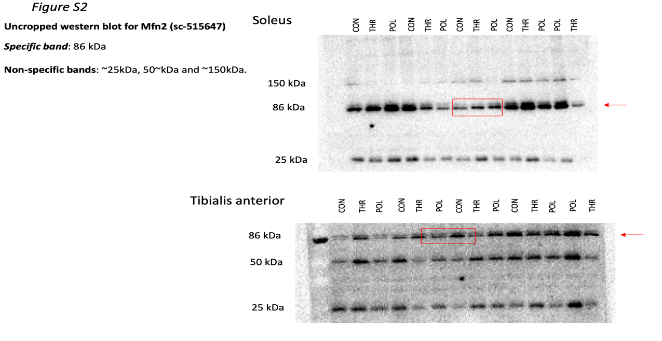
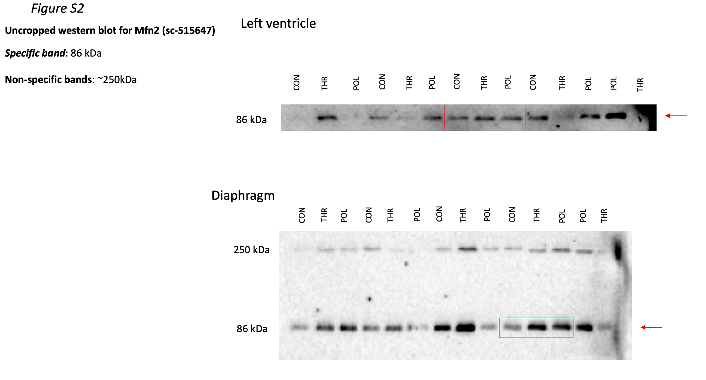
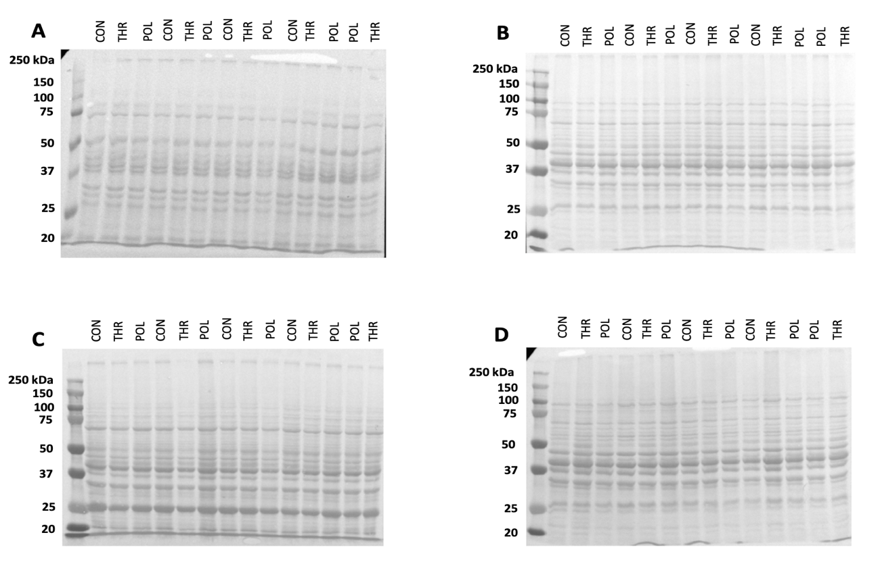
Figure S2 – Loading control of Ponceau S staining of (A: Left myocardium ventricle; B: Diaphragm; C: Soleus; D: Tibialis anterior) Mfn2 (86 kDa).
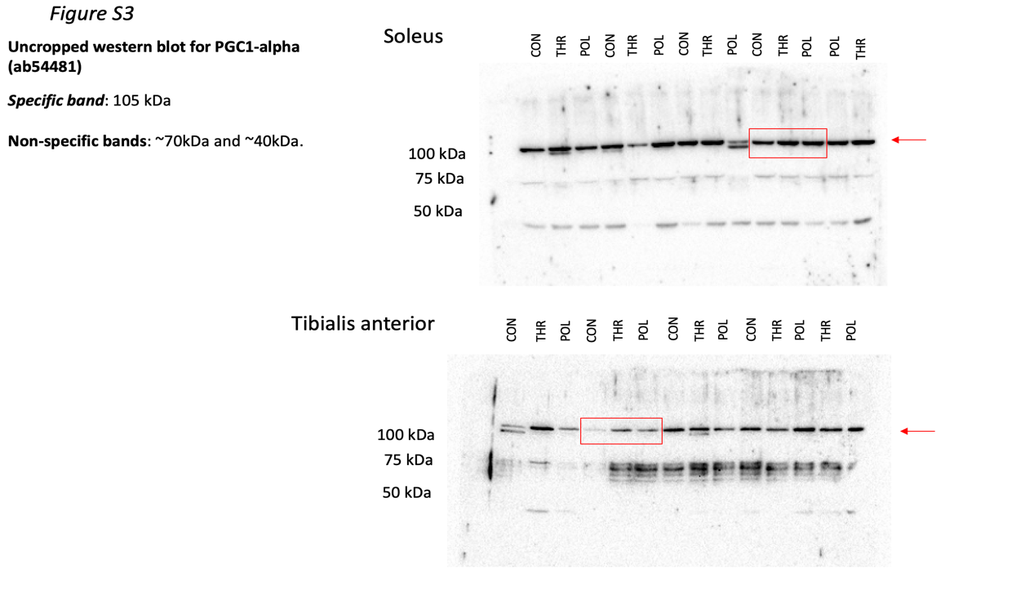
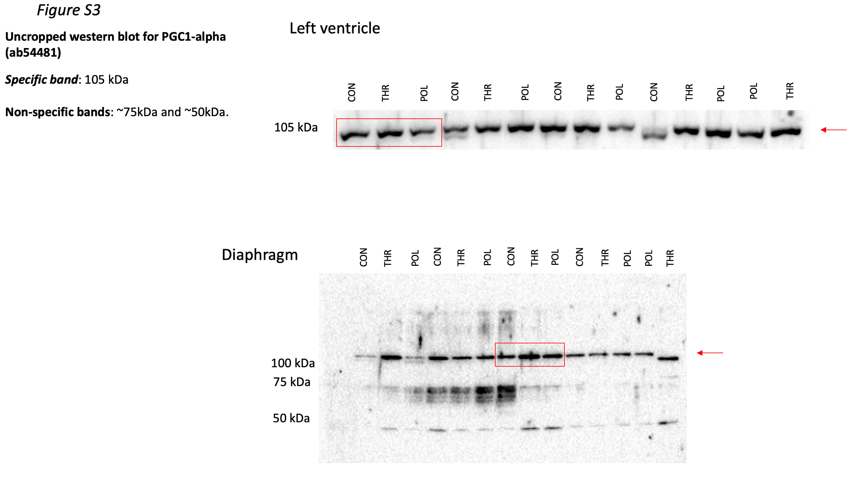
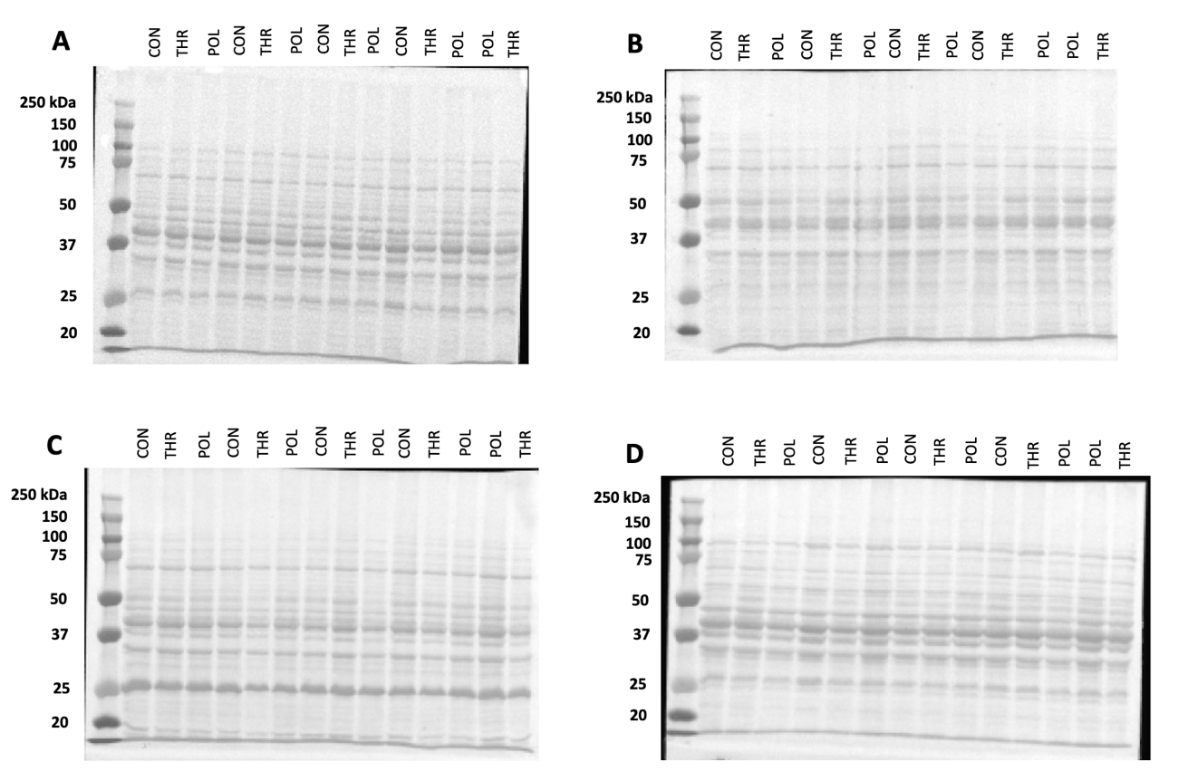
Figure S3 – Loading control of Ponceau S staining of (A: Left myocardium ventricle; B: Diaphragm; C: Soleus; D: Tibialis anterior) PGC-1𝛼 (105 kDa).

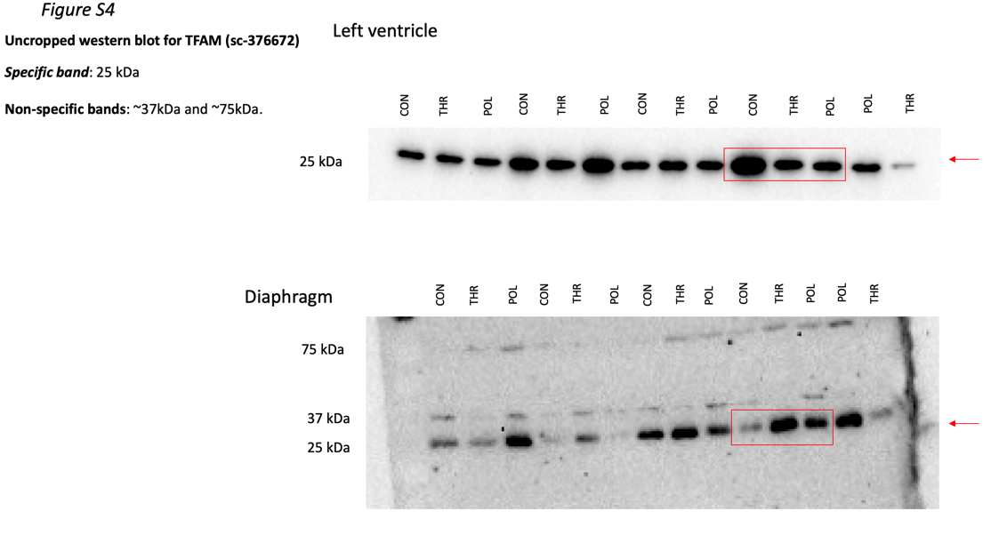

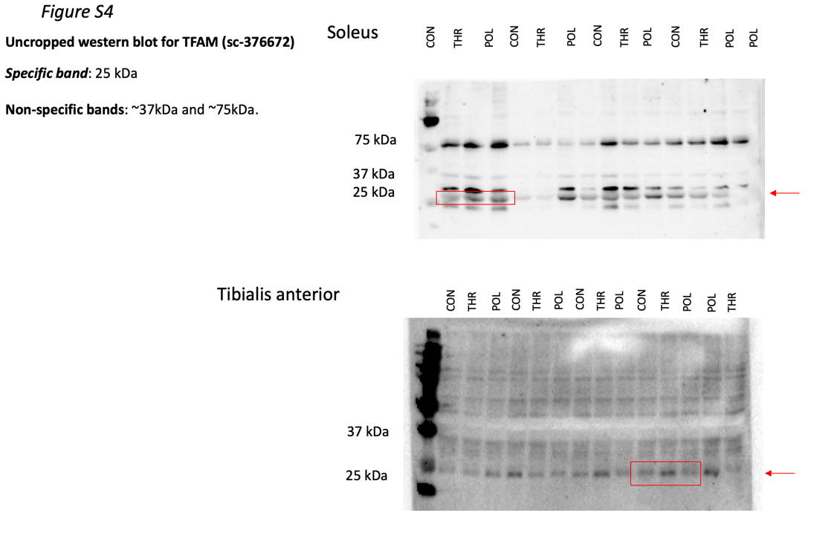
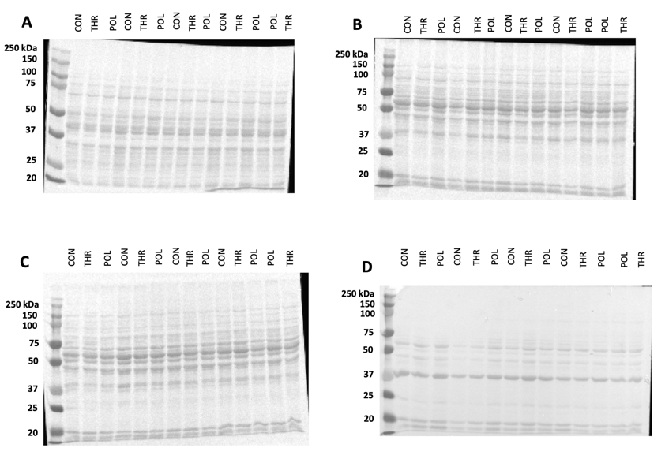
Figure S4 – Loading control of Ponceau S staining of (A: Left myocardium ventricle; B: Diaphragm; C: Soleus; D: Tibialis anterior) TFAM (25 kDa).

Figure S5
Uncropped western blot for DRP1 (#8170)
Specific band: 78-82 kDa
Non-specific bands: ~25kDa

Left Ventricle
Diaphragm
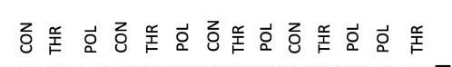
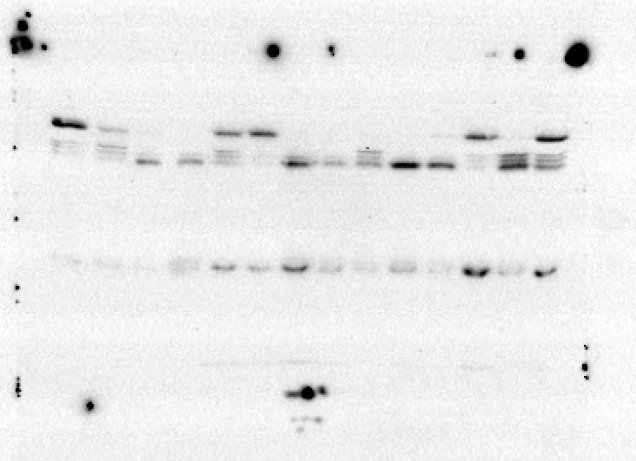
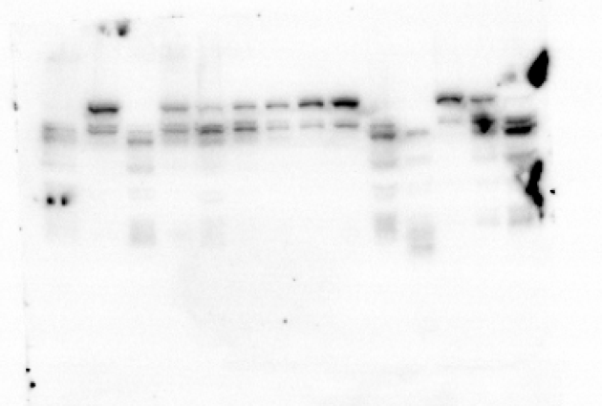
25kDa
78-82kDa
78-82kDa

Soleus
Tibialis anterior

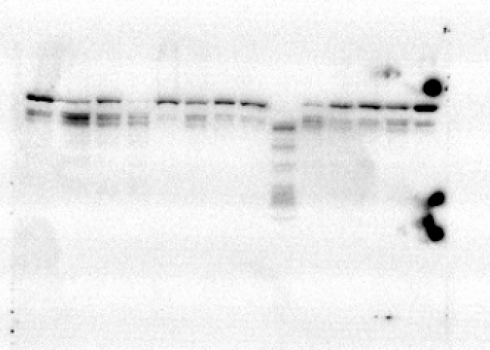
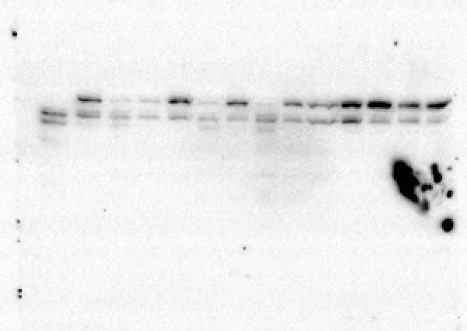

78-82kDa
78-82kDa

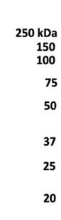
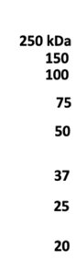
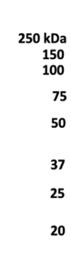
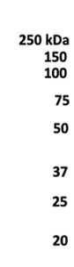
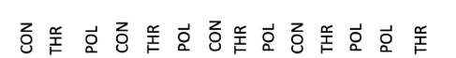
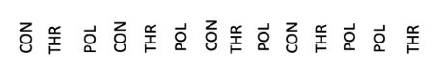
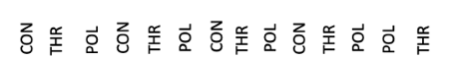
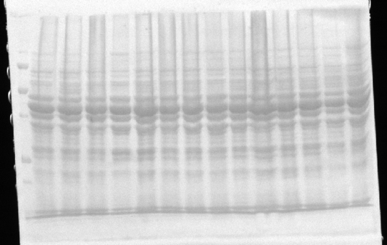
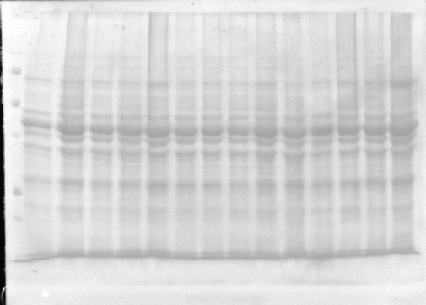
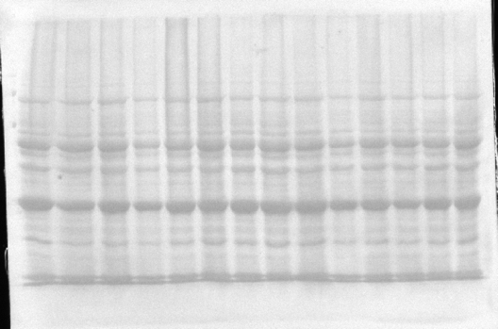
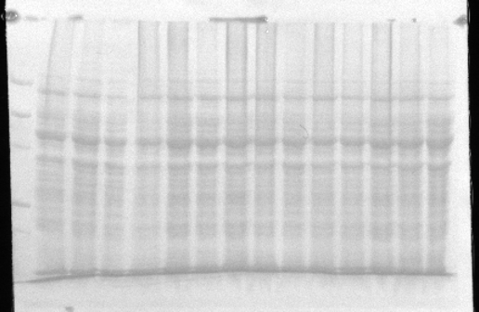
D
B
A
C
D

Figure S5 – Loading control of Ponceau S staining of (A: Left myocardium ventricle; B: Diaphragm; C: Soleus; D: Tibialis anterior) DRP1 (78-82 kDa).

Figure S6
Uncropped western blot for OPA1 (ab119685)
Specific band: 111 kDa
Non-specific bands: ~75kDa and ~37kDa
Diaphragm
Left Ventricle
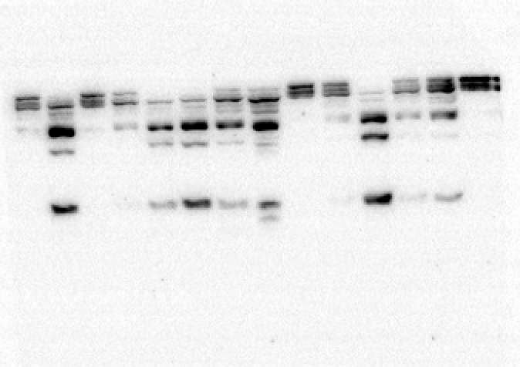
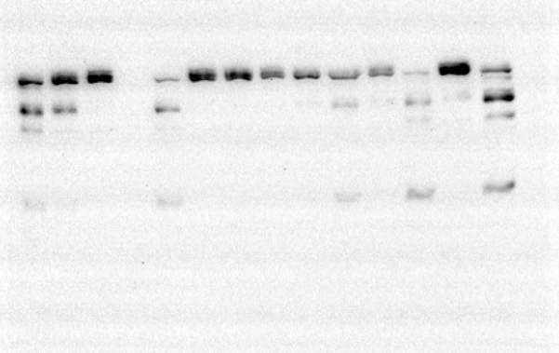
75kDa

111kDa
111kDa
37kDa
75kDa
37kDa

Soleus
Tibialis anterior
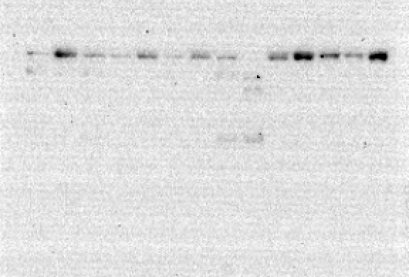
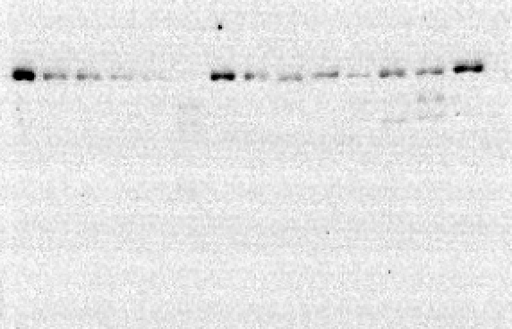
111kDa
111kDa

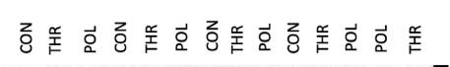
A
B
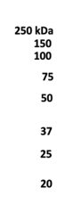
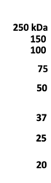
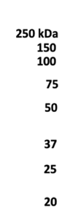
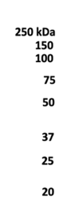
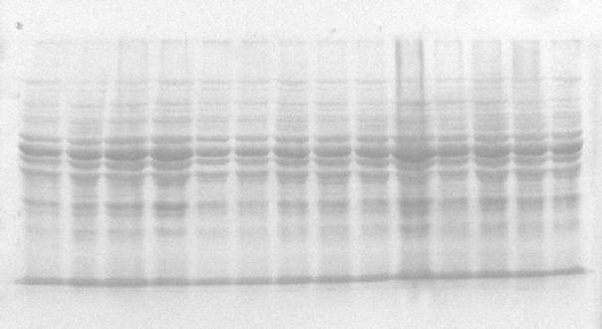
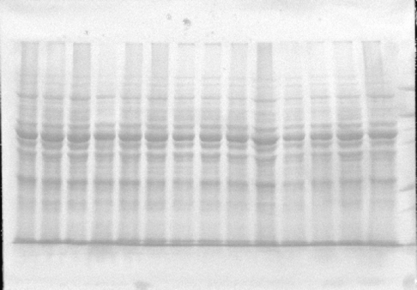
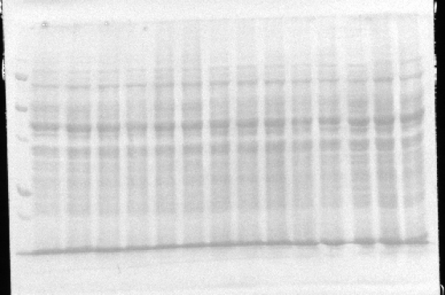
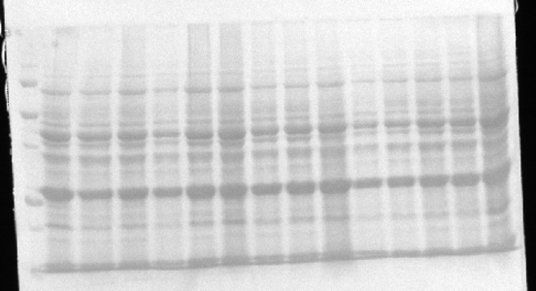
D
C

Figure S6 – Loading control of Ponceau S staining of (A: Left myocardium ventricle; B: Diaphragm; C: Soleus; D: Tibialis anterior) OPA1 (111kDa).

Figure S7
Uncropped western blot for TOM20 (sc-11415)
Specific band: 20 kDa
Left Ventricle
Diaphragm

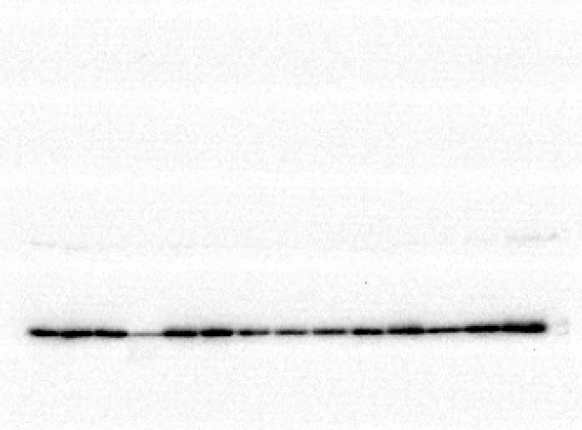
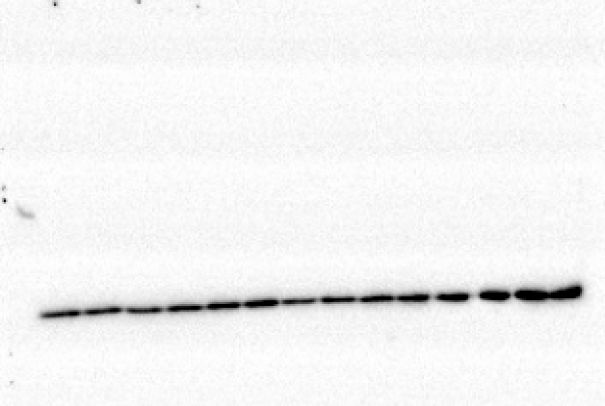

20kDa
20kDa

Tibialis anterior
Soleus
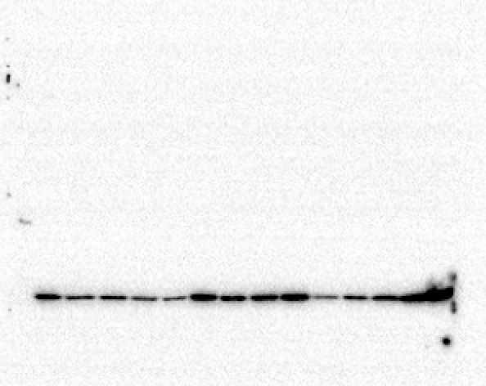
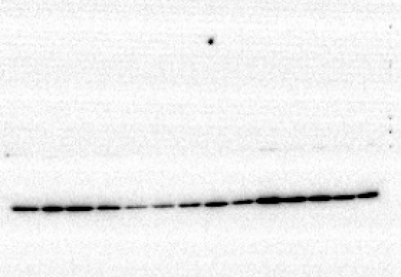

20kDa
20kDa

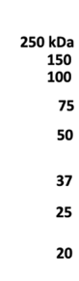
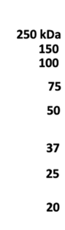
B
A
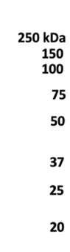
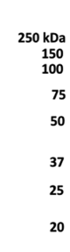
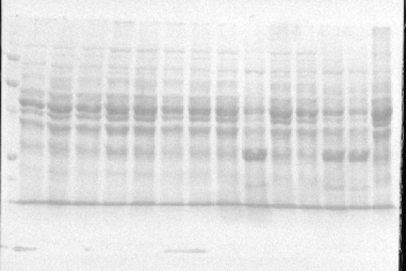
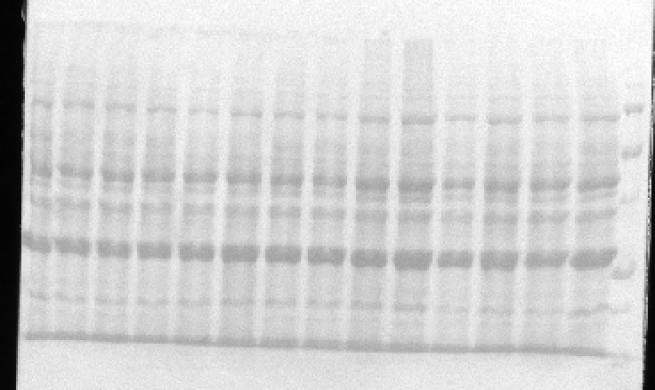
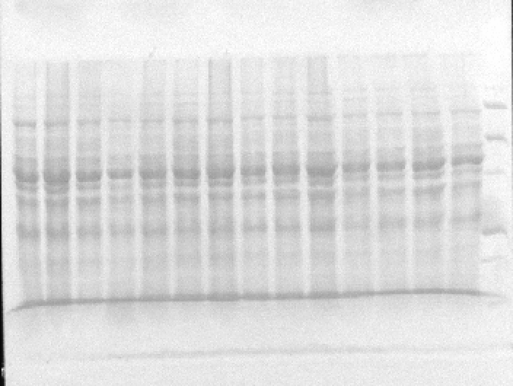
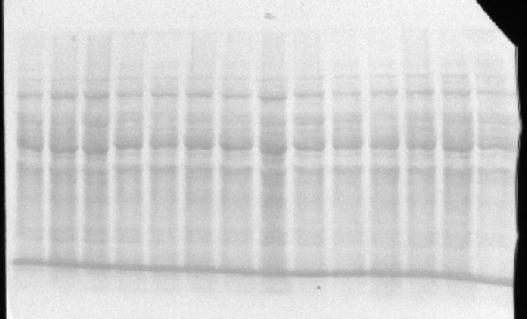
C
D
Figure S7 – Loading control of Ponceau S staining of (A: Left myocardium ventricle; B: Diaphragm; C: Soleus; D: Tibialis anterior) TOM20 (20 kDa).

