Supplementary tables and figures
Modulation of SIRT1/PPARγ Pathways and Tight Junction Proteins by Nicotinamide Riboside under Chronic Variable Stress

Abdullah Celik¹, Nurhan Sahin¹, Cemal Orhan¹, Besir Er², Fusun Erten³, Busra Ozmen¹, Mehmet Tuzcu⁴, Ibrahim Hanifi Ozercan⁵, Kazim Sahin^{1,*}
¹Department of Animal Nutrition, Faculty of Veterinary Medicine, Firat University, 23119, Elazig, Türkiye
²Department of Medical Services and Techniques, Vocational School of Health Services, Firat University, 23119, Elazig, Turkiye
³Department of Veterinary Science, Pertek Vocational School, Munzur University, 62500, Tunceli, Türkiye
⁴Department of Biology, Faculty of Science, Firat University, 23119, Elazig, Türkiye
⁵Department of Pathology, Medicine Faculty, Health Sciences Institution, Firat University, 23119, Elazig, Türkiye

*Correspondence: Kazim Sahin, DVM, Ph.D., Professor of Nutrition, Veterinary Faculty, Firat University, 23119 Elazig, Türkiye. Phone: +90 424 237 00 00 ext: 3938, Fax: +90 424 238 81 73, Email: nsahinkm@yahoo.com

Table A.1 Statistical analysis of final body weight with nicotinamide riboside (NR) supplementation in normal (N) and chronic variable stress (CVS) exposed rats. (Statistical Analysis Two-way ANOVA and Polynomial Contrast, p < 0.05)
ANOVA P
Condition |  | 0.001
NR |  | 0.045
Condition x NR |  | 0.970
Polynomial Contrast
N | Linear | 0.027
N | Quadratic | 0.828
N | Cubic | 0.967
CVS | Linear | 0.082
CVS | Quadratic | 0.809
CVS | Cubic | 0.779
NR: Nicotinamide Riboside, N: Normal Group, CVS: Chronic Variable Stress Group

Table A.2 The effect of NR on liver protein levels in groups exposed to normal and chronic variable stress. (Statistical Analysis Two-way ANOVA and Polynomial Contrast, p < 0.05)
 |  | PPARy | SIRT1 | FASN | GLUT2 | IRS1
ANOVA | Condition | 0.001 | 0.001 | 0.001 | 0.001 | 0.001
ANOVA | NR | 0.001 | 0.159 | 0.001 | 0.400 | 0.001
ANOVA | Condition x NR | 0.001 | 0.001 | 0.001 | 0.002 | 0.017
Polynomial Contrast
N | Linear | 0.129 | 0.025 | 0.080 | 0.002 | 0.413
N | Quadratic | 0.716 | 0.202 | 0.086 | 0.057 | 0.619
N | Cubic | 0.427 | 0.810 | 0.875 | 0.524 | 0.298
CVS | Linear | 0.001 | 0.001 | 0.001 | 0.001 | 0.001
CVS | Quadratic | 0.004 | 0.012 | 0.283 | 0.020 | 0.029
CVS | Cubic | 0.835 | 0.955 | 0.048 | 0.739 | 0.221
N: Normal group; CVS: Chronic variable stress group; NR: Nicotinamide riboside; PPARγ: Peroxisome proliferator-activated receptor gamma; SIRT1: Sirtuin 1; FASN: Fatty acid synthase; GLUT2: Glucose transporter-2; IRS1: Insulin receptor substrate-1

Table A.3 The effect of nicotinamide riboside (NR) on jejunum protein levels in groups exposed to normal (N) and chronic variable stress (CVS). (Statistical Analysis Two-way ANOVA and Polynomial Contrast, p < 0.05)
 |  | Claudin-1 | Claudin-4 | Occludin | ZO-1 | MUC2 | SGLT1 | GLUT2
ANOVA | Condition | 0.001 | 0.001 | 0.001 | 0.001 | 0.001 | 0.001 | 0.001
ANOVA | NR | 0.001 | 0.001 | 0.001 | 0.001 | 0.001 | 0.001 | 0.001
ANOVA | Condition x NR | 0.001 | 0.015 | 0.001 | 0.001 | 0.001 | 0.001 | 0.007
Polynomial Contrast
N | Linear | 0.376 | 0.009 | 0.001 | 0.078 | 0.005 | 0.001 | 0.001
N | Quadratic | 0.608 | 0.081 | 0.020 | 0.655 | 0.521 | 0.001 | 0.023
N | Cubic | 0.933 | 0.455 | 0.494 | 0.751 | 0.805 | 0.590 | 0.422
CVS | Linear | 0.001 | 0.001 | 0.001 | 0.001 | 0.001 | 0.001 | 0.001
CVS | Quadratic | 0.080 | 0.013 | 0.006 | 0.001 | 0.008 | 0.001 | 0.559
CVS | Cubic | 0.058 | 0.761 | 0.373 | 0.823 | 0.019 | 0.595 | 0.411
N: Normal group; CVS: Chronic variable stress group; NR: Nicotinamide riboside; ZO-1: Zona occludens-1; MUC-2: Mucin-2; SGLT1: Sodium-Glucose cotransporter-1; GLUT2: Glucose transporter-2

Table A.4 The effect of nicotinamide riboside (NR) on jejunum protein levels in groups exposed to normal and chronic variable stress (CVS). (Statistical Analysis Two-way ANOVA and Polynomial Contrast, p < 0.05)
 |  | PepT1 | LAT2 | EAAT3 | FABP2 | FATP4
ANOVA | Condition | 0.001 | 0.001 | 0.001 | 0.001 | 0.001
ANOVA | NR | 0.001 | 0.001 | 0.001 | 0.001 | 0.001
ANOVA | Condition x NR | 0.001 | 0.001 | 0.001 | 0.024 | 0.352
Polynomial Contrast
N | Linear | 0.001 | 0.515 | 0.001 | 0.086 | 0.001
N | Quadratic | 0.001 | 0.359 | 0.001 | 0.004 | 0.186
N | Cubic | 0.303 | 0.836 | 0.001 | 0.045 | 0.337
CVS | Linear | 0.001 | 0.001 | 0.821 | 0.001 | 0.001
CVS | Quadratic | 0.006 | 0.012 | 0.001 | 0.394 | 0.063
CVS | Cubic | 0.758 | 0.203 | 0.362 | 0.014 | 0.375
N: Normal group; CVS: Chronic variable stress group; NR: Nicotinamide riboside, PepT1: Peptide transporter 1, LAT2: L-type amino acid transporter 2, EAAT3: Excitatory amino acid transporter 3, FABP2: Fatty acid binding protein 2, FATP4: Fatty acid transport protein 4.

Table A.5 Effects of different nicotinamide riboside doses on villus length (A) and crypt depth (B) in jejunum tissue of rats exposed to normal and chronic variable stress. (Statistical Analysis Two-way ANOVA and Polynomial Contrast, p < 0.05)

 |  | Villus Length (µm) | Crypt Depth (µm)
ANOVA | Condition | 0.001 | 0.024
ANOVA | NR | 0.001 | 0.001
ANOVA | Condition x NR | 0.001 | 0.001
Polynomial Contrast
N | Linear | 0.078 | 0.131
N | Quadratic | 0.512 | 0.873
N | Cubic | 0.288 | 0.073
CVS | Linear | 0.001 | 0.001
CVS | Quadratic | 0.008 | 0.044
CVS | Cubic | 0.342 | 0.799
N: Normal group; CVS: Chronic variable stress group; NR: Nicotinamide riboside

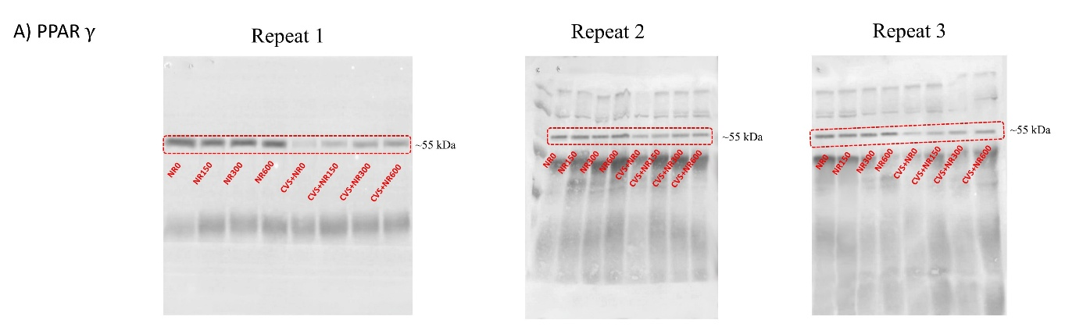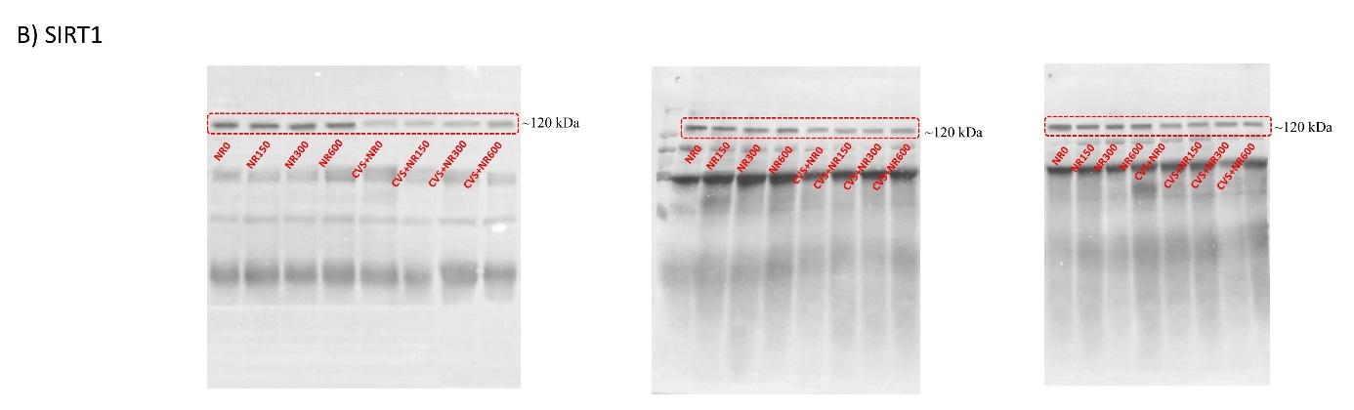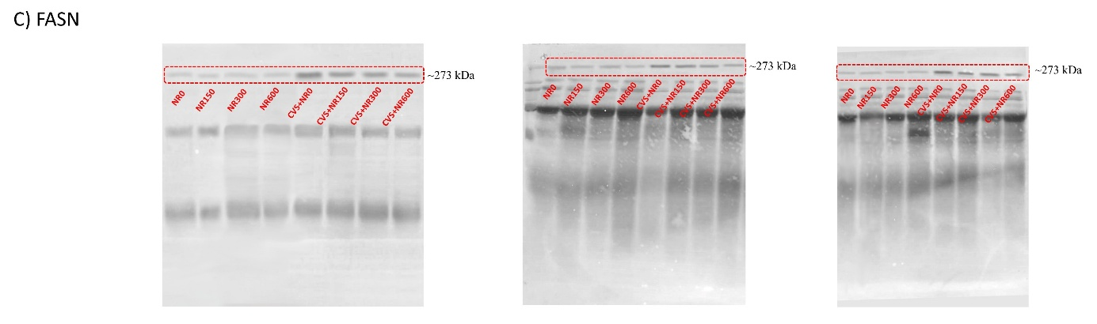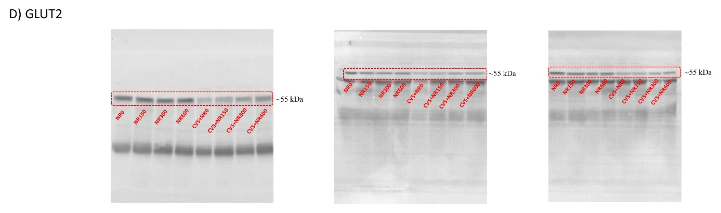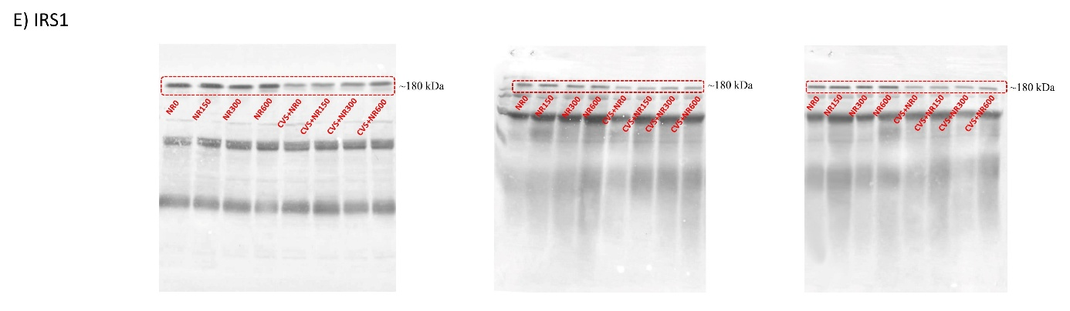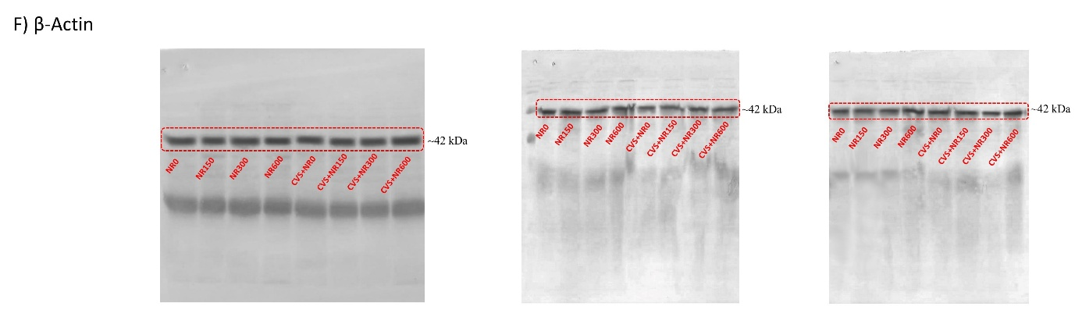

Fig. A.1 Full immunoblots related to Fig. 3 in the main text: The effects of different nicotinamide riboside doses on the levels of PPARγ (A), SIRT1 (B), FASN (C), GLUT2 (D), and IRS1 (E) proteins in the liver tissue of rats under normal (N) and chronic variable stress (CVS) conditions. The densitometric analysis of the relative intensity according to the control group of the Western blotting bands was performed with β-actin normalization to ensure equal protein loading (F). All experiments were independently repeated three times. Red dotted rectangles delineate the results shown in Fig. 3 in the main text. Molecular weight (in kDa) is indicated. PPARγ: Peroxisome proliferator-activated receptor gamma; SIRT1: Sirtuin 1; FASN: Fatty acid synthase; GLUT2: Glucose transporter-2; IRS1: Insulin receptor substrate-1

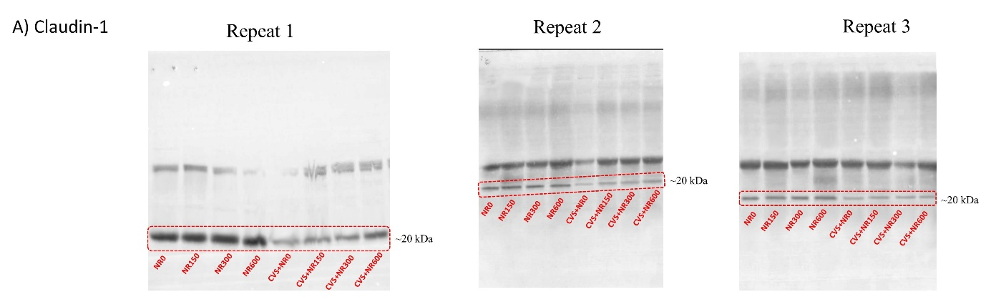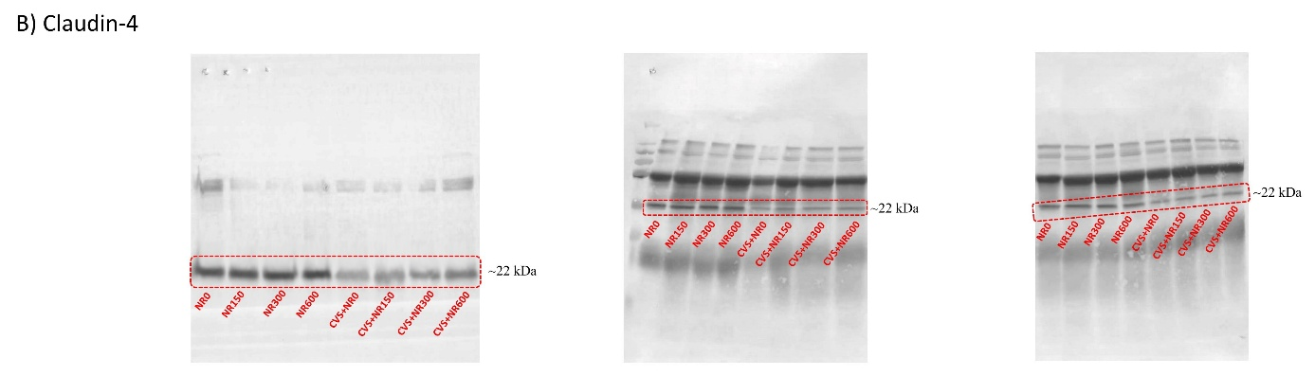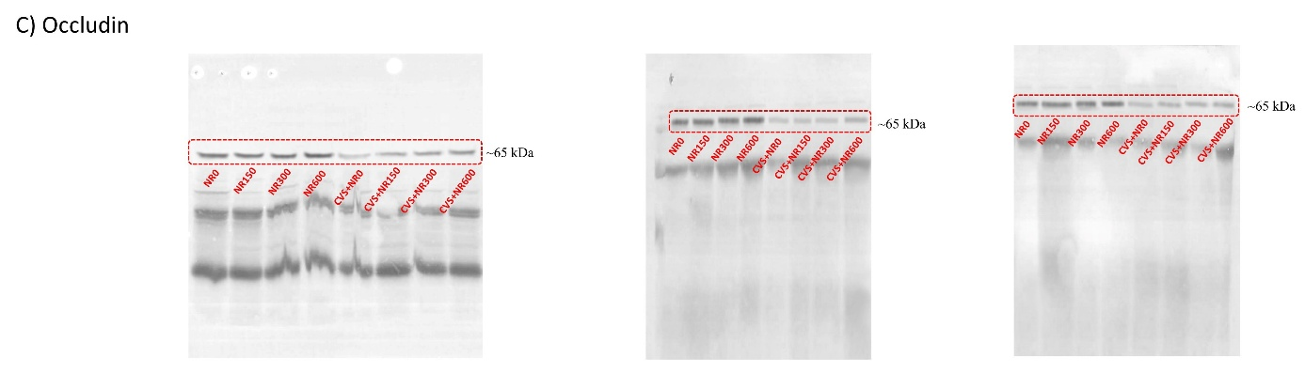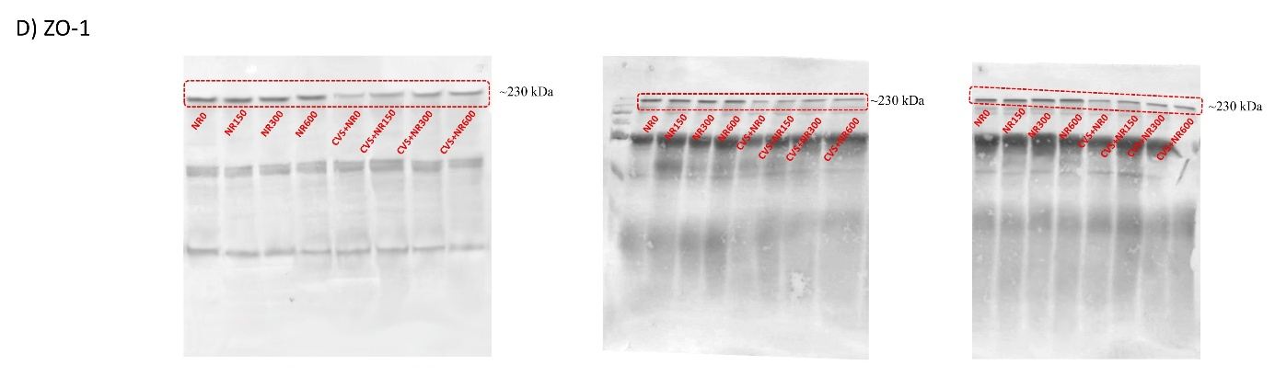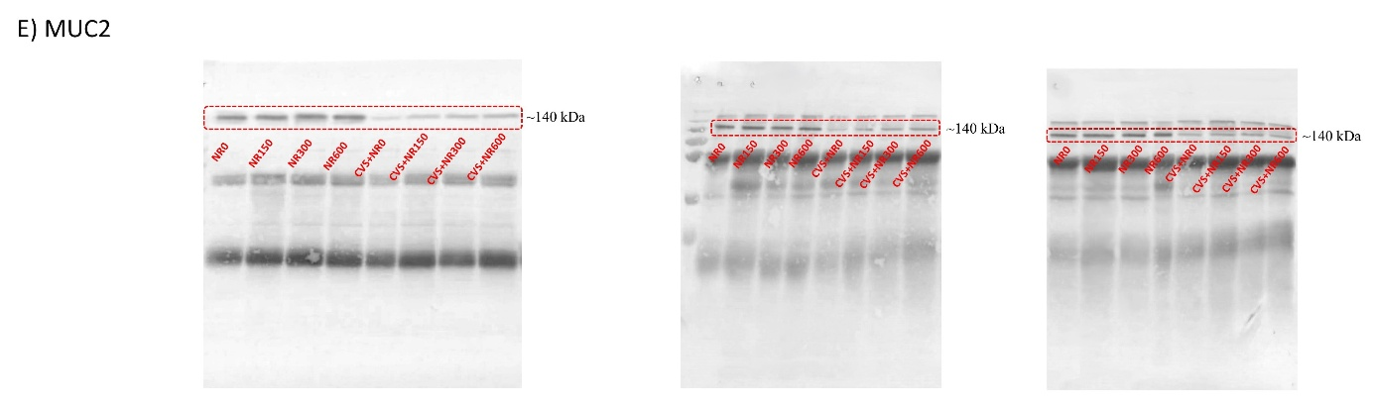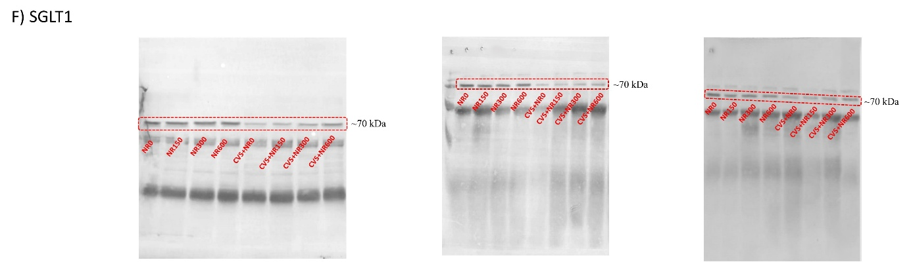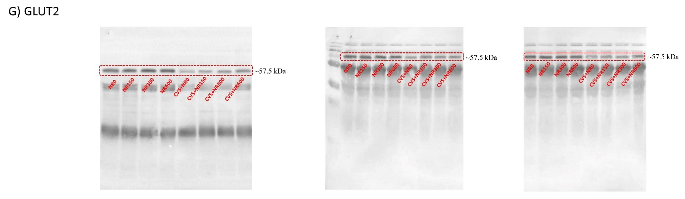
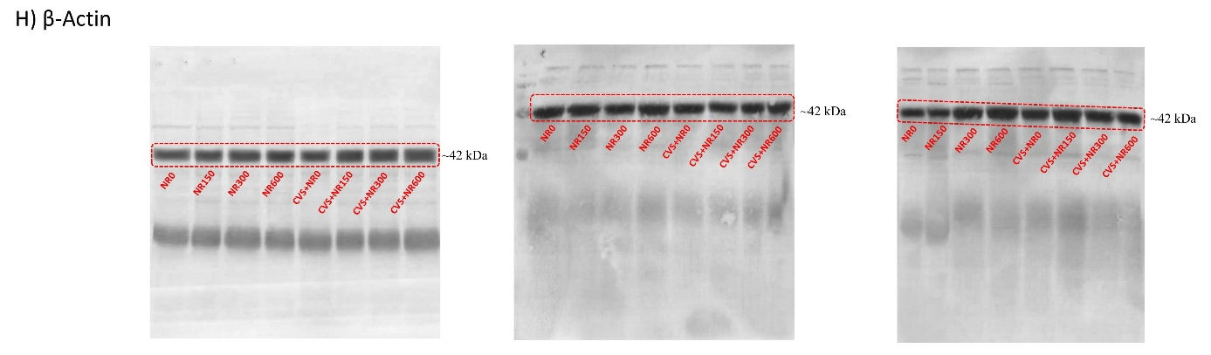

Fig. A.2 Full immunoblots related to Fig. 4 in the main text: The effects of different nicotinamide riboside doses on the levels of Claudin-1 (A), Claudin-4 (B), Occludin (C), ZO-1 (D), MUC-2 (E), SGLT1 (F), and GLUT2 (G) proteins in the jejunum tissue of rats under normal (N) and chronic variable stress (CVS) conditions. The densitometric analysis of the relative intensity according to the control group of the Western blotting bands was performed with β-actin normalization to ensure equal protein loading (H). All experiments were independently repeated three times. Red dotted rectangles delineate the results shown in Fig. 4 in the main text. Molecular weight (in kDa) is indicated. ZO-1: Zona occludens-1; MUC-2: Mucin-2; SGLT1: Sodium-Glucose cotransporter-1; GLUT2: Glucose transporter-2

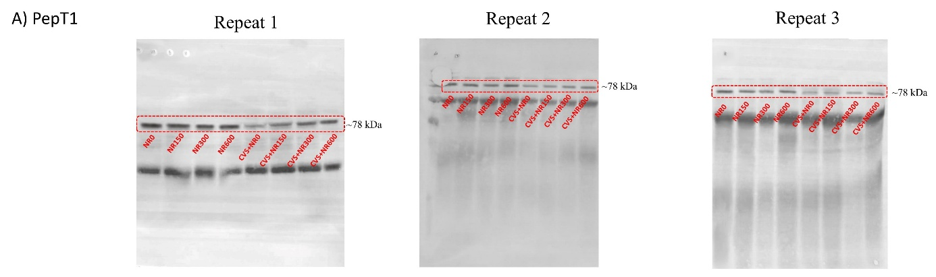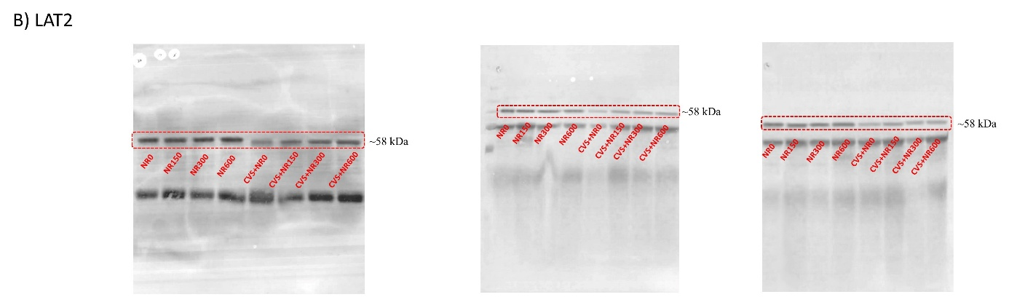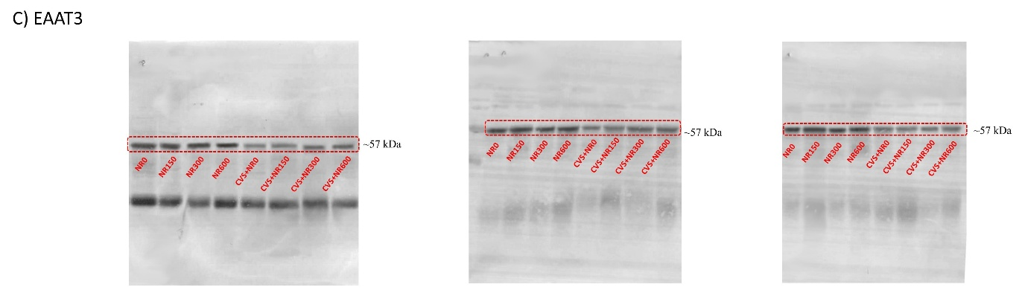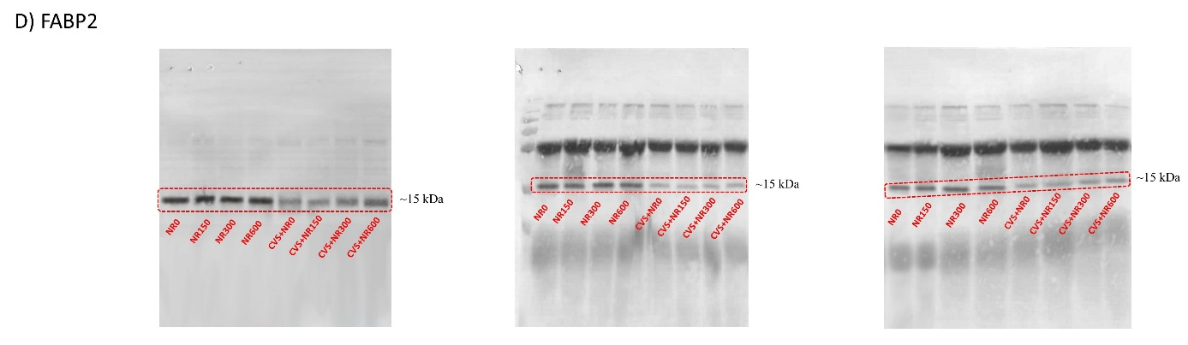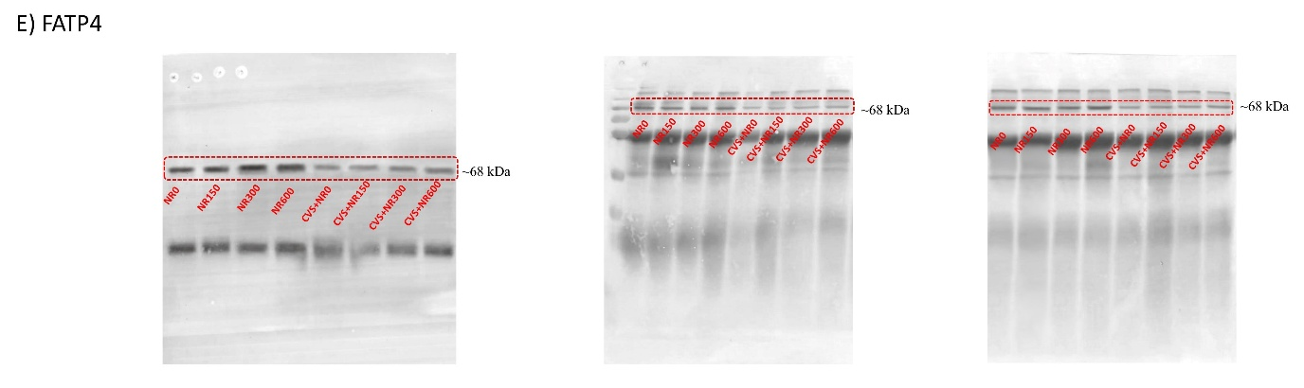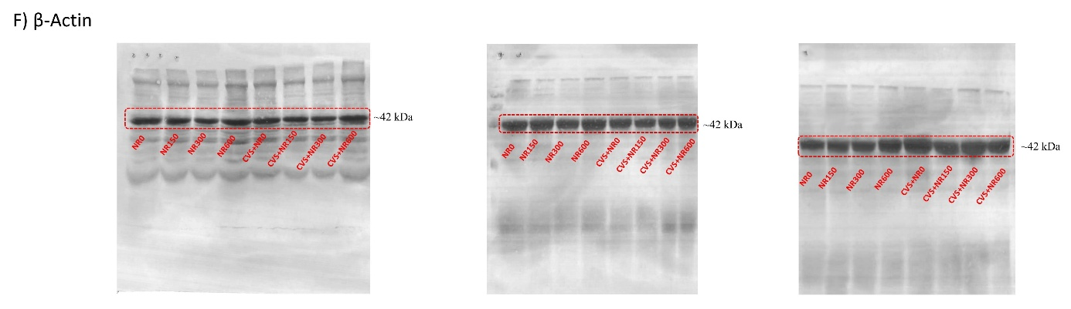

Fig. A.3 Full immunoblots related to Fig. 5 in the main text: The effects of different nicotinamide riboside doses on the levels of PepT1 (A), LAT2 (B), EAAT3 (C), FABP2 (D), and FATP4 (E) proteins in the jejunum tissue of rats under normal (N) and chronic variable stress (CVS) conditions. The densitometric analysis of the relative intensity according to the control group of the Western blotting bands was performed with β-actin normalization to ensure equal protein loading (F). All experiments were independently repeated three times. Red dotted rectangles delineate the results shown in Fig. 5 in the main text. Molecular weight (in kDa) is indicated. PepT1, Peptide transporter 1; LAT2, L-Type amino acid transporter 2; EAAT3, Excitatory amino acid transporter 3; FABP2, Fatty acid binding protein 2; FATP4, Fatty acid transport protein 4.

