Supplementary Material 10 (A-G). Publication bias analysis.
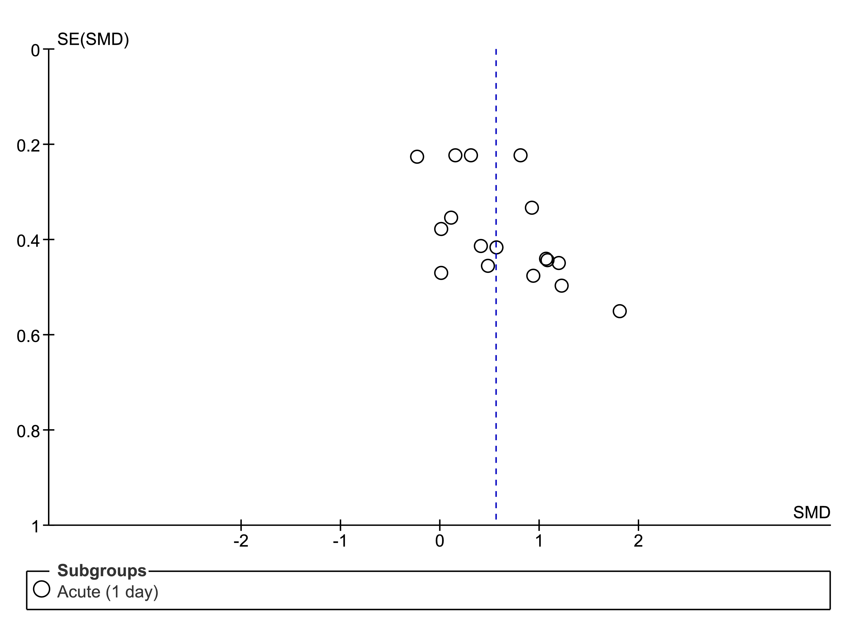
Supplementary Material 10A. Funnel plot of comparison: pre-intervention versus post-intervention; outcome: serum klotho concentration after acute exercise.

Regression-based Egger test for small-study effects
Random-effects model
Method: DerSimonian–Laird
H0: beta1 = 0; no small-study effects
beta1 = 4.35
SE of beta1 = 2.374
t = 1.83
Prob > |t| = 0.0869

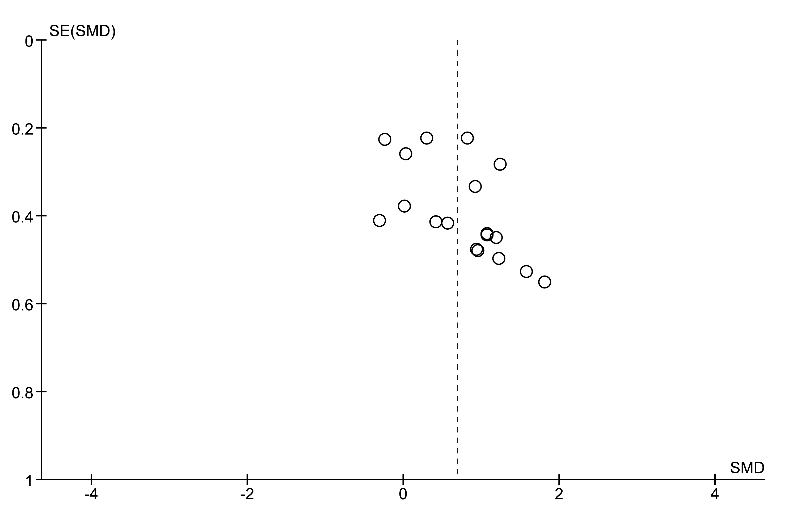
Supplementary Material 10B. Funnel plot of comparison: pre-intervention versus post-intervention; outcome: serum klotho concentration in healthy subjects after acute and subacute exercise.

Regression-based Egger test for small-study effects
Random-effects model
Method: DerSimonian–Laird
H0: beta1 = 0; no small-study effects
beta1 = 3.28
SE of beta1 = 1.316
t = 2.49
Prob > |t| = 0.0240*

* |t| ≤ 0.05 = statistically significant

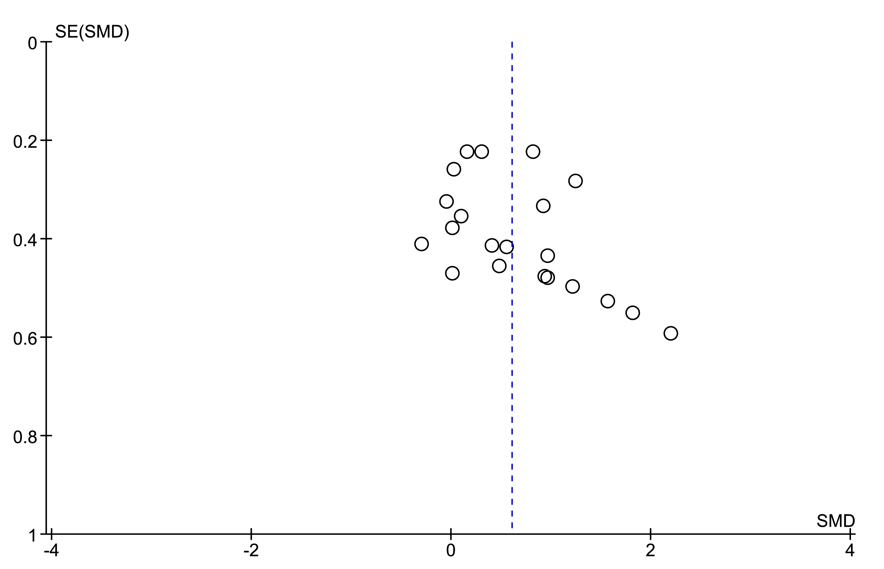
Supplementary Material 10C. Funnel plot of comparison: pre-intervention versus post-intervention; outcome: serum klotho concentration after acute and subacute aerobic exercise.

Regression-based Egger test for small-study effects
Random-effects model
Method: DerSimonian–Laird
H0: beta1 = 0; no small-study effects
beta1 = 2.95
SE of beta1 = 1.221
t = 2.42
Prob > |t| = 0.0258*

* |t| ≤ 0.05 = statistically significant

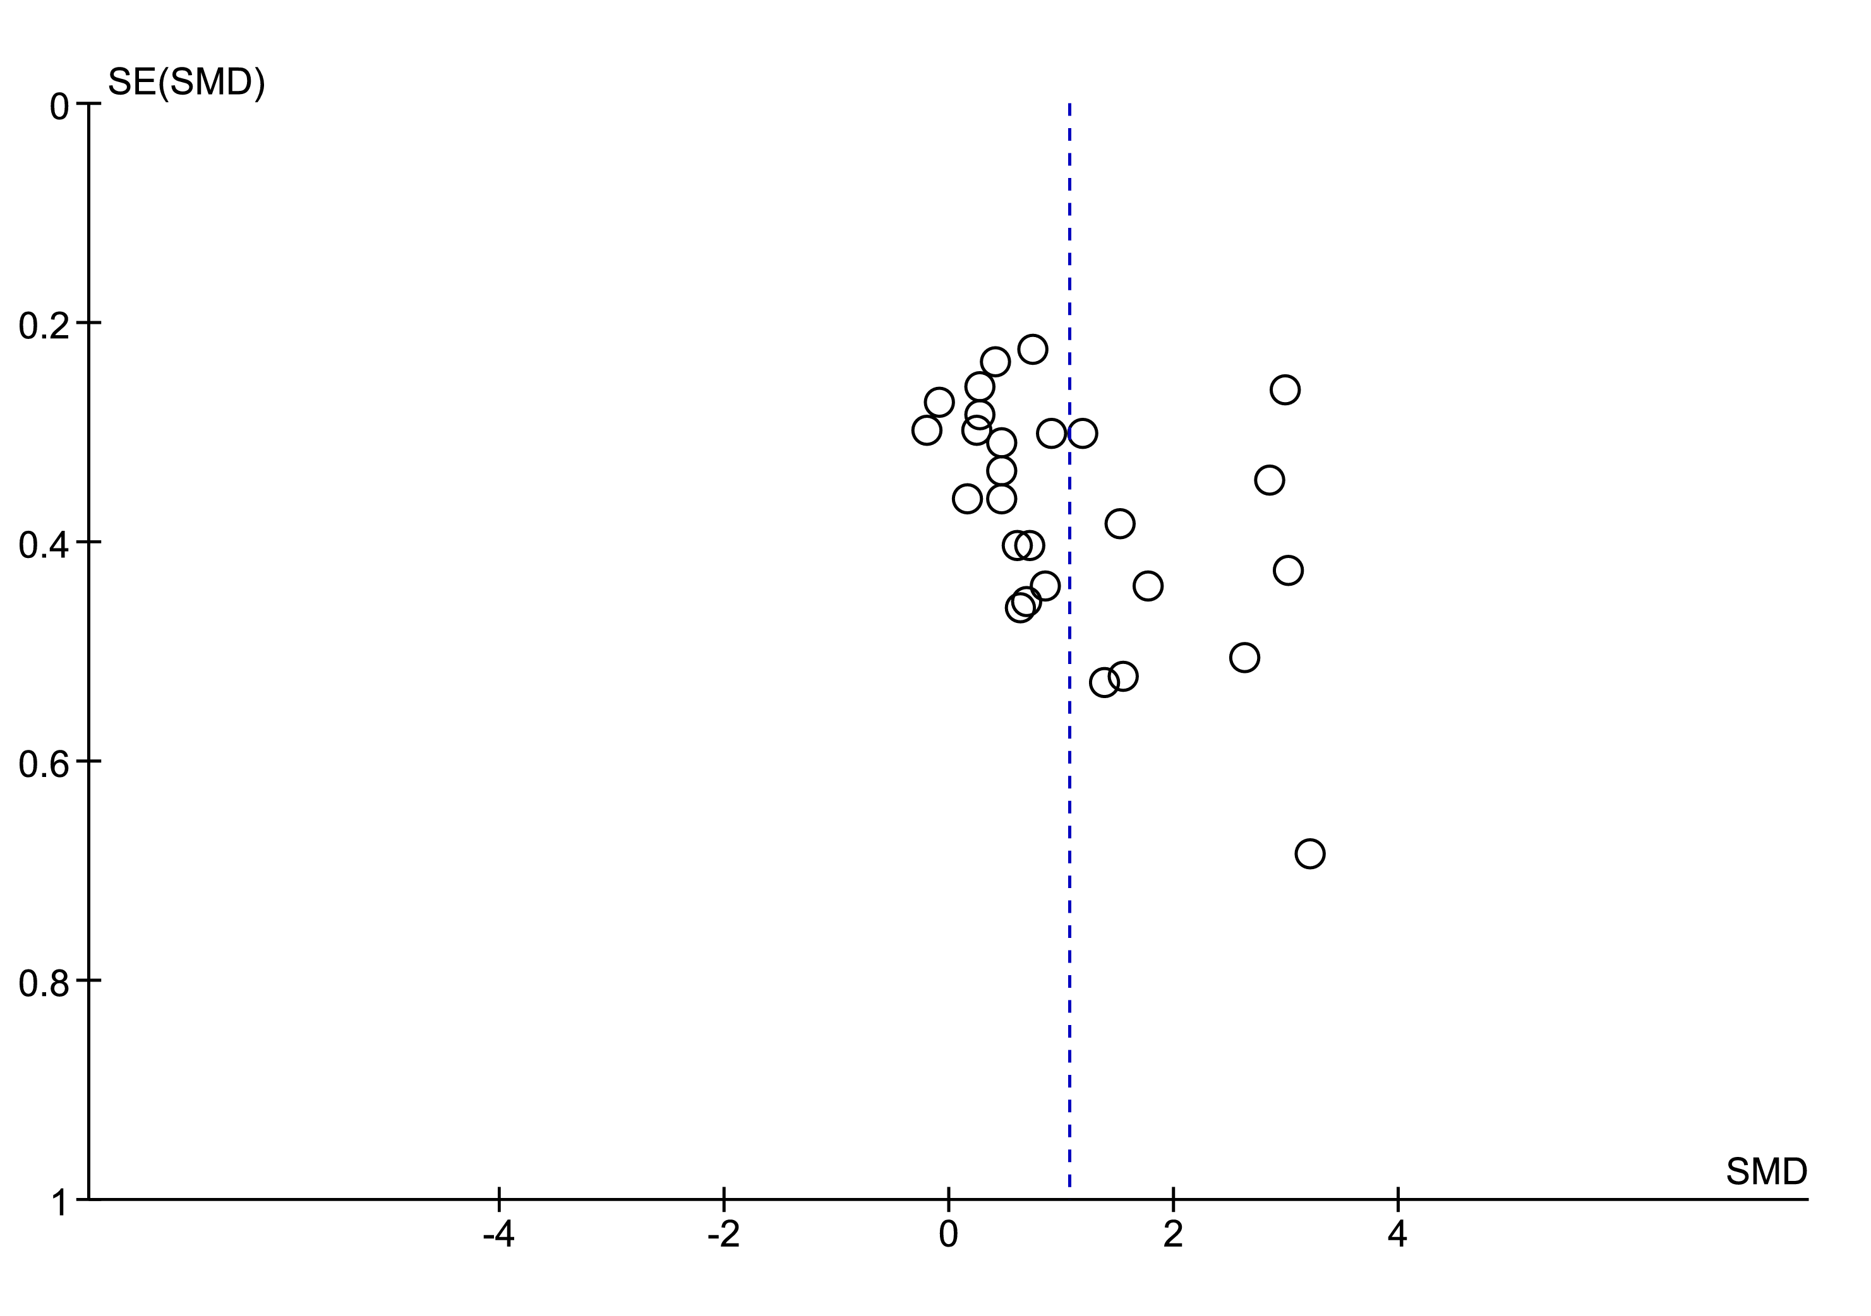
Supplementary Material 10D. Funnel plot of comparison: exercise versus control; outcome: serum klotho concentration after chronic exercise.

Regression-based Egger test for small-study effects
Random-effects model
Method: DerSimonian–Laird
H0: beta1 = 0; no small-study effects
beta1 = 5.01
SE of beta1 = 1.958
t = 2.56
Prob > |t| = 0.0169*

* |t| ≤ 0.05 = statistically significant

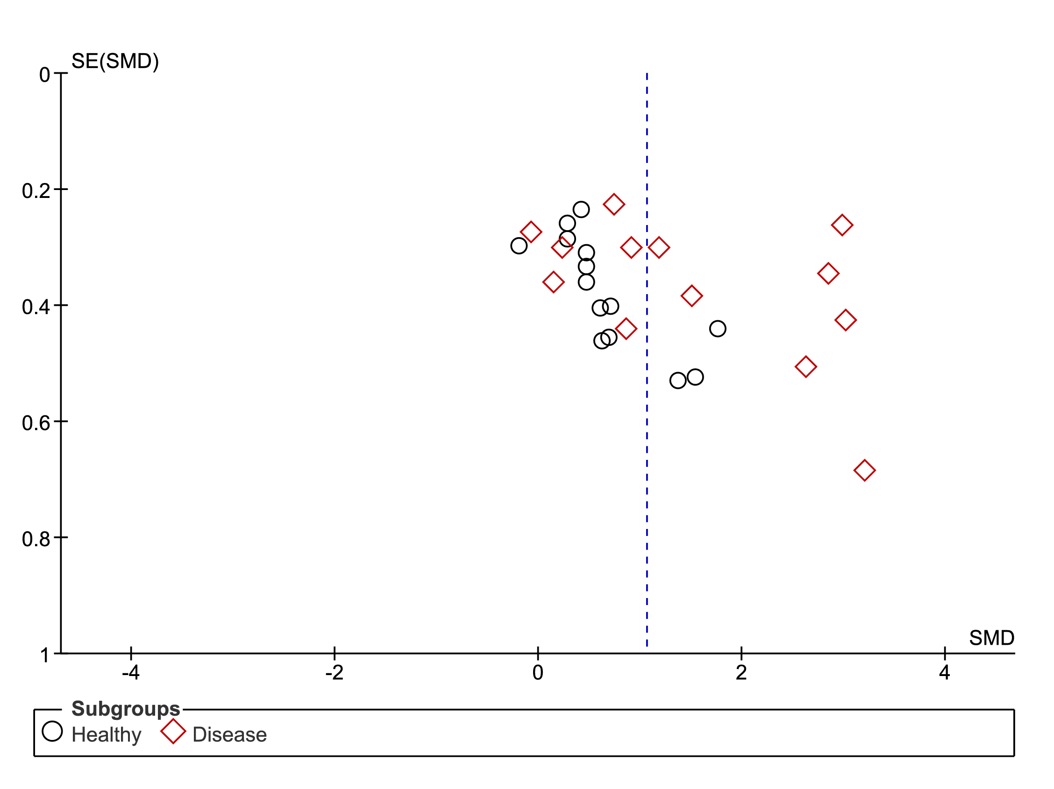
Supplementary Material 10E. Funnel plot of comparison: exercise versus control; outcome: serum klotho concentration in healthy and diseased subjects after chronic exercise.

Regression-based Egger test for small-study effects
Random-effects model
Method: DerSimonian–Laird

Subgroup: Healthy  H0: beta1 = 0; no small-study effects  beta1 = 5.84  SE of beta1 = 3.123  t = 1.87  Prob > |t| = 0.0882 | Subgroup: Disease  H0: beta1 = 0; no small-study effects  beta1 = 4.08  SE of beta1 = 1.149  t = 3.55  Prob > |t| = 0.0040*

* |t| ≤ 0.05 = statistically significant

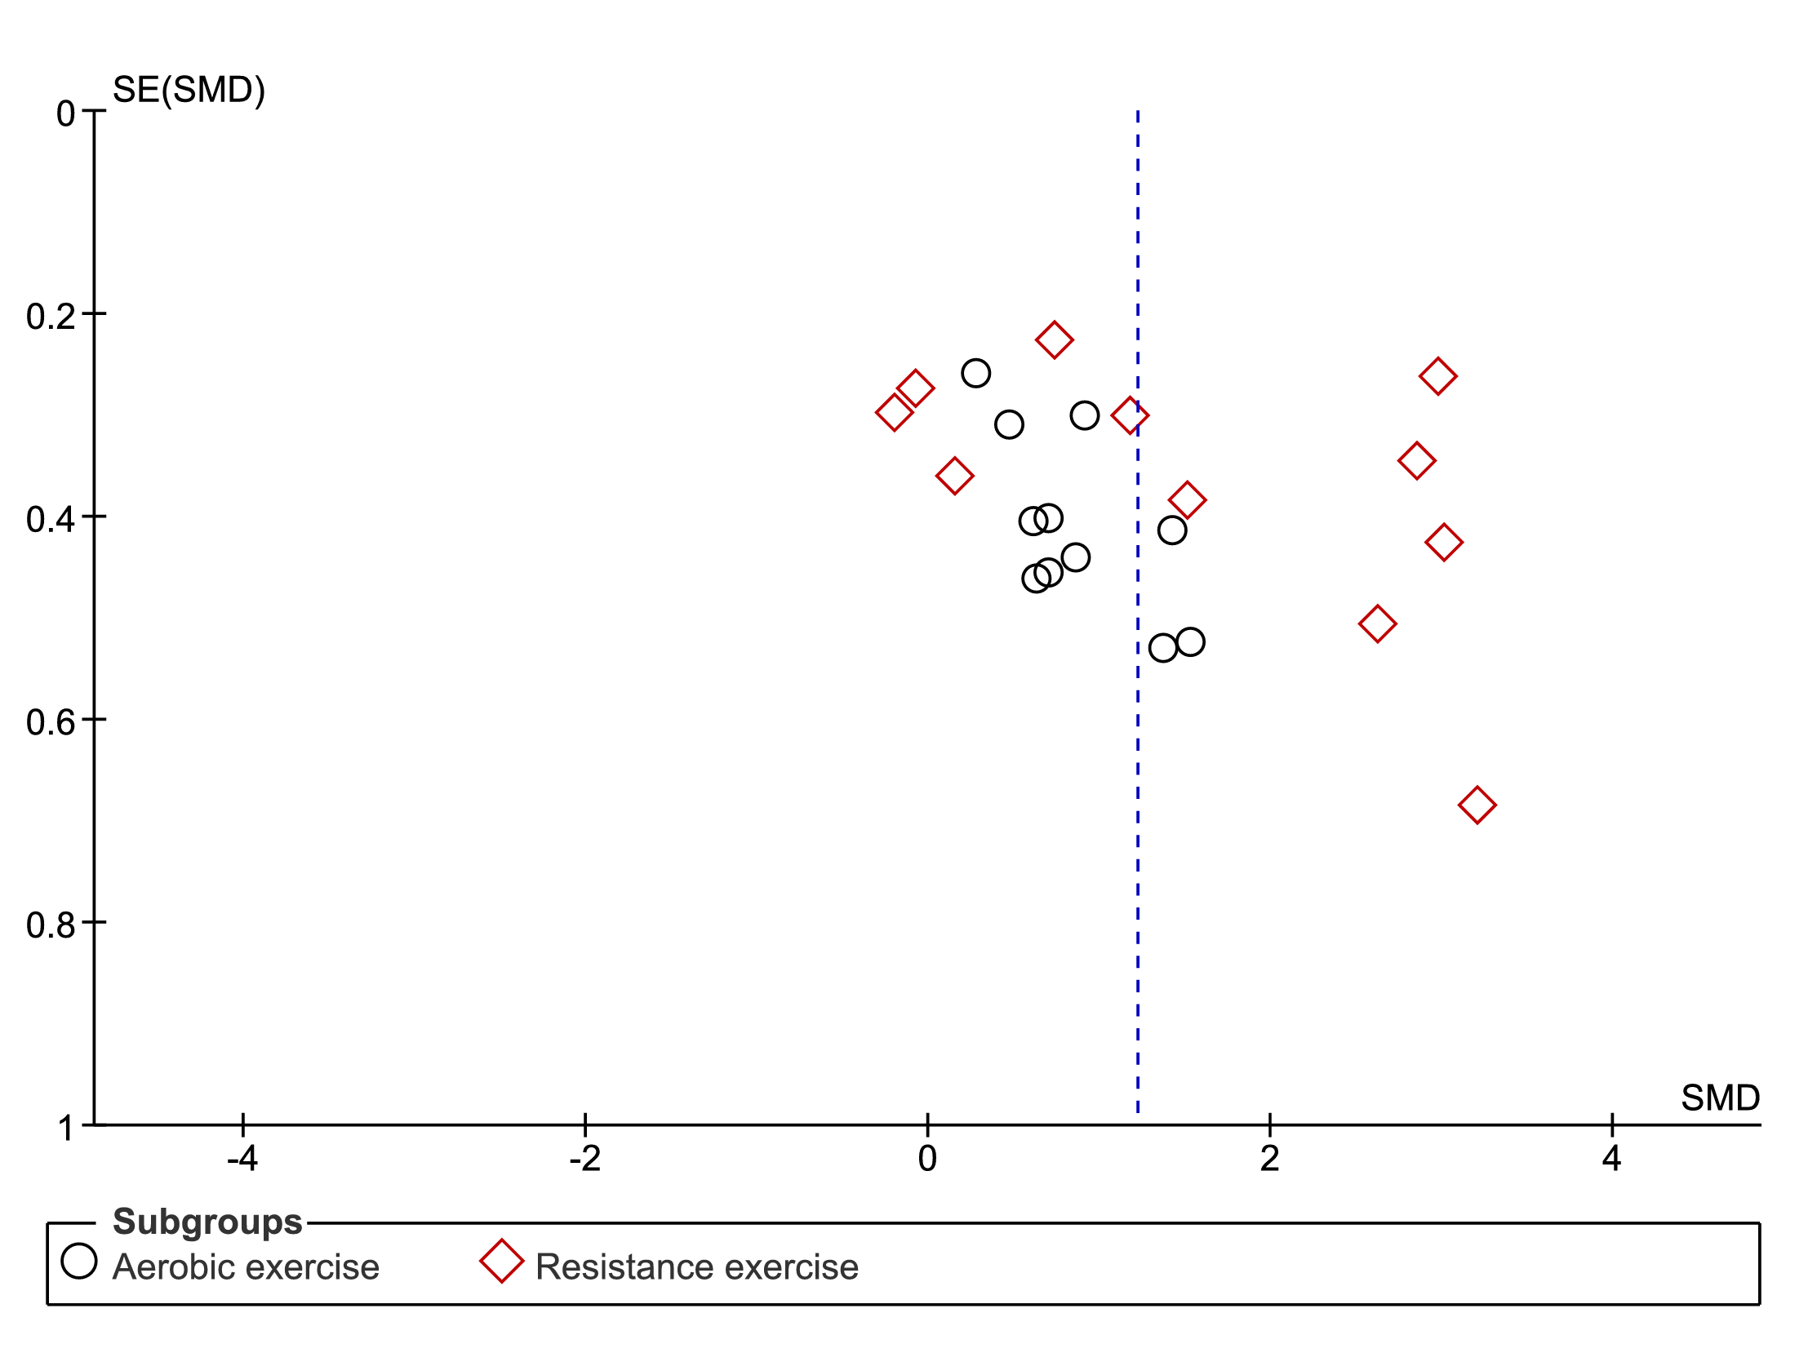
Supplementary Material 10F. Funnel plot of comparison: exercise versus control; outcome: serum klotho concentration after chronic aerobic exercise and resistance exercise.

Regression-based Egger test for small-study effects
Random-effects model
Method: DerSimonian–Laird

Subgroup: Aerobic exercise  H0: beta1 = 0; no small-study effects  beta1 = 3.32  SE of beta1 = 1.414  t = 2.35  Prob > |t| = 0.0435* | Subgroup: Resistance exercise  H0: beta1 = 0; no small-study effects  beta1 = 6.49  SE of beta1 = 3.536  t = 1.84  Prob > |t| = 0.0995

* |t| ≤ 0.05 = statistically significant

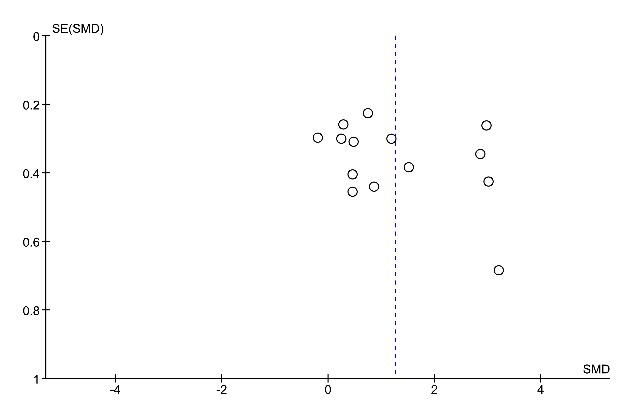
Supplementary Material 10G. Comparison funnel plot: exercise versus control; outcome: serum klotho concentration after chronic exercise three times per week.

Regression-based Egger test for small-study effects
Random-effects model
Method: DerSimonian–Laird
H0: beta1 = 0; no small-study effects
beta1 = 4.62
SE of beta1 = 3.185
t = 1.45
Prob > |t| = 0.1725

