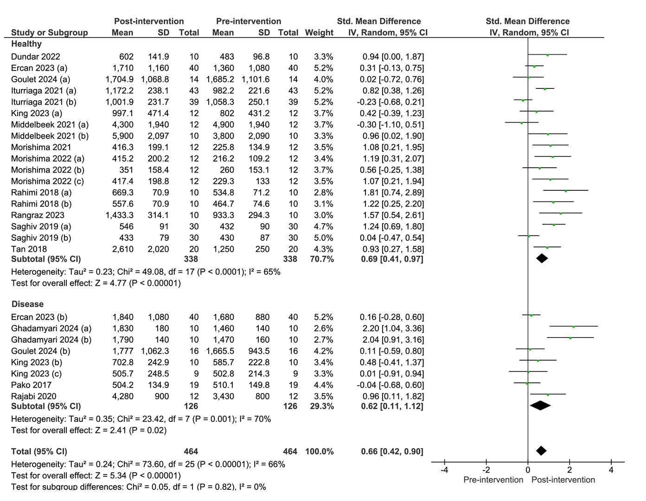

Supplementary Material 2. Forest plot of comparison: pre-intervention versus post-intervention; outcome: serum klotho concentration in healthy and diseased subjects after acute and subacute exercise. SD = standardized deviation; STD = standardized; CI = confidence interval.

