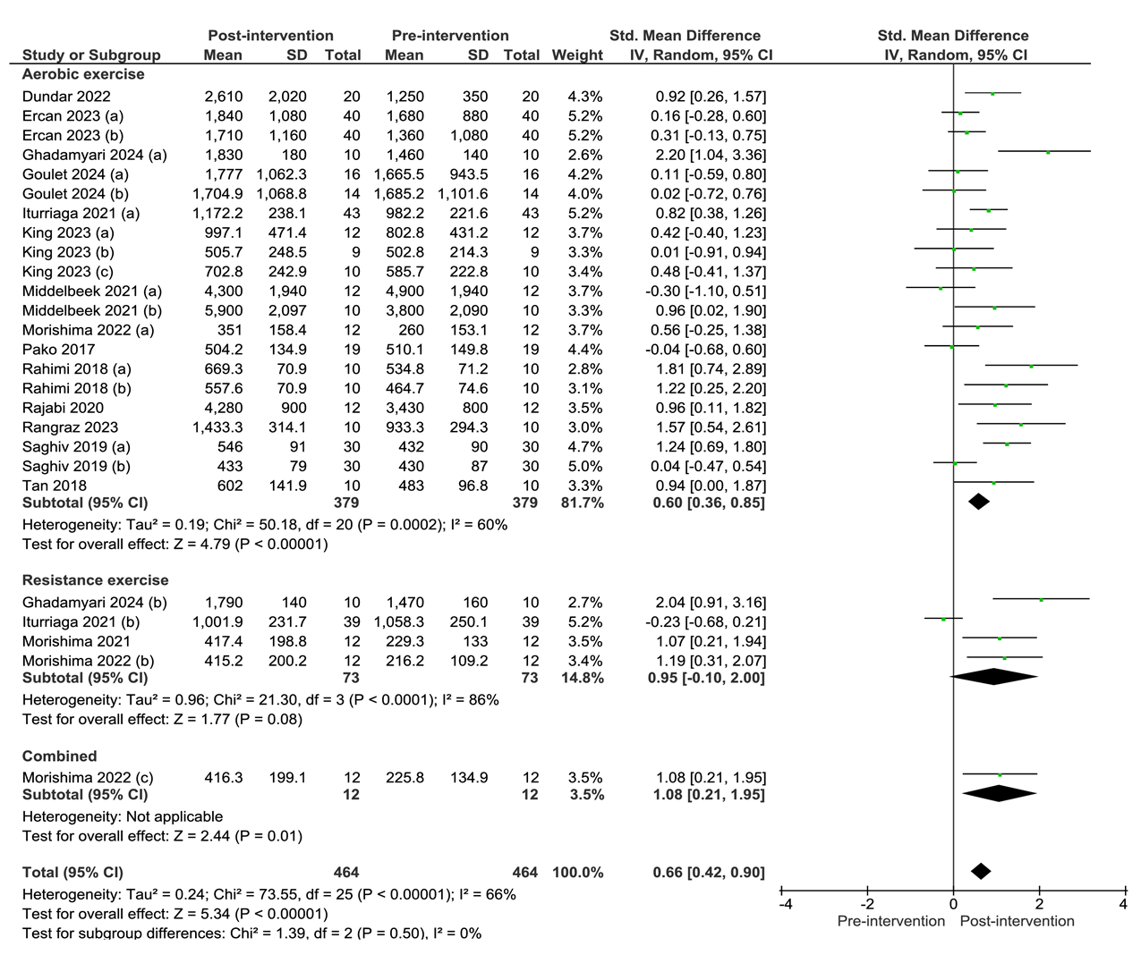

Supplementary Material 4. Forest plot of comparison: pre-intervention versus post-intervention; outcome: serum klotho concentration after acute and subacute aerobic exercise, resistance exercise or combination. SD = standardized deviation; STD = standardized; CI = confidence interval.

