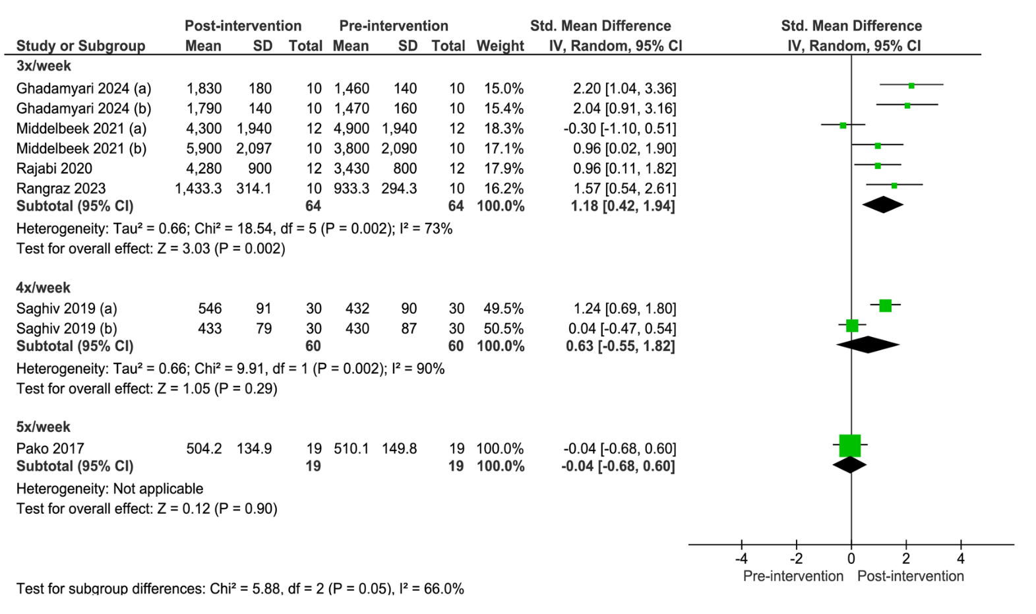

Supplementary Material 5. Forest plot of comparison: pre-intervention versus post-intervention; outcome: serum klotho concentration after subacute exercise performed 3, 4 or 5 times per week. SD = standardized deviation; STD = standardized; CI = confidence interval.

