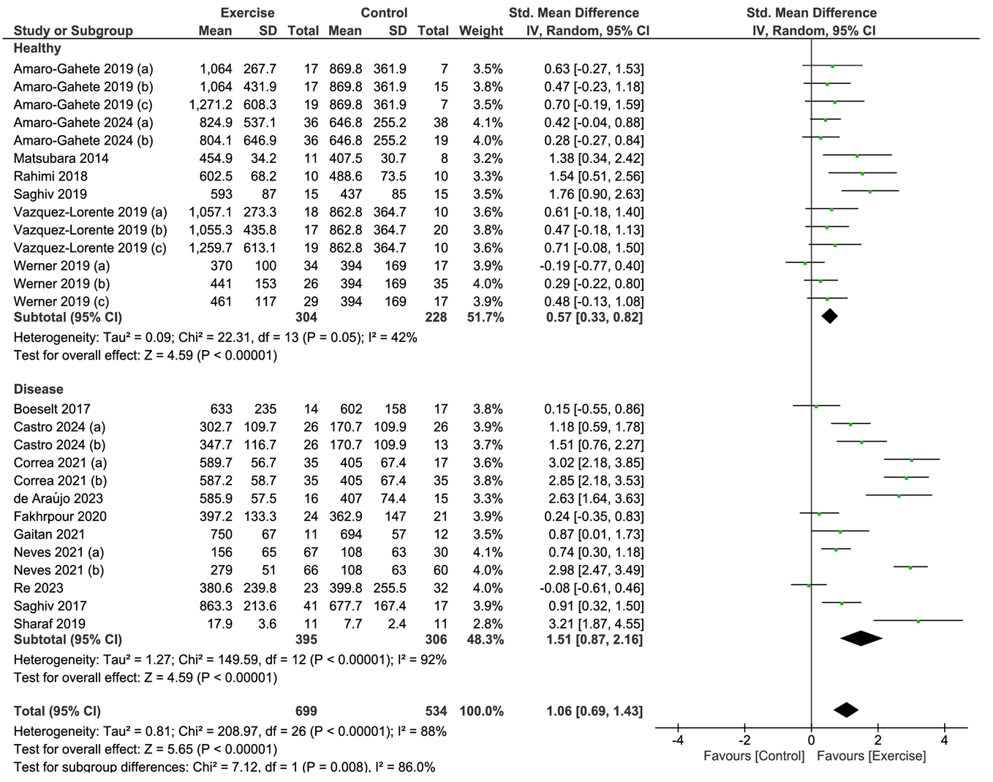

Supplementary Material 6. Forest plot of comparison: exercise versus control; outcome: serum klotho concentration in healthy and diseased subjects after chronic exercise. SD = standardized deviation; STD = standardized; CI = confidence interval.

