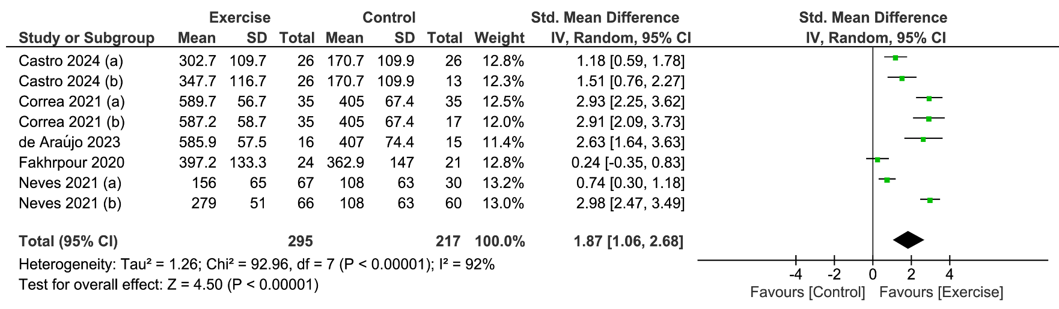

Supplementary Material 7. Forest plot of comparison: pre-intervention versus post-intervention; outcome: serum klotho concentration after chronic exercise on subjects with chronic kidney disease. SD = standardized deviation; STD = standardized; CI = confidence interval.

