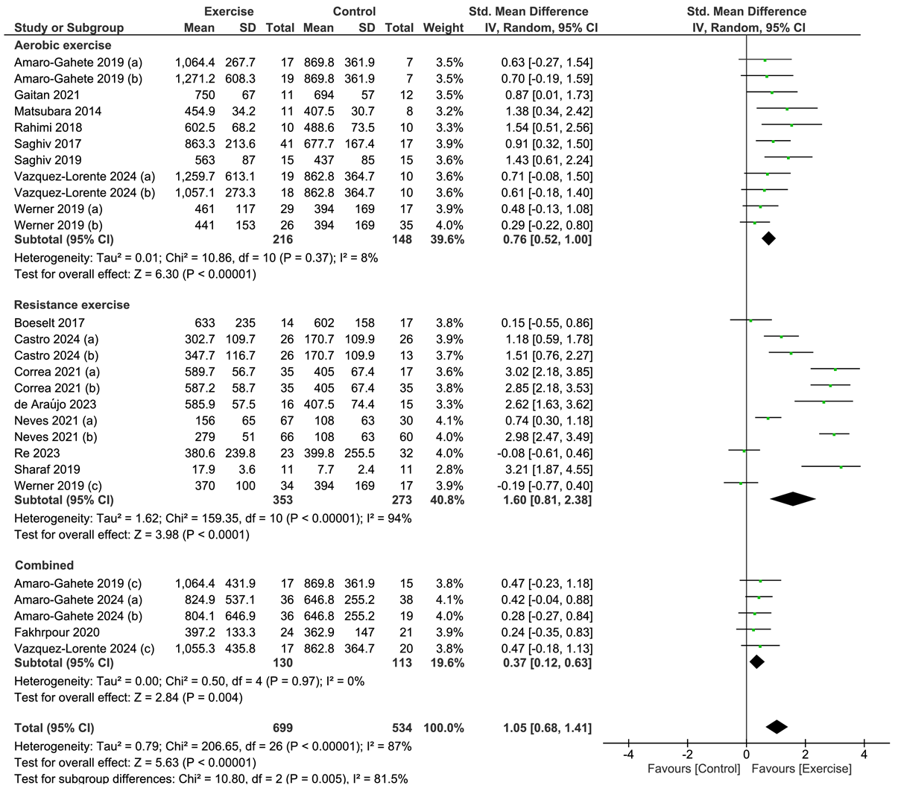

Supplementary Material 8. Forest plot of comparison: exercise versus control; outcome: serum klotho concentration after chronic aerobic exercise, resistance exercise or combination. SD = standardized deviation; STD = standardized; CI = confidence interval.

