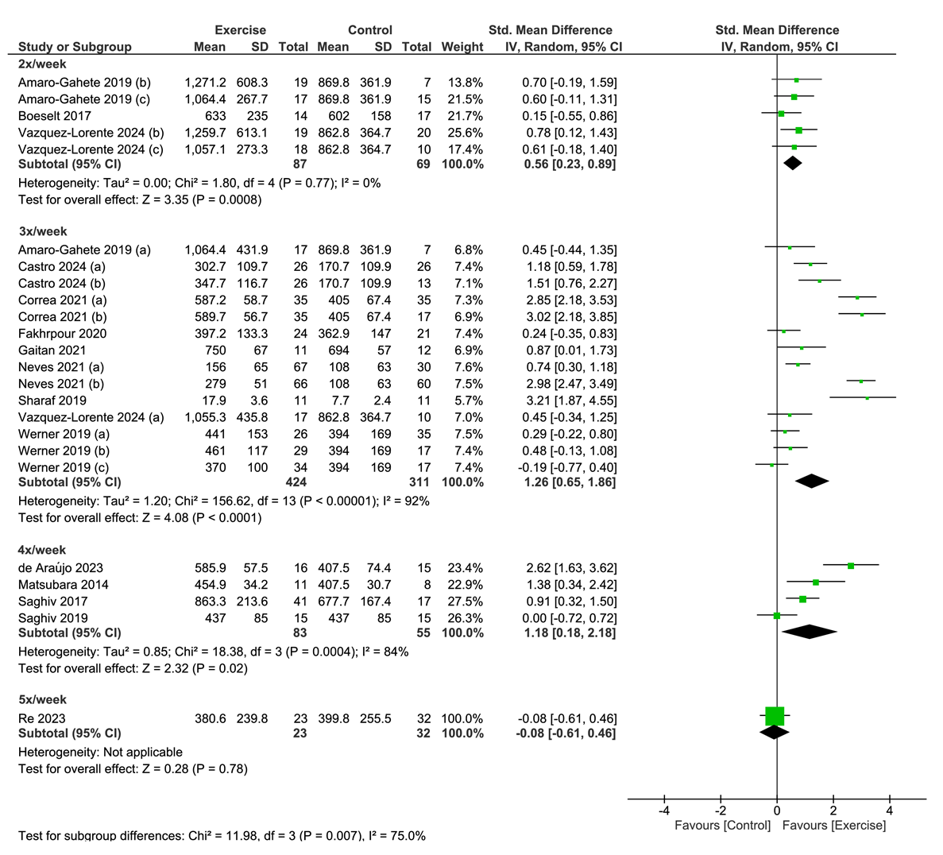

Supplementary Material 9. Forest plot of comparison: exercise versus control; outcome: serum klotho concentration after chronic exercise performed 2, 3, 4 or 5 times per week. SD = standardized deviation; STD = standardized; CI = confidence interval.

