Electronic supplementary material to

To what extent does the detection of climate change in Hungary depend on the choice of statistical methods?

Izsák Beatrix^{1*,2}, Szentimrey Tamás³
¹* Hungarian Meteorological Service, Unit of Climatology, Hungary, 1024 Budapest Kitaibel Pál u.1
² ELTE Faculty of Science, Doctoral School of Earth Sciences Budapest, Hungary
³Varimax Limited Partnership Budapest, Hungary
*Correspondence, izsak.b@met.hu (IB)

S.1. Comparison of series

The problem of the comparison of series turns on the issues of reference series creation, difference series constitution, multiple comparisons of series, etc. The main problem arises from the fact that the shape of the climate change signal is unknown. Therefore, so-called difference series are examined in order to filter out the climate change signal $μ(t)$.
Assuming that $X_{j}\left(t\right)$ is the candidate series and the others are the reference series, the difference series belonging to the candidate series can be constituted as
$Z_{j}\left(t\right)=X_{j}\left(t\right)-\sum_{i≠j}{λ_{ji}}X_{i}\left(t\right)=IH_{j}\left(t\right)-\sum_{i≠j}{λ_{ji}}IH_{i}\left(t\right)+ε_{Z_{j}}\left(t\right)$ (1)
by the condition $\sum_{i≠j}{λ_{ji}}=1$ for the weighting factors. As a result of the last condition, the unknown climate change signal $μ(t)$ has been filtered out. Consequently, any inhomogeneities can be detected via the examination of the above difference series. In addition, if an increase in the signal to noise ratio is required in order to increase the power of detection, then it is necessary to decrease the variance of the noise term $ε_{Z_{j}}\left(t\right)$. The optimal weighting factors $λ_{ji}$ that minimize the variance are determined by the spatial covariance matrices $C$ uniquely (Cressie 1991, Szentimrey 2006b).

S.2. Methodology for break point (changepoint) detection

One of the basic tasks of homogenization is the examination of difference series in order to detect the break points and to attribute them to the candidate series. The key question in the homogenization software is the development of automatic procedures to be applied to this attribution problem. The basic types of detection procedures are stepwise and multiple break point detection. The methods based on Bayesian model selection are the penalized likelihood methods. These methods are different in the penalty terms or criteria, e.g., Akaike criterion, Schwarz criterion, Caussinus-Lyazrhi criterion. The PRODIGE, HOMER, and ACMANT procedures (Caussinus and Mestre, 2004) based on the Caussinus-Lyazrhi criterion is an example of the penalized likelihood methods.
Another possibility is the use of hypothesis test methods for the detection of break points. In the MASH method (Szentimrey, 1999) a hypothesis test procedure was developed, as is desirable to avoid type one errors, that is, damage to a data series. The essence of this multiple break point detection procedure based on test of hypothesis at a given significance level is as follows.
If the detected break points of $Z(t)$ are $\hat{K}; {\hat{T}}_{1}<{\hat{T}}_{2}<.....<{\hat{T}}_{\hat{K}}$, then at the given significance level p (e.g.: p=0.1):
i, $Z(t)$ is not homogeneous above the intervals $({\hat{T}}_{k-1},{\hat{T}}_{k+1}]$ because,
$P \left( ∃\left({\hat{T}}_{k-1},{\hat{T}}_{k+1}\right] \text{above w}\text{itch Z(t) is homogeneous} \right)=p$
Consequently the detected break points ${\hat{T}}_{k}$ are not superfluous.
This means there is no serious type one error.
ii, $Z(t)$ can be accepted as homogeneous above the intervals $({\hat{T}}_{k-1},{\hat{T}}_{k}]$.
This means there is no serious type two error.
Confidence intervals are also given for the break points beside the point estimation in the MASH method (Szentimrey, 2014).

S.3. Methodology for correction of series

Beside detection, another basic task of homogenization is the correction of series. The calculation of correction factors can be based on the examination of difference series for estimation of shifts $IH\left({\hat{T}}_{k}\right)-IH\left({\hat{T}}_{k}+1\right)$ $\left(k=1,...,\hat{K}\right)$ at the detected break points. Almost all methods use point estimation for the correction factors at the detected break points. For example, the PRODIGE, HOMER, and ACMANT methods (Caussinus and Mestre, 2004) use the standard least squares technique for joint estimation of the correction factors. Probably the generalized least squares estimation technique based on spatial covariance structure would be more efficient. The MASH procedure (Szentimrey, 1999; Szentimrey 2014) is an exception because the correction factors are estimated on the basis of confidence intervals. The confidence intervals given for the break points and shifts also enable the automatic usage of metadata in MASH.

S.4 Modeling (MISH)

A possibility peculiar to meteorology is the use of the long meteorological data series for modeling of the climate statistical parameters in question. These data series make it possible to know the climate in accordance with the fundamentals of statistical climatology.
If some meteorological stations $S_{k} \left(k=1,..,K\right)$ $\left(S ∈D\right)$ have long data series, then the spatial trend differences $E\left(S_{k}\right)-E\left(S_{l}\right)$ $\left(k,l=1,...,K\right)$ as well as the covariances $\text{cov}\left(Z\left(S_{k}\right),Z\left(S_{l}\right)\right)$ $\left(k,l=1,...,K\right)$ can be estimated statistically. Consequently, these parameters are essentially known and provide much more information for modeling than the predictors $Z\left(s_{i},t\right) \left(i=1,...,M\right)$ only (Szentimrey and Bihari, 2007).
Change over the total period (°C)

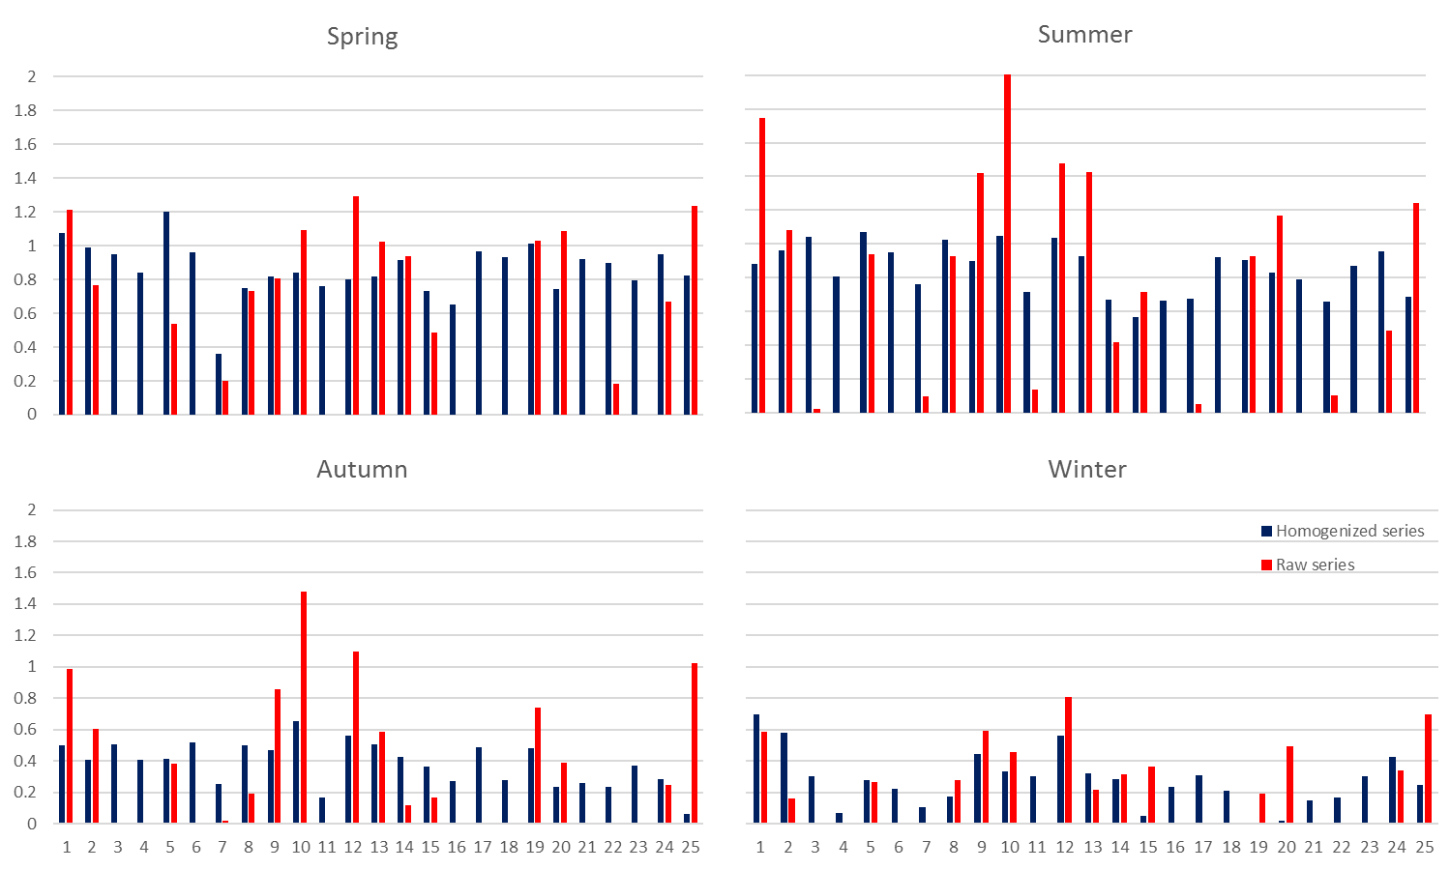
Station number

C
D
B
A
Fig. S1. Station data of seasonal mean temperature, homogenized series and raw series
Change over the total period, α=0.9 confidence level estimation ${\hat{c}}_{2_{α}}$ (n-1), 1901-2018 (°C)
Spring (A), Summer (B), Autumn (C), Winter (D)

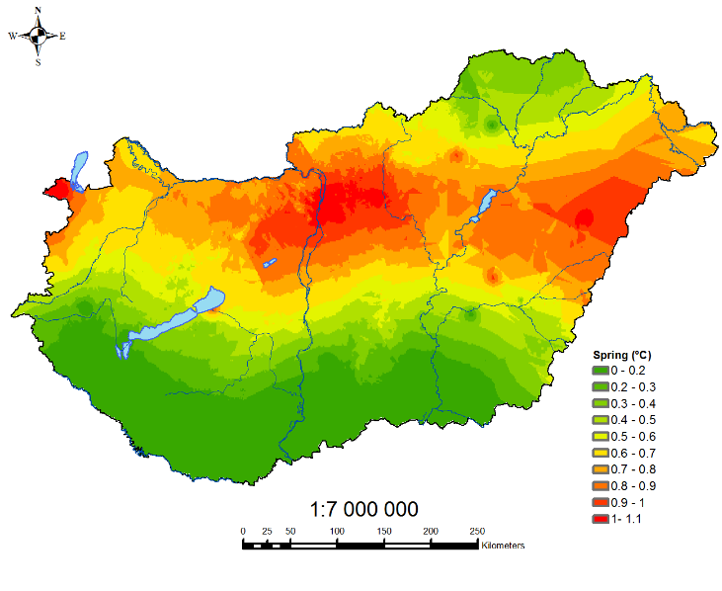
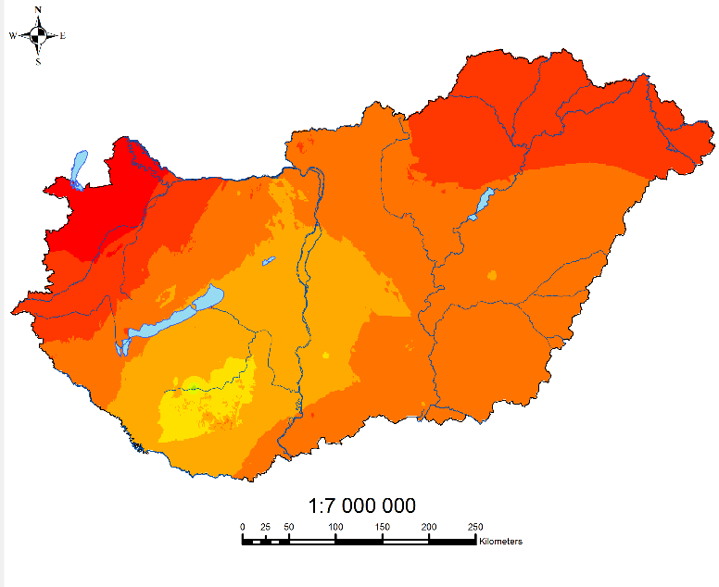
Fig. S2. Spring mean temperature, homogenized series (left) and raw series (right): Change over the total period, α=0.9 confidence level estimation ${\hat{c}}_{2_{α}}$ (n-1), 1901-2018 (°C)

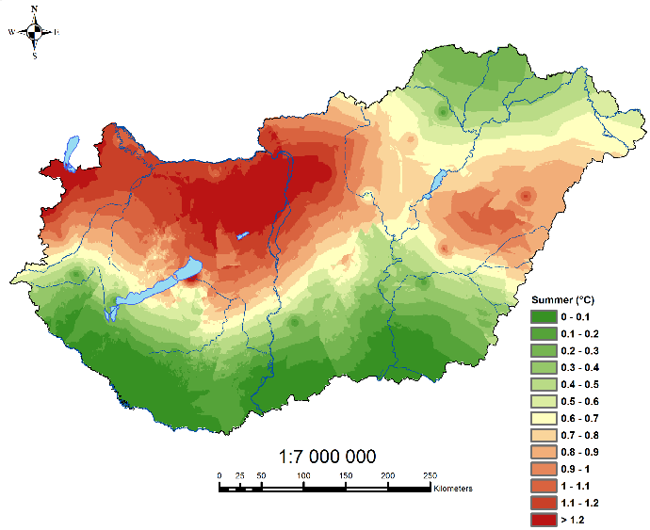
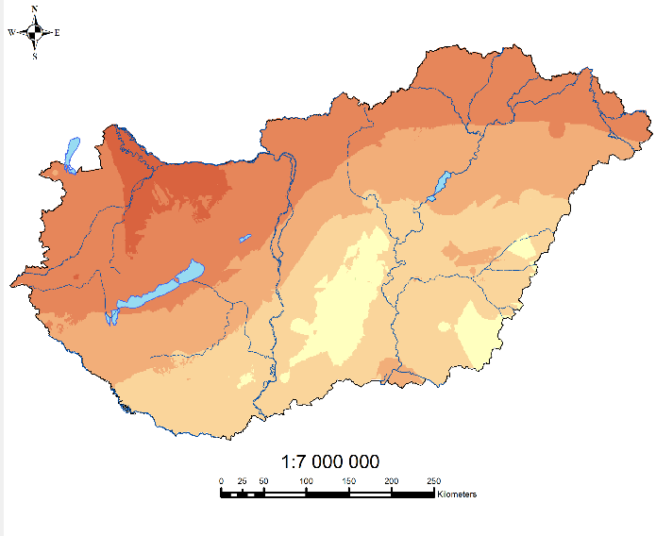
Fig. S3. Summer mean temperature, homogenized series (left) and raw series (right): Change over the total period, α=0.9 confidence level estimation ${\hat{c}}_{2_{α}}$ (n-1), 1901-2018 (°C)

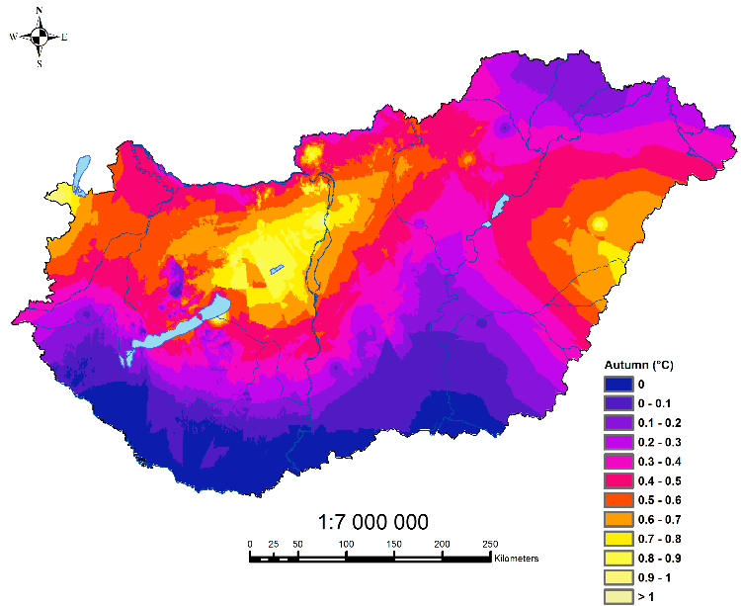
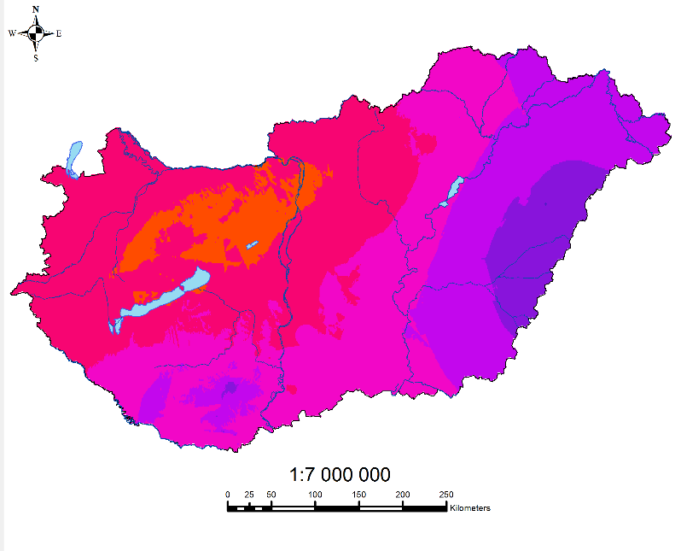
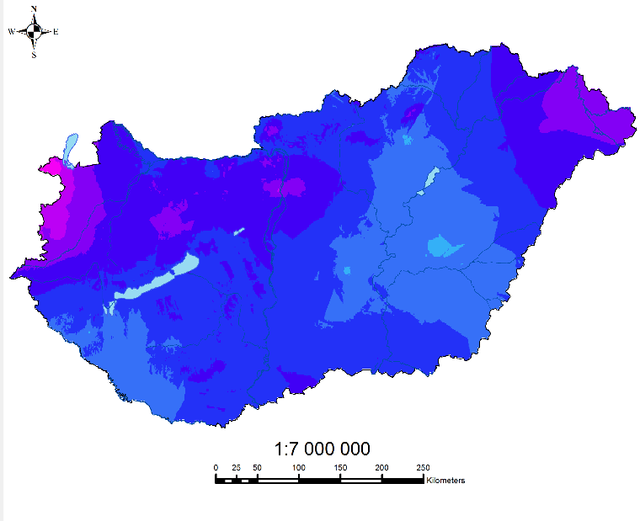
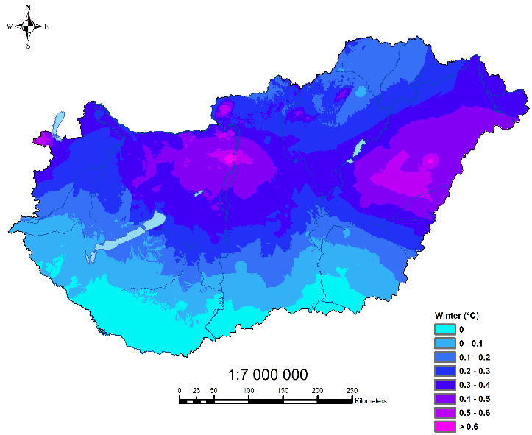
Fig. S5. Winter mean temperature, homogenized series (left) and raw series (right): Change over the total period, α=0.9 confidence level estimation ${\hat{c}}_{2_{α}}$ (n-1), 1901-2018 (°C)

Fig. S4. Autumn mean temperature, homogenized series (left) and raw series (right): Change over the total period, α=0.9 confidence level estimation ${\hat{c}}_{2_{α}}$ (n-1), 1901-2018 (°C)

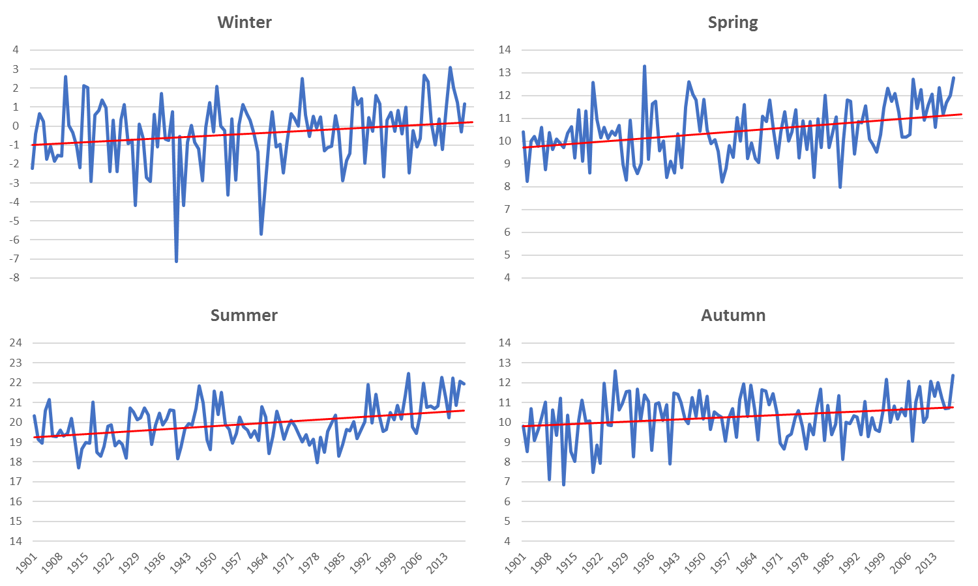
Fig. S6. Homogenized series: Seasonal mean temperature, national average, 1901-2018 (°C) and the fitted trendlines, Winter (A), Spring (B), Summer (C), Autumn (D)
Temperature (°C)

A
B
C
D
References
Cressie, N.: Statistics for Spatial Data. 900p. Wiley, New York (1991)
Caussinus, H., Mestre, O.: Detection and Correction of Artificial Shifts in Climate Series. Journal of the Royal Statistical Society. Series C (Applied Statistics) 53(3), 405-425 (2004)
Szentimrey, T., Bihari, Z.: Mathematical background of the spatial interpolation methods and the software MISH (Meteorological Interpolation based on Surface Homogenized Data Basis). In: Szalai, S., Bihari, Z., Szentimrey, T., Lakatos, M. (eds.) COST Action 719 -The Use of Geographic Information Systems in Climatology and Meteorology. Proceedings from the Conference on spatial interpolation in climatology and meteorology. 25-29 October 2004, Budapest, Hungary, pp. 17-28. COST Office (2007)
Szentimrey, T.: Multiple Analysis of Series for Homogenization (MASH). In: Szalai, S., Szentimrey, T., Szinell, C. (eds.) Proceedings of the second Seminar for Homogenization of Surface Climatological Data. Seminar for Homogenization of Surface Climatological Data, 2nd session (9-13 November 1998), Budapest, Hungary, WCDMP-No. 41. pp. 27-46. World Meteorological Organization (WMO) (1999)
Szentimrey, T.: An Overview on the Main Methodological Questions of Homogenization. In: Lakatos, M., Szentimrey, T., Bihari, Z., Szalai, S. (eds.) Proceedings of the Fifth Seminar for Homogenization and Quality Control in Climatological Databases. Seminar for Homogenization and Quality Control in Climatological Databases 5th session (29 May – 2 June 2006; Budapest, Hungary). WMO/TD- No. 1493; WCDMP- No. 71, pp. 1-6. World Meteorological Organization (WMO) (2006b)
Szentimrey, T.: Manual of homogenization software MASHv3.03. In. Hungarian Meteorological Service, Budapest, Hungary, (2014)
Szentimrey, T., Bihari, Z.: Manual of interpolation software MISHv1.03. p. 89. Hungarian Meteorological Service, Budapest, Hungary, (2014)
Szentimrey, T., Bihari, Z and Lakatos, M: Mathematical questions of spatial interpolation of climate variables. In: Lakatos, M., Szentimrey, T., Marton, A. (eds.) Eighth Seminar for Homogenization and Quality Control in Climatological Databases and Third Conference on Spatial Interpolation Techniques in Climatology and Meteorology 2014. WCDMP-No. 84, pp. 107-114. World Meteorological Organization (WMO) (2014)

