APPENDIX

TASK A

Screen #1
Read carefully the following information about the context in which the scene––you will see in the video––takes place.
Context information
The video shows a scene from a 3rd grade mathematics lesson, in which the students are solving a worksheet with tasks and word problems involving subtraction with and without regrouping.

What has happened in previous lessons?
Students have solved tasks on subtraction with and without regrouping using concrete and pictorial representations and the place value table. They have also applied knowledge of number composition and decomposition to written computation strategies. Understanding of the decimal system and the concept of subtraction are considered as prior knowledge, which should already have been acquired.
The following error appears in one of the last lessons, when students are applying what they have learnt to solve tasks on a worksheet.

Screen #2
Watch carefully the video. You may take notes of the aspects that seem relevant to you.



Screen #3

Lucas’ work looks like this:
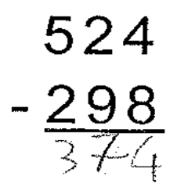
Please describe briefly the procedure used by Lucas to solve this subtraction task.

Using the same pattern of thinking, what would be Lucas’ answers to the following tasks?

253
- 172

745
- 487

Screen #3

It is possible to state that Lucas has subtracted in the following way:

i. subtracts the units and records it.
ii. subtracts the tens and records it.
iii. subtracts the hundreds and records it.
iv. in each case, he always subtracts the smallest digit from the largest

Please suggest, from a mathematics didactics perspective, three possible causes for this error.

Cause 1

Cause 2

Cause 3

TASK B

Screen #1
Read carefully the following information about the context in which the scene––you will see in the video––takes place.
Context information
The video shows a scene from a 3rd grade mathematics lesson, in which the students are solving a group of addition tasks with and without regrouping.

What has happened in previous lessons?
Students have solved addition with and without regrouping using concrete and pictorial representations and the place value table. They have also used nontraditional computation strategies and applied knowledge of number composition and decomposition to written computation strategies. Understanding of the decimal system and the concept of addition are considered as prior knowledge, which should already have been acquired. The following error appears in the lesson that is intended to move towards consolidation of the written algorithm.

Screen #2
Watch carefully the video. You may take notes of the aspects that seem relevant to you.

Screen #3

This is Isabel’s work:
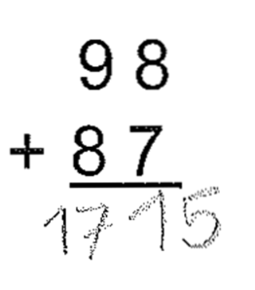
Please describe briefly Isabel’s procedure to solve this addition task.

Using the same pattern of thinking, what would be Isabel’s answers to the following tasks?

53
+ 78

27
+ 45

Screen #4

It can be stated that Isabel has added in the following way:

 | T | U
 | c | a
+ | d | b
 | c+d | a+b

Please suggest, from a mathematics didactics perspective, three possible causes for this error.

Cause 1

Cause 2

Cause 3

TASK C

Screen #1
Read carefully the following information about the context in which the scene––you will see in the video––takes place.
Context information
The video shows a scene from a 3rd grade student, who is solving subtraction tasks with and without regrouping, with numbers up to 999.

What has happened in previous lessons?
Students have worked on addition and subtraction tasks with and without regrouping, using concrete and pictorial representations and the place value table. In previous lessons and also in previous years, they have worked on the comprehension of the decimal number system and the concepts of addition, subtraction and multiplication.
The following error appears in one of the last lessons of the unit on addition or subtraction with whole numbers, when students are applying what they have learnt to solve tasks.

Screen #2
Watch carefully the video. You may take notes of the aspects that seem relevant to you.

Screen #3

Carlos’ work looks like this:
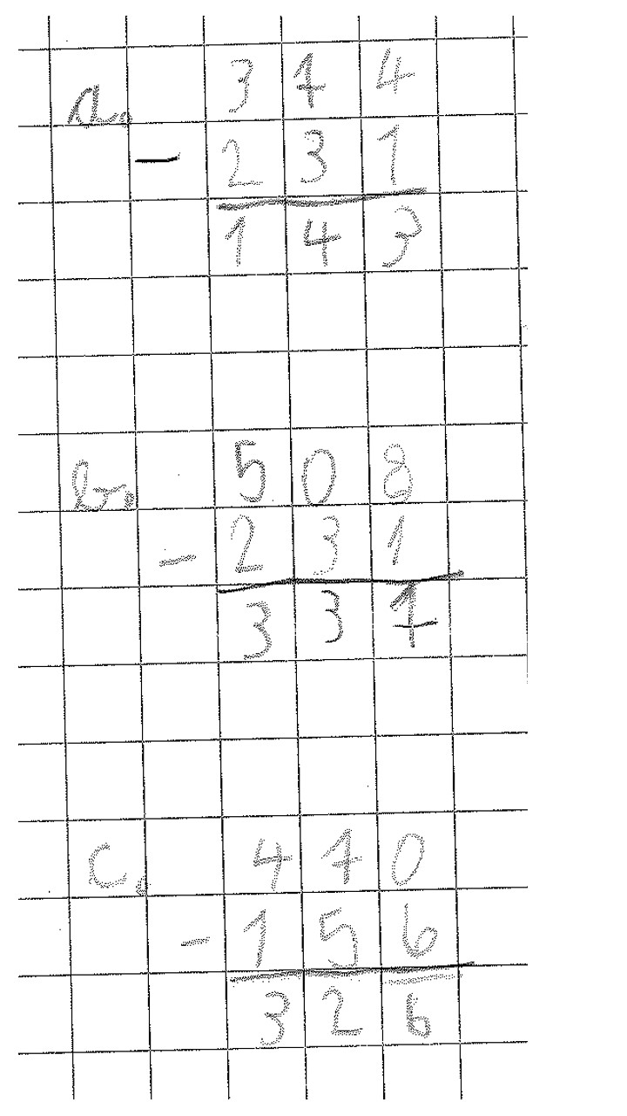

Please describe briefly the procedure used by Carlos to solve this subtraction task.

Using the same pattern of thinking, what would be Carlos’ answers to the following tasks?

305
- 142

530
- 237

Screen #4

It is possible to state that when Carlos finds a zero in one of the place value columns of the minuend, he uses the digit of the subtrahend as a result.

Please suggest, from a mathematics didactics perspective, three possible causes for this error.

Cause 1

Cause 2

Cause 3

TASK D

Screen #1
Read carefully the following information about the context––in which the scene you will see in the video––takes place.
Context information
The video shows a scene from a 3rd grade mathematics lesson, in which students are writing numbers up to 999 dictated by the teacher.

What has happened in previous lessons?
Starting from the knowledge obtained in the previous grades about the decimal number system, students have been representing numbers up to 1000 in a concrete (using base-10 blocks), pictorial and symbolic way.
They have also composed and decomposed numbers in the numerical domain up to 1000.
The dictation takes place after three sessions in which the work with concrete material has ceased, to give way to the pictorial and symbolic levels of representation.

Screen #2
Watch carefully the video. You may take notes of the aspects that seem relevant to you.

Screen #3

Cristian’s work looks like this:
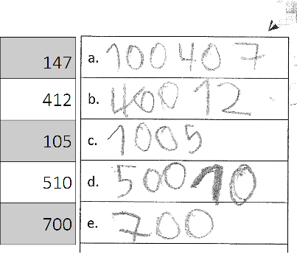

Please describe briefly the thinking applied by Cristian to write the numbers dictated by the teacher.

Using the same pattern of thinking, what would Cristian write if the teacher dictates the following numbers?

253

315

Screen #4

It is possible to state that Cristian writes numbers according to how they are verbalized. For example, when the teacher says:

two-hundreds thirty five, he writes:

200 30 5

Please suggest, from a mathematics didactics perspective, three possible causes for this error.

Cause 1

Cause 2

Cause 3

