How Do Multiplicative and Relational Thinking Contribute to Multidigit Division?
Andreas Schulz
Appendix A: Rasch analysis
The advantage of the one-dimensional Rasch model is that both the competency distribution and the item difficulties are mapped on a joint scale (logits, cf. equation 1) (Briggs & Wilson, 2003).
Equation 1 (Rasch model): P_{in} = $\frac{\exp{(θn-δi)}}{1+\exp{(θn-δi)}}$,
where θ_{n} is the ability of person n, and δ_{i} the difficulty of item i. P_{in} is the probability of success of person n on item i.
The fit of the Rasch model indicates that the sum score is a sufficient statistic for the parameter of a one-dimensional model and that the set of items can be ordered in a reproducible hierarchy in a kind of probabilistic Guttman scaling (Andrich, 1985). The ordering of the items according to their difficulty and their mapping on the joint scale allows for the identification of distinguishable proficiency levels of item difficulties for dichotomous items respectively thresholds for polytomous items (Combrinck et al., 2017; N. Wang, 2003). As students’ proficiencies are mapped on the joint scale too, such levels of item difficulties can be associated with levels of students’ proficiencies, in the following way: If the difficulty parameter of an item i equals the ability parameter of a person n, then the probability of person n of answering item i correctly is 0.5. If the ability parameter of person n is bigger than the difficulty parameter of a specific item i, then the probability of person n answering item i correctly is greater than 0.5, and vice versa. Accordingly, an item with a difficulty parameter δ_{i} at the lower boundary of an identified level may be used as a dividing line between two levels (cf. Cizek et al., 2004; N. Wang, 2003, p. 239): Students with lower ability parameters θ_{n} than δ_{i} are allocated to the lower proficiency level (‘cannot do’), and students with an ability θ_{n} greater than or equal to δ_{i} are allocated to the higher proficiency level (‘can do’).
The multidimensional random coefficients multinomial logit (MRCML) model (Adams et al., 1997) is an extension of the one-dimensional dichotomous Rasch model and allows for the multidimensional scaling of items with ordered categories (Briggs & Wilson, 2003; W. Wang et al., 1997). The parameters of the items (item difficulty estimates respectively thresholds) and persons (WLE estimates) were calculated using ConQuest software. WMNSQ values <1.2 indicate good item fit, values <1.3 are acceptable (Wright & Linacre, 2020; Wright et al., 1994).
Generally, MRCML models are more efficient in terms of model fit and reliability indices than separate one-dimensional models. They can also be applied to investigate scale interrelationships, and their parameters yield interpretations within one-dimensional model frameworks (Briggs & Wilson, 2003; W. Wang et al., 1997; Wu & Adams, 2006).
Appendix B: Multiplicative Thinking (MT) (translated)
Here is a picture of three fishes.
In reality, their length is …

Figure 2 - appendix
Picture for the measurement of MT (Clark & Kamii, 1996)

Fish A: 5 cm Fish B: 10 cm Fish C: 15 cm

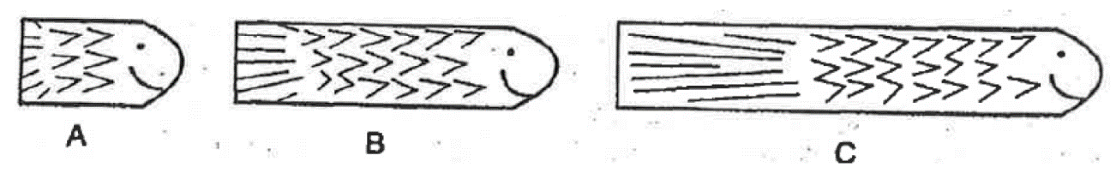

Fish B gets two times as many mosquitoes as fish A, because it is two times as long.
Fish C gets three times as many mosquitoes as fish A, because it is three times as long.

MT 1a, b) Fish A gets one mosquito.
How many mosquitoes do the other two fishes get?

Fish A | Fish B | Fish C
1 mosquito

MT 2a, b) Fish B gets 4 mosquitoes.
How many mosquitoes do the other two fishes get?

Fish A | Fish B | Fish C
 | 4 mosquitoes

MT 3a, b) Fish C gets 9 mosquitoes.
How many mosquitoes do the other two fishes get?

Fish A | Fish B | Fish C
 |  | 9 mosquitoes

MT 4a, b) Fish A gets 7 mosquitoes.
How many mosquitoes do the other two fishes get?

Fish A | Fish B | Fish C
7 mosquitoes

Appendix C: Relational Thinking (RT) (translated)
A7.
Start with the number 5193. Count backwards in steps of a hundred.
5193; ________; ________; ________;

A8. Complete the sequences:
a) 400; 390; 370; 340; ____; ____; ____; 120
b) 15; 30; 60; 120; ____; ____; ____; 1920

A9. Find the missing numbers, so that the equation is correct:
a) 999 – 101 = 1000 – _______
b) 172 – 98 = _______ – 100

A10. Find all number pairs in the box, so that the calculation is correct.
Fill in the pairs in the blank gaps:
____ ∙ ____ = 750; ____ ∙ ____ = 750; ____ ∙ ____ = 750;

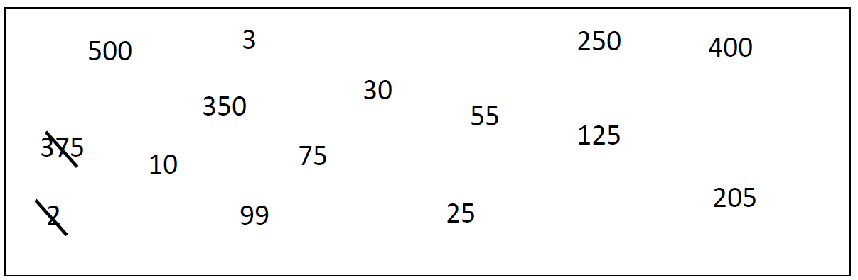
Example: 375 ∙ 2 = 750

A11.
98 021 ÷ 10 000
The result of the calculation is between …
◻ | 0 and 10
◻ | 10 and 100
◻ | 100 and 1 000
◻ | 1 000 and 10 000

A12. Find the missing numbers, so that the equation is correct:
a) 60 ∙ 370 = 6 ∙ _______
b) 5 ∙ 42 = 10 ∙ _______
c) 600 ÷ 30 = 1200 ÷ _______
d) 64 ÷ 14 = 32 ÷ _______

A13. Solve the calculations. Find two more calculations that match the sequence:
1 ∙ 48 = ____
2 ∙ 24 = ____
4 ∙ 12 = ____
___ ∙ ___ = ____
___ ∙ ___ = ____

References (Appendix)
Adams, R. J., Wilson, M [Mark], & Wang, W [Wen-chung] (1997). The Multidimensional Random Coefficients Multinomial Logit Model. Applied Psychological Measurement, 21(1), 1–23. https://doi.org/10.1177/0146621697211001
Andrich, D. (1985). An elaboration of Guttman scaling with Rasch models for measurement. Sociological Methodology, 15, 33. https://doi.org/10.2307/270846
Briggs, D., & Wilson, M [M.] (2003). An introduction to multidimensional measurement using Rasch models. Journal of Applied Measurement, 4(1), 87–100.
Cizek, G., Bunch, M., & Koons, H. (2004). Setting performance standards: Contemporary methods. Educational Measurement: Issues and Practice, 23(4), 31. https://doi.org/10.1111/j.1745-3992.2004.tb00166.x
Clark, F., & Kamii, C. (1996). Identification of multiplicative thinking in children in grades 1-5. Journal for Research in Mathematics Education, 27(1), 41–51.
Combrinck, C., Scherman, V., & Maree, D. (2017). The use of Rasch competency bands for reporting criterion-referenced feedback and curriculum-standards attainment. Perspectives in Education. Advance online publication. https://doi.org/10.18820/2519593X/pie.v34i4.5
Wang, N. (2003). Use of the Rasch IRT model in standard setting: An item‐mapping method. Journal of Educational Measurement, 40(3), 231–253.
Wang, W [W.], Wilson, M [M.], & Adams, R. (1997). Rasch models for multidimensionality between items and within items. In M. Wilson, G. Engelhard, & K. Draney (Eds.), Objective measurement: Theory into practice (Vol. 4, pp. 139–155). Ablex Publishing Corporation.
Wright, B., & Linacre, J. (2020). Reasonable mean-square fit values. https://www.rasch.org/rmt/rmt83b.htm
Wright, B., Linacre, J., Gustafson, J., & Martin-Lof, P. (1994). Reasonable mean-square fit values. Rasch Measurement Transactions, 8(3), 370.
Wu, M., & Adams, R. (2006). Modelling mathematics problem solving item responses using a multidimensional IRT model. Mathematics Education Research Journal, 18(2), 93–113.

