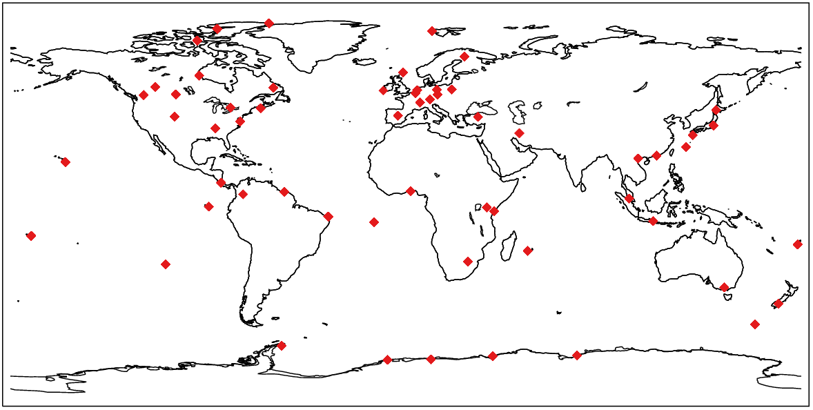
Online Resource 1. The map of locations of WOUDC stations used for the comparison of tropospheric ozone concentration. Red diamonds indicate individual WOUDC station.

