The East Asian Summer Monsoon Response to Global Warming in a High Resolution Coupled Model: Mean and Extremes

Zhen Liu^{1,2}, Sun-Seon Lee^{1,2}, Arjun Babu Nellikkattil^{1,2}, June-Yi Lee^{1,3,4}, Lan Dai^{1,2}, Kyung-Ja Ha^{1,3,4,5} and Christian L. E. Franzke^{1,2*}
¹ Center for Climate Physics, Institute for Basic Science, Busan, Republic of Korea
² Pusan National University, Busan, Republic of Korea
³ Department of Climate System, Pusan National University, Busan, Republic of Korea
⁴ Research Center for Climate Sciences, Pusan National University, Busan, Republic of Korea
⁵BK21 School of Earth and Environmental Systems, Pusan National University, Busan, Republic of Korea

*Corresponding Author: Christian L. E. Franzke, Center for Climate Physics, Institute for Basic Science, Busan, Republic of Korea. e-mail : christian.franzke@pusan.ac.kr
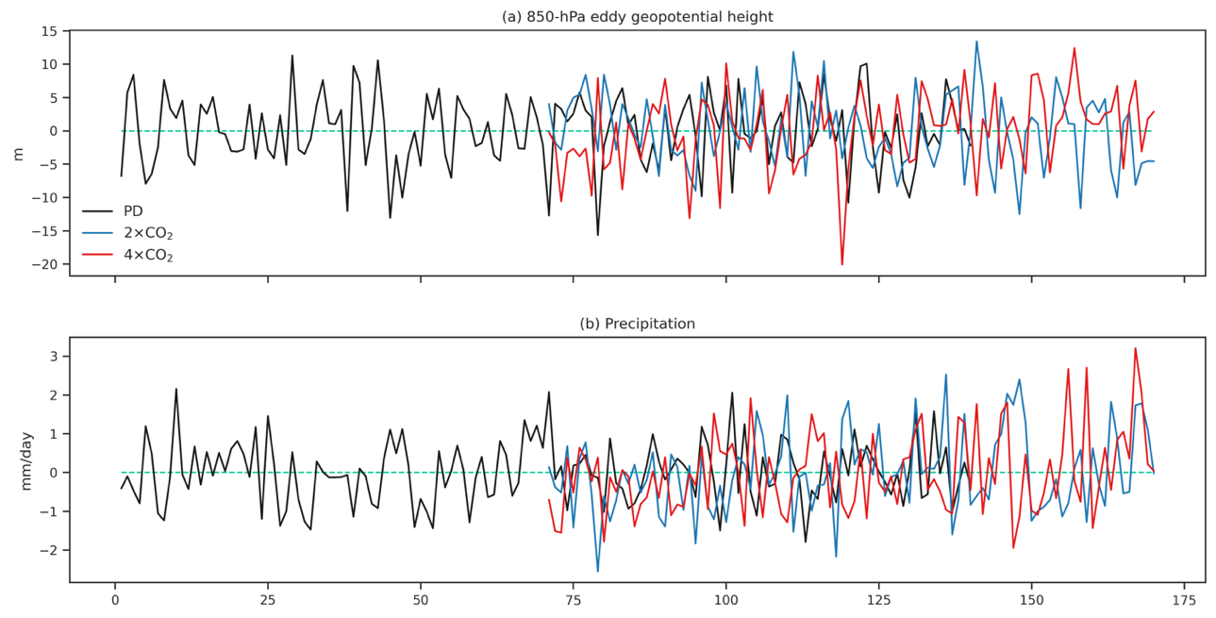
Fig. S1. Time series of (a) western Pacific subtropical high intensity defined as 850-hPa eddy geopotential height anomalies (m) averaged over 15°–30°N and 120°–150°E (Huang et al. 2015), (b) monsoon intensity defined as precipitation anomalies averaged over 27°–35°N, 105–125°E (Wang et al. 2008).

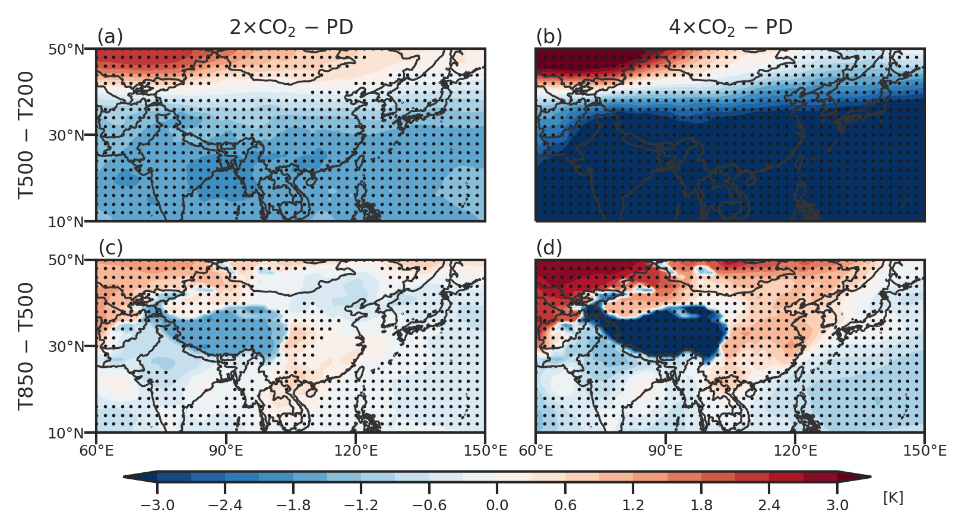
Fig. S2. The spatial distribution of summer changes in temperature differences (a) between 500 and 200 hPa (K) and (c) between 850 and 500 hPa between 2×CO₂ and PD simulation. (b, d) Same as (a, c) but for 4×CO₂ simulation. Black dots represent the changes at 0.05 significance level.
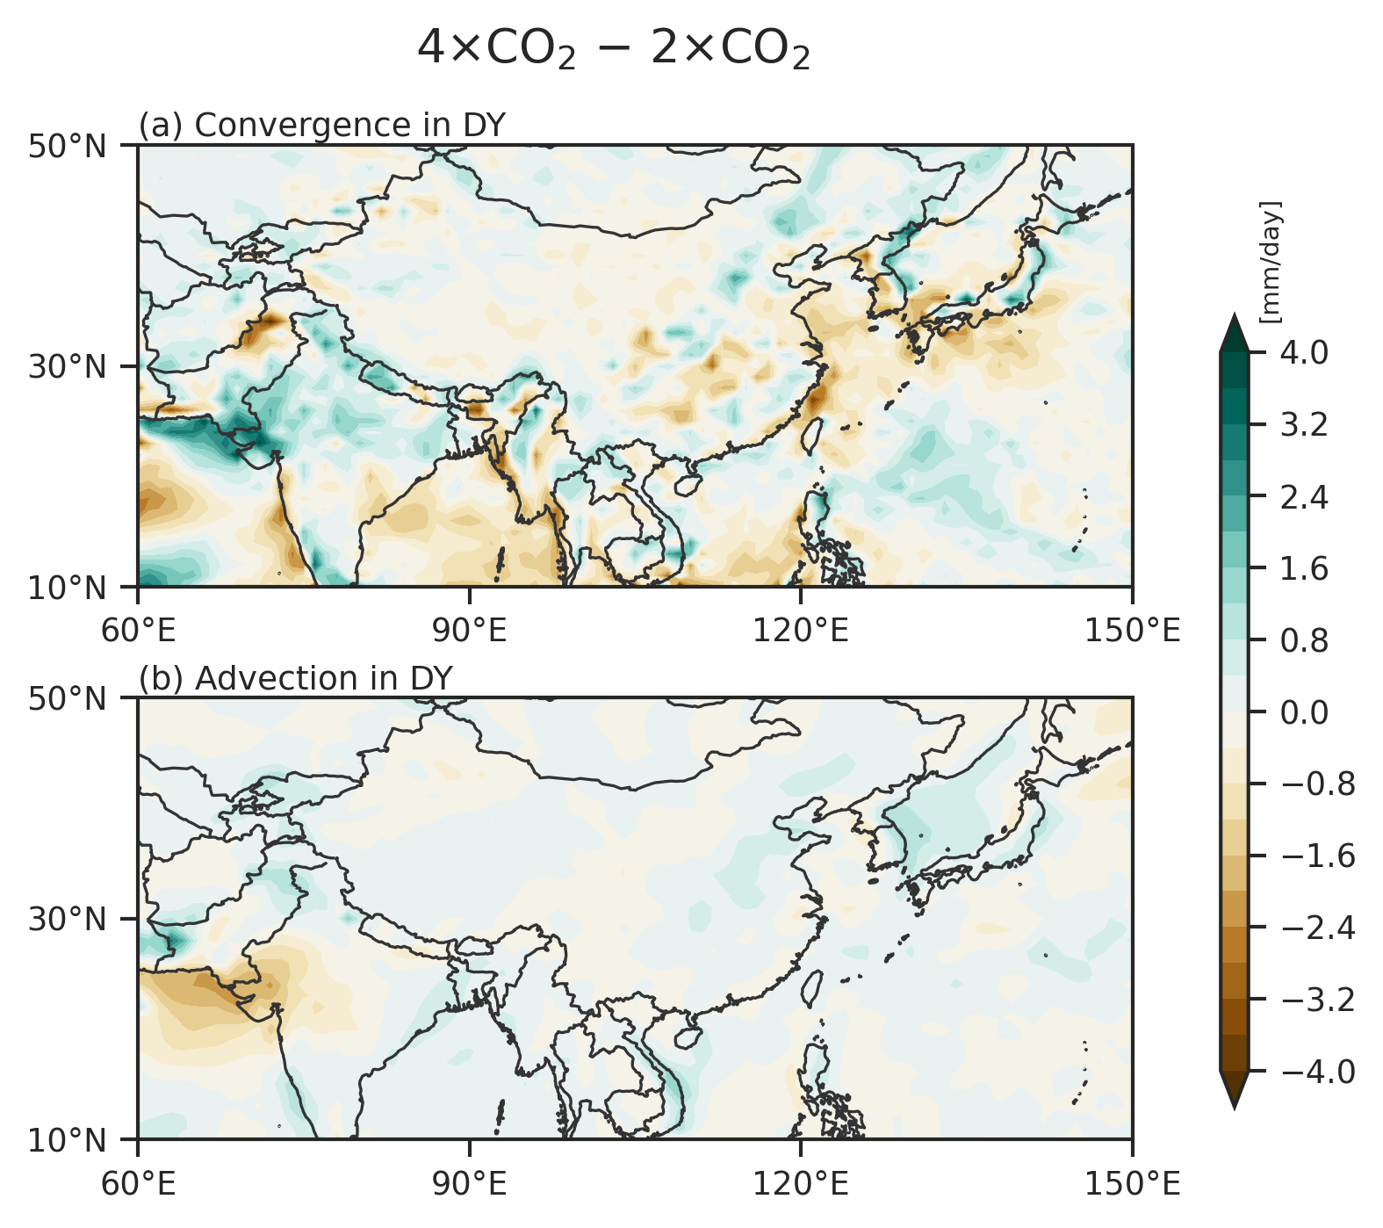

Fig. S3. Spatial distribution of changes (mm/day) in (a) convergence component and (b) advection component of dynamic term between 4×CO₂ and 2×CO_{2.}

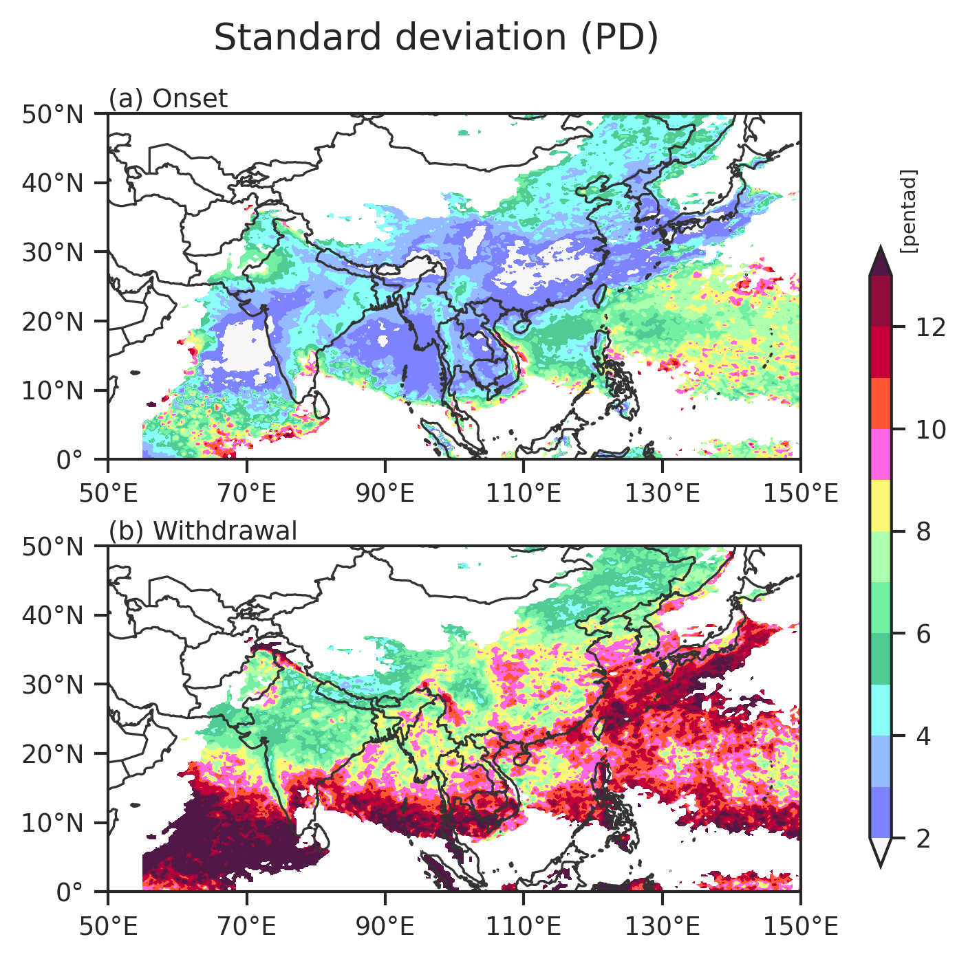
Fig. S4. The spatial distribution of the standard deviation of (a) onset and (b) withdrawal dates (pentad) in the PD experiment.

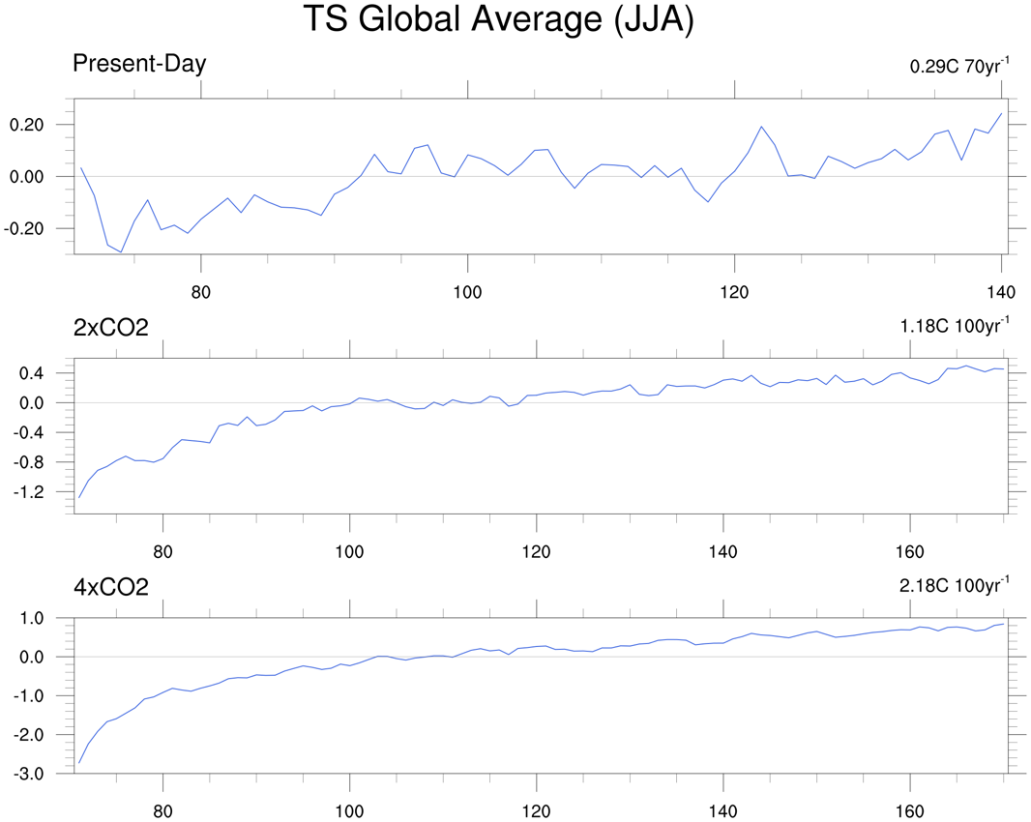
Fig. S5. The yearly global mean sea-surface temperature anomalies (°C) during the last 70 years (upper) in PD simulation and during the last 100 years in (middle) 2×CO₂ and (lower) 4×CO₂ simulations. The numbers in the upper-right corners denote the long-term trends.

References
Huang, Y., H. Wang, K. Fan, and Y. Gao, 2015: The western Pacific subtropical high after the 1970s: westward or eastward shift? Clim. Dyn., https://doi.org/10.1007/s00382-014-2194-5.
Wang, B., Z. Wu, J. Li, J. Liu, C. P. Chang, Y. Ding, and G. Wu, 2008: How to measure the strenght of the East Asian summer monsoon. J. Clim., https://doi.org/10.1175/2008JCLI2183.1.

