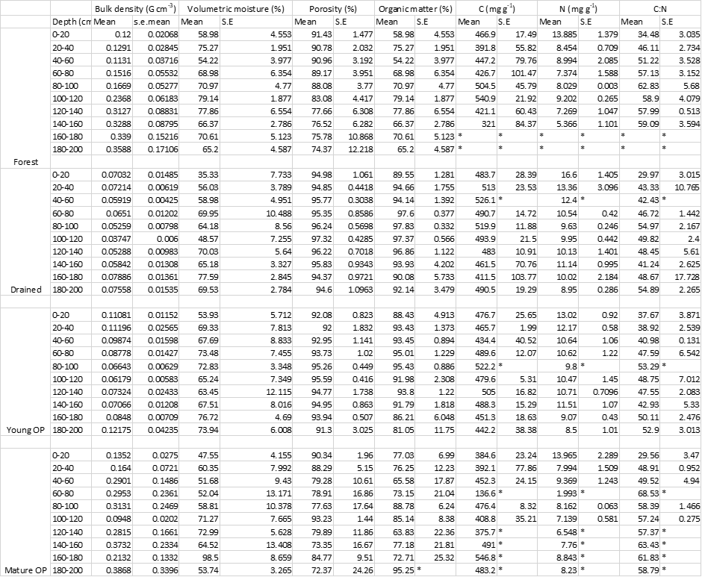Supplementary information table S1: mean values of peat properties along the depths of each 5 cores for each land-use type except Burnt land-use type.

Supplementary information table S2: Tukey’s multiple comparison test for each microbial groups and land-use type pairs showing the Difference value and their statistical significance. Note F denotes secondary forest, D denotes drained forest, B denotes Burnt peatlands, YOP denotes young oil palm plantations, MOP denotes Mature Oil palm plantations.

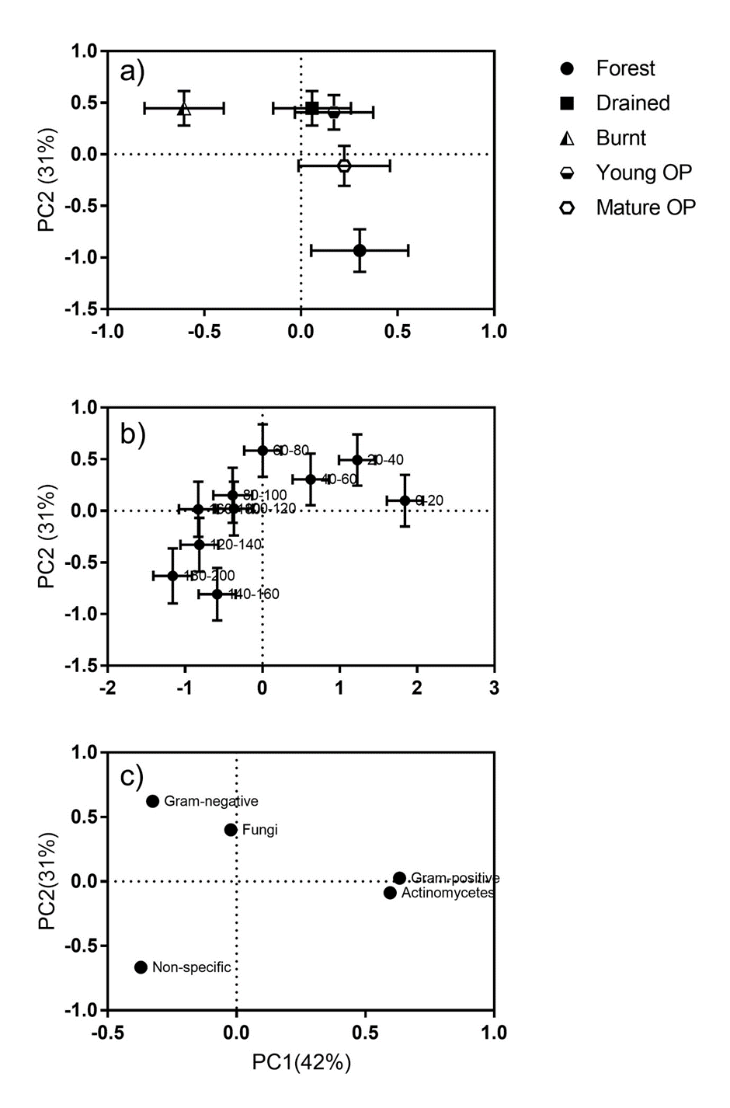
Supplemetal material fig S3: Effect of land-use type upon phenotypic structure of soil microbial communities determined by PLFA analysis, as shown by principal component (PC) analysis. (a) ordination of PC1 and 2 with respect to land-use type (OP = oil palm); (b) ordination of PC1 and 2 with respect to soil depth (point labels denote depth of sample in cm from surface; (c) associated loadings, point labels denote PLFA type. For (a, b) points denote means (n varies, see text), whiskers denote standard errors.

