Supplemental materials

Figures
Fig S1 Site characteristics, a) porewater constituents, b) leaf P and N concentrations
Fig S2 Chemometric fingerprints including 3 replicates from the Finkol Riverine site
Fig S3 f_{13C}/P vs. RGR

Tables
Table S1 Measured leaf data
Table S2 Measured bark data
Table S3 Measured soil data
Table S4 Measured porewater data
Table S5 Leaf averages by species
Table S6 Leaf averages for 2 site groups

Supplemental Figures

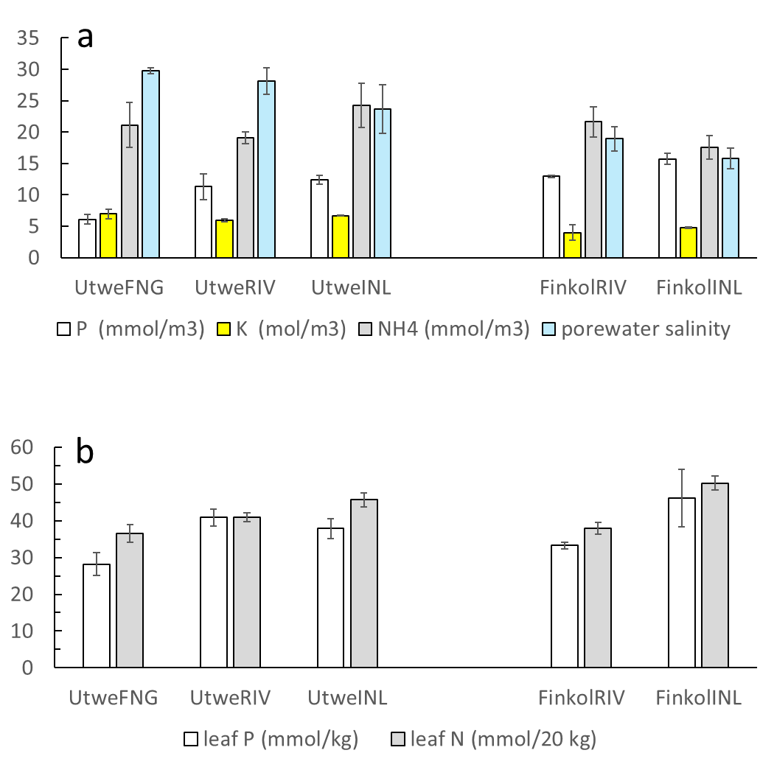

Fig. S1. Site characteristics, a) porewater constituents, b) leaf P and N concentrations.

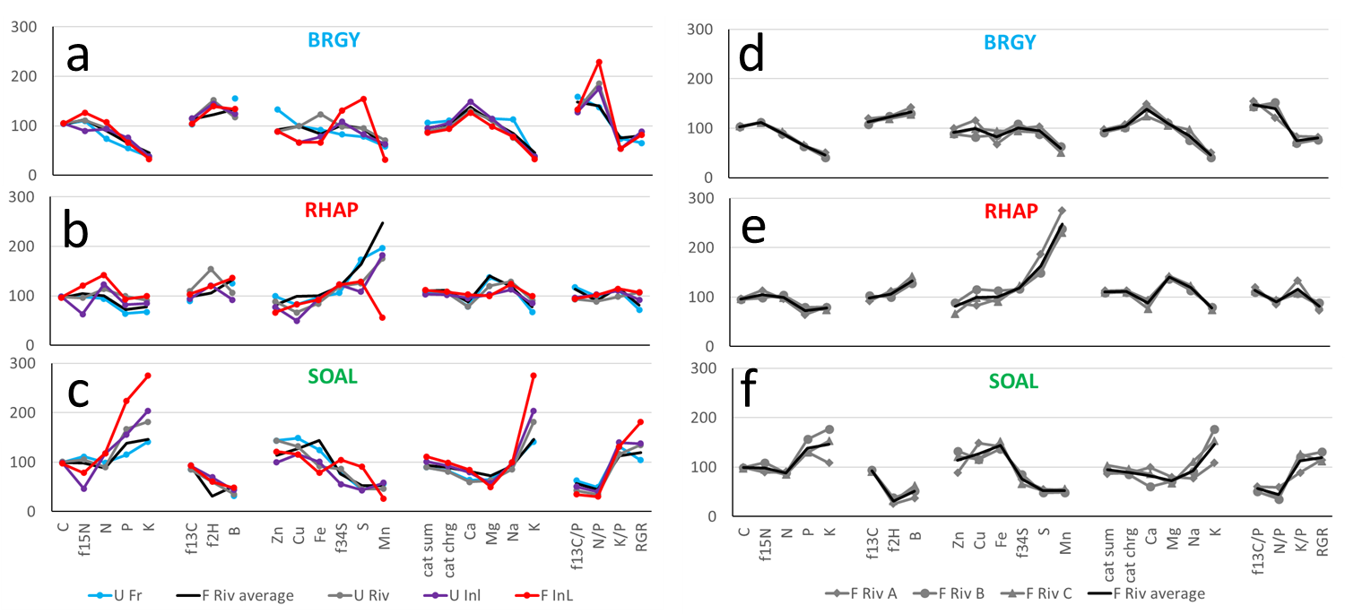

Fig. S2. Chemometric fingerprints including 3 replicates from the Finkol Riverine site. Leaf data are shown for each species at the 5 sites (a-c) and for replicates at one site, Finkol Riverine (d-f). Data in each panel are expressed relative to the species mean = 100. Panels A-C are the same as Fig. 9 in the main article.

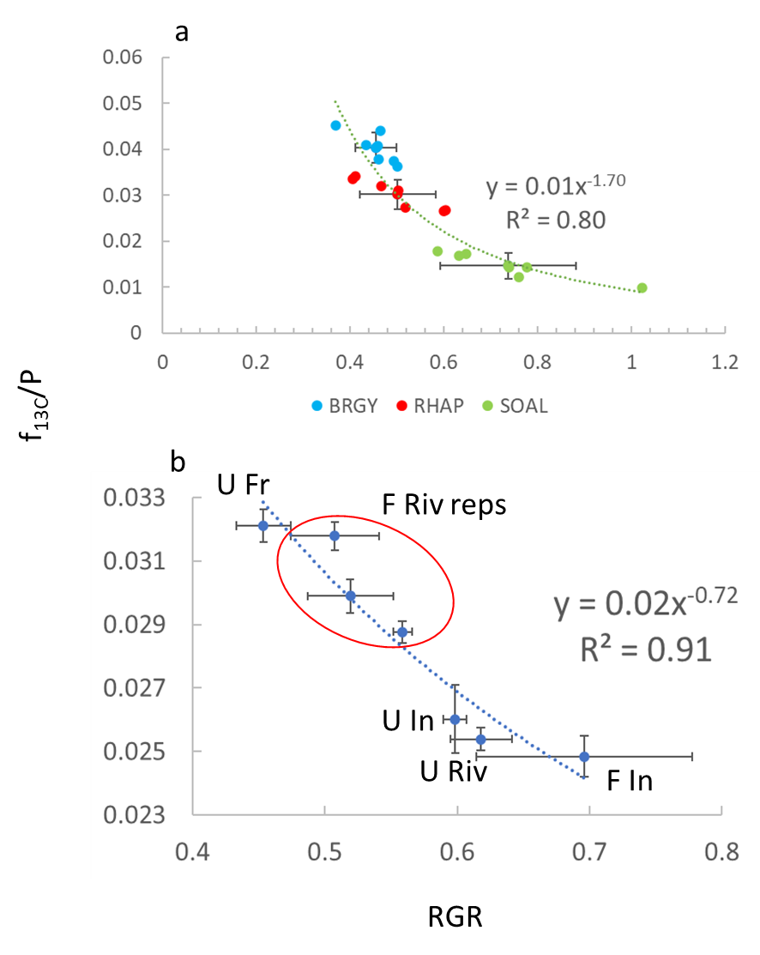

Fig. S3. f_{13C}/P vs. RGR, a) Species, measured data, b) Sites, data has been normalized for species effects prior to calculating f_{13C}/P and RGR. In both a) and b), RGR = (f_{P} + 0.5*f_{N} + 0.5*f_{13C})/2; model c in Fig. 8. Curves in each panel are best fit to all data.

Supplemental Tables

Table S1. Leaf data. For each mangrove species, samples were obtained from 5 individual trees, with three sun leaves per tree composited per species, so that a total of 15 leaves were composited per species per site or plot. The leaf samples were obtained with a pole from the forest canopy open to the sun at 3-5 m heights. Leaves were sun leaves, not larger thinner shade leaves.
Site | Reps | Species | C | N | P | S | δ²H_{SMOW} | δ¹³C_{VPDB}
 |  |  | mol/kg | mmol/kg | mmol/kg | mmol/kg | ‰ | ‰
UtweFNG | A | BRGY | 37.5 | 603 | 19.7 | 138 |  | -30.87
UtweRIV | A | BRGY | 38.3 | 784 | 26.5 | 167 | -92.8 | -31.92
UtweINL | A | BRGY | 37.9 | 767 | 27.4 | 145 | -90.5 | -31.96
FinkolRIV | A | BRGY | 36.8 | 713 | 23.5 | 183 | -83.2 | -32.38
FinkolRIV | B | BRGY | 37.4 | 729 | 22.9 | 156 | -83.5 | -31.35
FinkolRIV | C | BRGY | 37.9 | 763 | 23.9 | 161 | -81.5 | -31.74
FinkolINL | A | BRGY | 38.1 | 878 | 23.9 | 272 | -88.6 | -31.04
UtweFNG | A | RHAP | 35.6 | 773 | 23.2 | 306 |  | -29.77
UtweRIV | A | RHAP | 35.3 | 933 | 35.8 | 221 | -93.6 | -31.48
UtweINL | A | RHAP | 35.9 | 1010 | 29.7 | 191 | -82.2 | -30.14
FinkolRIV | A | RHAP | 35.2 | 788 | 23.2 | 329 | -79.1 | -29.93
FinkolRIV | B | RHAP | 34.5 | 855 | 28.7 | 263 | -75.0 | -30.92
FinkolRIV | C | RHAP | 34.9 | 809 | 26.8 | 273 | -76.5 | -30.56
FinkolINL | A | RHAP | 35.0 | 1167 | 33.5 | 227 | -81.5 | -30.95
UtweFNG | A | SOAL | 36.0 | 814 | 41.6 | 79 |  | -29.39
UtweRIV | A | SOAL | 36.6 | 738 | 60.3 | 81 | -61.1 | -29.36
UtweINL | A | SOAL | 35.9 | 962 | 56.4 | 77 | -64.2 | -30.07
FinkolRIV | A | SOAL | 36.2 | 744 | 47.1 | 98 | -48.9 | -30.08
FinkolRIV | B | SOAL | 36.0 | 727 | 56.5 | 85 | -53.2 | -30.13
FinkolRIV | C | SOAL | 35.5 | 699 | 46.8 | 92 | -50.9 | -29.91
FinkolINL | A | SOAL | 35.4 | 969 | 81.0 | 160 | -61.2 | -30.07

Site | Reps | Species | δ¹⁵N_{AIR} | δ³⁴S_{VCDT} | K | Ca | Mg | Na
 |  |  | ‰ | ‰ | mmol/kg | mmol/kg | mmol/kg | mmol/kg
UtweFNG | A | BRGY | 2.01 | -1.0 | 82 | 433 | 333 | 822
UtweRIV | A | BRGY | 1.98 | -5.2 | 79 | 438 | 325 | 552
UtweINL | A | BRGY | 2.55 | -8.0 | 82 | 500 | 333 | 574
FinkolRIV | A | BRGY | 1.95 | -5.6 | 110 | 503 | 329 | 591
FinkolRIV | B | BRGY | 1.93 | -8.2 | 90 | 473 | 321 | 552
FinkolRIV | C | BRGY | 1.97 | -4.2 | 97 | 418 | 308 | 709
FinkolINL | A | BRGY | 1.55 | -14.0 | 72 | 425 | 288 | 565
UtweFNG | A | RHAP | 2.32 | -7.3 | 146 | 265 | 400 | 874
UtweRIV | A | RHAP | 2.38 | -10.7 | 197 | 263 | 350 | 939
UtweINL | A | RHAP | 3.29 | -11.9 | 185 | 320 | 300 | 822
FinkolRIV | A | RHAP | 1.90 | -10.3 | 174 | 318 | 413 | 870
FinkolRIV | B | RHAP | 2.32 | -10.1 | 174 | 310 | 400 | 826
FinkolRIV | C | RHAP | 2.20 | -11.9 | 162 | 258 | 417 | 900
FinkolINL | A | RHAP | 1.72 | -11.8 | 215 | 345 | 292 | 900
UtweFNG | A | SOAL | 1.97 | -0.3 | 308 | 215 | 188 | 696
UtweRIV | A | SOAL | 2.13 | -2.0 | 395 | 203 | 183 | 626
UtweINL | A | SOAL | 3.74 | 6.1 | 444 | 268 | 167 | 717
FinkolRIV | A | SOAL | 2.56 | 1.0 | 236 | 335 | 233 | 561
FinkolRIV | B | SOAL | 2.02 | -1.8 | 385 | 203 | 208 | 665
FinkolRIV | C | SOAL | 2.40 | 3.3 | 333 | 290 | 196 | 809
FinkolINL | A | SOAL | 2.87 | -7.0 | 597 | 285 | 146 | 726

Site | Reps | Species | Fe | Mn | Zn | Cu | B
 |  |  | mmol/kg | mmol/kg | mmol/kg | mmol/kg | mmol/kg
UtweFNG | A | BRGY | 1.09 | 0.44 | 0.18 | 0.09 | 6.73
UtweRIV | A | BRGY | 1.46 | 0.53 | 0.12 | 0.09 | 5.09
UtweINL | A | BRGY | 0.93 | 0.47 | 0.12 | 0.06 | 5.36
FinkolRIV | A | BRGY | 0.80 | 0.47 | 0.14 | 0.11 | 6.18
FinkolRIV | B | BRGY | 1.02 | 0.47 | 0.12 | 0.08 | 5.64
FinkolRIV | C | BRGY | 1.13 | 0.38 | 0.12 | 0.09 | 5.55
FinkolINL | A | BRGY | 0.79 | 0.24 | 0.12 | 0.06 | 5.82
UtweFNG | A | RHAP | 1.14 | 1.47 | 0.14 | 0.08 | 5.45
UtweRIV | A | RHAP | 1.00 | 1.31 | 0.12 | 0.06 | 4.64
UtweINL | A | RHAP | 1.11 | 1.36 | 0.11 | 0.05 | 4.00
FinkolRIV | A | RHAP | 1.14 | 2.05 | 0.12 | 0.08 | 5.55
FinkolRIV | B | RHAP | 1.34 | 1.78 | 0.12 | 0.11 | 5.55
FinkolRIV | C | RHAP | 1.07 | 1.73 | 0.09 | 0.09 | 6.18
FinkolINL | A | RHAP | 1.09 | 0.42 | 0.09 | 0.08 | 5.91
UtweFNG | A | SOAL | 1.48 | 0.42 | 0.20 | 0.14 | 1.36
UtweRIV | A | SOAL | 1.09 | 0.35 | 0.20 | 0.13 | 1.55
UtweINL | A | SOAL | 1.20 | 0.44 | 0.14 | 0.11 | 1.91
FinkolRIV | A | SOAL | 1.68 | 0.40 | 0.12 | 0.14 | 1.64
FinkolRIV | B | SOAL | 1.63 | 0.36 | 0.18 | 0.11 | 2.27
FinkolRIV | C | SOAL | 1.80 | 0.42 | 0.17 | 0.11 | 2.73
FinkolINL | A | SOAL | 0.93 | 0.20 | 0.17 | 0.11 | 2.09

Table S2. Bark data. At each site, 4 samples equally spaced around tree trunks were taken at breast height from 5 individual trees of the same species near the trees sampled for leaves. Thus, each sample was a species composite containing 20 bark pieces.
Site | Rep | Species | C | Ν | P | S | δ²H_{SMOW} | δ¹³C_{VPDB}
 |  |  | mol/kg | mmol/kg | mmol/kg | mmol/kg | ‰ | ‰
UtweFNG | A | BRGY | 41.8 | 291.5 | 3.23 | 66.3 | -60.7 | -29.6
UtweRIV | A | BRGY | 41.4 | 377.1 | 3.23 | 71.7 | -84.3 | -29.7
UtweINL | A | BRGY | 42.1 | 298.7 | 3.23 | 67.3 | -48.9 | -30.5
FinkolRIV | A | BRGY | 42.1 | 291.0 | 3.23 | 61.6 | -49.3 | -30.9
FinkolRIV | B | BRGY | 41.6 | 268.7 | 3.23 | 63.0 | -54.1 | -30.3
FinkolRIV | C | BRGY | 42.7 | 263.3 | 3.23 | 57.7 | -43.8 | -30.3
FinkolINL | A | BRGY | 42.7 | 244.2 | 3.23 | 68.3 | -40.2 | -30.0
UtweFNG | A | RHAP | 42.9 | 140.4 | 3.23 | 15.9 | -103.7 | -29.5
UtweRIV | A | RHAP | 42.5 | 152.7 | 3.23 | 19.1 | -75.4 | -29.2
UtweINL | A | RHAP | 42.3 | 158.3 | 3.23 | 17.0 | -77.2 | -28.7
FinkolRIV | A | RHAP | 43.3 | 85.9 | 3.23 | 21.4 | -80.2 | -30.4
FinkolRIV | B | RHAP | 42.2 | 151.8 | 3.23 | 20.2 | . | -30.8
FinkolRIV | C | RHAP | 43.3 | 157.6 | 3.23 | 22.3 | -80.0 | -30.6
FinkolINL | A | RHAP | 43.3 | 176.7 | 3.23 | 24.1 | -81.7 | -31.7
UtweFNG | A | SOAL | 40.7 | 345.7 | 6.45 | 56.3 | -50.3 | -27.8
UtweRIV | A | SOAL | 39.1 | 380.3 | 6.45 | 74.7 | -78.0 | -27.2
UtweINL | A | SOAL | 39.7 | 384.3 | 6.45 | 73.3 | -45.3 | -28.1
FinkolRIV | A | SOAL | 39.1 | 476.3 | 9.68 | 78.4 | -53.1 | -28.7
FinkolRIV | B | SOAL | 40.7 | 358.5 | 6.45 | 70.8 | -57.0 | -28.2
FinkolRIV | C | SOAL | 40.4 | 338.5 | 6.45 | 70.4 | -52.0 | -28.0
FinkolINL | A | SOAL | 41.4 | 464.3 | 9.68 | 82.6 | -47.7 | -27.8

Site | Rep | Species | δ¹⁵N_{AIR} | δ³⁴S_{VCDT} | K | Ca | Mg | Na
 |  |  | ‰ | ‰ | mmol/kg | mmol/kg | mmol/kg | mmol/kg
UtweFNG | A | BRGY | 1.2 | -1.8 | 11.4 | 170.0 | 104.2 | 13.0
UtweRIV | A | BRGY | 0.9 | -7.5 | 10.0 | 167.5 | 62.5 | 8.7
UtweINL | A | BRGY | 2.5 | -8.5 | 16.5 | 125.0 | 58.3 | 30.4
FinkolRIV | A | BRGY | 1.3 | -5.6 | 19.2 | 147.5 | 54.2 | 30.4
FinkolRIV | B | BRGY | 0.6 | 1.6 | 39.0 | 137.5 | 79.2 | 187.0
FinkolRIV | C | BRGY | 1.0 | -2.0 | 18.7 | 180.0 | 45.8 | 47.8
FinkolINL | A | BRGY | 1.1 | -14.0 | 4.5 | 125.0 | 33.3 | 8.7
UtweFNG | A | RHAP | 1.6 | 1.5 | 11.5 | 92.5 | 79.2 | 8.7
UtweRIV | A | RHAP | 0.2 | 2.1 | 17.7 | 107.5 | 87.5 | 39.1
UtweINL | A | RHAP | 1.1 | -3.0 | 3.2 | 115.0 | 75.0 | 4.3
FinkolRIV | A | RHAP | 0.5 | 0.5 | 25.1 | 80.0 | 62.5 | 56.5
FinkolRIV | B | RHAP | 0.9 | 3.7 | 23.3 | 122.5 | 87.5 | 65.2
FinkolRIV | C | RHAP | 0.0 | 4.1 | 22.3 | 137.5 | 91.7 | 65.2
FinkolINL | A | RHAP | -0.9 | -7.8 | 17.4 | 127.5 | 75.0 | 47.8
UtweFNG | A | SOAL | -0.3 | 2.4 | 31.5 | 167.5 | 120.8 | 156.5
UtweRIV | A | SOAL | 1.3 | -2.7 | 33.4 | 435.0 | 79.2 | 73.9
UtweINL | A | SOAL | 2.8 | 2.3 | 58.8 | 297.5 | 75.0 | 191.3
FinkolRIV | A | SOAL | 0.6 | -0.6 | 50.0 | 592.5 | 83.3 | 156.5
FinkolRIV | B | SOAL | 0.4 | 0.6 | 39.5 | 247.5 | 87.5 | 204.3
FinkolRIV | C | SOAL | 0.6 | 3.2 | 64.6 | 307.5 | 95.8 | 252.2
FinkolINL | A | SOAL | 2.9 | -9.9 | 36.7 | 342.5 | 41.7 | 47.8

Site | Rep | Species | Fe | Mn | Zn | Cu | B
 |  |  | mmol/kg | mmol/kg | mmol/kg | mmol/kg | mmol/kg
UtweFNG | A | BRGY | 16.36 | 0.36 | 0.05 | 0.05 | 2.45
UtweRIV | A | BRGY | 20.96 | 0.24 | 0.06 | 0.05 | 4.55
UtweINL | A | BRGY | 22.52 | 0.18 | 0.08 | 0.05 | 1.82
FinkolRIV | A | BRGY | 9.18 | 0.27 | 0.06 | 0.06 | 5.18
FinkolRIV | B | BRGY | 12.30 | 0.29 | 0.06 | 0.06 | 5.09
FinkolRIV | C | BRGY | 7.82 | 0.18 | 0.08 | 0.05 | 5.00
FinkolINL | A | BRGY | 4.21 | 0.07 | 0.05 | 0.03 | 3.73
UtweFNG | A | RHAP | 4.86 | 1.47 | 0.08 | 0.03 | 2.18
UtweRIV | A | RHAP | 9.09 | 2.80 | 0.06 | 0.05 | 2.27
UtweINL | A | RHAP | 11.54 | 1.53 | 0.08 | 0.03 | 3.55
FinkolRIV | A | RHAP | 4.48 | 2.96 | 0.09 | 0.13 | 4.09
FinkolRIV | B | RHAP | 4.20 | 4.13 | 0.06 | 0.08 | 3.91
FinkolRIV | C | RHAP | 6.45 | 7.04 | 0.06 | 0.05 | 4.64
FinkolINL | A | RHAP | 4.46 | 0.76 | 0.06 | 0.05 | 3.27
UtweFNG | A | SOAL | 11.23 | 0.15 | 0.06 | 0.06 | 5.91
UtweRIV | A | SOAL | 8.41 | 0.16 | 0.09 | 0.09 | 5.45
UtweINL | A | SOAL | 11.25 | 0.11 | 0.11 | 0.06 | 3.91
FinkolRIV | A | SOAL | 4.71 | 0.15 | 0.11 | 0.08 | 8.91
FinkolRIV | B | SOAL | 5.30 | 0.13 | 0.06 | 0.06 | 6.09
FinkolRIV | C | SOAL | 4.75 | 0.16 | 0.08 | 0.06 | 7.55
FinkolINL | A | SOAL | 3.95 | 0.07 | 0.06 | 0.08 | 4.36

Table S3. Soil data. The upper 1 cm of sediment was collected from 4 locations within 2m of the trees sampled for bark; sediments from 5 trees per species were composited so that composites contained 20 surface sediment collections. Samples were placed in plastic bags in the field, then later dried at 60ºC. Sediment samples were acid-treated to remove carbonates prior to drying for organic C and N analysis.
Site | Rep | Species | C | N | AvgTP | S | δ¹³C_{VPDB} | δ¹⁵N_{AIR}
 |  |  | mol/kg | mol/kg | mol/kg | mol/kg | ‰ | ‰
UtweFNG | A | BRGY | 11.30 | 0.31 | 0.029 | 0.50 | -28.39 | 1.45
UtweRIV | A | BRGY | 12.51 | 0.35 | 0.035 | 1.31 | -28.49 | 0.90
UtweINL | A | BRGY | 10.28 | 0.28 | 0.026 | 1.53 | -28.66 | 1.11
FinkolRIV | A | BRGY | 18.38 | 0.66 | 0.044 | 0.64 | -28.56 | 1.79
FinkolRIV | B | BRGY | 19.62 | 0.64 | 0.039 | 0.90 | -28.45 | 1.79
FinkolRIV | C | BRGY | 19.49 | 0.69 | 0.045 | 0.52 | -28.43 | 1.80
FinkolINL | A | BRGY | 27.54 | 0.85 | 0.024 | 1.69 | -28.63 | 0.55
UtweFNG | A | RHAP | 12.24 | 0.37 | 0.031 | 0.65 | -28.37 | 1.06
UtweRIV | A | RHAP | 8.91 | 0.24 | 0.034 | 1.74 | -28.61 | 0.91
UtweINL | A | RHAP | 8.83 | 0.25 | 0.026 | 1.86 | -28.35 | 1.40
FinkolRIV | A | RHAP | 19.32 | 0.64 | 0.042 | 0.67 | -28.40 | 1.72
FinkolRIV | B | RHAP | 19.73 | 0.65 | 0.034 | 0.62 | -28.69 | 1.70
FinkolRIV | C | RHAP | 19.39 | 0.66 | 0.048 | 0.67 | -28.46 | 1.74
FinkolINL | A | RHAP | 28.52 | 0.93 | 0.021 | 1.51 | -28.83 | 1.07
UtweFNG | A | SOAL | 13.30 | 0.37 | 0.034 | 0.79 | -28.31 | 1.21
UtweRIV | A | SOAL | 15.75 | 0.41 | 0.032 | 1.04 | -28.88 | 1.03
UtweINL | A | SOAL | 10.77 | 0.31 | 0.029 | 1.15 | -28.48 | 1.25
FinkolRIV | A | SOAL | 21.45 | 0.76 | 0.040 | 0.60 | -28.69 | 1.60
FinkolRIV | B | SOAL | 20.62 | 0.32 | 0.040 | 0.75 | -28.51 | 1.58
FinkolRIV | C | SOAL | 19.84 | 0.67 | 0.037 | 0.60 | -28.47 | 1.44
FinkolINL | A | SOAL | 29.54 | 0.89 | 0.023 | 1.24 | -28.55 | 0.39

Site | Rep | Species | δ³⁴S_{VCDT} | AvgTK | AvgTCa | AvgTMg | AvgTNa
 |  |  | ‰ | mol/kg | mol/kg | mol/kg | mol/kg
UtweFNG | A | BRGY | -23.77 | 0.05 | 0.14 | 0.34 | 1.12
UtweRIV | A | BRGY | -28.42 | 0.05 | 0.15 | 0.34 | 1.07
UtweINL | A | BRGY | -29.14 | 0.04 | 0.11 | 0.25 | 0.79
FinkolRIV | A | BRGY | -19.79 | 0.05 | 0.21 | 0.44 | 1.35
FinkolRIV | B | BRGY | -22.08 | 0.06 | 0.23 | 0.46 | 1.54
FinkolRIV | C | BRGY | -18.63 | 0.05 | 0.22 | 0.41 | 1.20
FinkolINL | A | BRGY | -17.05 | 0.05 | 0.22 | 0.43 | 1.55
UtweFNG | A | RHAP | -22.29 | 0.05 | 0.16 | 0.39 | 1.52
UtweRIV | A | RHAP | -30.55 | 0.04 | 0.12 | 0.30 | 0.81
UtweINL | A | RHAP | -29.28 | 0.03 | 0.11 | 0.21 | 0.58
FinkolRIV | A | RHAP | -19.57 | 0.05 | 0.23 | 0.46 | 1.48
FinkolRIV | B | RHAP | -19.26 | 0.06 | 0.21 | 0.48 | 1.66
FinkolRIV | C | RHAP | -20.40 | 0.05 | 0.22 | 0.43 | 1.27
FinkolINL | A | RHAP | -16.48 | 0.08 | 0.23 | 0.40 | 1.48
UtweFNG | A | SOAL | -24.08 | 0.06 | 0.17 | 0.40 | 1.45
UtweRIV | A | SOAL | -27.09 | 0.05 | 0.16 | 0.34 | 1.20
UtweINL | A | SOAL | -26.07 | 0.04 | 0.11 | 0.26 | 0.85
FinkolRIV | A | SOAL | -19.15 | 0.12 | 0.23 | 0.44 | 1.43
FinkolRIV | B | SOAL | -20.85 | 0.06 | 0.23 | 0.46 | 1.54
FinkolRIV | C | SOAL | -20.58 | 0.08 | 0.22 | 0.41 | 1.28
FinkolINL | A | SOAL | -13.26 | 0.05 | 0.23 | 0.41 | 1.43

Site | Rep | Species | Avg TFe | Avg TZn | Avg TCu | Avg TB | NH4
 |  |  | mmol/kg | mmol/kg | mmol/kg | mmol/kg | (μg/ml)
 |  |  |  |  |  |  | from bulk soil
UtweFNG | A | BRGY | 211.65 | 0.89 | 0.49 | 15.64 | 1.95
UtweRIV | A | BRGY | 218.79 | 1.05 | 0.67 | 19.59 | 1.15
UtweINL | A | BRGY | 122.25 | 0.89 | 0.57 | 20.23 | 1.91
FinkolRIV | A | BRGY | 123.50 | 0.87 | 0.72 | 17.36 | 11.27
FinkolRIV | B | BRGY | 243.70 | 0.81 | 0.69 | 18.91 | 11.27
FinkolRIV | C | BRGY | 154.97 | 0.88 | 0.67 | 18.14 | 11.27
FinkolINL | A | BRGY | 150.04 | 0.67 | 0.39 | 19.86 | 12.94
UtweFNG | A | RHAP | 205.84 | 0.88 | 0.54 | 16.91 | 2.03
UtweRIV | A | RHAP | 98.72 | 1.10 | 0.63 | 14.09 | 3.65
UtweINL | A | RHAP | 86.25 | 0.88 | 0.53 | 20.59 | 3.02
FinkolRIV | A | RHAP | 157.77 | 0.84 | 0.67 | 18.41 | 16.35
FinkolRIV | B | RHAP | 92.91 | 0.66 | 0.58 | 15.32 | 16.35
FinkolRIV | C | RHAP | 152.83 | 0.83 | 0.66 | 16.91 | 16.35
FinkolINL | A | RHAP | 246.71 | 0.34 | 0.70 | 20.05 | 20.86
UtweFNG | A | SOAL | 217.26 | 1.12 | 0.57 | 18.27 | 5.10
UtweRIV | A | SOAL | 122.74 | 0.82 | 0.56 | 16.09 | 4.58
UtweINL | A | SOAL | 117.62 | 0.87 | 0.55 | 17.68 | 7.06
FinkolRIV | A | SOAL | 155.23 | 0.75 | 0.66 | 16.68 | 7.77
FinkolRIV | B | SOAL | 230.62 | 0.78 | 0.68 | 17.73 | 7.77
FinkolRIV | C | SOAL | 393.67 | 1.01 | 0.64 | 17.41 | 7.77
FinkolINL | A | SOAL | 360.71 | 0.42 | 0.39 | 18.45 | 10.45

Table S4. Porewater analyses. Porewater was collected once per site from a porewater well installed for about 1 hour prior to sampling at 10cm with a syringe. H isotopes in porewater were analysed by H₂-water equilibration (Koehler et al. 2000). Salinity was estimated by averaging two sets of measurements, refractometer measurements and isotope measurements. Hydrogen isotope measurements were made of porewater, then the Ladd and Sachs (2015) equation for mangrove estuarine waters was used to estimate salinity as: salinity = [(δ²H+23)/.77]. Salinity is unitless, on the practical salinity scale.
Site | Species | P | K | Ca | Mg | Na | Fe | Mn
 |  | (mmol/m³) | (mol/m³) | (mol/m³) | (mol/m³) | (mol/m³) | (mmol/m³) | (mmol/m³)
UtweFNG | BRGY | 5.65 | 5.35 | 5.32 | 33.25 | 295.96 | 0.00 | 0.36
UtweRIV | BRGY | 15.28 | 5.43 | 5.73 | 36.98 | 312.09 | 0.00 | 0.18
UtweINL | BRGY | 12.29 | 6.76 | 7.15 | 48.88 | 312.87 | 0.18 | 0.18
FinkolRIV | BRGY | 13.29 | 5.08 | 5.71 | 36.83 | 312.91 | 0.18 | 0.55
FinkolINL | BRGY | 15.61 | 4.74 | 4.95 | 30.14 | 267.00 | 0.54 | 0.18
UtweFNG | RHAP | 4.98 | 7.86 | 7.19 | 46.46 | 313.13 | 0.00 | 0.36
UtweRIV | RHAP | 10.30 | 6.11 | 6.53 | 41.92 | 312.61 | 0.00 | 0.18
UtweINL | RHAP | 11.30 | 6.71 | 6.94 | 48.50 | 312.87 | 0.18 | 0.18
FinkolRIV | RHAP | 12.96 | 5.31 | 5.68 | 37.74 | 312.65 | 0.18 | 0.36
FinkolINL | RHAP | 14.29 | 4.93 | 5.66 | 35.65 | 301.00 | 0.54 | 0.18
UtweFNG | SOAL | 7.64 | 7.62 | 7.73 | 48.75 | 313.52 | 0.00 | 0.36
UtweRIV | SOAL | 8.31 | 6.28 | 6.29 | 43.92 | 312.65 | 0.00 | 0.18
UtweINL | SOAL | 13.62 | 6.59 | 6.72 | 47.33 | 312.61 | 0.00 | 0.18
FinkolRIV | SOAL | 12.62 | 1.49 | 1.63 | 9.77 | 94.39 | 0.18 | 0.18
FinkolINL | SOAL | 17.28 | 4.67 | 5.15 | 33.12 | 288.48 | 0.36 | 0.18

Site | Species | Zn | Cu | B | NH₄ | δ²H_{SMOW} | salinity
 |  | (mmol/m³) | (mmol/m³) | (mol/m³) | (mmol/m³) | (‰) | unitless
UtweFNG | BRGY | 0.46 | 0.47 | 0.20 | 17.3 | 0.7 | 30.4
UtweRIV | BRGY | 0.62 | 1.72 | 0.19 | 17.3 | 1.0 | 31.6
UtweINL | BRGY | 2.15 | 2.34 | 0.25 | 28.8 | -5.3 | 27.5
FinkolRIV | BRGY | 1.54 | 2.03 | 0.20 | 23.4 | -8.2 | 22.6
FinkolINL | BRGY | 0.92 | 2.50 | 0.17 | 14.8 | -16.7 | 12.6
UtweFNG | RHAP | 0.15 | 0.31 | 0.29 | 17.7 | 0.9 | 30.0
UtweRIV | RHAP | 0.77 | 1.88 | 0.22 | 20.6 | -0.7 | 28.5
UtweINL | RHAP | 0.62 | 2.50 | 0.24 | 17.3 | -3.5 | 27.7
FinkolRIV | RHAP | 1.54 | 2.03 | 0.21 | 16.9 | -11.5 | 18.0
FinkolINL | RHAP | 0.46 | 1.88 | 0.19 | 21.0 | -12.0 | 17.1
UtweFNG | SOAL | 0.46 | 1.25 | 0.27 | 28.4 | 1.3 | 28.8
UtweRIV | SOAL | 0.31 | 1.41 | 0.24 | 19.4 | -6.4 | 24.3
UtweINL | SOAL | 0.77 | 1.72 | 0.25 | 26.7 | -12.5 | 15.8
FinkolRIV | SOAL | 1.38 | 2.19 | 0.06 | 24.6 | -10.4 | 16.2
FinkolINL | SOAL | 0.62 | 2.50 | 0.19 | 16.9 | -11.0 | 17.8

Table S5. Species averages, SEM, significance differences between species groups a, b, and c (respectively BRGY, RHAP and SOAL) at p<0.05, Tukey’s HSD t test. Final column shows significance differences (Signif Diff) among groups for data that has first been normalized for sites (SiteMeAdj) prior to testing for species differences. For example, significance difference “ab” indicates that means for group a (BRGY) and group b (RHAP) are significantly different. N = 7 for each mean, except N = 6 for δ²H.
parameter | units | BRGY mean | RHAP mean | SOAL mean | BRGY sem | RHAP sem | SOAL sem | Signif Diff | Signif Diff
 |  | group a | group b | group c |  |  |  | Measured data | SiteMeAdj
C | mol/kg | 37.70 | 35.20 | 35.94 | 0.18 | 0.17 | 0.15 | a,b,c | a,b,c
δ¹⁵N_{AIR} | ‰ | 1.99 | 2.31 | 2.53 | 0.11 | 0.19 | 0.24 | - | ac
N | mmol/kg | 748.21 | 904.96 | 807.79 | 31.43 | 54.15 | 42.82 | - | ab, bc
N/C | molar | 19.84 | 25.71 | 22.49 | 0.78 | 1.53 | 1.24 | ab | a,b,c
P | mmol/kg | 23.96 | 28.71 | 55.66 | 0.95 | 1.82 | 4.91 | ac,bc | ac,bc
P/C | molar | 0.64 | 0.82 | 1.55 | 0.02 | 0.05 | 0.14 | ac,bc | ac,bc
K | mmol/kg | 87.55 | 179.12 | 385.35 | 4.86 | 8.62 | 43.52 | ac,bc | a,b,c
 |  |  |  |  |  |  |  |  | a,b,c
δ¹³C_{VPDB} | ‰ | -31.61 | -30.54 | -29.86 | 0.20 | 0.24 | 0.13 | ab, ac | a,b,c
δ²Η_{SMOW} | ‰ | -86.69 | -81.33 | -56.59 | 1.86 | 2.71 | 2.59 | ac,bc | a,b,c
Zn | mmol/kg | 0.13 | 0.11 | 0.17 | 0.01 | 0.01 | 0.01 | ac,bc | ac,bc
Cu | mmol/kg | 0.08 | 0.08 | 0.12 | 0.01 | 0.01 | 0.01 | ac,bc | ac,bc
Fe | mmol/kg | 1.03 | 1.13 | 1.40 | 0.09 | 0.04 | 0.13 | ac,bc | ac,bc
δ³⁴S_{VCDT} | ‰ | -6.60 | -10.58 | -0.10 | 1.54 | 0.62 | 1.58 | ac,bc | a,b,c
S | mmol/kg | 174.68 | 258.53 | 95.81 | 17.19 | 18.52 | 11.04 | a,b,c | a,b,c
S/C | molar | 4.63 | 7.35 | 2.67 | 0.45 | 0.53 | 0.32 | a,b,c | a,b,c
Mn | mmol/kg | 0.43 | 1.45 | 0.37 | 0.04 | 0.20 | 0.03 | ab, bc | ab, bc
cat sum | mmol/kg | 1486.15 | 1718.94 | 1516.54 | 40.15 | 18.96 | 54.66 | ab,bc | ab, bc
cat charge | mmol/kg | 2261.15 | 2382.99 | 1962.01 | 47.95 | 29.68 | 57.46 | ac,bc | ac,bc
Ca | mmol/kg | 455.36 | 296.79 | 256.79 | 13.54 | 13.09 | 19.38 | ab, ac | a,b,c
Mg | mmol/kg | 319.64 | 367.26 | 188.69 | 6.28 | 20.22 | 10.67 | ac,bc | a,b,c
Na | mmol/kg | 623.60 | 875.78 | 685.71 | 38.92 | 15.90 | 29.85 | ab, bc | ab,bc
K | mmol/kg | 87.55 | 179.12 | 385.35 | 4.86 | 8.62 | 43.52 | ac,bc | a,b,c
B | mmol/kg | 5.77 | 5.32 | 1.94 | 0.21 | 0.29 | 0.18 | ac,bc | ac,bc
N/P | molar | 31.30 | 31.73 | 14.92 | 1.05 | 1.20 | 1.06 | ac,bc | ac,bc
f_{13C}/P | 100/mmol/kg | 4.04 | 3.02 | 1.47 | 0.13 | 0.12 | 0.11 | a,b,c | a,b,c
K/P | molar | 3.69 | 6.29 | 6.88 | 0.26 | 0.23 | 0.35 | ab,ac | ab,ac

Table S6. Leaf averages for 2 site groups, SEM, and F values from ANOVA where significance differences (p<0.05, Tukey’s HSD t test) were present between site groups. Group 1 (lower nutrient group; Utwe Fringe + Finkol Riverine (3reps)) vs. group 2 (higher nutrient group; Utwe Riverine + Utwe Inland + Finkol Inland). Data has first been normalized for species prior to testing for site differences. N = 12 for group 1 means except N = 9 for δ²H; N = 9 for group 2 means.
parameter | units | group 1 mean | group2 mean | grp 1 sem | grp 2 sem | F where sign
C | mol/kg | 36.11 | 36.47 | 0.11 | 0.14 | -
δ¹⁵N_{AIR} | ‰ | 2.14 | 2.47 | 0.06 | 0.21 | -
N | mmol/kg | 755.60 | 916.17 | 15.36 | 32.90 | 23.10
N/C | molar | 20.98 | 25.24 | 0.44 | 0.99 | 18.60
P | mmol/kg | 30.78 | 40.40 | 1.32 | 2.59 | 12.70
P/C | molar | 0.86 | 1.12 | 0.04 | 0.08 | 10.90
K | mmol/kg | 182.58 | 242.98 | 13.80 | 23.50 | 5.49
δ¹³C_{VPDB} | ‰ | -30.65 | -30.84 | 0.14 | 0.17 | -
δ²Η_{SMOW} | ‰ | -53.48 | -80.33 | 9.39 | 1.25 | -
Zn | mmol/kg | 0.14 | 0.13 | 0.01 | 0.01 | -
Cu | mmol/kg | 0.10 | 0.08 | 0.00 | 0.00 | 10.19
Fe | mmol/kg | 1.28 | 1.07 | 0.05 | 0.08 | 5.32
δ³⁴S_{VCDT} | ‰ | -4.89 | -7.36 | 0.65 | 1.36 | -
S | mmol/kg | 184.99 | 175.99 | 8.56 | 17.41 | -
S/C | molar | 5.16 | 4.83 | 0.24 | 0.48 | -
Mn | mmol/kg | 0.89 | 0.61 | 0.06 | 0.11 | 5.56
cat sum | mmol/kg | 1586.24 | 1576.88 | 26.91 | 39.48 | -
cat charge | mmol/kg | 2245.31 | 2192.15 | 28.80 | 45.37 | -
Ca | mmol/kg | 341.48 | 345.02 | 12.16 | 12.41 | -
Mg | mmol/kg | 317.58 | 270.24 | 5.86 | 10.24 | 18.10
Na | mmol/kg | 744.61 | 718.64 | 25.45 | 17.76 | -
K | mmol/kg | 182.58 | 242.98 | 13.80 | 23.50 | 5.49
B | mmol/kg | 4.71 | 4.18 | 0.14 | 0.19 | 5.33
N/P | molar | 26.95 | 26.30 | 0.56 | 1.24 | -
f_{13C}/P | 100/mmol/kg | 3.14 | 2.62 | 0.05 | 0.04 | 66.60
K/P | molar | 5.71 | 5.39 | 0.22 | 0.21 | -
RGR |  | 51.08 | 63.85 | 2.65 | 5.23 | 5.05

