Supplementary Information:
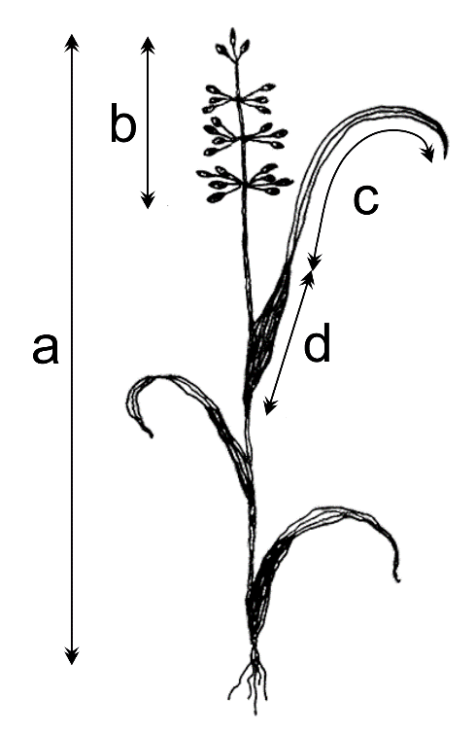
Fig. S1 A scheme of Coleanthus subtilis, showing measured traits: a. culm length, b. inflorescence length, c. leaf blade length, and d. leaf sheath length

