Supplementary Material for:

Spatiotemporal Variability of Carbon Dioxide and Methane Emissions in Six Temperate Wetlands

Pascal Bodmer^{1, *}, Kathryn A. Gannon^{1,2}, Meredith E. Theus¹, and Meredith A. Holgerson¹

¹ Department of Ecology and Evolutionary Biology, Cornell University, Ithaca, NY, USA
² Current affiliation: Institute of Arctic and Alpine Research, University of Colorado Boulder, Boulder, Colorado, USA

* Corresponding author: bodmerpascal@gmail.com
Supplementary methods
Vegetation survey
We conducted an additional vegetation survey in August 2023 to determine the present species at each wetland site. Briefly, we recorded the species present in 1 m² around the collar, then in 5 or 10 m2 around the collar (5 m² for bog and emergent wetlands, 10 m² for forested wetlands) we recorded the % cover of woody cover, graminoids, forbes, non-vascular plants, emergent aquatic vegetation, floating aquatic vegetation, submerged aquatic vegetation, coarse woody debris, fine woody debris, bare ground (i.e., no vegetation), and open water (no vegetation).
Supplementary figures
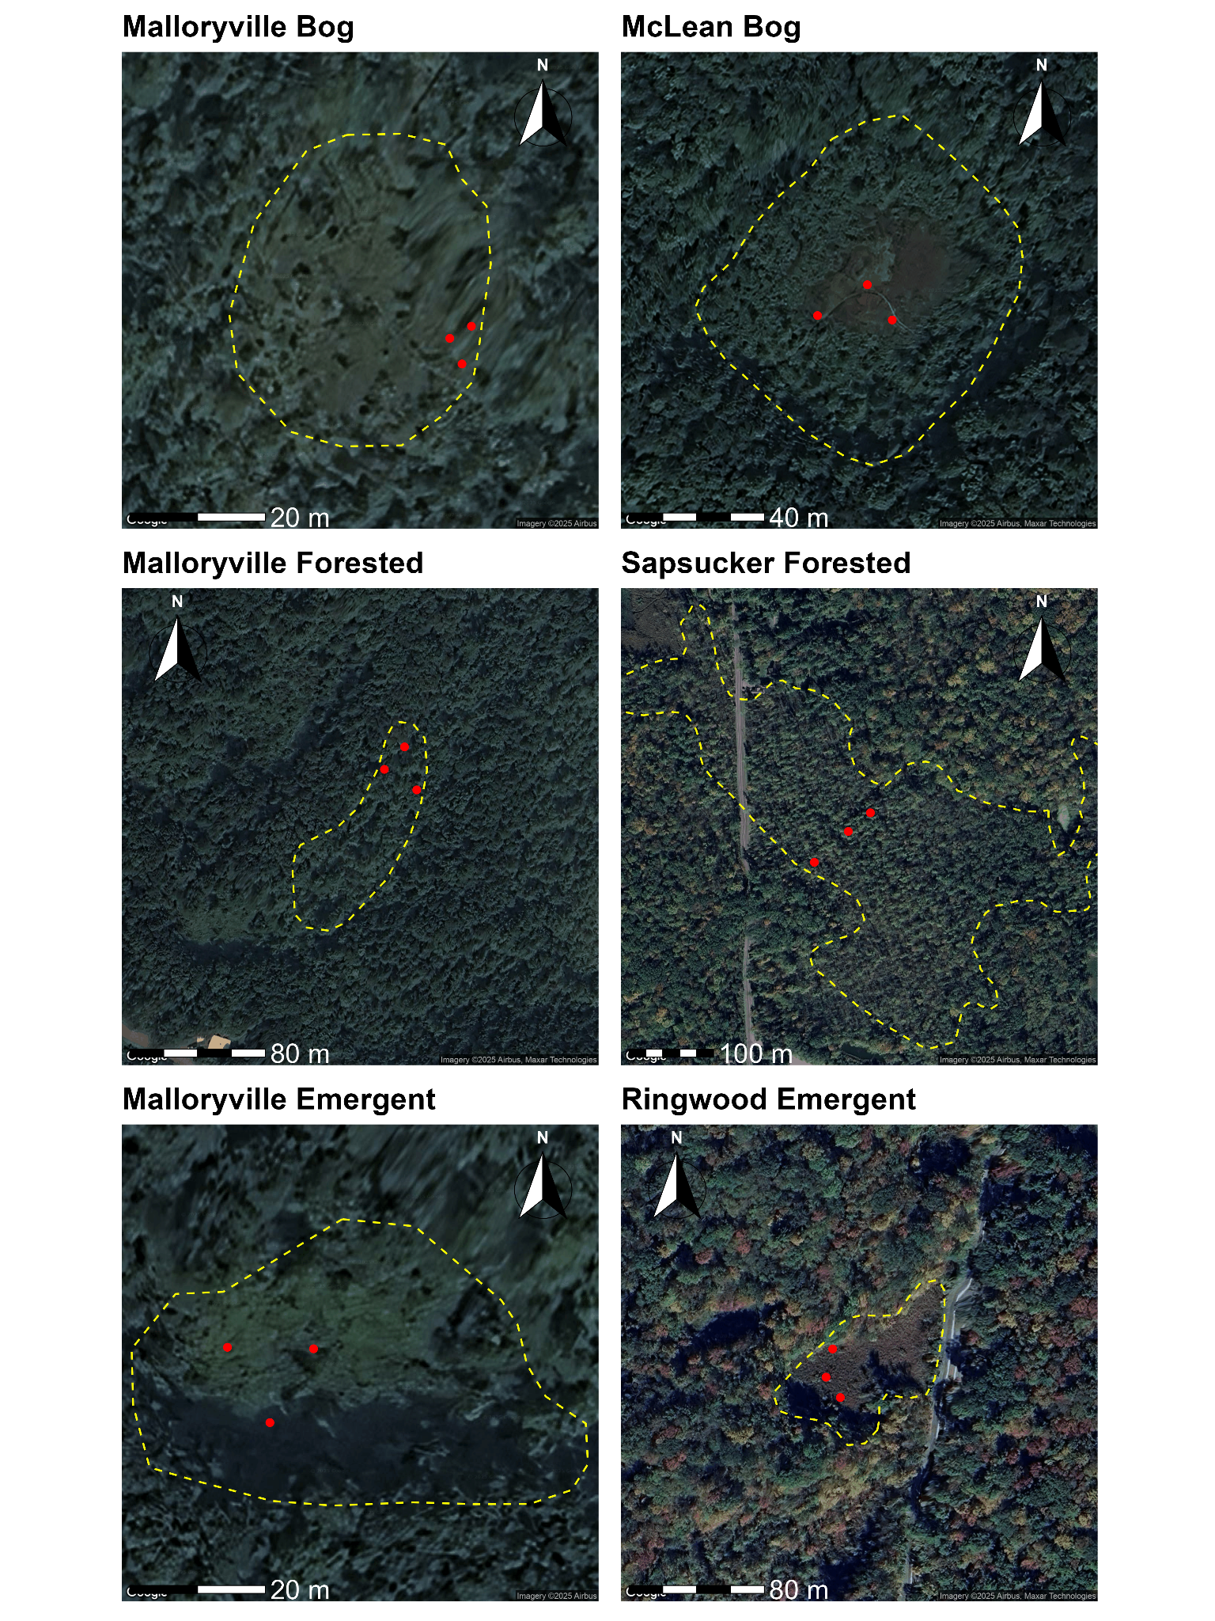
Figure S1. Approximate wetland polygons with approximate locations of the three collars. Collar locations were limited to regions adjacent to boardwalks in both bogs and Sapsucker Forested. In Malloryville Forested, the northernmost collar was next to a boardwalk.
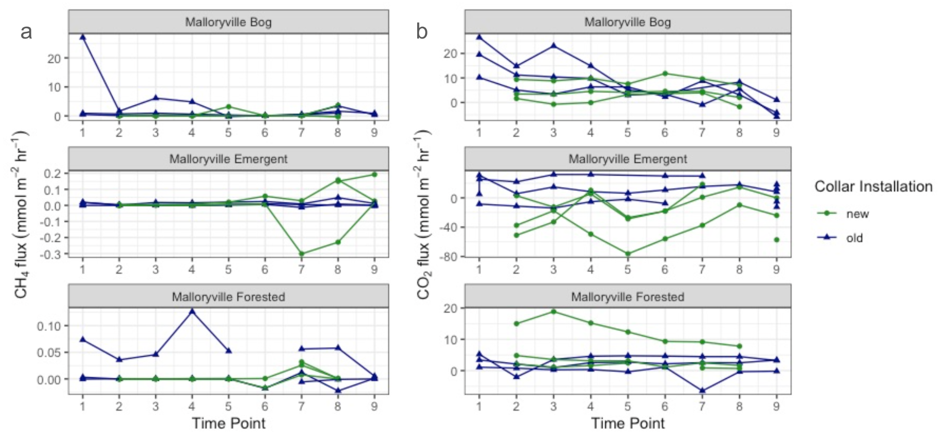
Figure S2. Flux of CH₄ (a) and CO₂ (b) over time following installation of new collars. Collars labeled as “old” were installed more than two months prior. Collars labeled “new” were installed at time point 2. Time points correspond to flux data 1- two weeks prior to new collar installation 2- immediately following installation, 3- one hour after installation, 4- three hours after installation 5- 24 hours after installation, 6 - 48 hours after installation, 7 - 1 week after installation, 8 - 2 weeks after installation, and 9 - 4 weeks after installation. Note different y-axes across sub-panels.
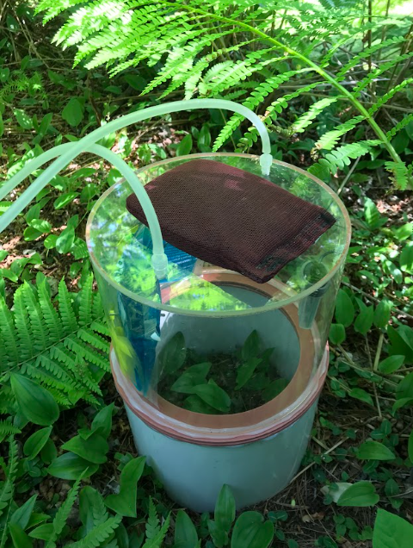
Figure S3. Set up of CO₂ and CH₄ flux measurement in the field.
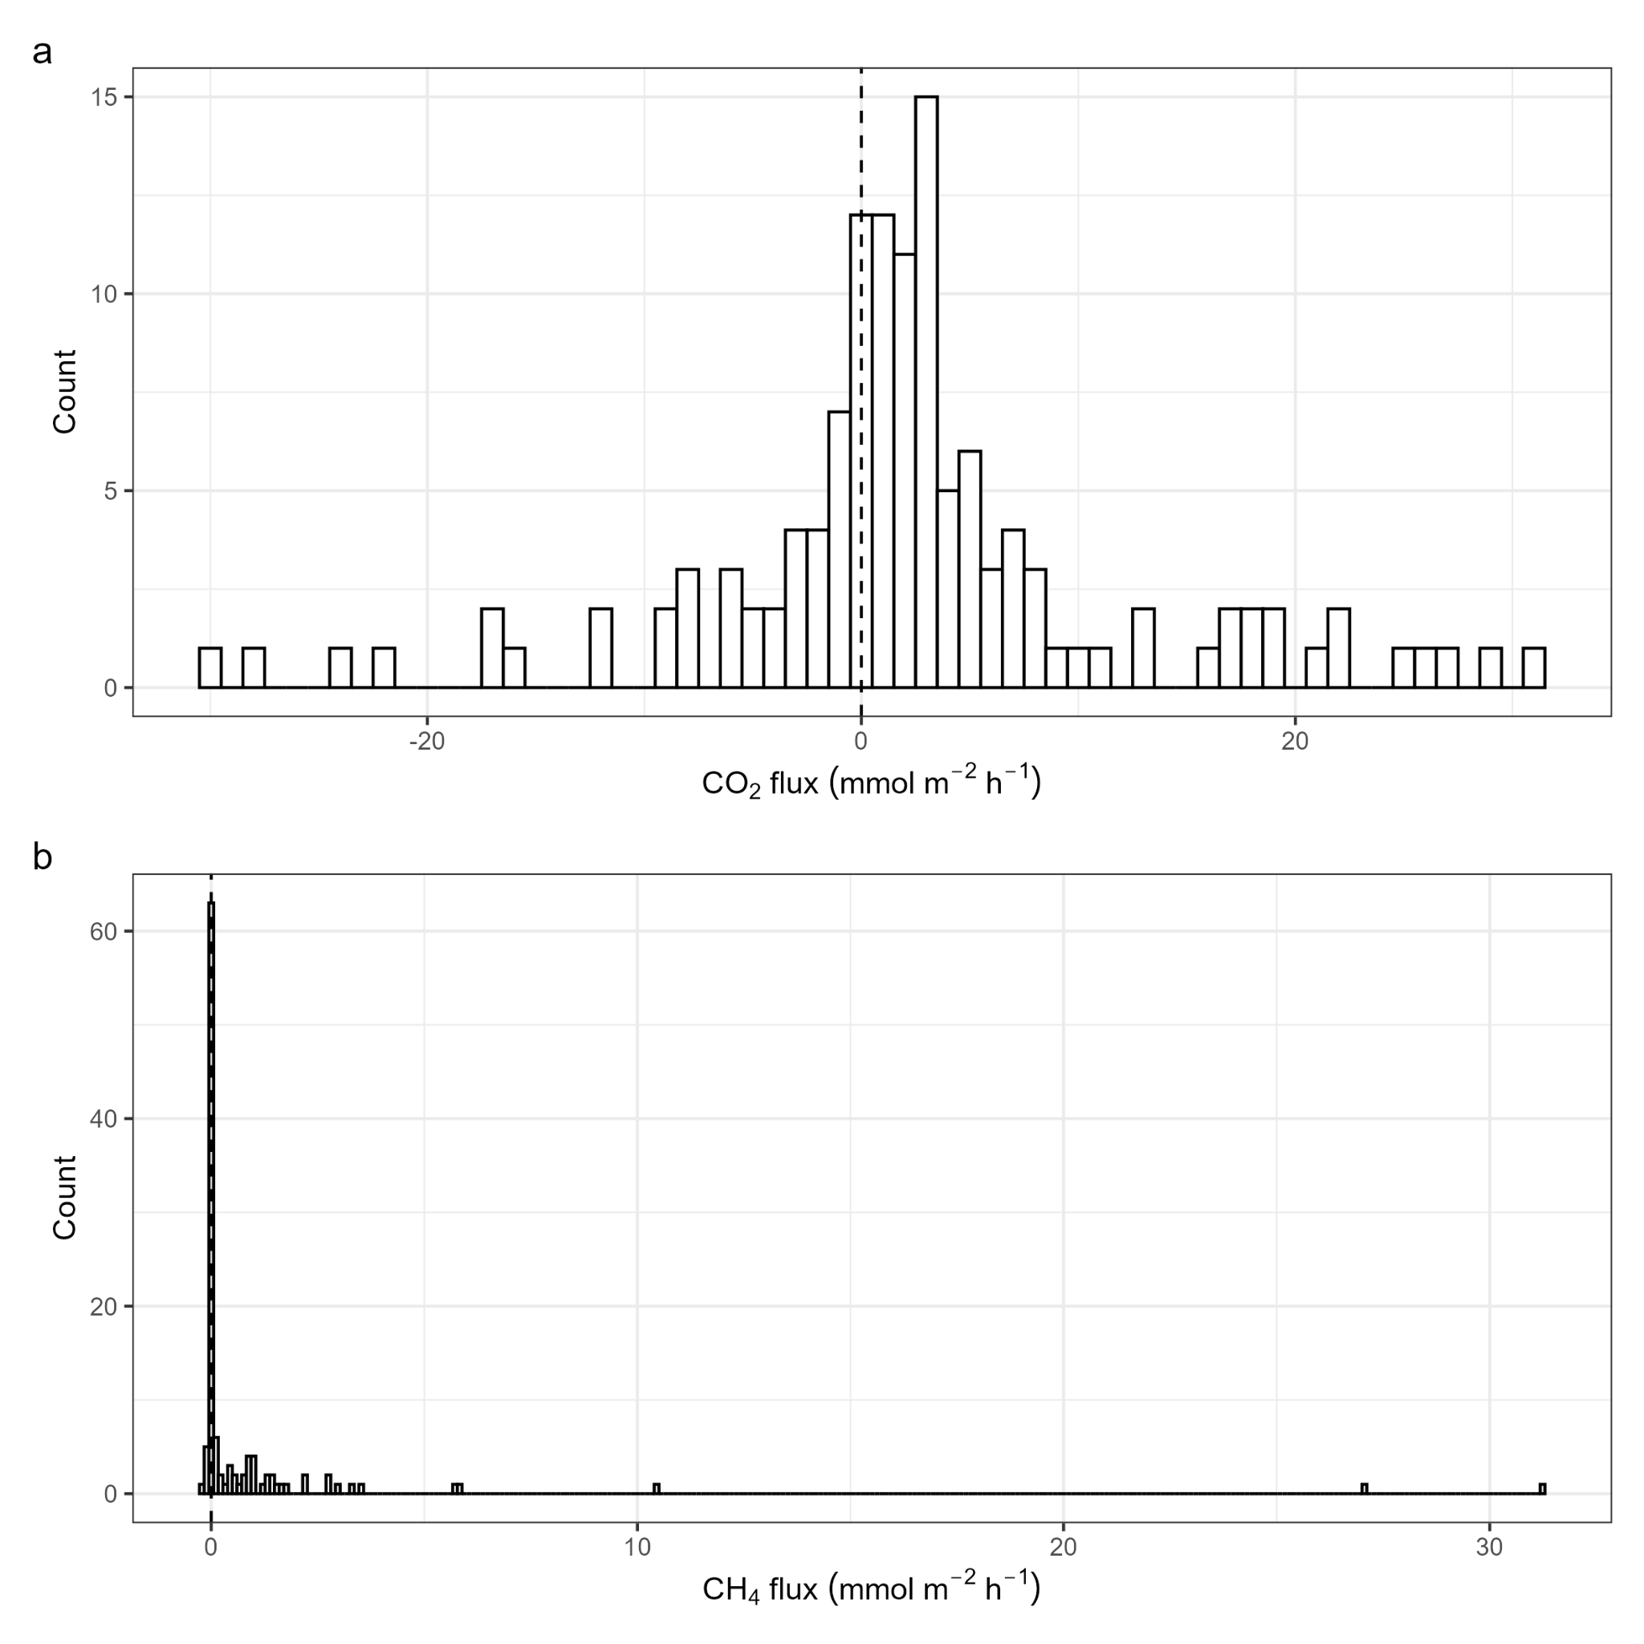
Figure S4. Histogram of measured a) CO₂ fluxes across all wetland sites and collars (n = 127) and b) CH₄ fluxes across all wetland sites and collars (n = 114).

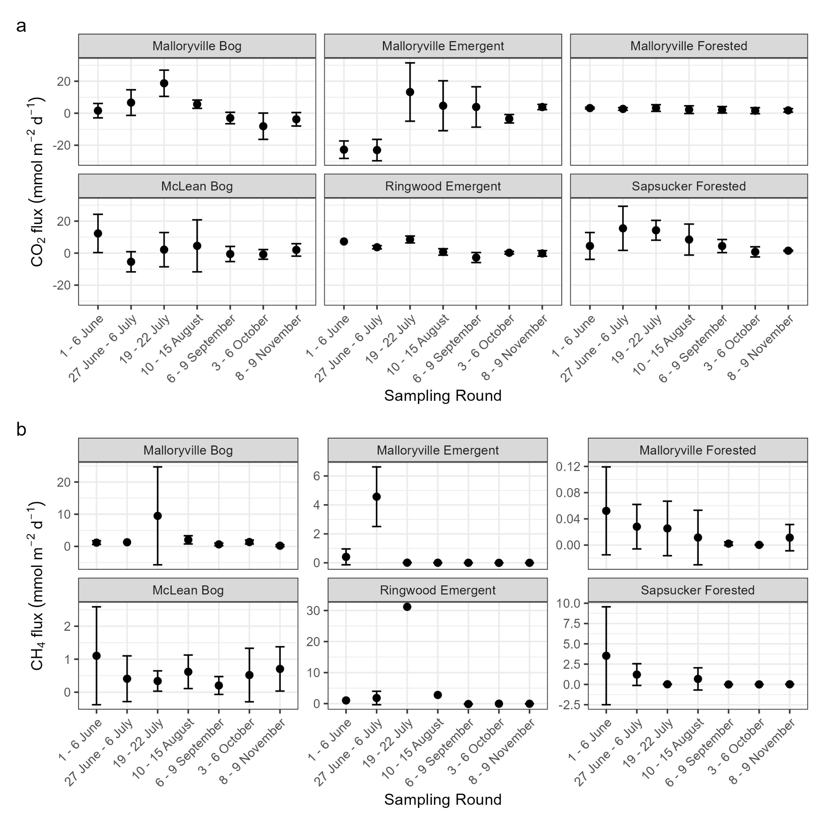
Figure S5. a) mean ± SD of CO₂ fluxes; b) mean ± SD of CH₄ fluxes (note different y-axes across sub-panels).
Supplementary tables
Table S1. Vegetation characteristics of the six sampled wetlands in this study.
Site name | Wetland type |  | Dominant species
Malloryville Bog | Bog |  | Sphagnum moss (Sphagnum sp.), sedge (Carex sp.), pitcher plant (Sarracenia purpurea)
McLean Bog | Bog |  | Sphagnum moss (Sphagnum sp.), three-way sedge (Dulichium arundinaceum), cranberry (Vaccinium sp.), pitcher plant (Sarracenia purpurea)
Malloryville Emergent | Emergent |  | Jewelweed (Impatiens capensis), sensitive fern (Onoclea sensibilis), skunk cabbage (Symplocarpus foetidus)
Ringwood Emergent | Emergent |  | Cattail (Typha sp.), jewelweed (Impatiens capensis), sensitive fern (Onoclea sensibilis), Sphagnum moss (Sphagnum sp.)
Malloryville Forested | Forested |  | Red maple (Acer rubrum), Eastern hemlock (Tsuga canadensis), skunk cabbage (Symplocarpus foetidus), cinnamon fern (Osmundastrum cinnamomeum)
Sapsucker Forested | Forested |  | Red maple (Acer rubrum), Eastern hemlock (Tsuga canadensis), cinnamon fern (Osmundastrum cinnamomeum), devil's beggarticks (Bidens frondosa)

Table S2. Results of the linear mixed models for CO₂ and CH₄ flux (mmol m⁻² h⁻¹), with wetland site and collar included as a random effect on the intercept. Significances of fixed effects were assessed with likelihood ratio tests with degrees of freedom = 1. Significant p values <0.05 are in bold; R²m = marginal R², R²c = conditional R²; CO₂ flux: n = 127; CH₄ flux: n = 114.
Response variable | Fixed effect(s) | χ² (1) | P value | R²m | R²c
CO₂ flux | Wetland type | 1.74 | 0.205 | 0.04 | 0.14
log₁₀(CH₄ flux + 0.2) | Wetland type | 3.45 | 0.171 | 0.12 | 0.21
CO₂ flux | Sampling round | 3.86 | 0.002 | 0.14 | 0.27
log₁₀(CH₄ flux + 0.2) | Sampling round | 5.05 | < 0.001 | 0.17 | 0.38
CO₂ flux | Wetland type * DOY | 5.40 | 0.006 | 0.12 | 0.22
log₁₀(CH₄ flux + 0.2) | Wetland type * DOY | 3.07 | 0.051 | 0.26 | 0.38

Table S3. Environmental drivers of CO₂ and CH₄ flux (mmol m⁻² h⁻¹) at different levels (collar, site) and different sampling dates (every month or selected months); if the relationship is significant, the direction of the relationship is indicated with a plus or minus sign; PP = porewater phosphorus; PN = porewater nitrogen; POC = porewater organic carbon.
Level (n) | Dependent variable | Independent variable | Random effect | P value  (+/-) | R²m | R²c
Collar, every date (119) | CO₂ flux | Collar standing water depth (cm) | Collar nested in site | 0.122 | 0.02 | 0.17
Collar, every date (107) | log₁₀(CH₄ flux + 0.2) | Collar standing water depth (cm) | Collar nested in site | 0.076 (-) | 0.04 | 0.25
Collar, every date (104) | CO₂ flux | Tallest plant (cm) | Collar nested in site | 0.218 | 0.02 | 0.18
Collar, every date (95) | log₁₀(CH₄ flux + 0.2) | Tallest plant (cm) | Collar nested in site | 0.002 (+) | 0.11 | 0.24
Site, every date (18) | Mean CO₂ flux | Site water table depth (cm) | Site | 0.727 | 0.01 | 0.06
Site, every date (18) | log₁₀(Mean CH₄ flux + 0.2) | Site water table depth (cm) | Site | 0.501 | 0.02 | 0.30
Site, every date (37) | log₁₀(Mean CO₂ flux + 24) | DO (%) | Site | 0.426 | 0.02 | 0.25
Site, every date (37) | log₁₀(Mean CH₄ flux + 0.20) | DO (%) | Site | 0.047 (-) | 0.15 | 0.17
Site, every date (37) | Mean CO₂ flux | pH | Site | 0.445 | 0.03 | 0.23
Site, every date (37) | log₁₀(Mean CH₄ flux + 0.20) | pH | Site | 0.049 (-) | 0.23 | 0.34
Site, every date (37) | Mean CO₂ flux | Porewater temperature (ºC) | Site | 0.147 | 0.06 | 0.18
Site, every date (37) | log₁₀(Mean CH₄ flux + 0.20) | Porewater temperature (ºC) | Site | <0.001 (+) | 0.25 | 0.38
Site, every date (38) | Mean CO₂ flux | Mean air temperature (ºC) | Site | 0.003 (+) | 0.20 | 0.27
Site, every date (38) | log₁₀(Mean CH₄ flux + 0.20) | Mean air temperature (ºC) | Site | 0.001 (+) | 0.22 | 0.37
Site, August & September (12) | Mean CO₂ flux | PW CO₂ conc. (µmol L⁻¹) | Site | 0.554 | 0.03 | 0.13
Site, August & September (12) | log₁₀(Mean CH₄ flux + 0.20) | PW CH₄ conc. (µmol L⁻¹) | Site | 0.791 | 0.01 | 0.01
Site, July & August (12) | Mean CO₂ flux | P_{pw} (mg L⁻¹) | Site | 0.309 | 0.10 | 0.21
Site, July & August (12) | Mean CH₄ flux | P_{pw} (mg L⁻¹) | Site | 0.535 | 0.04 | 0.35
Site, July & August (12) | Mean CO₂ flux | N_{pw} (mg L⁻¹) | Site | 0.075 (+) | 0.30 | 0.46
Site, July & August (12) | log₁₀(Mean CH₄ flux) | N_{pw} (mg L⁻¹) | Site | 0.253 | 0.04 | 0.95
Site, July & August (11) | Mean CO₂ flux | OC_{pw} (mg L⁻¹) | Site | 0.604 | 0.03 | 0.24
Site, July & August (11) | log₁₀(Mean CH₄ flux) | OC_{pw} (mg L⁻¹) | Site | 0.549 | 0.02 | 0.92

