Appendix 1 Inspection on the relationship between CH4 flux and environmental variables
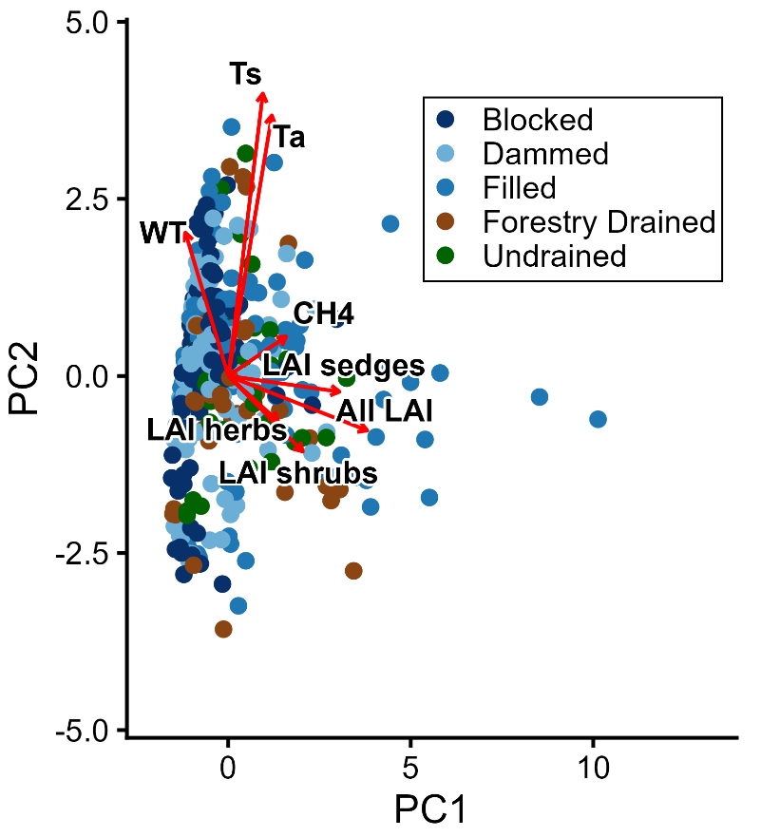
Fig. S1.1 Principal-components analysis (PCA) of 359 samples and 8 variables (CH4 flux, chamber temperature (Ta), soil temperature (Ts), water table (WT) and different components of leaf area index (LAI), namely total LAI, LAI of sedges, and LAI of shrubs). PC1 and PC2 explain 26.1% and 21.3% of total variance, respectively (47.5% cumulative). Arrows represent variable loadings; their lengths are proportional to their contribution to the PCs
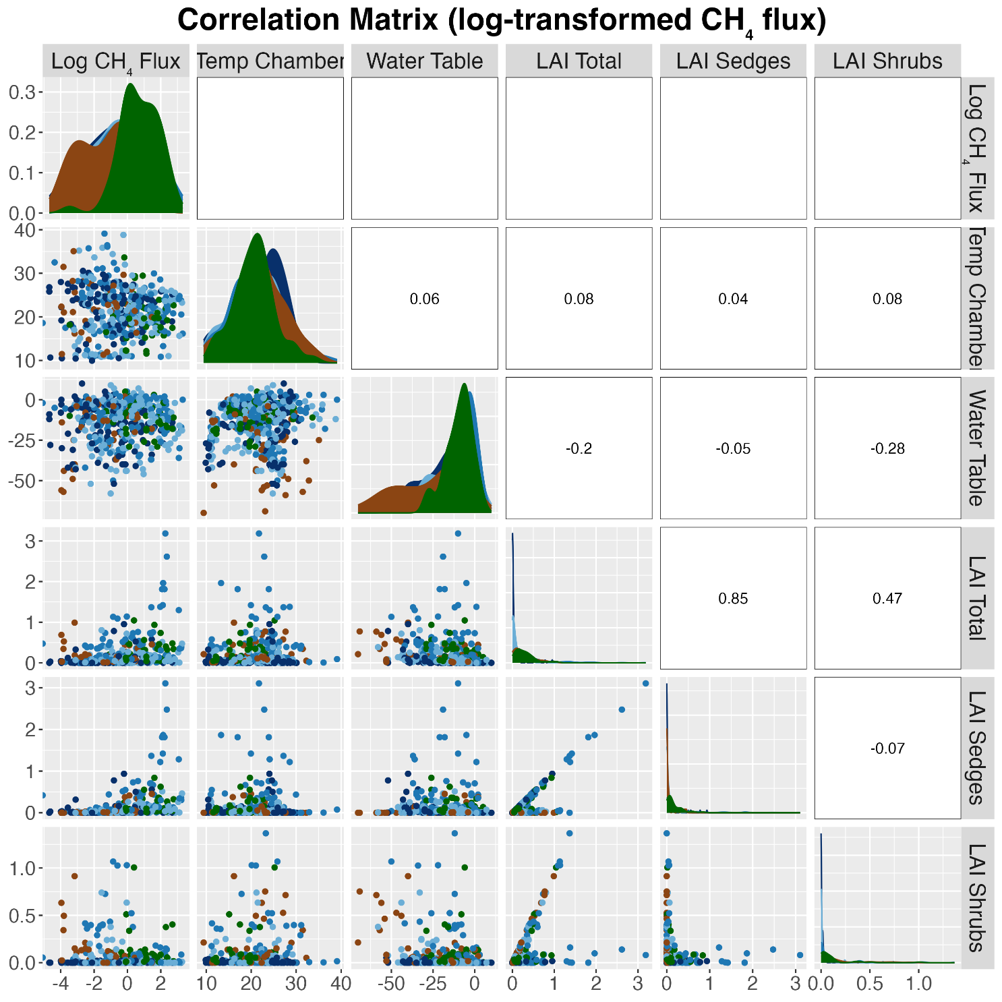
Fig S1.2 Correlation matrix based on log-transformed CH₄ flux (mg m⁻² h⁻¹) and five explanatory variables: air temperature inside chamber (°C), water table depth (cm), and leaf area indices (LAI) for total vegetation, sedges, and shrubs. Pearson correlation coefficients are shown in the upper panels. Diagonal panels show kernel density estimates for each variable. All data grouped by treatment type (color-coded)

