Supplementary Material

Anaerobic digestion of dairy cattle slurry – long-term effects on crop yields and chemical soil characteristics
Tatiana F. Rittl^{1,*}, Reidun Pommeresche¹, Anders Johansen², Håvard Steinshamn³, Hugh Riley³ and Anne-Kristin Løes¹

¹Norwegian Centre for Organic Agriculture (NORSØK), Norway
²Department of Environmental Science, Aarhus University, Denmark
³Norwegian Institute of Bioeconomy Research (NIBIO), Norway

Table 1. pH, soil nutrients and loss on ignition in the upper soil layer (0-20 cm) in autumn of 2021. AL indicates extraction by ammonium acetate lactate. Different letters indicate statistical difference between treatments within the same system, n=4.
Treatment | pH |  |  | P-AL (mg 100 g ⁻¹) |  |  | K-AL (mg 100 g ⁻¹) |  |  | Mg-AL (mg 100 g ⁻¹) |  |  | Ca-AL (mg 100 g ⁻¹) |  |  | Na-AL (mg 100 g ⁻¹) |  |  | LOI (%DM)
Treatment | Mean | sdt |  | Mean | sdt |  | Mean | sdt |  | Mean | sdt |  | Mean | sdt |  | Mean | sdt |  | Mean | sdt
Arable system
Control | 5.6 | 0.1 | c | 2.7 | 0.4 | a | 3.6 | 0.7 | a | 4.7 | 0.8 | b | 54.0 | 6.2 | b | 3.3 | 0.3 | b | 5.4 | 0.3 | a
USL | 5.7 | 0.1 | bc | 2.7 | 0.4 | a | 5.1 | 1.4 | a | 5.7 | 1.3 | ab | 65.8 | 8.5 | ab | 4.4 | 0.6 | a | 5.1 | 0.4 | a
USH | 5.9 | 0.1 | a | 3.0 | 0.2 | a | 5.2 | 0.7 | a | 7.1 | 0.8 | a | 73.8 | 7.4 | a | 4.4 | 0.1 | a | 5.4 | 0.3 | a
ADSL | 5.7 | 0.0 | c | 2.5 | 0.3 | a | 3.4 | 0.8 | a | 5.2 | 0.8 | b | 60.3 | 8.2 | ab | 3.9 | 0.8 | ab | 5.5 | 0.5 | a
ADSH | 5.9 | 0.1 | ab | 3.0 | 0.2 | a | 4.3 | 1.1 | a | 6.3 | 0.5 | ab | 68.5 | 1.7 | ab | 4.0 | 0.3 | ab | 5.1 | 0.5 | a
Grass system
Control | 5.5 | 0.1 | b | 3.0 | 0.3 | c | 3.2 | 0.7 | a | 4.1 | 0.4 | d | 71.3 | 17.7 | a | 3.8 | 0.5 | b | 8.2 | 1.4 | a
USL | 5.6 | 0.1 | ab | 3.6 | 0.4 | bc | 3.7 | 0.8 | a | 6.5 | 1.1 | bc | 83.3 | 20.5 | a | 4.3 | 0.4 | ab | 8.5 | 2.1 | a
USH | 5.9 | 0.2 | a | 4.7 | 0.7 | a | 4.7 | 1.1 | a | 9.7 | 1.0 | a | 109.0 | 15.2 | a | 5.2 | 0.3 | a | 9.5 | 1.9 | a
ADSL | 5.6 | 0.1 | ab | 3.4 | 0.4 | bc | 3.6 | 0.5 | a | 5.7 | 0.9 | cd | 87.0 | 23.9 | a | 4.5 | 0.6 | ab | 8.9 | 2.0 | a
ADSH | 5.8 | 0.1 | ab | 4.1 | 0.5 | ab | 3.7 | 0.9 | a | 7.6 | 0.6 | b | 113.8 | 25.0 | a | 4.9 | 0.7 | ab | 9.9 | 2.2 | a

Table 2. Mean values for the cereals production in the arable system. Ryegrass is the mean of two cuts.
Variable | Type of crop | Year | N | Control | USL | USH | ADL | ADSH
Fresh weight (kg m⁻²) | Oats | 2011 | 4 | 1.4 | 1.5 | 1.7 | 1.5 | 1.6
 | Ryegrass | 2012 | 8 | 0.7 | 0.8 | 0.9 | 1.2 | 0.9
 | Spring wheat | 2013 | 4 | 1.2 | 1.3 | 1.5 | 1.5 | 1.6
Dry matter (%) | Oats | 2011 | 4 | 38.3 | 38.7 | 35.8 | 38.6 | 37.7
 | Ryegrass | 2012 | 8 | 18.3 | 18.0 | 16.8 | 17.2 | 16.8
 | Spring wheat | 2013 | 4 | 24.0 | 25.5 | 25.1 | 25.3 | 25.8
Dry weight (kg DM m⁻²) | Oats | 2011 | 4 | 0.5 | 0.6 | 0.6 | 0.6 | 0.6
 | Ryegrass | 2012 | 8 | 0.1 | 0.1 | 0.1 | 0.2 | 0.1
 | Spring wheat | 2013 | 4 | 0.3 | 0.3 | 0.4 | 0.4 | 0.4

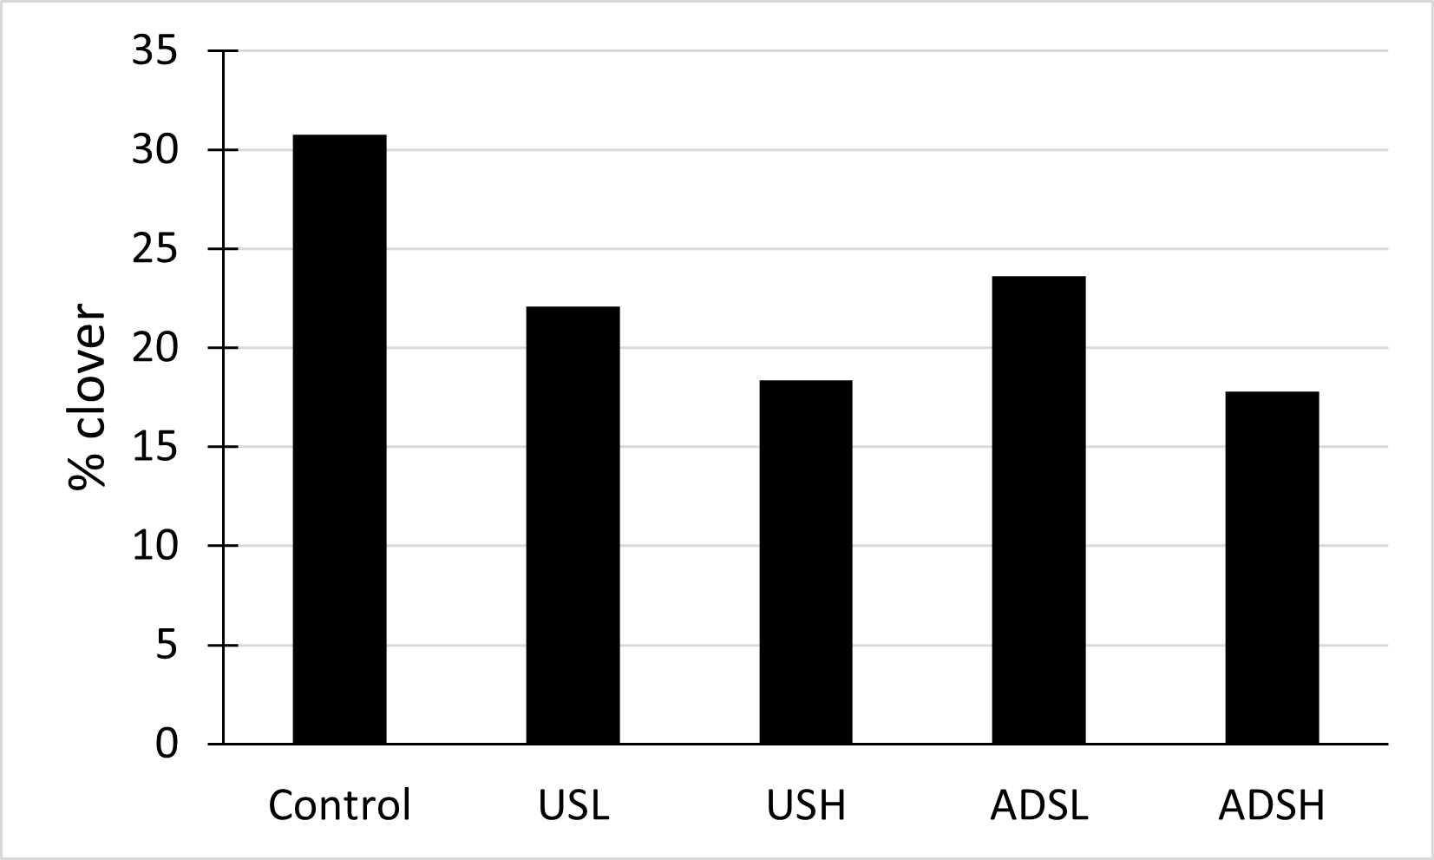
Figure.1 Proportion of clover (%) in the treatments
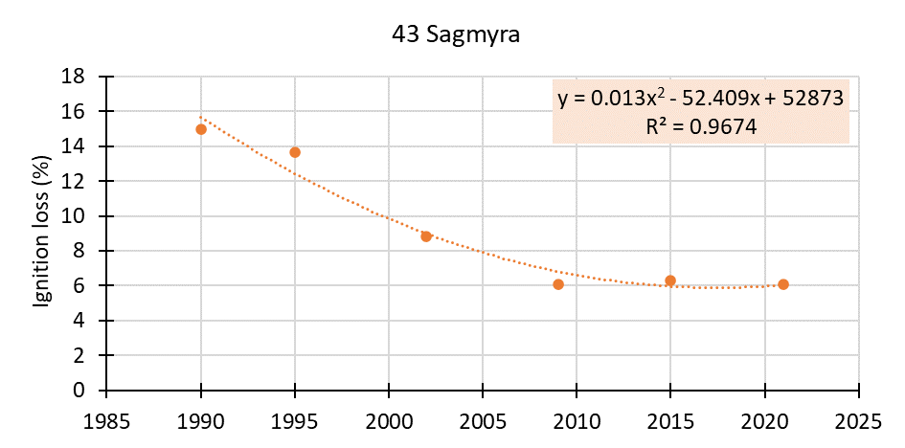

Figure 2. Ignition loss (%) since 1993 in the Sagmyra area, where the field experiment is located.

.
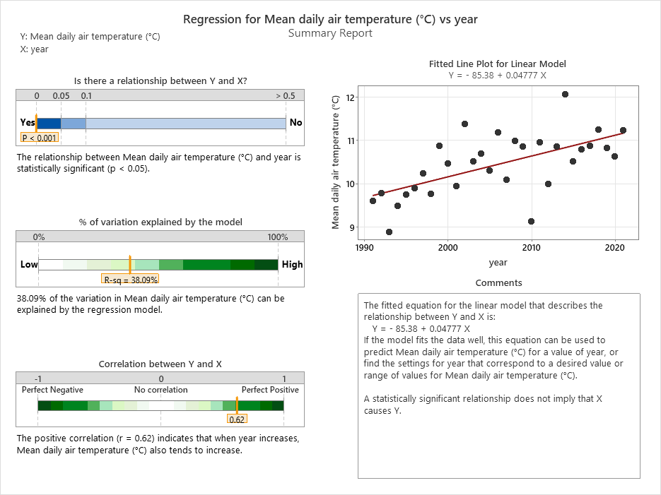
Figure 3. Changes in the temperature over the last 30 years.

