Supplemental materials
USE OF CACTUS PEAR PRUNING WASTE TO IMPROVE SOIL PROPERTIES AND TO PRODUCE HIGH QUALITY COMPOST
Bacchetta et al.

S1) Total polyphenols and antioxidant activity of basil plants growth on OFI mixed soils
Materials and methods
Total polyphenols content was evaluated in leaves of each sample following Folin-Ciocalteu method as reported by Procacci et al. (2020) with slight modifications. Briefly, an aliquot of 200 µL of standard solution or extract of sample (40 mg in 1 mL ethanol 80% at 30°C for 30 min) or 80% methanol (control) were mixed with 1.5 mL of Folin-Ciocalteu reagent (Sigma-Aldrich), which was previously diluted with double distilled water (1:10). The mixture was allowed to stand for 5 min, and then 1.5 mL of sodium carbonate (60g/L) was added to the mixture. Finally, the mixture was allowed to stand in the dark for about 30 min and the absorbance (Abs) was measured at 725 nm against a blank solution using a UV/Visible spectrophotometer (Lambda 2 – Perkin Elmer). All measurements were carried out in triplicate and results were expressed as milligrams of gallic acid eq./g dry weight (mg Gallic Acid eq./g. d.w.). A calibration curve was performed with gallic acid as standard (y = 0.0031x – 0.0338, R2 = 0.9981).
Results
Figure S1. Total polyphenols contents in plant of basil cultivated on soil supplemented with 0, 5, 10, 20%.
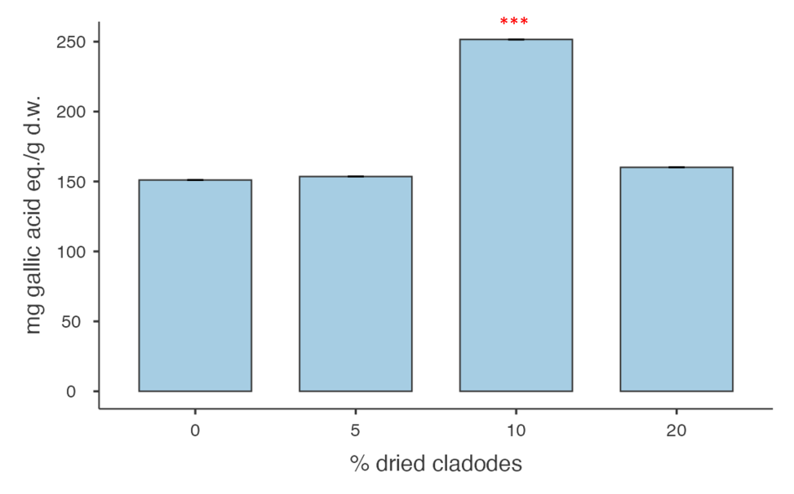
Significant differences are reported as ***p<0.001.
A significant difference in total polyphenols was detected in plants cultivated on soil supplemented with 10% of dried cladodes as reported in Figure 3 . These results agreed with other authors who reported agro-industrial waste promoted higher values of polyphenol content in lettuce (Aida Solís-Oba et al, 2020). Thus, application of these organic matter not only improves soil physical and chemical properties, but may also affects plant performance. As reported by Aida Solís-Oba et al. (2020), there was a significant difference between the lettuces grown on soil fertilized with vegetative herbal compost compared with those grown without fertilizing or fertilized with urea. Even if the phenolic amount in crops could differ in response to genotypes, to outdoor or indoor cultivation or to environmental stress (Zhao et al., 2009), we also noted an increment in polyphenol level of basil plants grown in dried cladodes mixed soil. Considering the different factors that could affect secondary metabolites of plants, further studies are required in order to better understand the influence of such amendment on secondary metabolites synthesis of plants grown in mixed soil and compared to control conditions.
References
Aida et al (2020) Effect of composts produced from vegetable waste and/or manure on lettuce crop and their antioxidants content. Mex J Biotechnol 2: 86-105.
Zhao et al (2009) Comparison of phenolic acids in organically and conventionally grown pac choi (Brassica rapa L. chinensis). J Sci Food Agric 89: 940-946.

S2) Main chemical and biological characteristics of inoculum used as starter for composting process
Materials and methods
Total Carbon and Total Nitrogen was performed by the elemental analyzer (ELEMENTAR, vario MACRO), while the other parameters were analyzed according to the methods provided by the reference guidelines “Metodi di Analisi del Compost. In Manuali e Linee Guida; ANPA: Roma, Italy, 2001; ISBN 88–448-0258-9”.
Table S2 Main characteristics of cured compost used as inoculum.
Parameter | Water  Content (%) | Total Carbon (%)  (g/g dry weight basis) | Total Nitrogen (%)  (g/g dry weight basis) | C/N | pH | Dynamic respiration index  (mgO₂KgSV¹h⁻¹) | Humic and Fulvic Acids  C% | Pathogens  (Fecal Coliform and Salmonella)
Value | 21 | 42.7 | 3.98 | 11 | 7.5 | 501 | 14.09 | Absent

S3) Chemical analysis on metal content of OFI compost
Materials and methods
Heavy metals total contents were obtained in OFI compost by total dissolution of the sample using a microwave-assisted acid digestion procedure. Then, metals concentrations were determined by ICP-MS analysis (ICP-MS, Agilent 7800); the automated mercury analyzer FKV AMA-254 was used for Hg analysis.
Results
As reported in table 2S the values of heavy metal concentrations determined for Cu, Zn, Pb, Cd, Ni, Hg and Cr(VI) were under the threshold values of national Directive (75/2010 and 10/07/2013)
Table 3S Heavy metals (Mean values ± SD) detected in OFI compost
Chemical elements | Mean value ± SD  (mg/kg) (n=3) | Allowed limits  national Directive (75/2010 and 10/07/2013) (mg/kg)
Ni | 30.7 ± 2.0 | 100
Cu | 19.9 ± 0.5 | 230
Cd | 0.143 ± 0.011 | 1.5
Pb | 6.18 ± 0.63 | 140
Zn | 269 ± 3 | 500
Mn | 150 ± 3
Hg | 0.033 ± 0.001 | 1.5
Cr(VI) | 0.134 ± 0.003 | 0.5

S4) Phytotoxic test on OFI compost
Materials and methods

The phytotoxic test of mature compost, was performed in five replications according to official method UNICHIM 10780/2003: the germination index (%IG) and the root inhibition lengthening of Lepidium sativum L. seeds were calculated as:

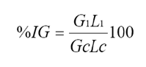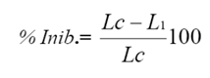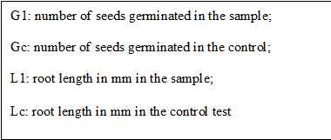

Results
The results of phytotoxicity test on Lepidium sativum, as model species is summarized as follow: the seed germination rates were 100±1.3; 95.9±3; 80.5±2.4 and 92.7±1.1 in elutriates at 0, 30, 50, 75 % of compost. Similarly, the inhibition of root development in the same samples was 0±1.1; 2.3±2.2; 5.9±2.1; 0±3.1 indicating that OFI compost obtained as described, not show any significant phytotoxic effects.

