Supplements

Table 1 Number and rearing of bull calves of the breeds German Holstein and Jersey grazed on a pasture with either a grass-clover (GRS) or a sward supplemented with herbs (HRB) in three years
 |  | 2018 |  |  | 2019 |  |  | 2020 |  |  | 2018–2020 |  |  | Grazing start
 |  | GRS | HRB | Total | GRS | HRB | Total | GRS | HRB | Total | GRS | HRB | Total | Mean ± SD
 |  | n | n | n | n | n | n | n | n | n | n | n | n | Age in d
Total |  | 15 | 13 | 28 | 18 | 19 | 37 | 23 | 23 | 46 | 56 | 55 | 111
 | Milkª
German Holstein | Dam | 1 | 2 | 3 | 4 | 6 | 10 | 8 | 7 | 15 | 13 | 15 | 28 | 120 ± 25
German Holstein | automatic^{b,c} | 4 | 1 | 5 | 1 | 0 | 1 | 0 | 0 | 0 | 5 | 1 | 6 | 109 ± 34
German Holstein | bucket^{b,d} | 5 | 5 | 10 | 9 | 9 | 18 | 9 | 9 | 18 | 23 | 23 | 46 | 108 ± 17
Jersey | bucket^{b,d} | 5 | 5 | 10 | 4 | 4 | 8 | 6 | 7 | 13 | 15 | 16 | 31 | 99 ± 7
In 2018, 2019, and 2020, the number of calves varied due to different availability, ª Each calf received 1,500 g concentrate pellets daily (70% oats, 19% wheat, 10% peas, and 1% minerals) and had ad libitum access to water, hay, and a feed mixture comprising 63.5% grass silage, 30.2% corn silage, 5.2% concentrates, and 1.2% minerals throughout the rearing period, ^{b} Each calf was offered 1,100 L of milk over a 3 months period, ^{c} warm whole milk by automatic calf feeder, ^{d} acidified cold whole milk by bucket feeders with teats

Table 2 Distribution of anthelmintic drug use in bull calves among years and treatments: Grass (GRS) and Herbs (HRB) according to breed: German Holstein and Jersey
 |  | 2018 |  |  | 2019 |  |  | 2020
 |  | GRS | HRB |  | GRS | HRB |  | GRS | HRB
German Holstein | treated | 0 | 0 |  | 10 | 2 |  | 4 | 0
 | twice treated | 0 | 0 |  | 4 | 1 |  | 0 | 1
Jersey | treated | 0 | 1 |  | 2 | 11 |  | 2 | 1
 | twice treated | 0 | 0 |  | 2 | 2 |  | 0 | 0

Table 3 Coverage degree of the sward compositions Grass (GRS) and Herbs (HRB) assessed during the grazing season in 2018–2020 (year/month) by applying the area percentage estimation according to Schechtner (1958)
 | GRS |  |  |  | HRB
 | 2018/5 | 2019/7 | 2020/9 |  | 2018/5 | 2019/7 | 2020/9
 | Mean | Mean | Mean |  | Mean | Mean | Mean
 | [%] | [%] | [%] |  | [%] | [%] | [%]
Grasses
Lolium perenne ^{a, b} | 84.2 | 70.9 | 66.1 |  | 72.5 | 48.8 | 40.8
Festuca pratensis | 1.1 | 0.7 | 0.6 |  | 2.0 | 1.3 | 1.1
Poa pratensis | 1.2 | 0.7 | 0.5 |  | 0.1 | 1.4 | 1.8
Poa trivialis | 0.0 | 1.3 | 1.7 |  | 0.1 | 3.9 | 5.2
Poa anua | 0.0 | 0.2 | 0.2 |  | 0.1 | 0.3 | 0.3
Elymus repens | 0.0 | 0.2 | 0.3 |  | 0.2 | 0.7 | 0.8
Bromus mollis | 0.0 | 0.0 | 0.0 |  | 0.0 | 0.0 | 0.0
Total | 86.5 | 74.0 | 69.4 |  | 74.9 | 56.3 | 50.1
Herbs
Cichorium intybus ^{b} | 0.0 | 0.0 | 0.0 |  | 3.0 | 2.2 | 1.9
Plantago lanceolata ^{b} | 0.0 | 0.3 | 0.4 |  | 3.2 | 5.5 | 6.2
Plantago major ^{c} | 0.0 | 0.1 | 0.1 |  | 0.1 | 0.9 | 1.1
Rumex crispus ^{c} | 0.3 | 0.2 | 0.1 |  | 0.7 | 0.2 | 0.0
Rumex acetosa ^{c} | 0.0 | 0.0 | 0.0 |  | 0.1 | 0.0 | 0.0
Rumex obtusifolius ^{c} | 0.8 | 0.6 | 0.5 |  | 4.4 | 5.8 | 6.2
Taraxacum officinale ^{c} | 0.5 | 1.8 | 2.2 |  | 1.3 | 1.1 | 1.0
Aethusa cynapium ^{c} | 0.0 | 0.0 | 0.0 |  | 0.1 | 0.0 | 0.0
Anthemis arvensis ^{c} | 0.0 | 0.0 | 0.0 |  | 0.1 | 0.0 | 0.0
Capsella bursa pastoris ^{c} | 0.2 | 0.1 | 0.0 |  | 0.1 | 0.0 | 0.0
Daucus carota subsp. carota ^{b} | 0.0 | 0.0 | 0.0 |  | 0.2 | 0.7 | 0.9
Ranuculus repens ^{c} | 0.6 | 0.6 | 0.7 |  | 0.3 | 0.5 | 0.5
Polygonum aviculare ^{c} | 0.0 | 0.0 | 0.0 |  | 0.1 | 0.0 | 0.0
Thlapsi arvense ^{c} | 0.0 | 0.0 | 0.0 |  | 0.0 | 0.0 | 0.0
Stellaria media ^{c} | 0.0 | 0.1 | 0.1 |  | 0.0 | 0.0 | 0.0
Achillea millefolium ^{c} | 0.0 | 0.0 | 0.0 |  | 0.0 | 0.6 | 0.9
Galium mollugo ^{c} | 0.0 | 0.0 | 0.0 |  | 0.0 | 0.0 | 0.0
Total | 2.4 | 3.7 | 4.1 |  | 13.6 | 17.5 | 18.7
Legumes
Trifolium repens^{,a, b} | 9.4 | 15.0 | 17.2 |  | 8.0 | 17.0 | 20.0
Trifolium pratense ^{a, b} | 1.7 | 7.3 | 9.2 |  | 3.4 | 9.0 | 10.8
Trifolium resupinatum ^{c} | 0.0 | 0.1 | 0.1 |  | 0.1 | 0.0 | 0.0
Lotus corniculatus ^{b} | 0.0 | 0.0 | 0.0 |  | 0.0 | 0.3 | 0.4
Total | 11.1 | 22.4 | 26.5 |  | 11.5 | 26.3 | 31.2
 | 100.0 | 100.0 | 100.0 |  | 100.0 | 100.0 | 100.0
ª Species of GRS sown in 2016
^{b} Species of HRB sown in 2016
^{c} Immigrant species
Table 4 Descriptive statistics of growth rate, carcass characteristics and meat quality from German Holstein and Jersey bull calves (n = 111) grazed on two swards: Grass (GRS) and Herbs (HRS)
 |  | Daily weight gain | Weight at slaughter | Carcass  weight  (hot) | Dressing percentage | LMA ª | IMF ^{b} | SFA ^{c} | MUFA ^{d} | PUFA ^{e} | n-6 ^{f} | n-3 ^{g} | n-6/n-3  ratio ^{h} | L* ^{i} | a* ^{j} | b* ^{k} | pH₂₄ ^{l}
 |  | [g] | [kg] | [kg] | [%] | [cm²] | [%] | [%] | [%] | [%] | [%] | [%] | [%]
GRS | Min | 57 | 138.0 | 54.0 | 32.8 | 17.5 | 0.28 | 44.59 | 28.29 | 3.57 | 2.11 | 1.46 | 1.43 | 33.02 | 11.44 | 3.45 | 5.3
 | 1st Quartile | 428 | 167.3 | 65.4 | 39.6 | 24.1 | 0.82 | 52.49 | 31.21 | 7.50 | 5.06 | 2.42 | 1.98 | 38.00 | 13.78 | 6.09 | 5.4
 | Median | 544 | 195.5 | 83.0 | 42.2 | 27.7 | 1.17 | 55.16 | 33.36 | 10.07 | 7.05 | 3.13 | 2.11 | 40.52 | 15.45 | 7.46 | 5.5
 | Mean | 570 | 197.8 | 83.7 | 41.9 | 28.8 | 1.35 | 55.21 | 33.34 | 11.45 | 7.88 | 3.57 | 2.21 | 40.60 | 15.45 | 7.18 | 5.5
 | SD | 222.0 | 37.89 | 21.40 | 3.45 | 6.50 | 0.713 | 4.247 | 2.690 | 5.069 | 3.690 | 1.513 | 0.460 | 3.782 | 2.214 | 1.672 | 0.21
 | 3rd Quartile | 709 | 222.5 | 97.8 | 44.6 | 33.4 | 1.80 | 57.70 | 34.87 | 14.55 | 10.11 | 4.48 | 2.38 | 43.33 | 16.62 | 8.27 | 5.6
 | Max | 1094 | 297.0 | 140.4 | 48.2 | 43.2 | 4.10 | 67.55 | 39.74 | 27.11 | 21.42 | 7.58 | 3.76 | 47.62 | 21.00 | 11.61 | 6.2
HRB | Min | -25 | 134.5 | 55.0 | 35.4 | 15.5 | 0.32 | 40.56 | 23.59 | 4.78 | 3.03 | 1.52 | 1.44 | 31.57 | 10.83 | 2.70 | 4.9
 | 1st Quartile | 423 | 180.0 | 71.4 | 39.2 | 23.4 | 0.80 | 51.09 | 29.75 | 8.45 | 5.68 | 2.72 | 1.88 | 37.22 | 13.73 | 6.35 | 5.4
 | Median | 557 | 1943 | 81.5 | 41.9 | 26.3 | 1.15 | 55.53 | 32.48 | 12.16 | 8.07 | 3.82 | 2.21 | 40.62 | 15.40 | 6.99 | 5.5
 | Mean | 555 | 198.4 | 83.9 | 42.0 | 26.9 | 1.22 | 54.77 | 32.31 | 12.92 | 9.01 | 3.91 | 2.28 | 40.44 | 15.60 | 7.10 | 5.5
 | SD | 209.9 | 31.62 | 18.09 | 3.64 | 5.71 | 0.613 | 5.459 | 3.270 | 5.487 | 4.251 | 1.393 | 0.532 | 4.482 | 2.874 | 1.802 | 0.20
 | 3rd Quartile | 665 | 218.8 | 93.7 | 45.0 | 29.8 | 1.42 | 58.32 | 34.53 | 15.38 | 10.91 | 4.64 | 2.48 | 42.63 | 17.16 | 8.03 | 5.6
 | Max | 1035 | 297.0 | 133.4 | 49.7 | 42.7 | 3.61 | 65.44 | 39.91 | 29.19 | 21.88 | 7.54 | 4.09 | 50.34 | 27.37 | 13.38 | 6.1
German Holstein | Min | -25 | 136.0 | 60.0 | 35.5 | 15.5 | 0.28 | 40.56 | 23.59 | 4.22 | 2.56 | 1.65 | 1.43 | 34.15 | 11.44 | 3.90 | 4.9
 | 1st Quartile | 442 | 185.0 | 78.8 | 40.6 | 24.8 | 0.74 | 51.13 | 30.14 | 8.36 | 5.62 | 2.75 | 1.89 | 38.43 | 14.60 | 6.62 | 5.4
 | Median | 574 | 206.0 | 87.9 | 42.9 | 29.1 | 1.03 | 55.18 | 32.21 | 12.58 | 8.56 | 3.98 | 2.13 | 41.72 | 15.68 | 7.47 | 5.5
 | Mean | 576 | 208.4 | 90.3 | 43.1 | 29.4 | 1.16 | 54.56 | 32.23 | 13.22 | 9.20 | 4.02 | 2.27 | 41.50 | 15.95 | 7.47 | 5.5
 | SD | 226.9 | 32.70 | 18.36 | 3.06 | 6.21 | 0.599 | 5.143 | 2.980 | 5.586 | 4.270 | 1.496 | 0.544 | 3.864 | 2.449 | 1.520 | 0.20
 | 3rd Quartile | 700 | 225.5 | 100.8 | 45.3 | 33.6 | 1.40 | 57.95 | 34.09 | 16.65 | 11.40 | 4.88 | 2.44 | 43.87 | 17.17 | 8.27 | 5.6
 | Max | 1094 | 297.0 | 140.4 | 49.7 | 43.2 | 4.10 | 65.44 | 39.86 | 29.19 | 21.88 | 7.58 | 4.09 | 50.34 | 27.37 | 13.38 | 6.2
Jersey | Min | 195 | 134.5 | 54.0 | 32.8 | 17.5 | 0.52 | 48.32 | 27.90 | 3.57 | 2.11 | 1.46 | 1.44 | 31.57 | 10.83 | 2.70 | 5.3
 | 1st Quartile | 412 | 154.0 | 59.2 | 37.2 | 21.6 | 1.19 | 54.01 | 33.55 | 7.45 | 5.06 | 2.33 | 2.00 | 35.57 | 12.63 | 4.78 | 5.4
 | Median | 493 | 166.0 | 62.2 | 38.6 | 23.6 | 1.41 | 55.43 | 34.56 | 9.29 | 6.28 | 2.74 | 2.17 | 37.65 | 13.91 | 6.21 | 5.6
 | Mean | 526 | 171.5 | 67.1 | 39.1 | 23.7 | 1.62 | 56.10 | 34.36 | 9.55 | 6.52 | 3.03 | 2.17 | 37.98 | 14.43 | 6.31 | 5.6
 | SD | 179.8 | 24.07 | 11.60 | 3.01 | 3.66 | 0.718 | 3.983 | 2.617 | 3.350 | 2.340 | 1.072 | 0.345 | 3.747 | 2.545 | 1.976 | 0.22
 | 3rd Quartile | 599 | 191.3 | 73.6 | 40.9 | 25.6 | 2.05 | 58.23 | 35.94 | 10.57 | 7.14 | 3.60 | 2.33 | 40.84 | 15.76 | 7.67 | 5.7
 | Max | 1018 | 223.0 | 101.2 | 46.9 | 34.1 | 3.61 | 67.55 | 39.91 | 19.87 | 13.72 | 6.15 | 3.15 | 47.62 | 20.30 | 11.61 | 6.1
ª Longissimus muscle area at the 9th rib of the thoracic vertebra on the left carcass side
^{b} Intramuscular fat in organic matter of longissimus muscle
Percentage of fatty acid methyl ester (FAME) of intramuscular fat in longissimus muscle:
^{c} Sum of saturated fatty acids: C12:0+C14:0+C15:0+C16:0+C17:0+C18:0+C20:0
^{d} Sum of monounsaturated fatty acids: C14:1+C16:1+C18:1n-9trans+C18:1n-9cis+C20:1
^{e} Sum of polyunsaturated fatty acids: C18:2n-6trans+C18:2n-6cis+C18:3n-3+C20:3n-6+C20:4n-6+C20:5n-3+C22:6n-3
^{f} Sum of n-6 fatty acids: C18:2n-6trans+C18:2n-6cis+C20:3n-6+C20:4n-6
^{g} Sum of n-3 fatty acids: C18:3n-3+C20:5n-3+C22:6n-3
^{h} Quotient of the sum of n-3 and n-6 fatty acids
Color at 24 h (longissimus muscle):
^{i} lightness (from 0: black to 100: white)
^{j} redness (from green if negative to red if positive)
^{k} yellowness (from blue if negative to yellow if positive)
^{l} pH of the longissimus muscle 24 h post mortem

Table 5 Dairy bull calves (n = 111) by conformation score (O–P) and fat score (1–2) according to EUROP scheme of each treatment: Grass (GRS) and Herbs (HRB) and breed: German Holstein and Jersey
 |  | O |  | P |  |  | 1 |  | 2
 |  | GRS | HRB | GRS | HRB |  | GRS | HRB | GRS | HRB
German Holstein | [n] | 13 | 15 | 26 | 26 |  | 27 | 33 | 12 | 8
Jersey | [n] | 1 | 0 | 15 | 15 |  | 13 | 13 | 3 | 2

Table 6 Model outcome for the weekly weight ratio of dairy bull calves (n = 111) of two breeds (German Holstein - reference, Jersey) grazed on two swards: Grass (GRS - reference) and Herbs (HRS)
Predictor | Item | Estimates | 95% CI | P-value ^{c}
Weekly weight ratioª | Intercept* | 1.03 | 1.01 – 1.06
 | Treatment (HRB) | 0.00 | -0.02 – 0.02 | 0.995
 | Individual age (normalized) ^{b} | 0.00 | -0.00 – 0.00 | 0.817
 | Breed (Jersey) | -0.00 | -0.00 – 0.00 | 0.483
 | Dry matter yield of treatments (normalized) | 0.00 | -0.01 – 0.01 | 0.834
 | Treatment (GRS vs. HRB) × Weekly age (normalized) | 0.00 | -0.00 – 0.00 | 0.741
ª Weekly weight ratio under grazing = body weight of current week / body weight of previous
^{b} Individual age on the weekly basis (normalized) = weekly date of weighing minus the date of birth
^{c} A Wald test was used for calculating the P-values and the level of significance was set at P ≤ 0.05
* Intercept for breed: German Holstein and treatment: GRS

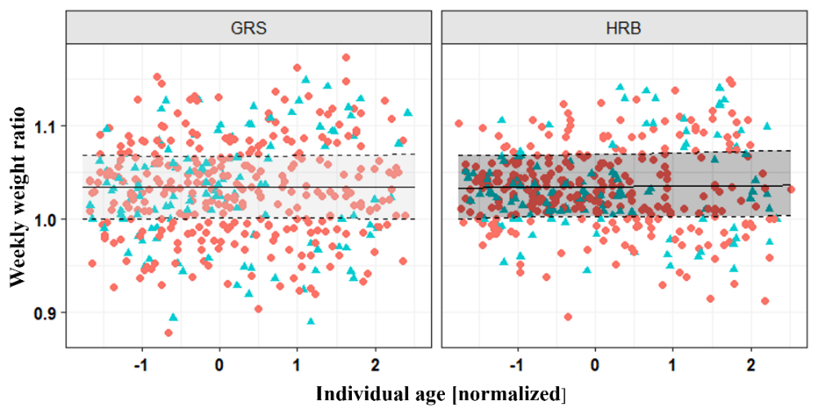
Fig. 1 Weekly weight ratio under grazing (= body weight of current week / bodyweight
of previous) by normalized individual age (= weekly date of weighing minus the date
of birth) of dairy bull calves (n = 111) grazed on two treatments: Grass (GRS)
and Herbs (HRS). Data points according to breed: Circles = German Holstein and triangles = Jersey (J)

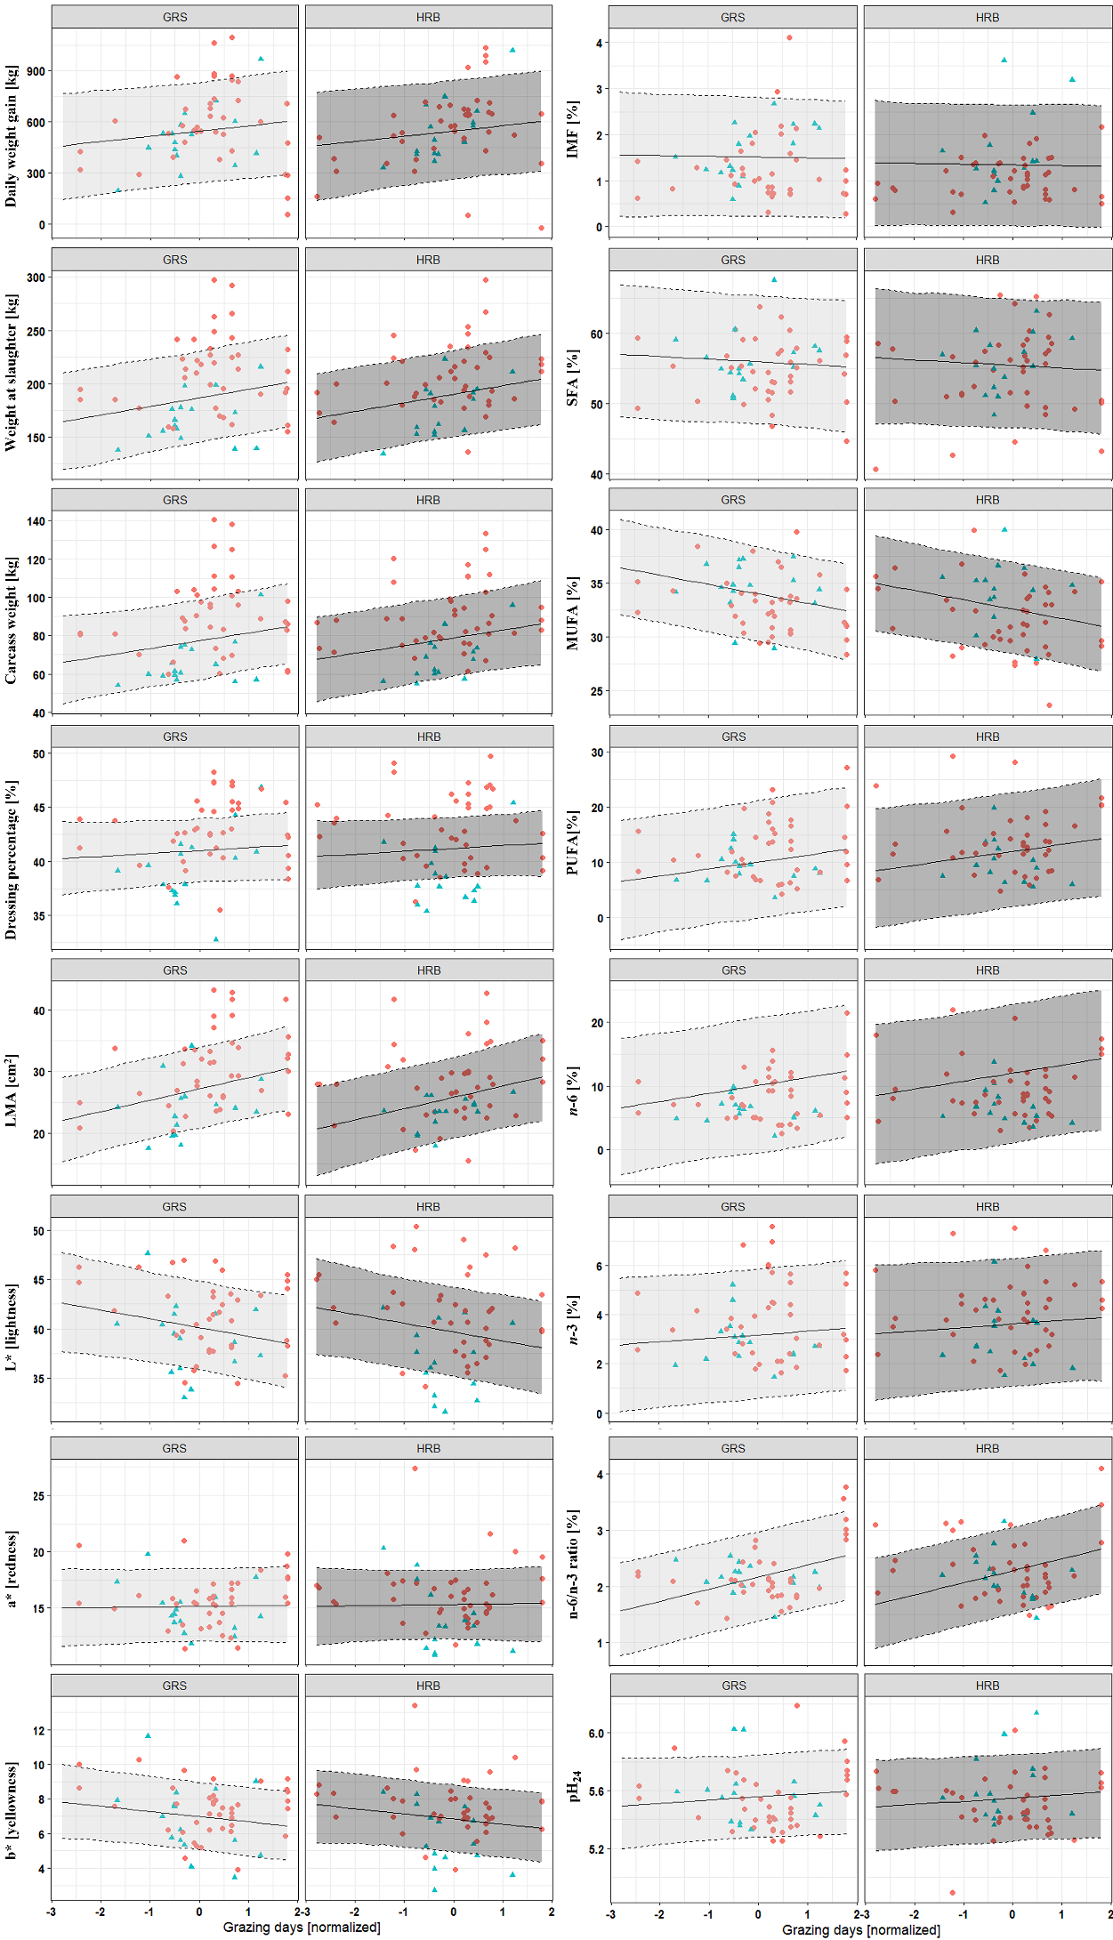
Fig. 2 Growth rate, carcass characteristics and indicators of meat quality by normalized grazing days* of dairy bull calves (n = 111) grazed on two sward treatments: Grass (GRS) and Herbs (HRS). Grazing days was calculated from the grazing days on the experimental paddock divided by total grazing days (which included grazing on the experimental paddock and the adjacent paddocks, early grazing, and grazing with the dam).
Abbreviations:
LMA = Longissimus muscle area at the 9th rib of the thoracic vertebra on the left carcass side
IMF = Intramuscular fat in organic matter of longissimus muscle
Color at 24 h (longissimus muscle): L* = lightness, a* = redness, b* = yellowness
Percentage of fatty acid methyl ester (FAME) of intramuscular fat in longissimus muscle:
SFA = Sum of saturated fatty acids: C12:0+C14:0+C15:0+C16:0+C17:0+C18:0+C20:0
MFA = Sum of monounsaturated fatty acids: C14:1+C16:1+C18:1n-9trans+C18:1n-9cis+C20:1
PUFA = Sum of polyunsaturated fatty acids: C18:2n-6trans+C18:2n-6cis+C18:3n-3+C20:3n-6+C20:4n-6+C20:5n-3+C22:6n-3
n-3 = Sum of n-3 fatty acids: C18:3n-3+C20:5n-3+C22:6n-3
n-6 = Sum of n-6 fatty acids: C18:2n-6trans+C18:2n-6cis+C20:3n-6+C20:4n-6
n-6/n3 ratio = Quotient of the sum of n-3 and n-6 fatty acids
pH₂₄ = pH of the longissimus muscle 24 h post mortem
Data points according to breed: Circles = German Holstein and triangles = Jersey (J)

