Supplementary Material

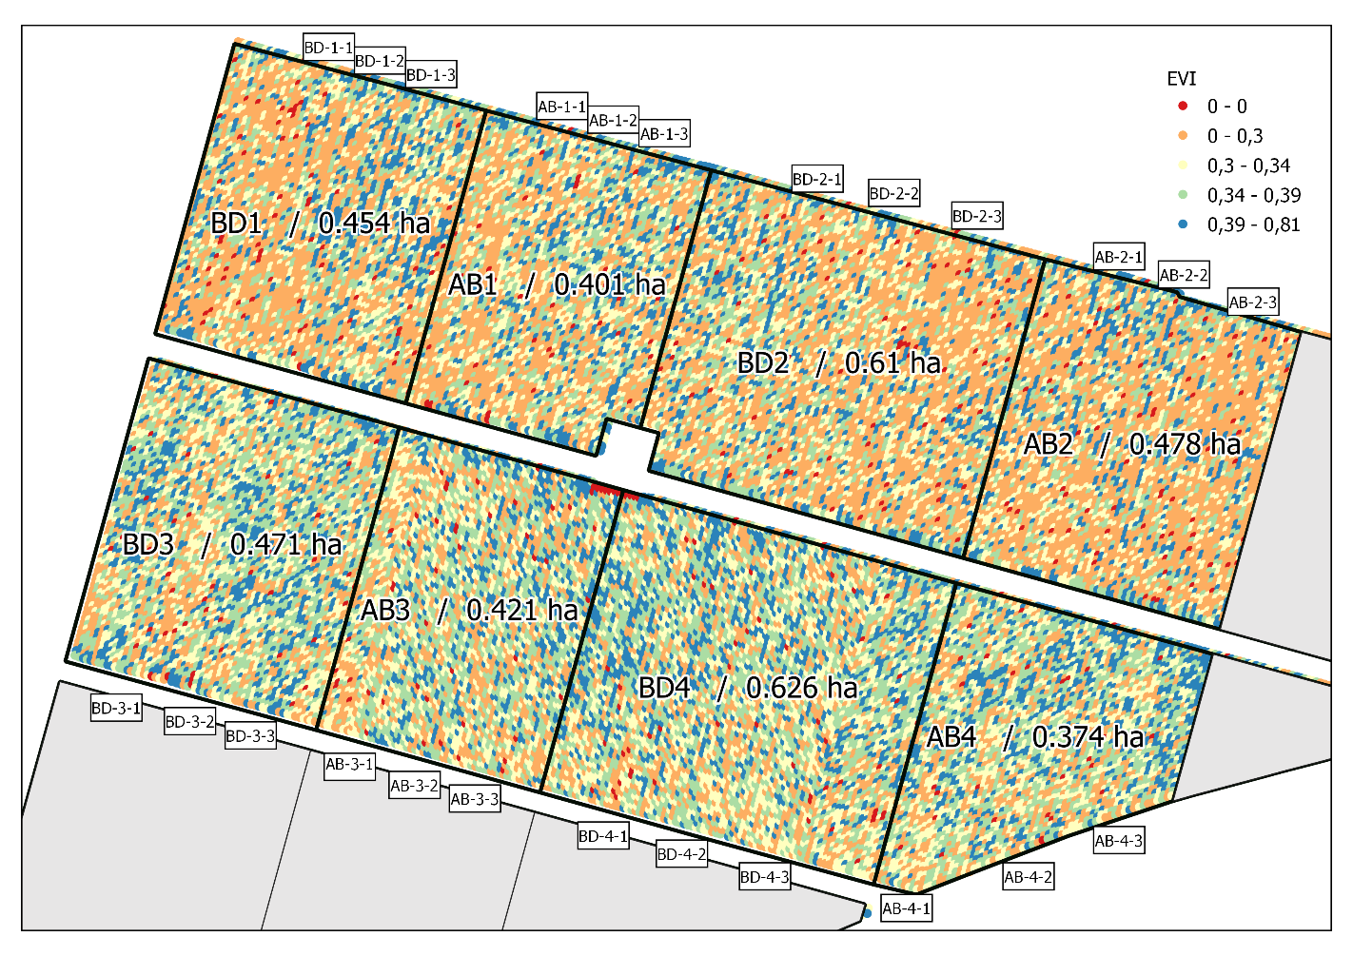
Supplementary data 1 Map of the EVI (Enhanced Vegetation Index) indicating the vigour of the vine plants in the experimental design. The black lines represent the limits of the experimental blocks. BD: Biodynamic treatment method; AB: Organic treatment method, control.

Supplementary data 2 Fertilising values of 500 preparation.
Preparation | 500
Moisture (%) | 70.6
Organic matter (%) | 25.5
Carbon (%) | 12.7
Nitrogen (%) | 0.9
P2O5 (%) | 0.2
K2O (%) | 0.1
CaO (%) | 0.9
MgO (%) | 0.2
Na (g.kg-1) | 0.3
Fe (g.kg-1) | 0.4
Cu (mg.kg-1) | 8.9
Bo (mg.kg-1) | 9.8
Mn (mg.kg-1) | 87.1
Zn (mg.kg-1) | 29

Supplementary data 3 Microbiological parameters of 500 and 501 preparations
Preparation | Total Yeast Count (UFC.mL⁻¹) | Total Bacterial Count (UFC.mL⁻¹) | Total Mold Count (UFC.mL⁻¹)
500 | <10 | 4.1. 10² | 2.6.10²
501 | <10 | 1.3.10² | <10

Supplementary data 4 Species of bacteria and moulds present among 10 identified and isolated clones from each preparation sample
Preparation | Bacteria | Mold
500 | Aminobacter aminovorans  Agromyces sp.  Bacillus subtilis sp.  Mycolicibacterium diernhoferi  Microterricola gilva  Cellulosimicrobium cellulans  Bacillus altitudinis complex  Rhodococcus erythropolis  Agromyces fucosus | Aspergillus terreus  Penicillium sp.  Penicillium brevicompactum
501 | Variovorax sp.  Aminobacter aminovorans  Olivibacter domesticus  Chitinophaga  Caulobacter sp.  Curvibacter lanceolatus  Bacillus pumilus  Bacillus amyloliquefaciens group  Bacillus altitudinid complex | NA*
* NA: Not applicable

Supplementary data 5 Meteorological data for the vintages 2022, 2023, and 2024 (Weather Station of Château Lafite Rothschild) Tmin: Monthly average of minimum temperatures; Tmoy: Monthly average of mean temperatures; Tmax: Monthly average of maximum temperatures; Pmens: Monthly rainfall total.
 | 2022 |  |  |  | 2023 |  |  |  | 2024
 | Tmin (°C) | Tmoy (°C) | Tmax (°C) | Pmens (mm) | Tmin (°C) | Tmoy (°C) | Tmax (°C) | Pmens (mm) | Tmin (°C) | Tmoy (°C) | Tmax (°C) | Pmens (mm)
January | -3.4 | 5.5 | 16.4 | 42.2 | -2.9 | 6.9 | 17.7 | 114.6 | 4.3 | 7.1 | 10.3 | 41.2
February | 0.4 | 9.0 | 17.3 | 34.8 | -3.3 | 6.5 | 17.9 | 46.6 | 6.7 | 9.7 | 13.1 | 157.2
March | 1.0 | 11.0 | 22.2 | 41.2 | -2.2 | 10.9 | 25.4 | 101.0 | 7.3 | 10.9 | 15.3 | 188
April | -1.4 | 12.4 | 24.2 | 108.8 | 1.3 | 13.0 | 25.9 | 46.2 | 8.7 | 13.1 | 18.1 | 79
May | 9.1 | 18.6 | 32.3 | 17.2 | 7.4 | 17.4 | 30.0 | 51.0 | 11.6 | 15.4 | 19.4 | 158.8
June | 11 | 20.5 | 39.6 | 113.2 | 13.2 | 21.7 | 31.5 | 75.4 | 15.2 | 20.1 | 24.0 | 60.2
July | 10.6 | 23 | 40.2 | 2.2 | 12.3 | 20.7 | 33.7 | 35.2 | 17.1 | 22.3 | 26.7 | 28.2
August | 14.3 | 23.9 | 38.5 | 13.8 | 10.8 | 21.5 | 39.3 | 43.4 | 17.7 | 23.2 | 27.5 | 6.0
Septembre | 7.9 | 18.8 | 35.1 | 23.8 | 10.3 | 21.2 | 35.6 | 60.6 | 12.9 | 16.7 | 21.5 | 146.4
Octobre | 10.2 | 18 | 28.5 | 51.8 | 7.2 | 18.4 | 31.4 | 174.8 | 12.1 | 15.3 | 19.8 | 98.6
Novembre | 1.7 | 11.6 | 20.8 | 135.2 | 8.2 | 11.2 | 14.5 | 318.8 | 8.1 | 11.4 | 15.9 | 80.8
Decembre | -2.8 | 7.5 | 19.4 | 72.6 | 6.2 | 8.7 | 11.4 | 136.4 | 4.7 | 7.6 | 10.7 | 72.6

Supplementary data 6 Results of mixed-effects ANOVA on berry weight.
Type of effect | Term or Source | Degrees of Freedom | Estimate | Standard Error | F Ratio | p-value
Random | Vintage | - | 6.763 x 10^10 | - | - | -
Fixed | Stage | 7(Stage),  568 (denom.) |  |  | 502.1259 | <0.0001****
Fixed | Method | 1(Method),  568 (denom.) |  |  | 8.7113 | 0.0033**
Fixed | Stage*Method | 8(Interaction), 568 (denom.) |  |  | 1.6732 | 0.1026

Supplementary data 7 Student’s t-test for differences in least square means on berry weight (α=0.050)
Level |  |  | Least Squares Mean | Standard Error
AB | A |  | 1.0201 | 0.00860
BD |  | B | 0.9840 | 0.00868

Supplementary data 8 Results of mixed-effects ANOVA on berry volume
Type of effect | Term or Source | Degrees of Freedom | Estimate | Standard Error | F Ratio | p-value
Random | Vintage | 190 (denom.) | 0.070226 | 0.011559 | - | <0.0001****
Fixed | Stage | 2(Stage),  209 (denom.) |  |  | 129.2858 | <0.0001****
Fixed | Method | 1(Method),  209 (denom.) |  |  | 5.1857 | 0.0238*
Fixed | Stage*Method | 2(Interaction), 209 (denom.) |  |  | 3.3294 | 0.0377*

Supplementary data 9 Student’s t-test for differences in least square means on berry volume (α=0.050)
Level |  |  | Least Squares Mean | Standard Error
AB | A |  | 1.11638 | -
BD |  | B | 1.07282 | -

Supplementary data 10 Results of mixed-effects ANOVA on exocarp width
Type of effect | Term or Source | Degrees of Freedom | Estimate | Standard Error | F Ratio | p-value
Random | Vintage | 125,2 (denom.) | 3.4952049 | 0.664455 | - | <0.0001****
Fixed | Stage | 1(Stage),  139 (denom.) |  |  | 7.4501 | 0.0072**
Fixed | Method | 1(Method),  139 (denom.) |  |  | 1.6241 | 0.2046
Fixed | Stage*Method | 1(Interaction), 139 (denom.) |  |  | 18.5981 | <0.0001****

Supplementary data 11 Student’s t-test for differences in least square means on the epidermis width (α=0.050)
Level |  |  |  | Least Squares Mean | Standard Error
BD, VER | A |  |  | 35.899 | 0.57033
AB, FG |  | B |  | 31.476 | 0.57033
AB, VER |  | B | C | 29.728 | 0.57033
BD, FG |  |  | C | 28.121 | 0.57033

Supplementary data 12 Results of mixed-effects ANOVA on cell wall thickness
Type of effect | Term or Source | Degrees of Freedom | Estimate | Standard Error | F Ratio | p-value
Random | Vintage | 70,71 (denom.) | 0.0854446 | 0.029415 | - | 0.0054**
Fixed | Stage | 1(Stage),  139 (denom.) |  |  | 10.5084 | 0.0015**
Fixed | Method | 1(Method),  139 (denom.) |  |  | 5.6092 | 0.0192*
Fixed | Stage*Method | 1(Interaction), 139 (denom.) |  |  | 3.1885 | 0.0763

Supplementary data 13 Student’s t-test for differences in least square means on cell wall thickness (α=0.050; t=1.96969)
Level |  |  | Least Squares Mean | Standard Error
BD | A |  | 1.2606 | 0.03551
AB |  | B | 1.1403 | 0.03551

Supplementary data 14 Results of mixed-effects ANOVA on PME activity
Type of effect | Term or Source | Degrees of Freedom | Estimate | Standard Error | F Ratio | p-value
Random | Vintage | - | -1.25 x 10^-10 | - | - | -
Fixed | Stage | 1(Stage),  280 (denom.) |  |  | 9.6863 | 0.0020**
Fixed | Method | 3(Method),  280 (denom.) |  |  | 6.0975 | 0.0005***
Fixed | Stage*Method | 3(Interaction), 280 (denom.) |  |  | 1.7782 | 0.1515

Supplementary data 15 Student’s t-test for differences in least square means on PME activity (α=0.050)
Level |  |  | Least Squares Mean | Standard Error
AB | A |  | 0.55469 | 0.01802
BD |  | B | 0.47537 | 0.01802

Supplementary data 16 Results of mixed-effects ANOVA on proportion of strong bonds polysaccharides
Type of effect | Term or Source | Degrees of Freedom | Estimate | Standard Error | F Ratio | p-value
Random | Vintage | 149.8 | 0.0101787 | 0.002476 | - | <0.0001*
Fixed | Stage | 3(Stage),  279 (denom.) |  |  | 265.2134 | <0.0001****
Fixed | Method | 1(Method),  279 (denom.) |  |  | 18.5308 | <0.0001****
Fixed | Stage*Method | 3(Interaction), 279 (denom.) |  |  | 2.7828 | 0.0413*

Supplementary data 17 Student’s t-test for differences in least square means on proportion of strong bonds polysaccharides (α=0.050)
Level |  |  | Least Squares Mean | Standard Error
BD | A |  | 0.24375 | 0.00334
AB |  | B | 0.22583 | 0.00334

Supplementary data 18 Results of mixed-effects ANOVA on proportion of large polysaccharides
Type of effect | Term or Source | Degrees of Freedom | Estimate | Standard Error | F Ratio | p-value
Random | Vintage | 1 | 0.0004568 | 0.000889 | - | 0.6979
Fixed | Stage | 3(Stage),  279 (denom.) |  |  | 128.9415 | <0.0001***
Fixed | Method | 1(Method),  279 (denom.) |  |  | 10.3220 | 0.0015**
Fixed | Stage*Method | 3(Interaction), 279 (denom.) |  |  | 5.5415 | 0.0010**

Supplementary data 19 Student’s t-test for differences in least square means on proportion of large polysaccharides (α=0.050)
Level |  |  | Least Squares Mean | Standard Error
BD | A |  | 0.16854 | 0.00225
AB |  | B | 0.15833 | 0.00225

Supplementary data 20 Partial contributions of the variables to the principal components of PCAs of polyphenols measured in grape skins at the maturity stage. A) Data for the 2022 vintage. B) Data for the 2023 vintage. C) Data for the 2024 vintage. STIL = stilbenes, FLAVO = flavonols, FLAVA = flavanols. Partial contributions are expressed as percentages.
A | Variable | Component 1 | Component 2
Flavanols | FLAVA-Catechin | 10.41092 | 1.42381
 | FLAVA-Gallocatechin | 10.05542 | 0.53103
 | FLAVA-Epigallocatechin | 6.38895 | 7.13726
 | FLAVA-Epicatchin | 6.21979 | 15.24921
 | FLAVA-ProcB1 | 7.96397 | 6.19005
 | FLAVA-ProcB2 | 4.58901 | 19.36528
Flavonols | FLAVO-Q3glu | 8.04031 | 4.7815
 | FLAVO-Q3gal | 9.03443 | 2.32274
 | FLAVO-Q3glucur | 10.40033 | 2.88026
 | FLAVO-Q3rut | 9.31014 | 16.1495
Stilbènes | STIL-E-vinif | 5.90957 | 1.28707
 | STIL-Pallidol | 0.4079 | 9.19219
 | STIL-t-Piceid | 7.53809 | 10.73698
 | STIL-c-Piceid | 4.55927 | 16.73316

B | Variable | Component 1 | Component 2
Flavanols | FLAVA-Catechin | 11.87504 | 0.08329
 | FLAVA-Gallocatechin | 11.90561 | 0.04713
 | FLAVA-Epigallocatechin | 11.48505 | 0.00097
 | FLAVA-Epicatchin | 12.26956 | 0.06337
 | FLAVA-ProcB1 | 11.49461 | 0.01206
 | FLAVA-ProcB2 | 7.89906 | 0.01206
Flavonols | FLAVO-Q3glu | 4.73992 | 13.43955
 | FLAVO-Q3gal | 4.6502 | 16.05225
 | FLAVO-Q3glucur | 2.73531 | 17.86072
 | FLAVO-Q3rut | 0.08196 | 18.98981
Stilbènes | STIL-E-vinif | 2.8699 | 2.80083
 | STIL-Pallidol | 2.1284 | 12.66238
 | STIL-t-Piceid | 5.6178 | 12.74076
 | STIL-c-Piceid | 10.24759 | 5.2373

C | Variable | Component 1 | Component 2
Flavanols | FLAVA-Catechin | 7.52438 | 0.13414
 | FLAVA-Gallocatechin | 12.85787 | 1.49219
 | FLAVA-Epigallocatechin | 12.17839 | 3.43184
 | FLAVA-Epicatchin | 13.34379 | 2.90297
 | FLAVA-ProcB1 | 13.19185 | 0.05618
 | FLAVA-ProcB2 | 11.03994 | 0.27986
Flavonols | FLAVO-Q3glu | 1.16329 | 22.581
 | FLAVO-Q3gal | 1.64692 | 18.28068
 | FLAVO-Q3glucur | 2.25297 | 19.50581
 | FLAVO-Q3rut | 1.51048 | 1.29027
Stilbènes | STIL-E-vinif | 0.02578 | 7.1319
 | STIL-Pallidol | 0.07073 | 2.76053
 | STIL-t-Piceid | 9.7455 | 2.74076
 | STIL-c-Piceid | 13.44812 | 0.84904

Supplementary data 21 Results of two-way ANOVA on berry degradation rate
Variables | Number of coefficients | Degrees of Freedom | Sum of Squares | F Ratio | Prob.>F
Days after sampling | 6 | 6 | 268045.18 | 70.2876 | <0.0001****
Method | 1 | 1 | 3516.61 | 5.5328 | 0.0199*
Days after sampling*Method | 6 | 6 | 3186.89 | 0.8357 | 0.5441

Supplementary data 22 Student’s t-test for differences in least square means on berry degradation rate (α=0.050)
Level |  |  | Least Squares Mean | Standard Error
AB | A |  | 88.119 | 2.7507
BD |  | B | 78.904 | 2.7898

