Supplement 1
Sexual Satisfaction and Shame Proneness
- b)
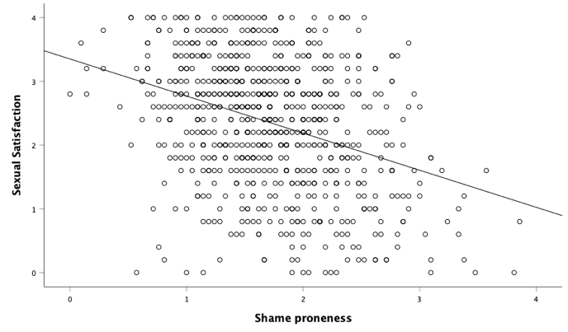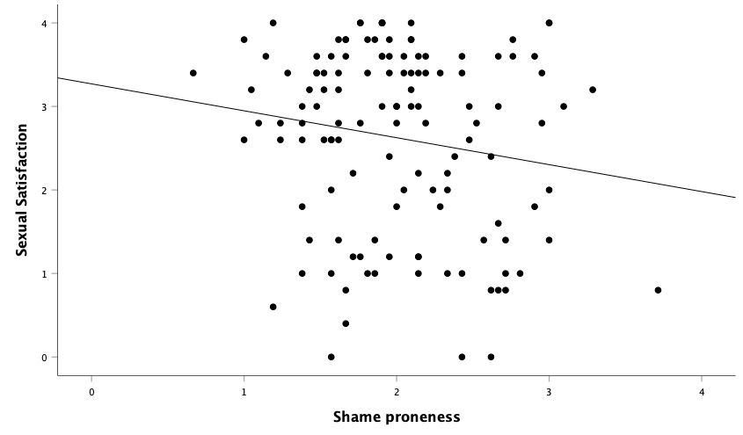
Note. Reported sexual satisfaction (y-axis) and shame proneness (x-axis) in GBM (Gay, Bisexual Men; n= 760) and LBW (Lesbian, Bisexual Women; n= 128). Dots represent individual mean values. Trend lines indicate relationship between variables. Higher scores indicate greater expression of the measured dimension. a) Sexual satisfaction and shame proneness in GBM. b) Sexual satisfaction and shame proneness in LBW.

Supplement 2
Sexual Satisfaction and LGB Identity Subscales
a) b)
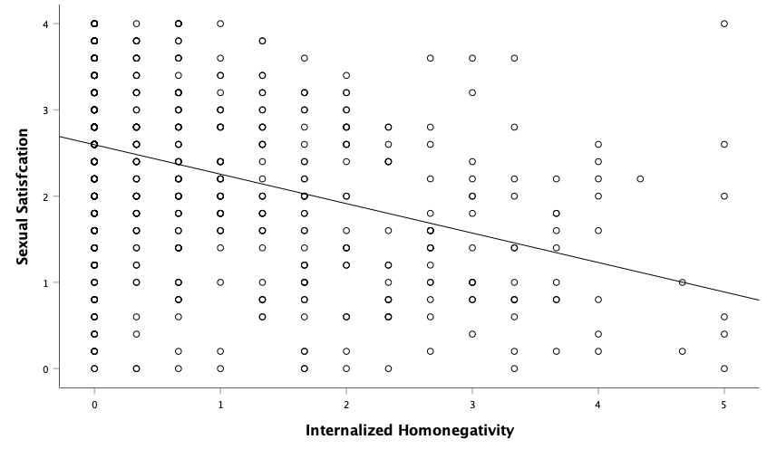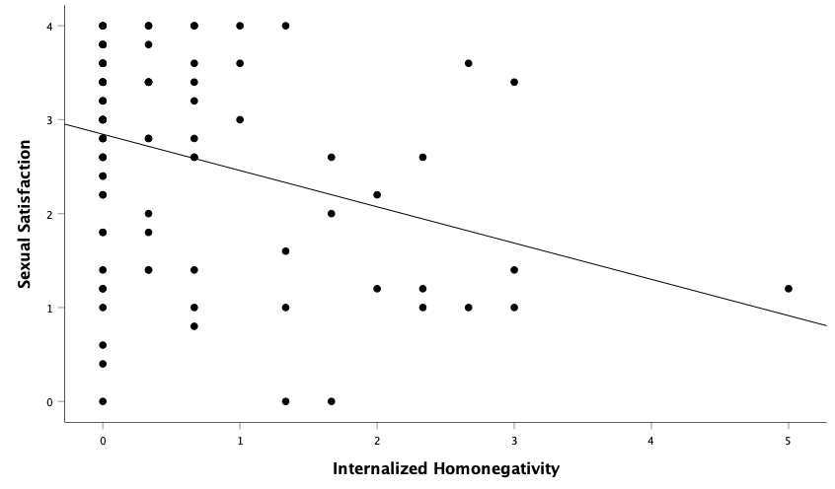
c) d)
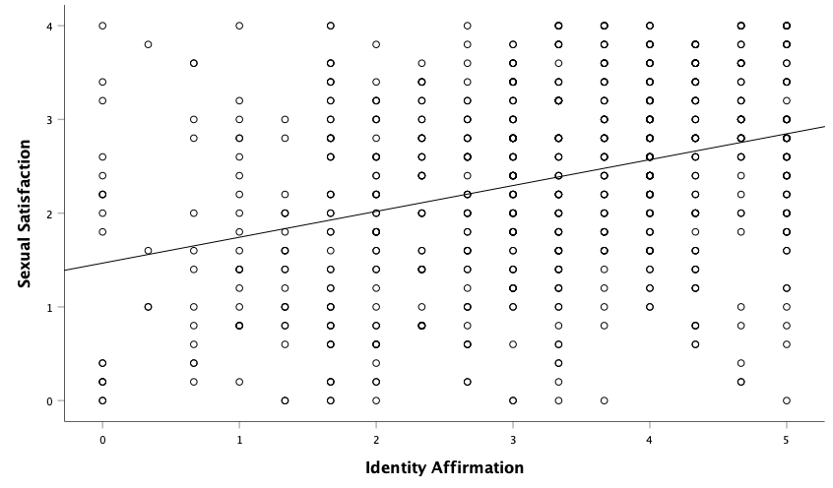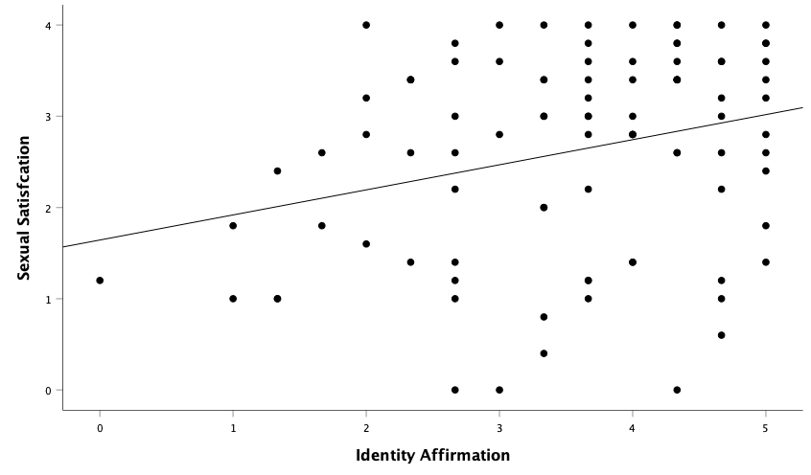

Note. Reported sexual satisfaction (y-axis) and LGBIS-DE subscales (x-axis) in GBM (Gay, Bisexual Men; n= 751) and LBW (Lesbian, Bisexual Women; n= 93). Dots represent individual mean values. Trend lines indicate relationship between variables. Higher scores indicate greater expression of the measured dimension. LGBIS= Lesbian, Gay, Bisexual Identity Scale. a) Sexual satisfaction and internalized homonegativity in GBM. b) Sexual satisfaction and internalized homonegativity. c) Sexual satisfaction and identity affirmation in GBM. d) Sexual satisfaction and identity affirmation in LBW.

